基于道氏理论的商品期货交易策略

策略回测（训练集）：

|  |  |  |  |  |  |  |
| --- | --- | --- | --- | --- | --- | --- |
| 年份 | 策略收益 | 最大回撤 | 夏普率 | 波动率 | Calmar | 月度胜率 |
| 2010 | 0.076386766 | -0.141703149 | 0.477696733 | 0.135364269 | 0.539061884 | 0.5 |
| 2011 | 0.073622071 | -0.090588096 | 0.375731801 | 0.159782751 | 0.81271243 | 0.75 |
| 2012 | 0.017348692 | -0.229507832 | 0.109911592 | 0.118955347 | 0.075590849 | 0.5 |
| 2013 | 0.200019118 | -0.067514045 | 1.352561804 | 0.110691715 | 2.962629761 | 0.75 |
| 2014 | 0.213841113 | -0.056374628 | 1.50242034 | 0.10098566 | 3.793215473 | 0.75 |
| 2015 | 0.189202887 | -0.084477721 | 1.035344218 | 0.131011255 | 2.239677926 | 0.666666667 |
| 2016 | 0.323565654 | -0.081324266 | 1.416327627 | 0.149038017 | 3.978709815 | 0.75 |
| 2017 | 0.07063857 | -0.097170841 | 0.492874734 | 0.112814881 | 0.72695234 | 0.5 |
| 2018 | 0.027914151 | -0.097940198 | 0.198617119 | 0.109325269 | 0.285012197 | 0.5 |
| 2019 | 0.03990618 | -0.1036789 | 0.257695295 | 0.119406113 | 0.384901651 | 0.416666667 |
| 2020 | 0.384788214 | -0.124526784 | 1.561928984 | 0.158033622 | 3.090003629 | 0.75 |
| 年化 | 0.14702122 | -0.229507832 | 1.452043958 | 0.124675623 | 0.640593475 | 0.621212121 |

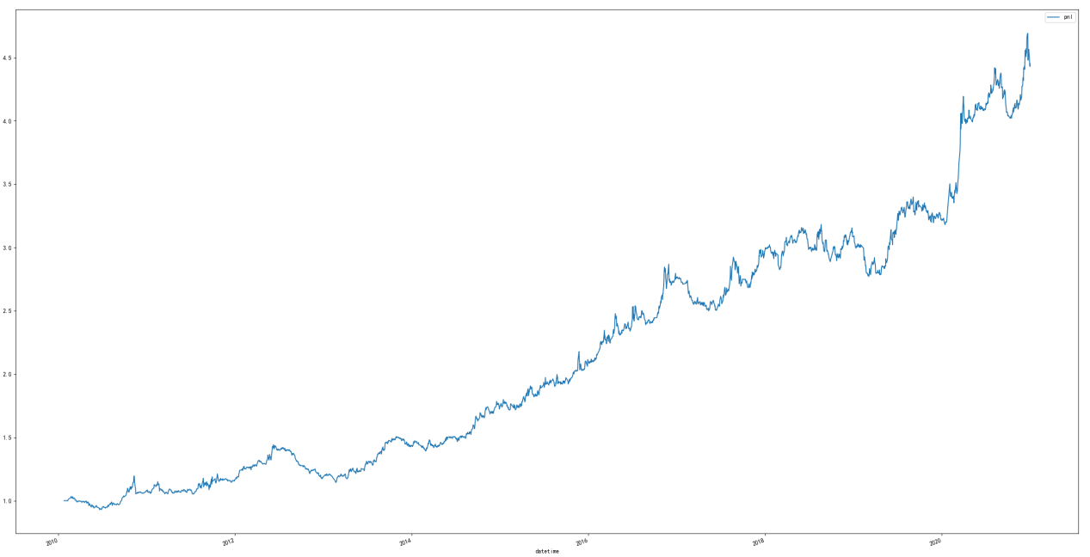

策略回测（测试集）：

|  |  |  |  |  |  |  |
| --- | --- | --- | --- | --- | --- | --- |
| 年份 | 策略收益 | 最大回撤 | 夏普率 | 波动率 | Calmar | 月度胜率 |
| 2021 | 0.262927847 | -0.186047215 | 0.935973493 | 0.180904436 | 1.413231836 | 0.666666667 |
| 2022 | 0.027403965 | -0.165510333 | 0.150917129 | 0.136085593 | 0.165572535 | 0.583333333 |
| 年化 | 0.145165906 | -0.186047215 | 1.384474633 | 0.166540534 | 0.780263797 | 0.625 |

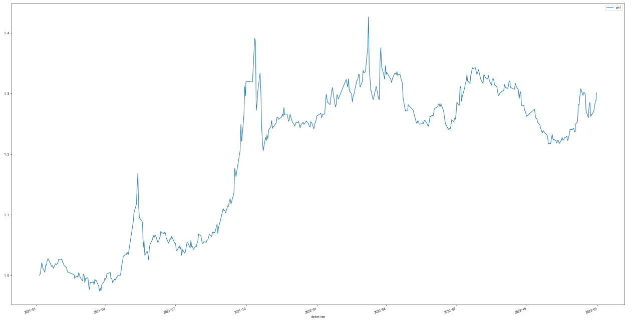

基于布林通道的商品期货交易策略

策略回测（训练集）：

|  |  |  |  |  |  |  |
| --- | --- | --- | --- | --- | --- | --- |
| 年份 | 策略收益 | 最大回撤 | 夏普率 | 波动率 | Calmar | 月度胜率 |
| 2010 | 0.135161898 | -0.076608123 | 0.925265702 | 0.123779917 | 1.764328547 | 0.666666667 |
| 2011 | 0.116753506 | -0.069314412 | 0.693859969 | 0.137156002 | 1.684404485 | 0.5 |
| 2012 | 0.211241028 | -0.032777694 | 1.877859384 | 0.085881698 | 6.444658009 | 0.833333333 |
| 2013 | 0.207891246 | -0.032871124 | 1.903735575 | 0.082033658 | 6.324433749 | 0.75 |
| 2014 | 0.122981831 | -0.056346751 | 1.13949656 | 0.076794547 | 2.182589594 | 0.666666667 |
| 2015 | 0.236604789 | -0.060017275 | 1.588138705 | 0.10192943 | 3.942278069 | 0.833333333 |
| 2016 | 0.374707291 | -0.059459964 | 2.145314665 | 0.117343807 | 6.301841917 | 0.75 |
| 2017 | -0.010590898 | -0.045680006 | -0.109605227 | 0.076525605 | -0.23184975 | 0.333333333 |
| 2018 | 0.109903763 | -0.06929713 | 0.870986213 | 0.095280045 | 1.585978572 | 0.5 |
| 2019 | 0.068579606 | -0.071374297 | 0.615077875 | 0.085550508 | 0.960844578 | 0.666666667 |
| 2020 | 0.305624267 | -0.048230714 | 1.886265617 | 0.120067332 | 6.336714546 | 0.75 |
| 年化 | 0.170805302 | -0.076608123 | 1.832509319 | 0.10983395 | 2.229597799 | 0.659090909 |

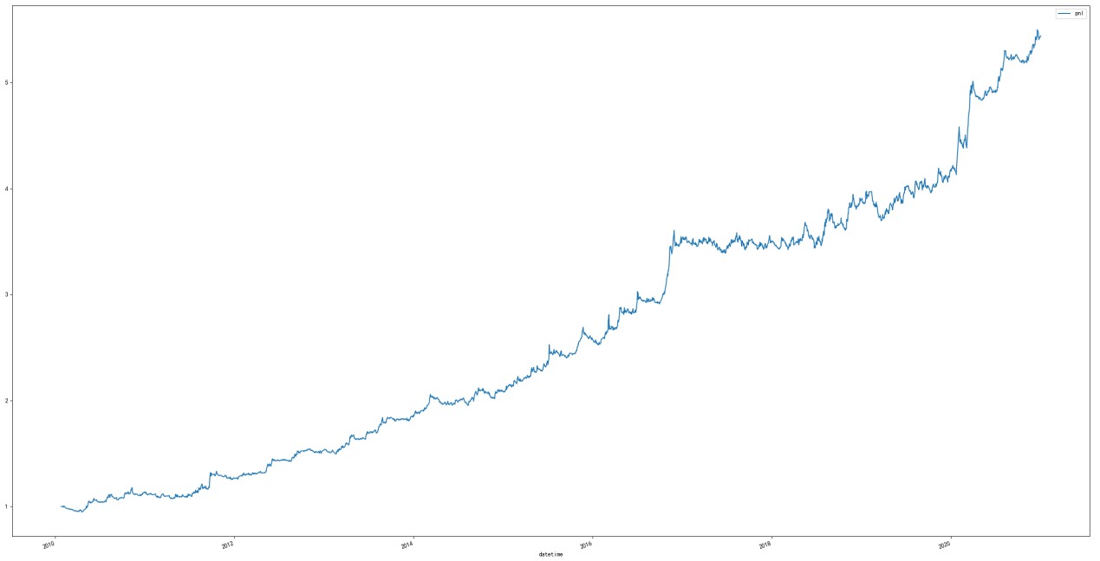

策略回测（测试集）：

|  |  |  |  |  |  |  |
| --- | --- | --- | --- | --- | --- | --- |
| 年份 | 策略收益 | 最大回撤 | 夏普率 | 波动率 | Calmar | 月度胜率 |
| 2021 | 0.154784092 | -0.129259844 | 1.008430054 | 0.109190363 | 1.197464638 | 0.75 |
| 2022 | 0.032576188 | -0.074838041 | 0.275915134 | 0.089641728 | 0.435289159 | 0.583333333 |
| 年化 | 0.09368014 | -0.129259844 | 1.753336559 | 0.086414037 | 0.724742792 | 0.666666667 |

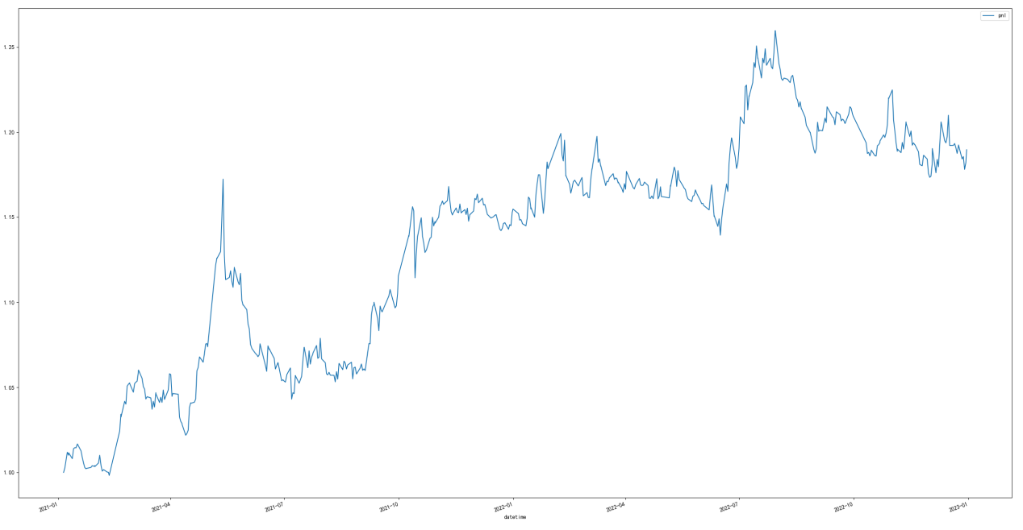

基于动量的股指期货交易策略

策略回测结果（训练集）：

|  |  |  |  |  |  |  |
| --- | --- | --- | --- | --- | --- | --- |
| 年份 | 策略收益 | 最大回撤 | 夏普率 | 波动率 | Calmar | 月度胜率 |
| 2010 | 0.136357481 | -0.024491245 | 1.826371465 | 0.084737209 | 5.56760107 | 0.555555556 |
| 2011 | 0.332064688 | -0.088298378 | 1.687444161 | 0.144809516 | 3.76071107 | 0.583333333 |
| 2012 | 0.233551098 | -0.060535038 | 1.329120304 | 0.137709855 | 3.858114331 | 0.666666667 |
| 2013 | 0.095914939 | -0.065677166 | 0.712930888 | 0.110950843 | 1.460400081 | 0.5 |
| 2014 | 0.276604401 | -0.081472295 | 1.644522109 | 0.128464712 | 3.395073159 | 0.5 |
| 2015 | 0.276644507 | -0.046299921 | 2.284782407 | 0.09415894 | 5.975053616 | 0.833333333 |
| 2016 | 0.067127842 | -0.125844731 | 0.291241568 | 0.182581256 | 0.533417973 | 0.666666667 |
| 2017 | 0.083956531 | -0.078950384 | 0.82793345 | 0.083066047 | 1.063408771 | 0.583333333 |
| 2018 | 0.134584653 | -0.045989225 | 1.068743251 | 0.100232947 | 2.926438818 | 0.5 |
| 2019 | 0.185143988 | -0.043019926 | 1.523322506 | 0.096490072 | 4.303679847 | 0.666666667 |
| 2020 | 0.271601605 | -0.042776327 | 1.975305032 | 0.103128729 | 6.34934378 | 0.583333333 |
| 年化 | 0.190322885 | -0.125844731 | 2.413654686 | 0.092147212 | 1.512362755 | 0.603535354 |

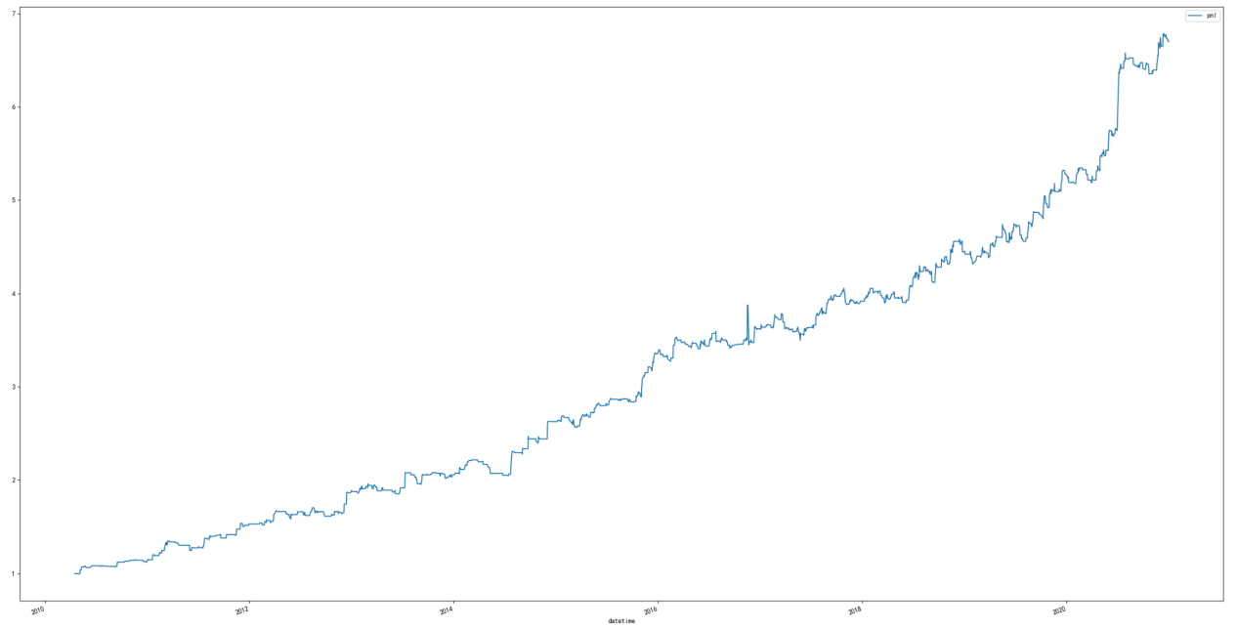

策略回测结果（测试集）：

|  |  |  |  |  |  |  |
| --- | --- | --- | --- | --- | --- | --- |
| 年份 | 策略收益 | 最大回撤 | 夏普率 | 波动率 | Calmar | 月度胜率 |
| 2021 | 0.127767295 | -0.051363109 | 1.451814488 | 0.069980284 | 2.487530409 | 0.666666667 |
| 2022 | -0.093205859 | -0.116455162 | -0.995641633 | 0.084079095 | -0.800358334 | 0.416666667 |
| 年化 | 0.017280718 | -0.116455162 | 0.186386531 | 0.156251616 | 0.148389452 | 0.541666667 |

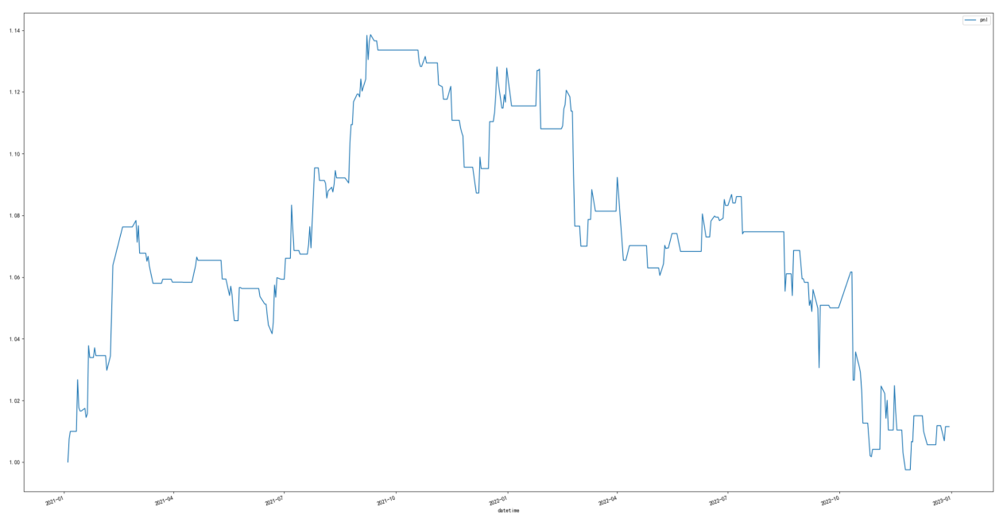

CTA复合策略

回测结果（训练集）：

|  |  |  |  |  |  |  |
| --- | --- | --- | --- | --- | --- | --- |
| 年份 | 策略收益 | 最大回撤 | 夏普率 | 波动率 | Calmar | 月度胜率 |
| 2010 | 0.115968715 | -0.071960535 | 1.236856721 | 0.078898836 | 1.61155994 | 0.666666667 |
| 2011 | 0.176315404 | -0.037009768 | 1.40094147 | 0.097914341 | 4.764023482 | 0.75 |
| 2012 | 0.162713168 | -0.039911278 | 1.640360649 | 0.076736723 | 4.076871883 | 0.666666667 |
| 2013 | 0.16028817 | -0.027429354 | 1.905393493 | 0.064359503 | 5.843672907 | 0.75 |
| 2014 | 0.206514764 | -0.047573687 | 2.350036124 | 0.061853523 | 4.340945103 | 0.666666667 |
| 2015 | 0.23990367 | -0.034222294 | 2.345673829 | 0.071846524 | 7.010157392 | 0.833333333 |
| 2016 | 0.231612268 | -0.051468024 | 1.755199767 | 0.090102756 | 4.500119665 | 0.833333333 |
| 2017 | 0.046494317 | -0.047787203 | 0.652659235 | 0.055443701 | 0.97294493 | 0.5 |
| 2018 | 0.095578838 | -0.049701913 | 1.148073517 | 0.062475707 | 1.923041422 | 0.666666667 |
| 2019 | 0.106199497 | -0.045281969 | 1.285771687 | 0.062159535 | 2.345293301 | 0.666666667 |
| 2020 | 0.311589236 | -0.049991112 | 2.623842194 | 0.08341352 | 6.232892668 | 0.75 |
| 年化 | 0.168470732 | -0.071960535 | 2.912224003 | 0.076162365 | 2.341154524 | 0.704545455 |

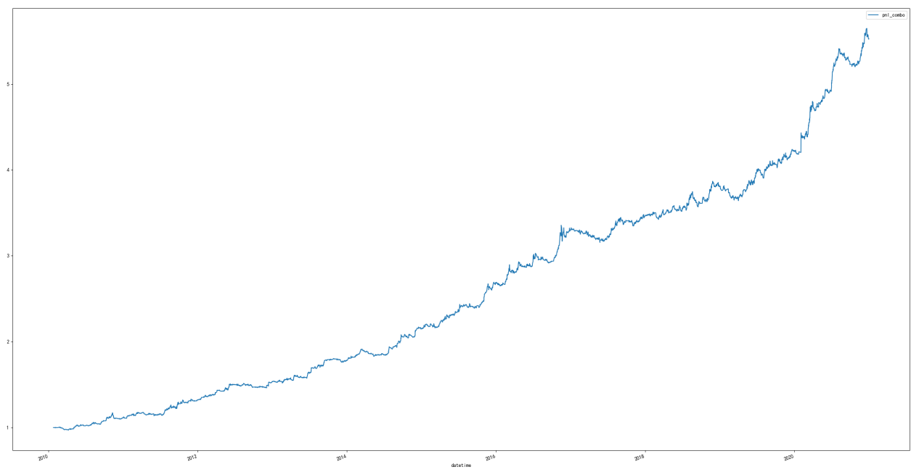

回测结果（测试集）：

|  |  |  |  |  |  |  |
| --- | --- | --- | --- | --- | --- | --- |
| 年份 | 策略收益 | 最大回撤 | 夏普率 | 波动率 | Calmar | 月度胜率 |
| 2021 | 0.181826411 | -0.082770248 | 1.361935889 | 0.091805373 | 2.196760499 | 0.666666667 |
| 2022 | -0.008977173 | -0.083804707 | -0.093329842 | 0.074577565 | -0.10712015 | 0.416666667 |
| 年化 | 0.086424619 | -0.083804707 | 0.871734983 | 0.134918508 | 1.031262109 | 0.541666667 |

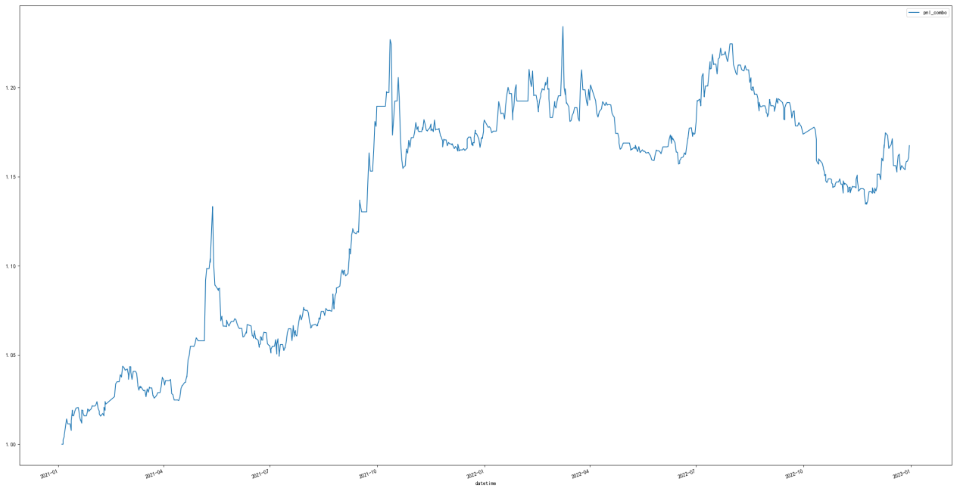

|  |  |  |  |
| --- | --- | --- | --- |
| 指标 | 股指动量 | 布林线 | 道氏趋势 |
| 换手率 | 0.61 | 0.103 | 0.07 |
| 杠杆 | 1.65 | 1.876 | 2.318 |