时序和截面策略组合

策略回测（训练集，无杠杆）：

|  |  |  |  |  |  |  |
| --- | --- | --- | --- | --- | --- | --- |
| 年份 | 策略收益 | 最大回撤 | 夏普率 | 波动率 | Calmar | 月度胜率 |
| 2012 | 0.079197467 | -0.018279575 | 2.324105781 | 0.029910277 | 4.332566149 | 0.545454545 |
| 2013 | 0.15308739 | -0.008326374 | 2.376760038 | 0.054140766 | 18.38584079 | 0.916666667 |
| 2014 | 0.127799431 | -0.027207866 | 3.110407678 | 0.031397692 | 4.697150127 | 0.833333333 |
| 2015 | 0.150737555 | -0.00906693 | 3.236497826 | 0.037902436 | 16.62498288 | 0.916666667 |
| 2016 | 0.123929139 | -0.02161658 | 2.255925293 | 0.042690163 | 5.733059522 | 0.666666667 |
| 2017 | 0.076842135 | -0.025629796 | 1.83853464 | 0.033656863 | 2.998156272 | 0.916666667 |
| 2018 | 0.104654077 | -0.012744847 | 2.919960164 | 0.029020968 | 8.211481791 | 0.75 |
| 2019 | 0.052998657 | -0.040312045 | 1.453902302 | 0.027954125 | 1.314710224 | 0.75 |
| 2020 | 0.179085523 | -0.012325608 | 3.644268987 | 0.038583482 | 14.52954905 | 0.833333333 |
| 年化 | 0.116481264 | -0.040312045 | 3.864968421 | 0.041454241 | 2.889490347 | 0.792087542 |

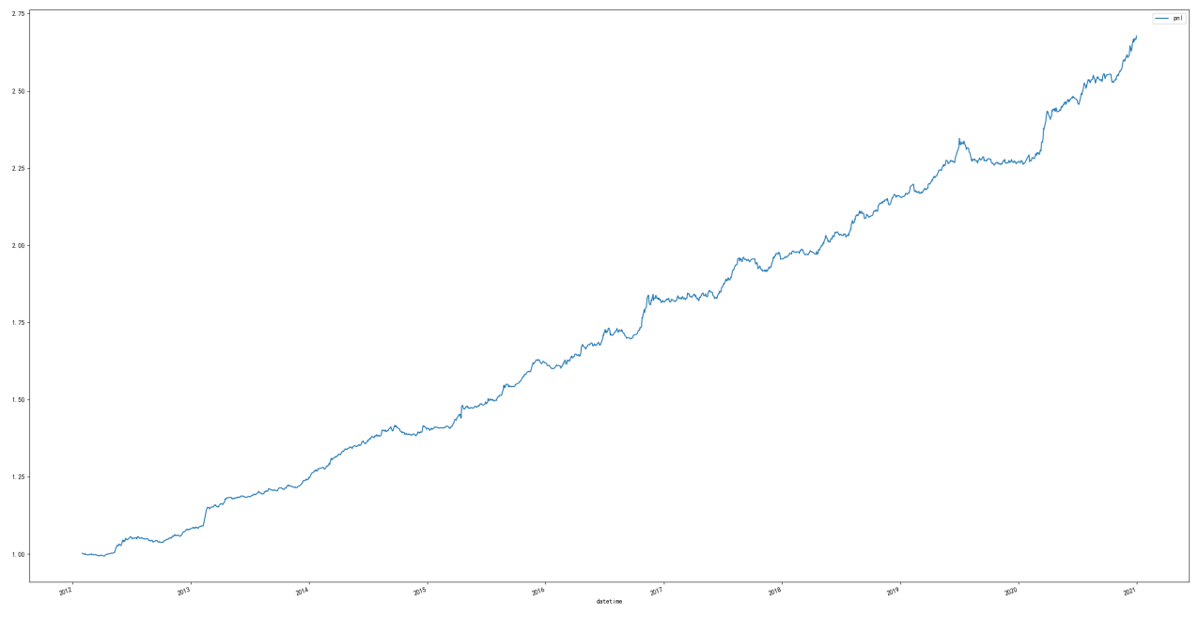

策略回测（测试集，无杠杆）：

|  |  |  |  |  |  |  |
| --- | --- | --- | --- | --- | --- | --- |
| 年份 | 策略收益 | 最大回撤 | 夏普率 | 波动率 | Calmar | 月度胜率 |
| 2021 | 0.184770685 | -0.023924241 | 3.04332047 | 0.046870702 | 7.723157622 | 0.833333333 |
| 2022 | 0.058899807 | -0.03434247 | 1.235281523 | 0.040925184 | 1.715071973 | 0.666666667 |
| 年化 | 0.121835246 | -0.03434247 | 2.366432426 | 0.089004151 | 3.547655351 | 0.75 |

