# 安全工程概论题库

PS 红字为正确答案，黄字为曾经错选

### Quiz1

Topic The fire problem

Reading:AB P1-9,P17-25

1. The Commission believes that a reduction of _______ in deaths, injuries, and property losses is possible within the next generation.
   1. 75%
   2. 10%
   3. 100%
   4. 25%
   5. 50%
2. At the time of the America Burning report, approximately how many deaths were caused by fire?
   1. 50000
   2. 12000
   3. 25000
   4. 10000
   5. 5000
3. According to the America Burning report, what accounts for 20 to 30 percent of all service calls in large cities in the U.S.?
   1. False alarms
   2. Chemical processing
   3. Arson
   4. Lightening
   5. Hot work
4. When America Burning was published, what was the main recommendation that the Commission made to the U.S. Congress?
   1. Standardization
   2. Distribute fire loss equally throught the government
   3. Establish a U.S. Fire Administration
   4. Collect more data
   5. Spend more money
5. According to the America Burning report, which one of the following alternatives for the future was an official recommendation made by the Commission?
   1. Hire people with college degree
   2. Consolidation of police and frighters
   3. Part volunteer, part paid firefrighters
   4. Auxiliary firefighters
   5. Women power
6. When America Burning was published, about 5 cents of every dollar spent on the fire services is used to extinguish fires; only about 95 cents is spent on efforts-mostly fire prevention inspections and public education programs – to prevent fires from starting.
   1. True
   2. Flase
7. According to the America Burning report, the best way to improve fire protection is more money.
   1. True
   2. False
8. According to the America Burning report, there is an old saying in the fire protection field, to the effect that fire has three causes.  What are they?
   1. Pets
   2. Mother nature
   3. Men
   4. Women
   5. Children
9. When America Burning was published, what trends occurring in the U.S. were affecting effective response to fires?
   1. Urbanization
   2. Natural disasters
   3. Increased cost
   4. Population boom
   5. Technological revolution
10. Most large cities have  fire departments; many smaller communities are protected by  departments.

## Quiz2

1. Which is not a fire and life safety inspection category?
   1. Issuance of a permit
   2. Imminent hazard
   3. Routine
   4. Change in building ownership
2. Which of the following categories of inspections is required when an existing structure is altered?
   1. Response to a compliant
   2. Change in occupancy
   3. Issance of a permit
   4. New construction
3. Which of the following categories of inspections occurs when it becomes obvious that the occupancy poses a hazard to life and property?
   1. Response to a compliant
   2. Change in occupancy
   3. Issuance of permit
   4. Change in ownership
   5. Imminent hazard
4. The statement “a fire that does not occur is the one that is most easily controlled” accurately describes the ultimate goal of what?
   1. Fire Department
   2. Legislation
   3. Compliance procedure
   4. The public sector
   5. Fire and life safety inspection programs
5. Inspectors must follow procedures when conducting inspections and document all actions taken.  Put the following inspection actions in order of how they are generally enacted.
   1. **Written notification of infractions**
   2. **Follow-up inspection**
   3. **Sancation**
   4. **Prosecution**
6. AHJ stands for what Authority Having Jurisdiction
7. All levels of government have created fire inspection and code enforcement organizations with the authority to manage certain programs. It is their _______ to accomplish the goal of protecting lives and property from uncontrolled fires and other hazards.
   1. Liability
   2. Civil right
   3. Duty
   4. Authurity
   5. Requirement
8. ______________ is defined as commission of an unlawful act that is knowingly committed by a public official.
   1. Malfeasance
   2. None of the answers are correct
   3. Nonfeasance
   4. Public duty doctrine
   5. Misfeasance
9. Model fire codes grant the AHJ ___________ as often as necessary to perform an inspection or to execute any duties authorized by the fire code.
   1. Right of entry
   2. Authority
   3. Search warrants
   4. Liability
   5. Duty
10. An inspector is given the ___________ to perform his or her duties based on the laws adopted by the AHJ or regulations established by the private sector organization.
    1. Authority
    2. Search warrant
    3. Duty
    4. Obligation
    5. Right of entry

## Activity1

国际性机构组织的缩写以及目的，略

## Quiz3

1. Air consists of about ___ percent oxygen.
   1. 100
   2. 50
   3. 21
   4. 18
   5. 25
2. Which of the following is the transfer of heat within an object or to another object by direct contact?
   1. Rollover
   2. Conduction
   3. Radiation
   4. Convection
   5. Incipient
3. Which of the following is the transmission of energy as an electromagnetic wave without an intervening medium?
   1. Incipient
   2. Rollover
   3. Radiation
   4. Conduction
   5. Convection
4. Class B fires involve what types of fuels?
   1. Flammable liquids
   2. Animal fats
   3. Wood and paper
   4. Combustible metals
   5. Energized electrical equipment
5. Which of the following is a condition where the un-burned fire gases accumulated at the top of a compartment ignite and flames propagate through the hot-gas layer or across the ceiling?
   1. Incipient
   2. Flammable
   3. Rollover
   4. Flashover
   5. Backdraft
6. Which stage of fire occurs when all combustible materials in the compartment are burning?
   1. Growth
   2. Rollover
   3. Incipient
   4. Decay
   5. Fully developed
7. A flammable liquid has a has a flashpoint that is _BELOW__ a temperature of _100华氏度 .
8. Exothermic reactions absorb energy as they occur.
   1. True
   2. False
9. Water has a specific gravity of 1.0
   1. True
   2. Flase
10. What are the four elements of the fire tetrahedron?
    1. Chemical chain reaction
    2. Conduction
    3. Fuel
    4. Heat/source of ignition
    5. Air/oxygen
    6. Convection
    7. Vaporization
    8. Pyrolisis

## Quiz4

1. Using ___________, building officials and code enforcement personnel can gain a reasonable expectation of the hazard level in a building.
   1. Building permits
   2. Occupancy classifications
   3. Authority
   4. Construction types
   5. Fire load
2. The International Code Council has how many general occupancy categories?
   1. 9
   2. 6
   3. 10
   4. 7
   5. 8
3. Fire Load____________ is used as a measure of the potential heat release of a fire within a compartment.
4. Trusses typically use a _____________ configuration to provide stability and efficiently transfer the applied loads.
   1. Triangular
   2. Circular
   3. Rectangular
   4. Linear
   5. Cylindrical
5. Which type of wall will support the weight of a roof?
   1. Load-bearing
   2. Nonload-bearing
6. Which is not a factor in determining the type of construction used in a building?
   1. Building size
   2. Presence of automatic sprinklers
   3. Fire resistance of construction materials
   4. Occupancy type
   5. Building owner
7. Which construction type is least likely to contribute to the spread of a fire?I
8. What is the most common example of Type V construction?
   1. School
   2. Warehouse
   3. Single-family house
   4. Church
   5. Retail store

## Activity2

观看视频并且标注各个阶段的时刻

## Avtivity3

看图并且识别建筑类型以及墙体结构

T15Type 3

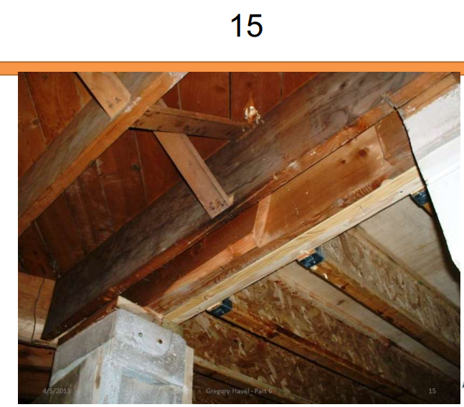

T19Type 5

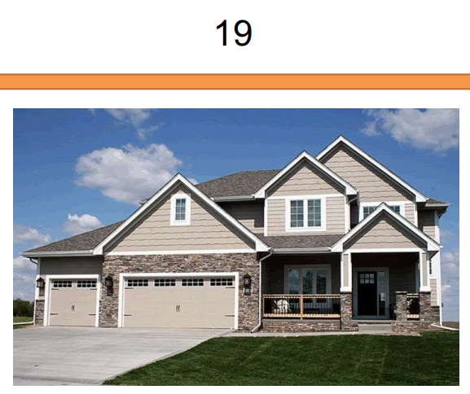

T2、4

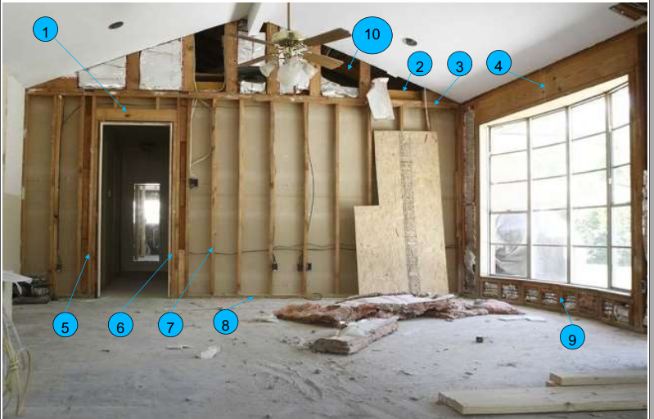

Joist

header

## Quiz 5

1. Which is not one of the common factors that continues to be cited during investigations associated with means of egress systems?
   1. Inaccessible exits
   2. None of the answer is correct
   3. Overcrowded occupancies
   4. In properly designed or marked exits
2. Name three basic elements of an egress system
   1. Exit discharge
   2. Exit access
   3. Corridor
   4. Door
   5. Exit
   6. Hallway
3. Match the term with its definition.
   1. Exit
   2. Exit discharge
   3. Exit access
   4. Means of egress
   5. Common path of travel
4. A public way must have a clear width of _____feet and a clear height of _____feet
5. The total number of people for which the means of egress of a building or portion thereof is designed is call the:
   1. Occupancy max
   2. Exit load
   3. Occupancy classification
   4. Building load
   5. Occupant load
6. Model codes permit escalators, elevators, or moving walkways to be considered as part of a means of egress in new occupancies regardless of design.
   1. Ture
   2. False

## Quiz 6

1. Connecting an object that conducts electricity to the soil with something that is a conductor is known as:
   1. Arcing
   2. Melding
   3. Grounding
   4. Bonding
   5. Hot work
2. Connecting two objects that conduct electricity with something that is also a conductor is known as:
   1. Arcing
   2. Melding
   3. Grounding
   4. Bonding
   5. Hot work
3. According to your textbook, which of the following are not physical hazards
   1. Toxicity
   2. Flammability
   3. Reactivity
   4. Oxidizer
   5. Pyrophoric
   6. Corrosives
4. What are pyrophoric materials
   1. Materials with the potential to self-heat when they come in contact with air
   2. Liquids, solids, or gaseous materials that in small quantities and without external ignition sources can ignite within 5 minutes of coming into contact with air
   3. Materials that may not be stored in locations or in a manner where they can become combustible or dangerous
   4. Liquids, solids,or gaseous materials that are capable of causing a fire through friction or retained heat
5. Safety cans are a maximum of5gallons in size
6. Which of the following is a device that opens well below any pressure that would threaten the integrity of a tank?
   1. Ventilation valve
   2. Pressure-relief valve
   3. Regulator
   4. Frangible bulb
   5. Safety vent
7. 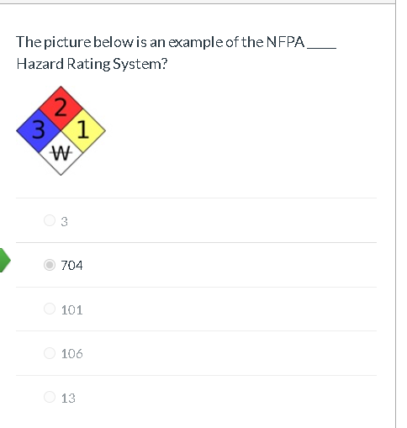
8. SDS stands for:
   1. Safety Data Sheet
   2. Sheets for Data Safety
   3. Safety Defined Standards
   4. Supplier Data and Safety information
   5. Safety Data Sources
9. 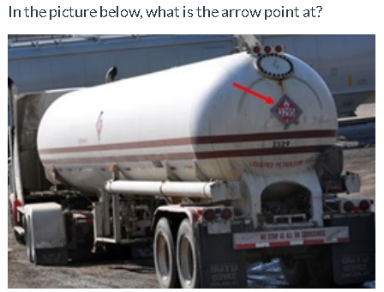
   1. Placard
   2. Sign
   3. ID
   4. Label
   5. Warning

## Activity 4

Using NFPA 30 Flammable and Combustible Liquids Code, match the term with its definition.

1. Class 1A Flammable Liquid
   1. Class IA liquids — those liquids that have flash points below 73°F (22.8°C) and boiling points below 100°F (37.8°C)
2. Class 1B Flammable Liquid
   1. Class IB liquids — those liquids that have flash points below 73°F (22.8°C) and boiling points at or above 100°F (37.8°C)
3. Class 1C Flammable Liquid
   1. Class IC liquids — those liquids that have flash points at or above 73°F (22.8°C), but below 100°F(37.8°C).
4. Class II Combustible Liquid
   1. Class II Liquid — any liquid that has a flash point at or above 100°F (37.8°C) and below 140°F (60°C)
5. Class IIIA Combustible Liquid
   1. Class IIIA — any liquid that has a flash point at or above 140°F (60°C), but below 200°F (93°C)
6. Class IIIB Combustible Liquid
   1. Class IIIB — any liquid that has a flash point at or above 200°F (93°C).

Quiz 7

1. Which classification is assigned to fires involving energized electrical equipment?
   1. Class A
   2. Class B
   3. Class C
   4. Class D
   5. Class K
2. What is the potential threat of clean-agent fire-extinguishing systems?
   1. Chenmical burns
   2. Smoke inhalation
   3. Asphyxiation
   4. Thermal burns
   5. Dehydration
3. Water are the best agent to extinguish fires involving__fuels
   1. Class D
   2. Class C
   3. Class B
   4. Class K
   5. Class A
4. Proper placement of fire extinguishers results in extinguishers that are
   1. Away form normal path of travel
   2. Near points of egress
   3. Stored behind equipment
   4. In closest to propect them
   5. Discretely placed
5. NPFA 10 recommends that fire extinghisher inspections be performed
   1. Annually
   2. Quarterly
   3. Monthly
   4. Biennially
   5. Semiannually
6. Wet chemical extinguish systems are most effective on fire involving what type of equipment
   1. Class C
   2. Commercial cooking
   3. Oil and gas production
   4. Retail gas pump
   5. Class A fuels
7. What is the name of the test used to check the integrity of fire extinguisher cylinders
   1. Audit
   2. Operational
   3. Hydrostatic
   4. Inspection
   5. Maintenance
8. Which standard governs portable fire extinguisher installation, inspection and maintenance requirements?
   1. NFPA 13
   2. NFPA 70
   3. NFPA 10
   4. NFPA 600
   5. NFPA 72
9. Dry chemical and dry powder extinguishing agents are essentially the same.
   1. True
   2. False
10. Water can be used in class D fire
    1. True
    2. False

Activity5

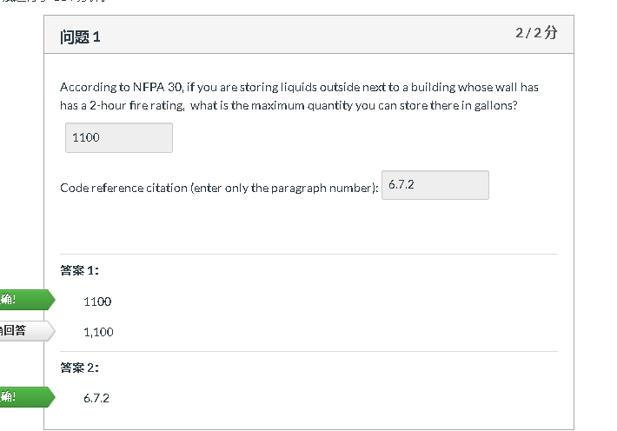

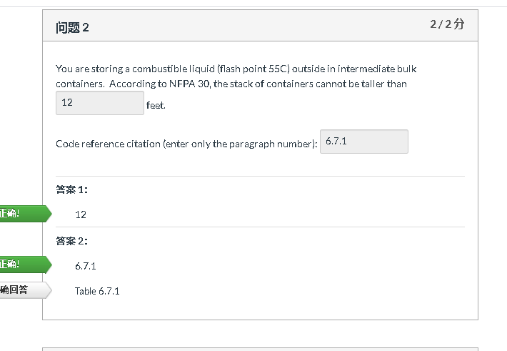 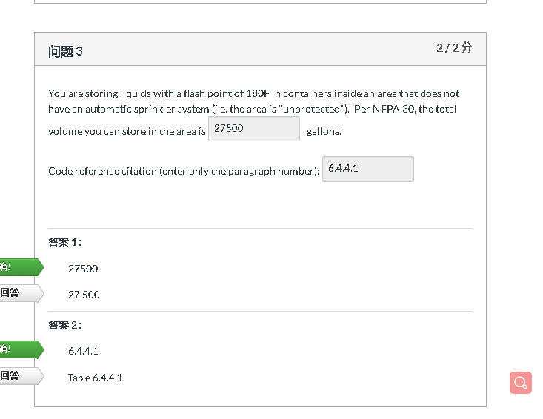 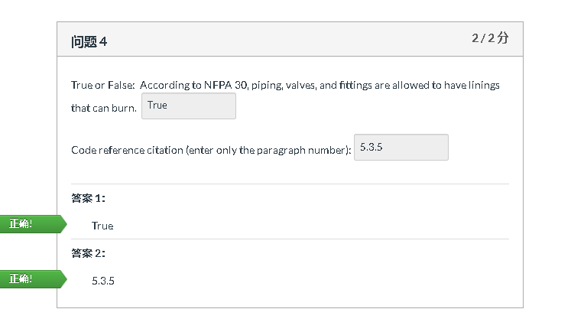 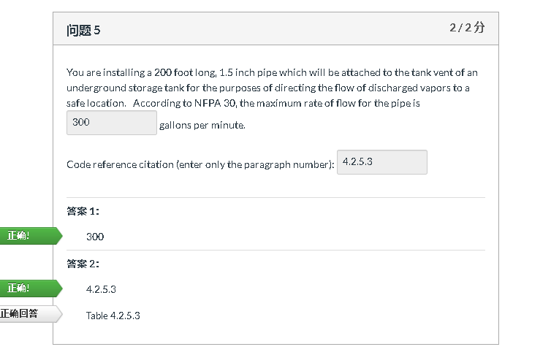

Quiz 8

1. Which is not a type of smoke detector?(select all that apply)
   1. Rate compensation
   2. Ionizing
   3. Rate of rise
   4. Photoelectric
   5. Air-sampling
2. Which is not a type of flame detector?(select all that apply)
   1. UV
   2. IR
   3. Ionizing
   4. Fire sprinkler
   5. Rate of rise
3. Which is not an example of notification device?
   1. None of the answers are correct
   2. Smoke detector
   3. Bells
   4. Speakers
   5. Store lights
4. The National Fire Alarm Code for the US isNFPA72
5. Which alarm system is widely used in large commercial or industrial applications?
   1. Central station
   2. Protected premises
   3. Proprietary
   4. Remote station
   5. Local
6. Which alarm system sends an alarm signal directly to the fire department?
   1. Proprietary system
   2. Remote station
   3. Central station
   4. Local
   5. Protected premises
7. Which alarm system is widely used only to notify occupants on the premises?
   1. Proteted premises
   2. Public emergency alarm reporting
   3. Proprietary system
   4. Remote station
   5. Central station
8. Which is not an example of fire alarm initiating device
   1. Strobe
   2. Fire sprinkler system water flow sensor
   3. Manual pull station
   4. Smoke detector
   5. Heat detector
9. The name of the fire detector typically found in a house is a smoke detector.
   1. True
   2. False
10. Photoelectric smoke detectors usually respond quicker to smoldering fires.
    1. True
    2. False

Quiz 9

1. Which views are two-demisional views of a site and building as seen from directly above the area?
   1. Detailed views
   2. Floor Plans
   3. Sectional views
   4. Elevation views
   5. Site Plan views
2. Which views are vertical views of a building as if it were cut into two parts?
   1. Plan views
   2. Floor Plans
   3. Sectional views
   4. Detailed views
   5. Elevation views
3. Which views are two-demensional views of a building as seen from the exterior
   1. Sectional views
   2. Floor Plans
   3. Elevation views
   4. Detailed views
   5. Plan views
4. Which views are provided when it is necessary to show a feature in lager size than what is on a small-scale drawing in order to show specifics?
   1. Sectional views
   2. Detailed views
   3. Elevation views
   4. Floor Plan
   5. Plan views
5. Floor plans include all of the following EXCEPT:
   1. Walls
   2. Stairs if applicable
   3. Sprinklers
   4. Windows
   5. Doors
6. Before checking proposed building fire sprinkler systems, plans reviewers must first:
   1. Classify the hazard by occupancy
   2. Obtain manufacturer’s cut sheets
   3. Calculate storage capacity
   4. Determine occupant load
   5. Obtain hydraulic calculations
7. Which is **not** an example of supporting documentation for construction documemts
   1. Sprinkler calculations
   2. Hydraulic calculations of applicable
   3. Safety Data Sheets
   4. Cut sheets
   5. As-built drawings
8. Regarding submitted drawings for review, the determination of a building’s occupancy classification is the responsibility of the:
   1. AHJ
   2. Safety Professional
   3. Inspector
   4. Building owner
   5. Architect
9. After verifying occupant load of a space, the plans examiner needs to evaluate
   1. Construction classification
   2. Overall size of the building
   3. Exit capacity
   4. Occupancy classification
   5. Meams of egress