Explanation Stability and Post-hoc Trust Governance
for Class-Incremental Network Traffic Classification
OFRA prediction with an offline ETG evidence ledger
WU LIQIANG

Abstract
Class-incremental network traffic classification requires a model to learn newly introduced classes without an oracle task identifier while retaining earlier decisions. This paper studies prediction, explanation stability, and post-hoc governance as linked but separately bounded layers. OFRA combines a shared FT-Transformer encoder, family-specific low-rank binary heads, bounded replay, and a DP-Means router. SHAP expected gradients explain the registered joint-cap class margin, and ETG records certification, refusal, escalation, and strict recertification outcomes without changing the underlying prediction. Four completed FT-Transformer seeds on MalayaNetwork_GT and NSL-KDD provide descriptive evidence. An additive TabM mean-embedding encoder comparison has now completed five Malaya seeds while preserving the existing OFRA heads, router, memory, and joint-score rule. Over the four seeds shared with FT-Transformer 512x12, TabM-OFRA raises joint-cap accuracy by 5.23 percentage points but changes Macro-F1 by only +0.15 points, balanced accuracy by -0.64 points, and forgetting by -0.01 points. A separate cumulative CatBoost diagnostic reaches 66.50% accuracy and 34.76% Macro-F1, indicating feature-level classification headroom, but it is not a matched OFRA arm. The completed Malaya seed-1 explanation analysis identifies 12 silent-drift events among 17 eligible class-by-adjacent-checkpoint transitions; ETG records six admissions, four refusals, four escalations, one strict recertification, and two recertification failures. The evidence supports an integrated offline audit pipeline, not an online feedback loop.
The cumulative CatBoost and TabM rows retrain on all seen-class training samples and therefore have more information than OFRA's bounded replay pipeline. They diagnose classification headroom but cannot isolate the effect of the encoder, family heads, router, or memory budget. The CatBoost 400-tree setting is exploratory because it followed a seed-1 sensitivity check; no confirmatory superiority claim is made.
Keywords: class-incremental learning; network traffic classification; explainable AI; explanation drift; SHAP; trust governance; intrusion detection.

1. Introduction

1.1 Background and motivation
Network traffic changes as applications, services, attacker behaviour, and collection environments evolve. A fixed classifier therefore becomes incomplete, but repeatedly retraining one shared model can overwrite knowledge of earlier classes. Class-incremental learning addresses this setting by presenting new classes sequentially and evaluating all classes observed so far. For a security-facing system, predictive retention is only one requirement. Analysts may also rely on explanations to understand why a class score was produced, so a stable accuracy value does not by itself guarantee stable decision evidence.
This study distinguishes prediction, explanation, and governance. OFRA produces the class decision. SHAP explains the registered winning-class margin at stored checkpoints. ETG consumes performance and explanation evidence after inference and writes a governance ledger. This separation prevents an explanation-quality failure from silently cancelling an intrusion alert, while also avoiding the stronger claim that ETG already controls the learner.

1.2 Problem statement
Current class-incremental NIDS evaluation commonly prioritises accuracy and forgetting, whereas explanation stability and operational response are less consistently measured. A valid audit must explain the same score used by the registered inference path; an approximate wrapper or a separate surrogate model cannot establish governance of the deployed decision. The present study therefore uses a source-bound analysis of OFRA's registered joint-cap score. The remaining problem is to determine whether the current predictor retains useful performance across increments, whether its explanation ranking changes under performance-preserved transitions, and how uncertain or unstable explanations should be recorded without overstating deployment maturity.

1.3 Research questions and objectives
RQ1: Under legitimate class-incremental model updates, how stable are the feature attributions supporting OFRA's registered routed decision when class-level predictive performance remains within a declared stability rule?
RQ2: What accuracy, Macro-F1, balanced-accuracy, and forgetting trade-offs arise between registered OFRA decision arms, and what additional headroom is indicated by bounded classifier comparisons?
RQ3: How can explanation evidence be certified, refused, escalated, and re-certified after prediction without suppressing the underlying network-classification alert?
RO1 is to implement a fixed-probe, adjacent-checkpoint protocol for the actual joint-cap class margin. RO2 is to compare registered OFRA decision arms and bounded encoder or classifier diagnostics without changing the primary method or mixing unmatched protocols. RO3 is to operate an offline ETG ledger whose state transitions and limitations are explicitly auditable.

2. Related Work

2.1 Continual learning and parameter-efficient adaptation
Catastrophic forgetting motivates regularisation, rehearsal, distillation, exemplar, and parameter-isolation methods in continual learning (French, 1999; Kirkpatrick et al., 2017; Rebuffi et al., 2017). LoRA freezes a base transformation and represents a trainable update with low-rank matrices (Hu et al., 2022). For tabular representation learning, TabM uses parameter-efficient ensembling to produce multiple predictions within one model (Gorishniy et al., 2025), while CatBoost is a gradient-boosted tree method designed to reduce prediction shift in boosting (Prokhorenkova et al., 2018). The present family-specific low-rank head and TabM mean-embedding adapter are project integration choices; neither is presented as a new derivation of the cited methods.

2.2 Explanation drift and IDS governance
Recent work has moved beyond one-time post-hoc explanation. E2D2 detects explanation-based drift in unsupervised NIDS, but it targets distributional drift monitoring rather than legitimate class-incremental parameter updates (Nugraha and Bauschert, 2026). Maseno et al. (2026) use SHAP instability as an auxiliary signal for adversarial evasion, whereas the present study excludes adversarial perturbation and compares consecutive learning checkpoints. Goncalves and Alomari (2026) evaluate analyst-facing SHAP and LIME explanations in cloud intrusion detection, but do not define a class-incremental explanation ledger. Adabara et al. (2025) combine SHAP, probability calibration, and uncertainty in a cognitive IDS, yet do not test non-suppressing governance actions after explanation drift. These studies establish closely related motivation, but none closes the specific gap between legitimate class expansion, the exact routed decision score, and a governance record that leaves the predictive alert active.
Table 1. Positioning against the four recent studies identified during review.
Study | Drift or trust trigger | IDS setting | Gap relative to this work
E2D2 (2026) | Unsupervised explanation-based drift | Unsupervised NIDS | Not legitimate class-incremental model updates; no ETG action ledger
Maseno et al. (2026) | Adversarial SHAP instability | Recurrent multiclass IDS | Adversarial trigger, not benign learning increments; no non-suppressing governance
Goncalves and Alomari (2026) | Human interpretation of SHAP/LIME | AWS GuardDuty | User study rather than longitudinal routed-score stability
Adabara et al. (2025) | Calibration, uncertainty, and SHAP | CICIDS2017 | No class-incremental sequence or explanation-state transition ledger

2.3 Research gap
The gap is not simply the absence of SHAP in NIDS. It is the absence of a source-bound protocol that (i) explains the same routed score used for prediction, (ii) measures stability under legitimate class-incremental updates, and (iii) converts that evidence into auditable, non-suppressing governance states. This paper addresses that narrower gap and avoids claiming that explanation stability alone proves prediction correctness or security effectiveness.

3. Methodology

3.1 Scope and dataset separation
Each dataset is preprocessed, trained, and evaluated independently; records from different datasets are never pooled. The current formal FT-Transformer evidence includes MalayaNetwork_GT and NSL-KDD seeds 1-4. Malaya is an application-traffic classification dataset rather than an intrusion-detection benchmark, so benign false-positive rate and attack recall are not reported for it. The additive TabM-OFRA comparison has completed Malaya seeds 1, 2, 3, 4, and 42. The registered five-dataset suite also includes UNSW-NB15, CIC-IDS-2017, and CSE-CIC-IDS2018, but new current-model formal results for those datasets remain incomplete and are not used for performance claims here.
Dataset-specific preprocessing removes identifiers, normalises labels, converts features to finite numerical arrays, fixes feature and class order, and constructs class-by-split shards. NSL-KDD retains its official train/test files and training-only categorical vocabularies, producing 122 features. Malaya uses 31 derived-flow CSVs at frozen revision 384a5927..., removes IP addresses, ports, and timestamps, and holds out one capture per class, producing 77 numerical features. This capture-level split avoids leakage from correlated rows within one capture.
Standardisation is fitted on Task-0 training data and then frozen in the current formal pipeline. The submission claim nevertheless remains bounded until every OFRA internal statistic and preprocessing branch is re-audited to confirm that no later-task distributional information is consumed before its increment.

3.2 OFRA architecture and registered decision arms
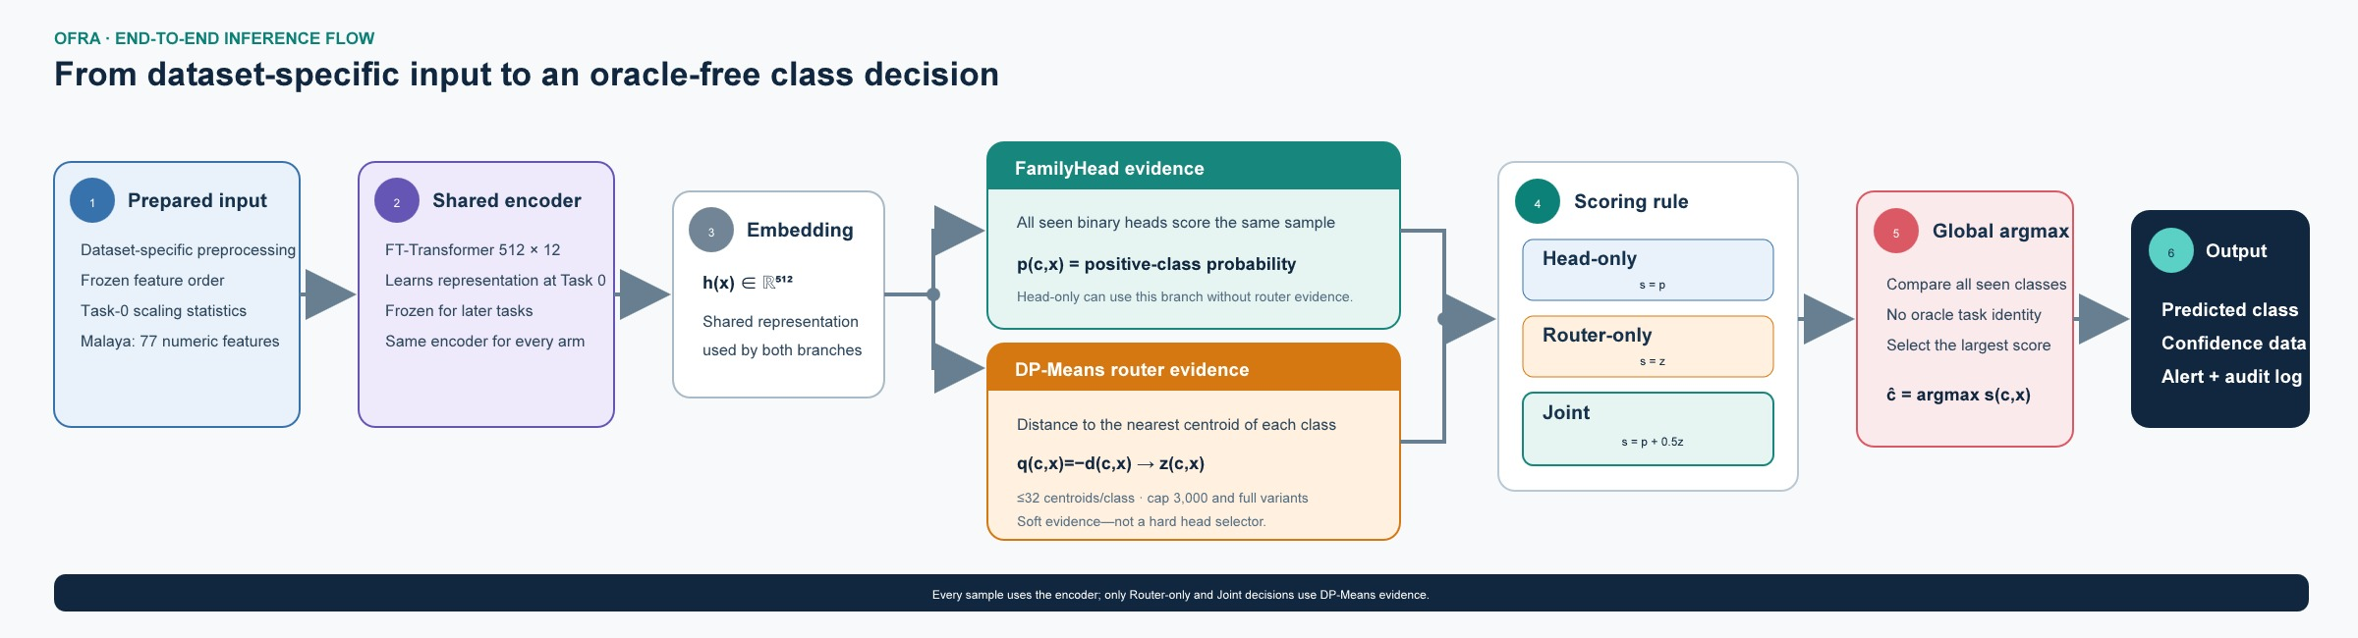
Figure 1. End-to-end OFRA inference. The DP-Means router supplies soft class evidence; it is not a hard selector of one family head.
The shared FT-Transformer maps a numerical row to a 512-dimensional representation using 12 layers, 16 attention heads, head dimension 32, and dropout 0.1. Task 0 is trained for eight epochs; each later task is trained for ten epochs. Each seen class has a rank-8, alpha-16 positive-versus-negative low-rank head. Replay retains at most 50 exemplars per class from a candidate pool of at most 5,000.
The DP-Means router stores up to 32 centroids per class. The capped router fits centroids from at most 3,000 selected training samples per class; the cap limits router fitting cost and majority-class influence, not test-set size. The registered arms are head-only p(c,x), router-only z(c,x), and joint p(c,x)+0.5z(c,x), each with capped and full router variants. Prediction is the global argmax across all seen classes. The joint weight 0.5, cap 3,000, distance quantile 0.3, and centroid limit 32 are study-defined registered settings rather than universal constants.

3.3 Training, metrics, and statistical boundary
The reported FT-Transformer configuration uses focal loss (gamma 2.0, alpha 0.75), learning rate 0.001, training batch size 384, evaluation batch size 512, and a negative-to-positive sampling ratio of four. At every checkpoint, evaluation covers all classes seen so far. Accuracy measures all correct predictions; Macro-F1 averages class F1 equally; balanced accuracy averages class recall; forgetting is the mean reduction from each earlier task's best historical accuracy to its later value. FT-Transformer values in this revision are means plus or minus sample standard deviation across seeds 1-4. TabM-OFRA and cumulative classifier diagnostics use seeds 1, 2, 3, 4, and 42. Comparisons are paired only over common seeds and are treated as descriptive because the protocols and available seed sets are not identical.

3.4 Additive classifier-comparison protocol
TabM is added as a minimally invasive OFRA encoder comparison (Gorishniy et al., 2025). It produces 16 member embeddings of width 256 and averages them to the single representation required by the existing family-head interface. The family heads, exemplar budget, DP-Means routers, joint weight 0.5, cap 3,000, task order, and metric definitions remain unchanged. This is a mean-embedding adapter rather than a member-wise TabM-OFRA redesign.
CatBoost is evaluated separately as a cumulative multiclass diagnostic (Prokhorenkova et al., 2018). At each checkpoint it retrains on all training rows from classes seen so far. It does not use OFRA family heads, bounded replay, DP-Means routing, or ETG, and its native feature attribution is not the registered routed-margin SHAP target. The comparison therefore estimates classification headroom in the fixed feature representation rather than a matched continual-learning effect.

3.5 SHAP explanation protocol
The analyzer uses shap.GradientExplainer, an expected-gradients approximation for the differentiable FT-Transformer. It reconstructs the official joint-cap class margin g_c(x)=joint_cap_c(x)-max_{f not equal c}joint_cap_f(x) and attributes that margin to input features. Positive attributions support the explained margin; negative attributions oppose it. Top-15 features are ranked by absolute attribution magnitude. The fixed probe and background contracts are source-bound and reused across adjacent checkpoints.
For adjacent checkpoints, top-feature overlap is J(A,B)=|A intersection B|/|A union B|. A silent explanation-drift event requires performance to stay within the registered stability rule while top-15 Jaccard falls below 0.70. The 0.70 threshold and the performance tolerance are project governance settings, not externally validated standards. The event unit is a class-by-adjacent-checkpoint transition, not a packet, flow, sample, or real-world incident.

3.6 ETG governance scope
ETG is an offline explanation-governance ledger. It can certify an admission, refuse insufficient explanation evidence, escalate a drifted transition, and require strict recertification. A failed explanation action withholds the explanation alert or routes the evidence for review; it does not cancel OFRA's underlying classification alert. The completed analysis consumes stored OFRA checkpoint evidence for Malaya seed 1. ETG has therefore been connected to the actual routed-score evidence path, but it has not been evaluated as a closed loop that changes future routing, training, or replay.

3.7 Attribution-method robustness protocol
The earlier occlusion-versus-input-gradient comparison changed 19 of 39 admission decisions, demonstrating that certification can be method-sensitive. That comparison belongs to the legacy separate-MLP experiment and is not mixed with the present routed-margin result. The current source-bound run uses expected gradients only. Before submission, the registered robustness analysis will compare expected gradients, integrated gradients, and gradient-times-input (with occlusion retained as a model-agnostic reference where computationally feasible). It will report pairwise top-15 Jaccard, admission-decision agreement, ETG-state agreement, and the proportion of transitions whose conclusion is unchanged across all methods. No unrun agreement value is reported in this revision.

4. Results

4.1 RQ1: Explanation stability
In the completed Malaya seed-1 source-bound analysis, 17 class-by-adjacent-checkpoint transitions satisfy the eligibility rules and 12 meet the registered silent explanation-drift definition, giving 70.59%. This value must always be labelled as a single-seed Malaya result rather than a prevalence estimate, because the evidence unit is a registered class transition and not traffic volume or an operational incident.
The high event proportion shows that stable predictive evidence under the chosen tolerance does not guarantee stable top-feature membership. It does not establish that the model became unsafe, that the explanation was wrong, or that 70.59% of network flows drifted. It identifies transitions that require closer interpretation under this registered audit rule.

4.2 RQ2: Predictive performance and retention
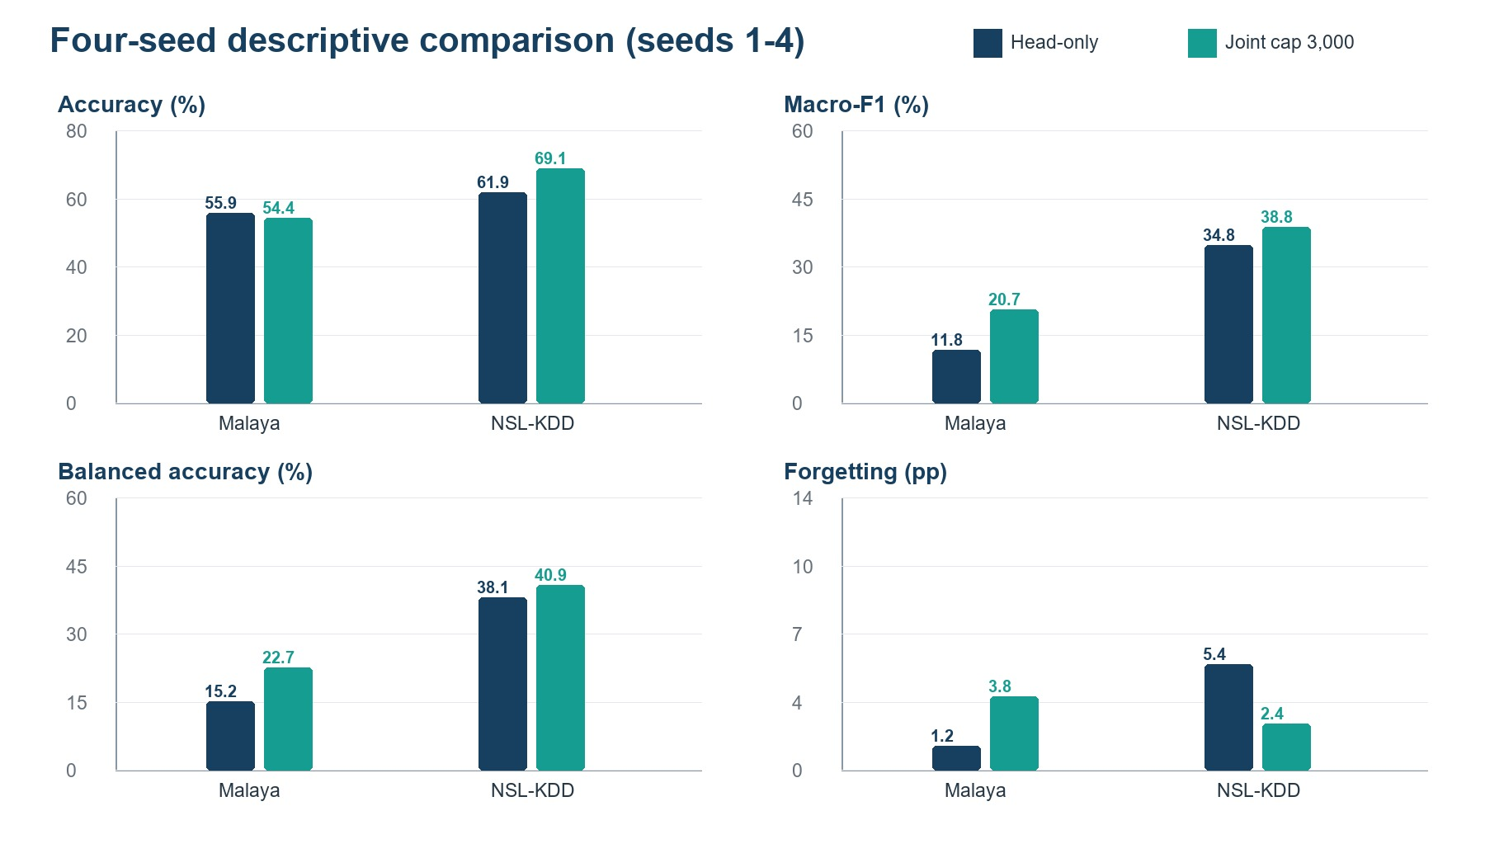
Figure 2. Head-only versus joint-cap four-seed descriptive results. Error bars are sample standard deviations.
Table 2. Four-seed descriptive evidence for the two main decision arms.
Dataset | Arm | Accuracy | Macro-F1 | Balanced acc. | Forgetting
Malaya | Head-only | 55.87 +/- 0.33 | 11.81 +/- 0.93 | 15.16 +/- 0.58 | 1.25 +/- 1.19 pp
Malaya | Joint cap | 54.37 +/- 3.02 | 20.70 +/- 3.72 | 22.70 +/- 3.86 | 3.79 +/- 0.64 pp
NSL-KDD | Head-only | 61.94 +/- 19.92 | 34.76 +/- 10.29 | 38.12 +/- 6.94 | 5.44 +/- 9.48 pp
NSL-KDD | Joint cap | 69.07 +/- 3.38 | 38.81 +/- 3.04 | 40.87 +/- 2.96 | 2.38 +/- 1.34 pp
On Malaya, joint-cap sacrifices 1.50 accuracy points relative to head-only but gains 8.89 Macro-F1 points and 7.54 balanced-accuracy points, indicating improved recognition across classes. Forgetting rises by 2.54 points, so the routed arm does not provide a retention benefit on this dataset. On NSL-KDD, joint-cap improves accuracy by 7.13 points, Macro-F1 by 4.05 points, balanced accuracy by 2.75 points, and reduces forgetting by 3.06 points. The very large head-only seed variability on NSL-KDD is itself a warning against selecting one favourable run.

4.3 RQ2: Additive classifier comparison
Table 3. Malaya classifier comparisons. Values are mean +/- sample SD; protocols and seed sets are shown explicitly.
Model and protocol | Accuracy | Macro-F1 | Balanced acc. | Forgetting
TabM-OFRA joint cap, 5 seeds | 57.99 +/- 3.93 | 20.46 +/- 1.19 | 21.60 +/- 1.70 | 4.39 +/- 2.56 pp
FT512-OFRA joint cap, 4 seeds | 54.37 +/- 3.02 | 20.70 +/- 3.72 | 22.70 +/- 3.86 | 3.79 +/- 0.64 pp
CatBoost cumulative, 5 seeds | 66.50 +/- 0.44 | 34.76 +/- 0.69 | 39.10 +/- 0.73 | 15.34 +/- 0.73 pp
TabM cumulative, 5 seeds | 65.01 +/- 0.96 | 32.66 +/- 1.31 | 34.41 +/- 1.51 | 9.43 +/- 1.80 pp
Over the four seeds shared with FT-Transformer 512x12, TabM-OFRA joint-cap accuracy increases from 54.37% to 59.59% (+5.23 percentage points), while Macro-F1 changes by +0.15 points, balanced accuracy by -0.64 points, and forgetting by -0.01 points. The improvement is therefore concentrated in aggregate accuracy. BitTorrent constitutes 53.39% of the test set and its mean recall rises by 10.54 points, whereas recall falls for Steam, TeamViewer, Discord, and Webex. The TabM result does not support a general claim of improved minority-class recognition.

4.4 RQ3: ETG governance outcomes
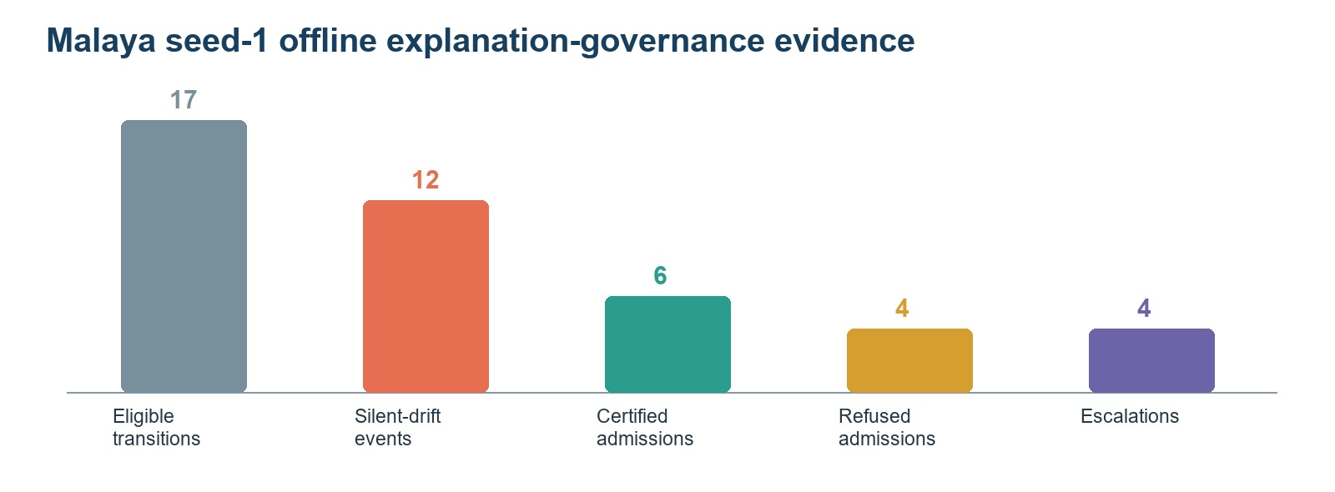
Figure 3. Malaya seed-1 ETG evidence. Counts are governance outcomes, not production incidents or completed human reviews.
ETG records six certified admissions and four refused admissions. Four transitions are escalated, one strict recertification succeeds, and two strict-recertification attempts fail. Final states include six UNEXPLAINABLE, three CERTIFIED_STABLE, and one DRIFTED class record. These outcomes demonstrate execution of the registered state machine on actual joint-cap explanation evidence. They do not quantify analyst benefit, false-alarm reduction, production remediation, or causal improvement of later OFRA checkpoints.

5. Discussion

5.1 When is the trade-off operationally worthwhile?
The value of routing depends on the threat model and dataset. On NSL-KDD, the matched result is favourable across accuracy, class-balanced metrics, and forgetting, although four seeds remain insufficient for a final superiority claim. On Malaya, routing improves minority-class coverage while worsening forgetting and slightly reducing overall accuracy. This trade may be acceptable when failure on an underrepresented class is more costly than a small aggregate accuracy reduction, such as when a security team prioritises coverage of rare but consequential attack families. It is not automatically worthwhile for application-traffic classification, and the decision should be based on per-class costs, not overall accuracy alone.

5.2 Classifier capacity and class imbalance
The new comparisons separate two questions that were previously conflated. TabM-OFRA asks whether a different differentiable encoder can improve the existing OFRA pipeline without changing its router, heads, or memory rules. The cumulative models ask how much performance is available when all seen-class rows are retained and a fresh multiclass classifier is trained. TabM-OFRA improves aggregate accuracy but not class-balanced metrics, whereas cumulative CatBoost improves all final classification metrics while showing greater checkpoint forgetting. Together with the per-class recall audit, this indicates that model capacity alone is not the main bottleneck; class imbalance and the combination of binary heads, routing, and bounded replay remain material.

5.3 Meaning of the integrated evidence chain
The current contribution is an integrated offline audit chain: OFRA generates the registered joint-cap decision; expected gradients explain its class margin; ETG applies declared evidence rules and records the outcome. Calling this a closed-loop OFRA-ETG system would be premature because ETG does not alter later model behaviour. The distinction matters for both scientific validity and system safety: post-hoc governance evidence can support review without being presented as a validated adaptive control mechanism.

5.4 Attribution dependence
The legacy 19-of-39 admission flip demonstrates that ETG states can inherit instability from the attribution method. The correct response is not to hide that sensitivity but to quantify it and, if necessary, require method-consensus or uncertainty-aware admission. Until the registered three-method experiment is complete, Expected Gradients should be described as the current operational explainer rather than as a uniquely correct attribution method.

6. Limitations and Threats to Validity
First, the main FT-Transformer predictive aggregate contains four seeds, not the registered five, and only Malaya and NSL-KDD have completed current-model formal runs. The five-seed TabM-OFRA result is an additive encoder comparison on Malaya only; it does not replace the primary FT-Transformer evidence. Second, the SHAP and ETG evidence is Malaya seed 1 only and has not been executed for TabM. Third, attribution-method robustness is not yet bounded for the current routed-margin pipeline. Fourth, the silent-drift thresholds are study-defined operating rules and have not been externally calibrated. Fifth, ETG actions are simulated and no analyst study or deployed feedback loop has been conducted.
Sixth, Task-0-only scaling is documented in the current formal protocol, but every internal feature statistic must still pass a code-level no-look-ahead audit before the term oracle-free is used without qualification. Seventh, Malaya is not an intrusion-detection dataset, and its application labels cannot support attack-recall or benign false-positive claims. Eighth, Malaya is strongly imbalanced: BitTorrent constitutes 53.39% of the test set, so TabM's accuracy increase is not evidence of uniform class improvement. Ninth, cumulative CatBoost and TabM retrain on all seen-class rows and are capacity diagnostics rather than matched continual-learning baselines; the CatBoost 400-tree setting is exploratory because it followed a seed-1 sensitivity check. Tenth, the results do not yet report complete runtime, explanation latency, energy, analyst burden, or protocol-matched statistical tests across the full dataset suite.

7. Conclusion
This revision provides a bounded evaluation of OFRA prediction, additive classifier diagnostics, and post-hoc ETG governance. The FT-Transformer evidence shows dataset-dependent routing trade-offs. The five-seed Malaya TabM adapter improves joint-cap aggregate accuracy relative to FT-Transformer on four common seeds, but it does not materially improve Macro-F1, balanced accuracy, or forgetting; the gain is driven mainly by the majority BitTorrent class. Cumulative CatBoost and TabM results show that the fixed feature representation contains additional classification headroom, but they are not OFRA or ETG results. A source-bound Malaya seed-1 analysis finds 12 silent explanation-drift events among 17 eligible transitions and executes the ETG state machine on the same routed-score evidence. The work therefore supports an integrated offline audit pipeline, not an online adaptive loop. Submission readiness still depends on completing the missing FT seeds and datasets, current-pipeline attribution robustness, multi-seed SHAP and ETG analysis, and a full no-look-ahead audit.

Declarations
Funding: No external funding was declared for this study.
Conflict of interest: The author declares no conflict of interest.
Ethics and data governance: The study uses previously collected public benchmark or research datasets and does not involve direct interaction with human participants. Dataset licences and institutional computing rules remain applicable. No restricted credentials or private institutional data are included in the public repository.
Code and data availability: Reproducibility code, configurations, preprocessing contracts, result summaries, and public evidence bindings are available at https://github.com/1838904818/Class-IL. Original datasets remain with their respective providers; the repository documents acquisition and preparation rather than redistributing data where licence or size makes redistribution inappropriate.

References
Adabara, I., Sadiq, B. O., Aliyu, N. S., Yale, I. D., Maninti, V., and Mutebi, J. (2025). Toward trustworthy cyber defense: A cognitive intrusion detection system with explainability and probabilistic uncertainty calibration. KIU Journal of Science, Engineering and Technology, 4(2), 160-172. https://doi.org/10.59568/KJSET-2025-4-2-16
French, R. M. (1999). Catastrophic forgetting in connectionist networks. Trends in Cognitive Sciences, 3(4), 128-135. https://doi.org/10.1016/S1364-6613(99)01294-2
Goncalves, H., and Alomari, Z. (2026). Explainable AI for cloud intrusion detection: A user study of SHAP and LIME in AWS GuardDuty. 2026 IEEE 5th International Conference on AI in Cybersecurity. https://doi.org/10.1109/ICAIC67076.2026.11395766
Gorishniy, Y., Kotelnikov, A., and Babenko, A. (2025). TabM: Advancing tabular deep learning with parameter-efficient ensembling. International Conference on Learning Representations. https://arxiv.org/abs/2410.24210
Hu, E. J., Shen, Y., Wallis, P., Allen-Zhu, Z., Li, Y., Wang, S., Wang, L., and Chen, W. (2022). LoRA: Low-rank adaptation of large language models. International Conference on Learning Representations. https://openreview.net/forum?id=nZeVKeeFYf9
Kirkpatrick, J., et al. (2017). Overcoming catastrophic forgetting in neural networks. Proceedings of the National Academy of Sciences, 114(13), 3521-3526. https://doi.org/10.1073/pnas.1611835114
Lundberg, S. M., and Lee, S.-I. (2017). A unified approach to interpreting model predictions. Advances in Neural Information Processing Systems, 30.
Maseno, E. M., Sun, Y., and Wang, Z. (2026). Detecting adversarial evasion in deep learning intrusion detection systems using explainable AI. International Journal of Information Security, 25, Article 125. https://doi.org/10.1007/s10207-026-01299-x
Nugraha, B., and Bauschert, T. (2026). E2D2: A modular framework for explanation-based drift detection in unsupervised network intrusion detection. 2026 IFIP Networking Conference. https://doi.org/10.23919/IFIPNetworking70592.2026.11578962
Prokhorenkova, L., Gusev, G., Vorobev, A., Dorogush, A. V., and Gulin, A. (2018). CatBoost: Unbiased boosting with categorical features. Advances in Neural Information Processing Systems, 31.
Rebuffi, S.-A., Kolesnikov, A., Sperl, G., and Lampert, C. H. (2017). iCaRL: Incremental classifier and representation learning. Proceedings of the IEEE Conference on Computer Vision and Pattern Recognition, 2001-2010.
Tolomei, G., Silvestri, F., Haines, A., and Lalmas, M. (2017). Interpretable predictions of tree-based ensembles via actionable feature tweaking. Proceedings of KDD, 465-474.

