Explanation Stability and Post-hoc Trust Governance
for Class-Incremental Network Traffic Classification
OFRA prediction with an offline ETG evidence ledger
WU LIQIANG

Abstract
Class-incremental network-traffic classification requires a model to learn newly introduced classes without an oracle task identifier while retaining earlier decisions. This paper evaluates prediction, explanation stability, and post-hoc governance as linked but separately bounded layers. OFRA combines a shared tabular encoder, family-specific low-rank binary heads, bounded replay, and a DP-Means router. Expected-Gradients SHAP explains the registered joint-cap class margin, while ETG records certification, refusal, escalation, and strict recertification without changing the prediction. Strict five-seed prediction evidence is available for all five independently processed datasets: NSL-KDD, UNSW-NB15, CIC-IDS-2017, CSE-CIC-IDS2018, and MalayaNetwork_GT, with model capacity disclosed per dataset. On Malaya FT512x12, joint cap 3,000 changes accuracy by -1.34 percentage points, Macro-F1 by +9.37 points, balanced accuracy by +7.97 points, and forgetting by +0.39 points relative to head-only. A source-bound Malaya seed-1 analysis identifies 12 silent-drift events among 17 eligible transitions and executes the ETG state machine on the same routed score. A three-method pilot quantifies attribution dependence. The current formal preprocessing fits both numerical statistics and categorical vocabularies from Task-0 training data only, freezes them, and maps later unseen categorical values to registered all-zero blocks. The evidence supports a reproducible offline audit pipeline and dataset-dependent trade-offs, not an online feedback loop or universal superiority. A separate seed-42 ReplayIDS expected-contract pilot found that the registered confidence-and-distance gates missed all held-out FTP-Patator rows, whereas a subsequent labelled OFRA update achieved 82.30% new-class recall with a 0.27-percentage-point old-class accuracy reduction.
Keywords: class-incremental learning; network traffic classification; explainable AI; explanation drift; SHAP; trust governance; intrusion detection.

1. Introduction

1.1 Background and motivation
Network traffic changes as applications, services, attacker behaviour, and collection environments evolve. A fixed classifier therefore becomes incomplete, but repeatedly retraining one shared model can overwrite knowledge of earlier classes. Class-incremental learning addresses this setting by presenting new classes sequentially and evaluating all classes observed so far. For a security-facing system, predictive retention is only one requirement. Analysts may also rely on explanations to understand why a class score was produced, so a stable accuracy value does not by itself guarantee stable decision evidence.
This study distinguishes prediction, explanation, and governance. OFRA produces the class decision. SHAP explains the registered winning-class margin at stored checkpoints. ETG consumes performance and explanation evidence after inference and writes a governance ledger. This separation prevents an explanation-quality failure from silently cancelling an intrusion alert, while also avoiding the stronger claim that ETG already controls the learner.

1.2 Problem statement
Current class-incremental NIDS evaluation commonly prioritises accuracy and forgetting, whereas explanation stability and operational response are less consistently measured. A valid audit must explain the same score used by the registered inference path; an approximate wrapper or a separate surrogate model cannot establish governance of the deployed decision. The present study therefore uses a source-bound analysis of OFRA's registered joint-cap score. The remaining problem is to determine whether the current predictor retains useful performance across increments, whether its explanation ranking changes under performance-preserved transitions, and how uncertain or unstable explanations should be recorded without overstating deployment maturity.

1.3 Research questions and objectives
RQ1: How does oracle-free class-incremental learning affect predictive performance, class-balanced detection, and forgetting across heterogeneous network-traffic datasets?
RQ2: To what extent do prediction explanations remain stable across successive class-incremental updates when class-level predictive performance remains stable?
RQ3: How can explanation instability be converted into auditable governance decisions without altering or suppressing the underlying security prediction?
RO1 is to evaluate accuracy, Macro-F1, balanced accuracy, attack recall, false-positive rate, and forgetting under independently preprocessed five-seed class-incremental protocols. RO2 is to measure explanation stability on fixed probes across adjacent checkpoints using source-bound attribution, Top-k feature overlap, and class-performance constraints. RO3 is to implement and evaluate an offline evidence ledger that records certification, refusal, escalation, and re-certification decisions from prediction and attribution evidence.

2. Related Work

2.1 Continual learning and parameter-efficient adaptation
Catastrophic forgetting motivates regularisation, rehearsal, distillation, exemplar, and parameter-isolation methods in continual learning (French, 1999; Kirkpatrick et al., 2017; Rebuffi et al., 2017). LoRA freezes a base transformation and represents a trainable update with low-rank matrices (Hu et al., 2022). For tabular representation learning, TabM uses parameter-efficient ensembling to produce multiple predictions within one model (Gorishniy et al., 2025), while CatBoost is a gradient-boosted tree method designed to reduce prediction shift in boosting (Prokhorenkova et al., 2018). The present family-specific low-rank head and TabM mean-embedding adapter are project integration choices; neither is presented as a new derivation of the cited methods.

2.2 Explanation drift and IDS governance
Recent work has moved beyond one-time post-hoc explanation. E2D2 detects explanation-based drift in unsupervised NIDS, but it targets distributional drift monitoring rather than legitimate class-incremental parameter updates (Nugraha and Bauschert, 2026). Maseno et al. (2026) use SHAP instability as an auxiliary signal for adversarial evasion, whereas the present study excludes adversarial perturbation and compares consecutive learning checkpoints. Goncalves and Alomari (2026) evaluate analyst-facing SHAP and LIME explanations in cloud intrusion detection, but do not define a class-incremental explanation ledger. Adabara et al. (2025) combine SHAP, probability calibration, and uncertainty in a cognitive IDS, yet do not test non-suppressing governance actions after explanation drift. These studies establish closely related motivation, but none closes the specific gap between legitimate class expansion, the exact routed decision score, and a governance record that leaves the predictive alert active.
Table 1. Positioning against the four recent studies identified during review.
Study | Drift or trust trigger | IDS setting | Gap relative to this work
E2D2 (2026) | Unsupervised explanation-based drift | Unsupervised NIDS | Not legitimate class-incremental model updates; no ETG action ledger
Maseno et al. (2026) | Adversarial SHAP instability | Recurrent multiclass IDS | Adversarial trigger, not benign learning increments; no non-suppressing governance
Goncalves and Alomari (2026) | Human interpretation of SHAP/LIME | AWS GuardDuty | User study rather than longitudinal routed-score stability
Adabara et al. (2025) | Calibration, uncertainty, and SHAP | CICIDS2017 | No class-incremental sequence or explanation-state transition ledger

2.3 Research gap
The gap is not simply the absence of SHAP in NIDS. It is the absence of a source-bound protocol that (i) explains the same routed score used for prediction, (ii) measures stability under legitimate class-incremental updates, and (iii) converts that evidence into auditable, non-suppressing governance states. This paper addresses that narrower gap and avoids claiming that explanation stability alone proves prediction correctness or security effectiveness.

3. Methodology

3.1 Scope and dataset separation
Each dataset is preprocessed, trained, and evaluated independently; records from different datasets are never pooled. The strict five-seed table uses seeds 1, 2, 3, 4, and 42. NSL-KDD, UNSW-NB15, CIC-IDS-2017, and CSE-CIC-IDS2018 use FT-Transformer 256x4; MalayaNetwork_GT uses FT-Transformer 512x12. These are dataset-specific audits, not a capacity-matched pooled comparison. The CSE-CIC-IDS2018 8+10-epoch campaign completed as DICC Job 402073 and passed the protected SHA-256 manifest check.
Dataset-specific preprocessing removes identifiers, normalises labels, converts features to finite numerical arrays, fixes feature and class order, and constructs class-by-split shards. NSL-KDD retains its official train/test files; its protocol, service, and flag vocabularies are fitted on Task-0 training rows only and frozen, producing 116 features. UNSW-NB15 likewise retains its official 175,341-row training and 82,332-row testing files; its protocol, service, and state vocabularies are fitted on Task-0 training rows only and frozen, producing 186 features. Later unseen categorical values use the registered all-zero block for that field. Malaya uses 31 derived-flow CSVs at frozen revision 384a5927..., removes IP addresses, ports, and timestamps, and holds out one capture per class, producing 77 numerical features. The capture-level Malaya split avoids leakage from correlated rows within one capture.
The current formal preprocessing passes the registered no-look-ahead contract. Numerical standardisation reads only Task-0 training shards, freezes before pretraining, and rejects later updates. NSL-KDD and UNSW-NB15 categorical vocabularies are also fitted from Task-0 training rows only and frozen; later unseen values are mapped to all-zero categorical blocks. The strict widths are 116 and 186 features, respectively, and the affected five-seed experiments were rerun. A legacy audit had identified six and eight future-only one-hot columns under the earlier 122/194-feature builders, affecting about 0.9% of later-task rows. That bounded schema exposure is retained as historical motivation, not as a limitation of the current formal prediction results. CIC-IDS-2017, CIC-IDS-2018, and Malaya have no data-derived categorical vocabulary.

3.2 OFRA architecture and registered decision arms
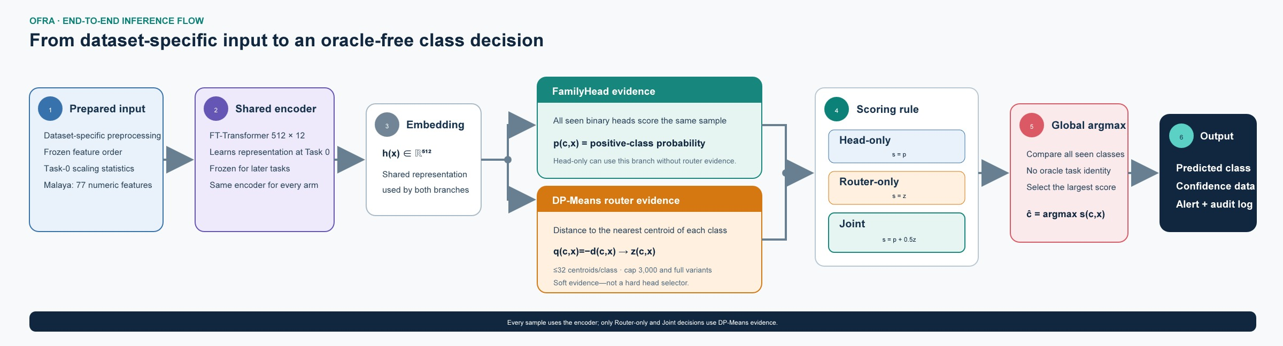
Figure 1. End-to-end OFRA inference. The DP-Means router supplies soft class evidence; it is not a hard selector of one family head.
The shared FT-Transformer maps a numerical row to a 512-dimensional representation using 12 layers, 16 attention heads, head dimension 32, and dropout 0.1. Task 0 is trained for eight epochs; each later task is trained for ten epochs. Each seen class has a rank-8, alpha-16 positive-versus-negative low-rank head. Replay retains at most 50 exemplars per class from a candidate pool of at most 5,000.
The DP-Means router stores up to 32 centroids per class. The capped router fits centroids from at most 3,000 selected training samples per class; the cap limits router fitting cost and majority-class influence, not test-set size. The registered arms are head-only p(c,x), router-only z(c,x), and joint p(c,x)+0.5z(c,x), each with capped and full router variants. Prediction is the global argmax across all seen classes. The joint weight 0.5, cap 3,000, distance quantile 0.3, and centroid limit 32 are study-defined registered settings rather than universal constants.

3.3 Training, metrics, and statistical boundary
The reported FT-Transformer configuration uses focal loss (gamma 2.0, alpha 0.75), learning rate 0.001, training batch size 384, evaluation batch size 512, and a negative-to-positive sampling ratio of four. At every checkpoint, evaluation covers all classes seen so far. Accuracy measures all correct predictions; Macro-F1 averages class F1 equally; balanced accuracy averages class recall; forgetting is the mean reduction from each earlier task's best historical accuracy to its later value. Current formal prediction values use seeds 1, 2, 3, 4, and 42. Model capacity and schedule are disclosed per dataset, and conclusions are descriptive unless a paired interval is explicitly reported.

3.4 Additive classifier-comparison protocol
TabM is added as a minimally invasive OFRA encoder comparison (Gorishniy et al., 2025). It produces 16 member embeddings of width 256 and averages them to the single representation required by the existing family-head interface. The family heads, exemplar budget, DP-Means routers, joint weight 0.5, cap 3,000, task order, and metric definitions remain unchanged. This is a mean-embedding adapter rather than a member-wise TabM-OFRA redesign.
CatBoost is evaluated separately as a cumulative multiclass diagnostic (Prokhorenkova et al., 2018). At each checkpoint it retrains on all training rows from classes seen so far. It does not use OFRA family heads, bounded replay, DP-Means routing, or ETG, and its native feature attribution is not the registered routed-margin SHAP target. The comparison therefore estimates classification headroom in the fixed feature representation rather than a matched continual-learning effect.

3.5 SHAP explanation protocol
The analyzer uses shap.GradientExplainer, an expected-gradients approximation for the differentiable FT-Transformer. It reconstructs the official joint-cap class margin g_c(x)=joint_cap_c(x)-max_{f not equal c}joint_cap_f(x) and attributes that margin to input features. Positive attributions support the explained margin; negative attributions oppose it. Top-15 features are ranked by absolute attribution magnitude. The fixed probe and background contracts are source-bound and reused across adjacent checkpoints.
For adjacent checkpoints, top-feature overlap is J(A,B)=|A intersection B|/|A union B|. The registered silent explanation-drift rule requires the class recall to fall by no more than 5 percentage points while top-15 Jaccard falls below 0.70. Both thresholds are project governance settings rather than externally validated standards. The event unit is a class-by-adjacent-checkpoint transition, not a packet, flow, sample, or real-world incident.

3.6 ETG governance scope
ETG is an offline explanation-governance ledger. It can certify an admission, refuse insufficient explanation evidence, escalate a drifted transition, and require strict recertification. A failed explanation action withholds the explanation alert or routes the evidence for review; it does not cancel OFRA's underlying classification alert. The completed analysis consumes stored OFRA checkpoint evidence for Malaya seed 1. ETG has therefore been connected to the actual routed-score evidence path, but it has not been evaluated as a closed loop that changes future routing, training, or replay.

3.7 Attribution-method robustness protocol
The source-bound robustness pilot uses the same Malaya seed-1 checkpoints, fixed probes, joint-cap-3000 class margin, top-15 rule, random-control admission threshold, and ETG state machine. Its three primary rankings are Expected Gradients, single-feature ablation to the frozen checkpoint mean, and Gradient x Input. Pairwise top-15 Jaccard, admission agreement, ETG-state agreement, and transition-level silent-drift agreement are reported. Integrated Gradients were also attempted with a Task-0 mean baseline and 16-point Gauss-Legendre quadrature, but its completeness check failed on the piecewise routed score; it is retained as a numerical diagnostic and excluded from primary agreement claims. This design measures method dependence rather than assuming that any explainer is uniquely correct.

3.8 No-look-ahead audit protocol
The audit traces every data-dependent preprocessing state to its fitting split and task availability. It checks numerical accumulator reads and freeze points, categorical-vocabulary construction, official-test access, and row-level impact of future-only categories. The audit distinguishes future-category schema exposure from future-label training and from test leakage, then reports exact affected columns and rows rather than a binary pass/fail label.

3.9 Paired checkpoint-selection protocol
A ReplayIDS-aligned CIC-IDS-2017 D2 experiment compares two checkpoint rules under the same fixed split, seeds {1, 2, 3, 4, 42}, FT256x4 encoder, replay-50 budget, training trajectory, and official joint-cap-3,000 inference. The baseline uses each class head at its last epoch. The candidate selects the earliest epoch with maximum binary Macro-F1 on a training-only calibration holdout. Heartbleed has one calibration row and therefore uses the registered last-epoch fallback. The five seeds are paired training repetitions on one data split, not five independent datasets.

4. Results

4.1 RQ2: Explanation stability
In the completed Malaya seed-1 source-bound analysis, 17 class-by-adjacent-checkpoint transitions satisfy the eligibility rules and 12 meet the registered silent explanation-drift definition, giving 70.59%. This value must always be labelled as a single-seed Malaya result rather than a prevalence estimate, because the evidence unit is a registered class transition and not traffic volume or an operational incident.
The high event proportion shows that stable predictive evidence under the chosen tolerance does not guarantee stable top-feature membership. It does not establish that the model became unsafe, that the explanation was wrong, or that 70.59% of network flows drifted. A single-seed sensitivity grid over top-k {10, 15, 20}, Jaccard thresholds {0.6, 0.7, 0.8}, and allowed class-recall drops {2, 5, 10} percentage points confirms that the event rate is threshold-sensitive. The tolerance is class recall, not overall accuracy, and the grid does not establish a universal threshold.

4.2 RQ2: Attribution-method robustness
The three primary methods agree on admission for 40.0% of 30 checkpoint-class rows, on ETG state for 43.3%, and on the silent-drift conclusion for 20.0% of 20 adjacent class transitions. Pairwise mean top-15 Jaccard ranges from 0.380 to 0.567. Expected Gradients reports 12/17 silent-drift events, feature ablation 0/17, and Gradient x Input 7/17. The result bounds rather than removes attribution dependence: ETG outcomes are method-conditioned, and the registered Expected-Gradients result is not treated as uniquely correct.
Table 2. Attribution-method agreement on the source-bound Malaya seed-1 routed score.
Pair | Top-15 Jaccard | Admission | ETG state | Drift event
Expected vs ablation | 0.567 | 56.7% | 60.0% | 40.0%
Expected vs Grad x Input | 0.380 | 63.3% | 60.0% | 35.0%
Ablation vs Grad x Input | 0.405 | 60.0% | 56.7% | 65.0%
Integrated Gradients are excluded from Table 2 because their completeness check failed (mean row-level error 11.58; maximum 373.72). They are retained as a failed numerical diagnostic. The three valid rankings quantify sensitivity but do not determine which explainer is causally correct.

4.3 RQ1: Predictive performance and retention
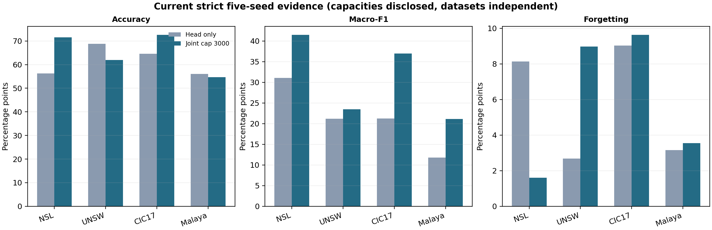
Figure 2. Head-only versus joint-cap current strict five-seed means. Capacities are disclosed by dataset and are not pooled.
Table 3. Current strict five-seed prediction evidence for the two main decision arms.
Dataset / model | Arm | Accuracy | Macro-F1 | Balanced acc. | Forgetting
NSL-KDD  FT256x4 | Head only | 56.29 | 31.08 | 36.48 | 8.14 pp
NSL-KDD  FT256x4 | Joint cap | 71.56 | 41.46 | 42.25 | 1.60 pp
UNSW-NB15  FT256x4 | Head only | 68.78 | 21.16 | 23.52 | 2.68 pp
UNSW-NB15  FT256x4 | Joint cap | 61.95 | 23.50 | 28.45 | 8.97 pp
CIC-IDS-2017  FT256x4 | Head only | 64.59 | 21.25 | 25.91 | 9.04 pp
CIC-IDS-2017  FT256x4 | Joint cap | 72.57 | 36.95 | 63.13 | 9.63 pp
Malaya  FT512x12 | Head only | 56.03 | 11.77 | 15.05 | 3.16 pp
Malaya  FT512x12 | Joint cap | 54.68 | 21.15 | 23.03 | 3.55 pp
CSE-CIC-IDS2018  FT256x4 | Head only | 79.21 | 19.06 | 21.15 | 2.00 pp
CSE-CIC-IDS2018  FT256x4 | Joint cap | 50.16 | 33.55 | 52.15 | 19.07 pp
The routing effect is dataset-dependent. On NSL-KDD, joint cap 3,000 improves accuracy, Macro-F1, balanced accuracy, and forgetting. On UNSW-NB15, it improves Macro-F1 and balanced accuracy but lowers overall accuracy and increases forgetting. On CIC-IDS-2017, it improves accuracy and class-balanced metrics but does not reduce forgetting. On Malaya, the paired five-seed difference is -1.34 accuracy points, +9.37 Macro-F1 points, +7.97 balanced-accuracy points, and +0.39 forgetting points; pooled per-class results show non-zero recall for all ten classes under joint cap, but several minority recalls remain low. The table therefore supports dataset-specific trade-offs, not universal superiority.
The strict CSE-CIC-IDS2018 FT256x4 campaign completed five registered seeds with eight Task-0 epochs and ten epochs per later task. Head-only achieved 79.21% accuracy, 19.06% Macro-F1, 21.15% balanced accuracy, 2.00 points of forgetting, 31.70% attack recall, and 6.57% benign false-positive rate. Joint cap-3000 achieved 50.16%, 33.55%, 52.15%, 19.07 points, 91.82%, and 51.85%, respectively. Joint uncapped achieved 54.39%, 33.72%, 51.35%, 15.39 points, 84.38%, and 46.48%. Thus routing recovers minority/attack coverage but produces an operationally severe accuracy, retention, and false-positive cost on this dataset. The earlier 1+1-epoch closure remains historical and is not mixed with this result.

4.4 RQ1: Additive classifier comparison
Table 4. Malaya classifier comparisons. Values are mean +/- sample SD across five seeds; protocols remain separate.
Model and protocol | Accuracy | Macro-F1 | Balanced acc. | Forgetting
TabM-OFRA joint cap, 5 seeds | 57.99 +/- 3.93 | 20.46 +/- 1.19 | 21.60 +/- 1.70 | 4.39 +/- 2.56 pp
FT512-OFRA joint cap, 5 seeds | 54.68 +/- 2.71 | 21.15 +/- 3.37 | 23.03 +/- 3.42 | 3.55 +/- 0.77 pp
CatBoost cumulative, 5 seeds | 66.50 +/- 0.44 | 34.76 +/- 0.69 | 39.10 +/- 0.73 | 15.34 +/- 0.73 pp
TabM cumulative, 5 seeds | 65.01 +/- 0.96 | 32.66 +/- 1.31 | 34.41 +/- 1.51 | 9.43 +/- 1.80 pp
Across the same five seeds, TabM-OFRA joint-cap accuracy is 57.99% versus 54.68% for FT512-OFRA, a +3.31-point difference. Macro-F1 is 20.46% versus 21.15% (-0.69 points), balanced accuracy is 21.60% versus 23.03% (-1.43 points), and forgetting is 4.39 versus 3.55 points (+0.84 points). The TabM change therefore improves aggregate accuracy but not the class-balanced or retention metrics. Because BitTorrent is the majority class, this result is not evidence of uniform minority-class improvement.

4.5 RQ3: ETG governance outcomes
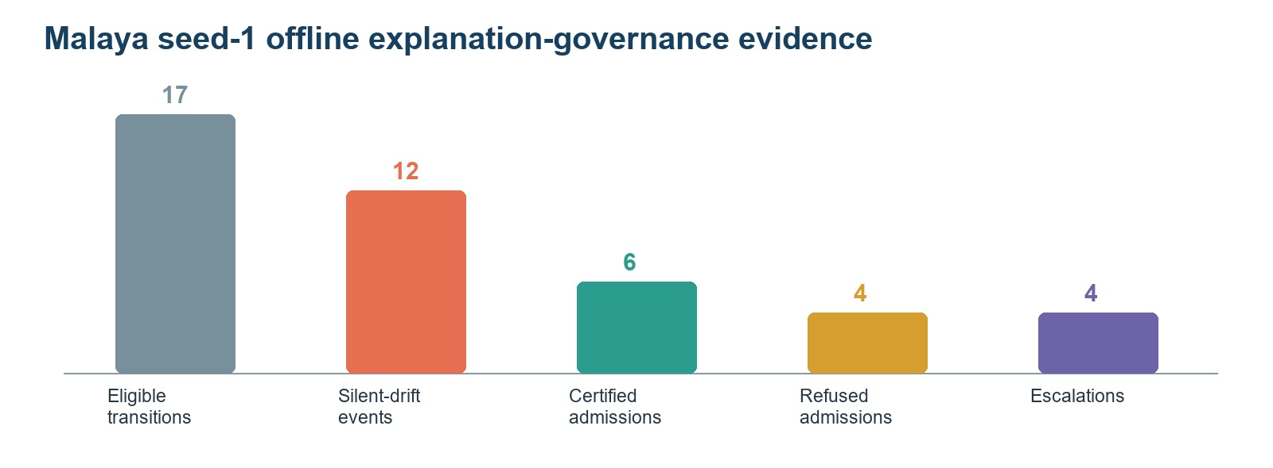
Figure 3. Malaya seed-1 ETG evidence. Counts are governance outcomes, not production incidents or completed human reviews.
ETG records six certified admissions and four refused admissions. Four transitions are escalated, one strict recertification succeeds, and two strict-recertification attempts fail. Final states include six UNEXPLAINABLE, three CERTIFIED_STABLE, and one DRIFTED class record. These outcomes demonstrate execution of the registered state machine on actual joint-cap explanation evidence. They do not quantify analyst benefit, false-alarm reduction, production remediation, or causal improvement of later OFRA checkpoints.

4.6 Exploratory open-set and labelled-head pilot
The separate seed-42 O1 pilot used FTP-Patator as an unseen class before its declared labelled increment. Thresholds were fitted on 11,647 training-only known-class calibration rows; the test set was not used for threshold selection. Confidence-only, centroid-distance-only, conservative joint, and empirical-joint rejection all produced 0% unknown recall. The best AUROC was 0.5303, the OSCR-style AUC was 0.4699, and the primary candidate buffer contained 509 known rows and no FTP-Patator rows. The registered gate therefore failed as an unknown-discovery mechanism.
After FTP-Patator labels were supplied at the legitimate task boundary, the ordinary supervised OFRA update achieved 82.30% new-class recall. Old-class accuracy changed from 87.28% to 87.01% (-0.27 percentage points). The evaluator never creates a semantic head automatically. This single-seed result supports labelled adaptation, not autonomous zero-day discovery, and remains an expected-contract reconstruction rather than an unchanged ReplayIDS reproduction.
Table 5. Seed-42 O1 open-set and post-label adaptation diagnostic.
Stage or metric | Result
Held-out class / test rows | FTP-Patator / 1,588
Pre-update known accuracy | 87.28% (226,135 rows)
Unknown recall, all four gates | 0.00%
Best AUROC / OSCR-style AUC | 0.5303 / 0.4699
Post-label new-class recall | 82.30%
Old-class accuracy change | -0.27 percentage points

4.7 Paired checkpoint-selection result
The training-only rule changes the operating trade-off but does not establish a stable improvement. Relative to last-epoch selection, final accuracy increases from 85.51% to 87.52% and Macro-F1 from 54.40% to 56.34%, while average task accuracy decreases from 79.78% to 77.88%, forgetting increases from 3.52% to 5.18%, and attack recall decreases from 85.73% to 83.76%. Benign FPR decreases from 13.10% to 10.44%. Every paired 95% confidence interval includes zero; the Holm-adjusted p-value for the two registered primary outcomes, Macro-F1 and forgetting, is 0.755. The candidate is therefore retained as an inconclusive ablation, and last-epoch selection remains the primary configuration.
Figure 4. Five-seed checkpoint-selection trade-off on the ReplayIDS-aligned D2 contract. Lower is better for forgetting and benign FPR.
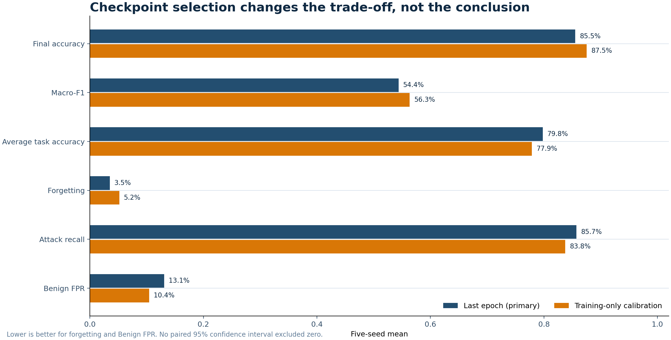
Table 6. Per-class official joint-cap-3,000 results. Class-wise accuracy is recall; values are five-seed mean +/- sample SD on one fixed test split.
Class | Support | Last recall | Cal. recall | Last F1 | Cal. F1
Benign | 174,421 | 86.9% +/- 8.3% | 89.6% +/- 5.0% | 90.7% +/- 4.4% | 92.1% +/- 2.8%
DoS GoldenEye | 2,059 | 97.8% +/- 0.9% | 94.7% +/- 4.8% | 90.2% +/- 7.3% | 92.5% +/- 2.0%
DoS Hulk | 46,215 | 81.0% +/- 13.7% | 81.1% +/- 18.1% | 80.6% +/- 8.2% | 82.7% +/- 7.5%
DoS Slowhttptest | 1,100 | 75.0% +/- 14.3% | 79.5% +/- 5.8% | 54.6% +/- 7.7% | 53.8% +/- 8.0%
DoS slowloris | 1,159 | 69.0% +/- 21.2% | 74.2% +/- 11.0% | 48.3% +/- 16.5% | 49.6% +/- 10.5%
FTP-Patator | 1,588 | 69.0% +/- 44.3% | 70.1% +/- 24.9% | 30.9% +/- 28.5% | 51.5% +/- 19.9%
Heartbleed | 2 | 60.0% +/- 54.8% | 60.0% +/- 54.8% | 9.4% +/- 13.3% | 7.6% +/- 10.4%
SSH-Patator | 1,179 | 82.3% +/- 23.3% | 69.0% +/- 38.7% | 30.4% +/- 14.7% | 21.0% +/- 16.6%
The per-class record explains why aggregate gains are not sufficient. Heartbleed has only two official test rows, so its mean and standard deviation are not a stable population estimate. FTP-Patator F1 improves under calibration, whereas SSH-Patator recall and F1 decline. The class-specific trade-offs reinforce the decision not to promote the candidate.

5. Discussion

5.1 When is the trade-off operationally worthwhile?
The value of routing depends on the dataset and operational cost model. NSL-KDD is favourable across the four displayed metrics. UNSW-NB15 trades lower accuracy and higher forgetting for better class-balanced metrics. CIC-IDS-2017 gains predictive coverage without a retention gain. Malaya improves coverage of minority application classes while its accuracy and forgetting differences remain uncertain. Such a trade may be worthwhile when a missed underrepresented class is more costly than a small aggregate-accuracy loss, but the decision must be based on per-class costs and cannot be inferred from overall accuracy alone.

5.2 Classifier capacity and class imbalance
The new comparisons separate two questions that were previously conflated. TabM-OFRA asks whether a different differentiable encoder can improve the existing OFRA pipeline without changing its router, heads, or memory rules. The cumulative models ask how much performance is available when all seen-class rows are retained and a fresh multiclass classifier is trained. TabM-OFRA improves aggregate accuracy but not class-balanced metrics, whereas cumulative CatBoost improves all final classification metrics while showing greater checkpoint forgetting. Together with the per-class recall audit, this indicates that model capacity alone is not the main bottleneck; class imbalance and the combination of binary heads, routing, and bounded replay remain material.

5.3 Meaning of the integrated evidence chain
The current contribution is an integrated offline audit chain: OFRA generates the registered joint-cap decision; expected gradients explain its class margin; ETG applies declared evidence rules and records the outcome. Calling this a closed-loop OFRA-ETG system would be premature because ETG does not alter later model behaviour. The distinction matters for both scientific validity and system safety: post-hoc governance evidence can support review without being presented as a validated adaptive control mechanism.

5.4 Attribution dependence
The completed source-bound pilot confirms that ETG states inherit material attribution-method dependence. Agreement must therefore be reported at several levels rather than reduced to one feature-overlap number. Expected Gradients remains the registered operational explainer, but governance conclusions should be treated as method-conditioned; a future deployment should require method consensus, uncertainty-aware admission, or external calibration. The failed Integrated-Gradients completeness check further shows that a differentiable attribution method cannot be assumed valid for the complete piecewise routed score.

6. Limitations and Threats to Validity
First, strict five-seed prediction evidence is complete for all five datasets, but model capacity differs between Malaya and the four FT256x4 datasets. Second, source-bound SHAP and ETG evidence remains limited to Malaya seed 1; additional seeds have not yet passed the complete source-bound workflow. Third, attribution dependence is bounded by a three-method single-seed pilot, and Integrated Gradients failed its completeness diagnostic. Fourth, silent-drift thresholds are study-defined operating rules and have not been externally calibrated. Fifth, ETG actions are simulated and no analyst study or deployed feedback loop has been conducted.
Sixth, the current formal preprocessing uses Task-0-only numerical statistics and categorical vocabularies; the legacy 122/194-feature schema exposure was closed by strict cache rebuilding and affected five-seed reruns. Seventh, Malaya is not an intrusion-detection dataset, and its application labels cannot support attack-recall or benign false-positive claims. Eighth, Malaya is strongly imbalanced and several minority recalls remain low even after routing. Ninth, cumulative CatBoost and TabM diagnostics are not matched continual-learning baselines. Tenth, complete runtime, explanation latency, energy, analyst burden, and protocol-matched external-baseline tests are not yet available across the full dataset suite. Eleventh, the FTP-Patator open-set result is a single-seed, single-held-out-class diagnostic; its 0% unknown recall invalidates the current gate but does not establish that all open-set methods will fail. Twelfth, the paired checkpoint-selection experiment uses five seeds on one fixed split; it does not establish cross-split generalization, and the Heartbleed calibration fallback prevents a fully uniform class rule.

7. Conclusion
This revision provides a bounded evaluation of OFRA prediction, additive classifier diagnostics, explanation stability, and post-hoc ETG governance. Strict five-seed prediction evidence across five independently processed datasets shows that routing effects are dataset-dependent. CSE-CIC-IDS2018 exposes the strongest failure mode: routing improves Macro-F1 and attack recall but incurs high false positives, forgetting, and accuracy loss. A source-bound Malaya seed-1 analysis finds 12 silent explanation-drift events among 17 eligible transitions and executes ETG on the same routed-score evidence. The work supports a reproducible offline audit pipeline and an explicit trade-off analysis, not an online adaptive loop or universal superiority claim. The exploratory O1 pilot further shows that the current confidence-and-distance gate cannot discover FTP-Patator, while a subsequent labelled increment can learn it with limited old-class accuracy loss. A paired five-seed checkpoint-selection ablation is statistically inconclusive and leaves last-epoch selection as the primary setting.

Declarations
Funding: No external funding was declared for this study.
Conflict of interest: The author declares no conflict of interest.
Ethics and data governance: The study uses previously collected public benchmark or research datasets and does not involve direct interaction with human participants. Dataset licences and institutional computing rules remain applicable. No restricted credentials or private institutional data are included in the public repository.
Code and data availability: Reproducibility code, configurations, preprocessing contracts, result summaries, and public evidence bindings are available at https://github.com/1838904818/Class-IL. Original datasets remain with their respective providers; the repository documents acquisition and preparation rather than redistributing data where licence or size makes redistribution inappropriate.

References
Adabara, I., Sadiq, B. O., Aliyu, N. S., Yale, I. D., Maninti, V., and Mutebi, J. (2025). Toward trustworthy cyber defense: A cognitive intrusion detection system with explainability and probabilistic uncertainty calibration. KIU Journal of Science, Engineering and Technology, 4(2), 160-172. https://doi.org/10.59568/KJSET-2025-4-2-16
French, R. M. (1999). Catastrophic forgetting in connectionist networks. Trends in Cognitive Sciences, 3(4), 128-135. https://doi.org/10.1016/S1364-6613(99)01294-2
Goncalves, H., and Alomari, Z. (2026). Explainable AI for cloud intrusion detection: A user study of SHAP and LIME in AWS GuardDuty. 2026 IEEE 5th International Conference on AI in Cybersecurity. https://doi.org/10.1109/ICAIC67076.2026.11395766
Gorishniy, Y., Kotelnikov, A., and Babenko, A. (2025). TabM: Advancing tabular deep learning with parameter-efficient ensembling. International Conference on Learning Representations. https://arxiv.org/abs/2410.24210
Hu, E. J., Shen, Y., Wallis, P., Allen-Zhu, Z., Li, Y., Wang, S., Wang, L., and Chen, W. (2022). LoRA: Low-rank adaptation of large language models. International Conference on Learning Representations. https://openreview.net/forum?id=nZeVKeeFYf9
Kirkpatrick, J., et al. (2017). Overcoming catastrophic forgetting in neural networks. Proceedings of the National Academy of Sciences, 114(13), 3521-3526. https://doi.org/10.1073/pnas.1611835114
Lundberg, S. M., and Lee, S.-I. (2017). A unified approach to interpreting model predictions. Advances in Neural Information Processing Systems, 30.
Maseno, E. M., Sun, Y., and Wang, Z. (2026). Detecting adversarial evasion in deep learning intrusion detection systems using explainable AI. International Journal of Information Security, 25, Article 125. https://doi.org/10.1007/s10207-026-01299-x
Nugraha, B., and Bauschert, T. (2026). E2D2: A modular framework for explanation-based drift detection in unsupervised network intrusion detection. 2026 IFIP Networking Conference. https://doi.org/10.23919/IFIPNetworking70592.2026.11578962
Prokhorenkova, L., Gusev, G., Vorobev, A., Dorogush, A. V., and Gulin, A. (2018). CatBoost: Unbiased boosting with categorical features. Advances in Neural Information Processing Systems, 31.
Rebuffi, S.-A., Kolesnikov, A., Sperl, G., and Lampert, C. H. (2017). iCaRL: Incremental classifier and representation learning. Proceedings of the IEEE Conference on Computer Vision and Pattern Recognition, 2001-2010.
Tolomei, G., Silvestri, F., Haines, A., and Lalmas, M. (2017). Interpretable predictions of tree-based ensembles via actionable feature tweaking. Proceedings of KDD, 465-474.

