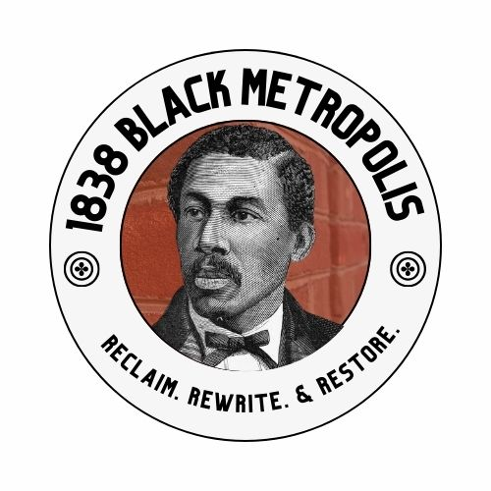
HISTORIC EDEN CEMETERY
Brand Narrative, Tour &
Technical Architecture
A complete brand, storytelling, and digital foundation for a Black institution built to preserve dignity, memory, and permanence.

PREPARED FOR HISTORIC EDEN CEMETERY BY 1838 BLACK METROPOLIS
RECLAIM. REWRITE. & RESTORE. · 2026

Contents
SECTION 1 Brand Narrative and Awareness Strategy 3
Core Positioning 3
Voice, Narrative Architecture & Headlines 4
Strategic Sequencing — Workstreams 1 & 2 7
Appendix A — Elevator Pitches & Statement of Importance 10
Appendix B — 90-Day Action Plan (one page) 14
Appendix C — Partnership Pathway (one page) 15
SECTION 2 Tour 16
The Tour — formats, links, key themes 16
The Route — eight stops 18
How the Tour Was Built — six design decisions 19
SECTION 3 Technical Architecture 23
Summary of Work 23
Technical Architecture Recommendation 25

Historic Eden Cemetery

Brand Narrative and Awareness Strategy
Brand narrative, positioning, and the core story of a Black institution built to preserve dignity, memory, and permanence.

PREPARED FOR 1838 BLACK METROPOLIS × HISTORIC EDEN CEMETERY · 2026
NORTH STAR
Eden is the full-circle answer to a long history of Black dispossession: a place created so that dignity would not end at death, and where the lives of Black Philadelphia could remain visible, protected, and connected to future generations.

Core Positioning
Historic Eden Cemetery is not simply a burial ground. It is a sacred Black cultural landscape created through collective agency at a moment when racism, segregation, urban expansion, condemnation, and the closure of earlier Black cemeteries threatened both the dignity of the dead and the continuity of Black memory. Eden became the community's answer: Black-controlled ground where people could be buried with respect and where their histories would endure.
Today, Eden holds more than 93,000 lives across 17,000 lots on 53 acres — including abolitionists, educators, ministers, veterans, artists, physicians, architects, civic leaders, families, and everyday Black citizens whose collective stories helped build Black Philadelphia and shape the nation. Eden's cultural importance is therefore not based only on who is famous enough to be called “notable.” Its power lies in the extraordinary and the everyday resting together, preserving the full social fabric of Black life.
That makes Eden a “full-circle” institution: Black communities created sacred space when dominant systems denied them dignity; Eden later received people displaced from Black burial grounds that had been erased or forced to close; and today the cemetery can return those lives to public memory through preservation, education, research, visitation, and community stewardship.
Brand Promise
Eden protects more than graves. It protects the dignity, evidence, memory, and continuity of Black life — so that what was pushed out of sight is never pushed out of history.
Primary Brand Idea
From displacement to dignity. From burial to memory. From the ancestors to us.
Strategic Objective
Drive awareness of Eden as an essential Black cultural institution and convert that awareness into visitation, partnership, sponsorship, preservation support, and long-term financial sustainability.

Voice, Narrative Architecture & Headlines
How Eden Should Sound
A voice grounded in reverence, agency, intimacy, and historical consequence — never morbidity, nostalgia, or generic heritage tourism.
Brand Voice
01 Sacred, not solemn-only: Death is present, but the language should center on continuity, dignity, reverence, kinship, and ancestral relationship rather than fear or morbidity. Focus on the spiritual interconnectedness of Blackness.
02 Historically grounded: Use evidence, names, places, dates, and institutional history to make Eden's significance undeniable.
03 Black-centered and self-determined: Eden should be described as something Black Philadelphians built, protected, and sustained — not merely as a site where Black people happen to be buried.
04 Accessible, not flattened: The story should be clear enough for families, students, tourists, and media while retaining intellectual depth. A concise elevator pitch — see Appendix A.
05 Present-tense: Eden is not a relic. It is an active cemetery, research resource, gathering place, classroom, sacred landscape, and living institution.
Narrative Pillars
01 Dignity as Resistance — Eden was founded so death would not become another site of racial dispossession. The very existence of Black-controlled burial space is an act of agency.
02 The Collection Cemetery — When earlier Black burial grounds were forced to close, Eden became a place of return, preservation, and continuity. It gathered what the city displaced.
03 Black Philadelphia in Full — Eden holds the famous and the familiar. Its 93,000 stories reveal Black life across class, profession, faith, family, politics, art, science, military service, and everyday community.
04 Memory Across Generations — Eden is where descendants can find evidence of themselves. The cemetery makes ancestry tangible and gives younger generations a place to encounter the people who came before them.
05 A Living Future — Preservation is not backward-looking. Protecting Eden enables future education, research, public history, family connection, and community ownership.
Community-Rooted Headline Territory
That's ours
Eden held them.
From the ordinary to the extraordinary
Where Black memory lives
Refusing to let Black history be buried twice
Suggested Taglines / Headline Copy
Eden held them. Eden holds us still.
Where Black memory lives.
Founded for dignity. Preserved for generations.
Founded for dignity. Preserved for us.
93,000 lives. ONE sacred Black archive.
The people who built Black Philadelphia are here.
From the ancestors to us.
Black history will NOT be buried twice.
A sacred landscape of Black life, memory, and freedom.
Audience Messaging
One Story, Different Doorways
The core narrative stays consistent; the reason to care changes by audience.
Audience | Key Messaging | Primary Call to Action
Black Philadelphians | Eden belongs inside the living cultural map of Black Philadelphia. It is a place to find ancestors, learn the city's Black institutional history, gather across generations, and claim a heritage that has repeatedly been displaced or minimized. | Visit. Bring family. Research your people. Join preservation efforts. Become a recurring supporter.
National audiences | Eden is a nationally significant Black historical landscape where the stories of abolition, voting rights, faith, medicine, architecture, military service, art, and civil rights converge. It is a place where American history can be understood through Black lives rather than appended as an aside. | Visit when in Philadelphia. Include Eden in educational and heritage itineraries. Support preservation.
Funders & Sponsors | Eden is both a preservation responsibility and a public history opportunity. Supporting Eden protects 93,000 individual records and a rare Black-controlled cultural landscape while expanding access, interpretation, education, and stewardship. Focus on Black change-agents and sponsoring their preservation. | Fund preservation, digitization, interpretation, programming, infrastructure, and visitor access.
Media | Eden offers a powerful reporting frame: what happens when Black communities create permanence in response to dispossession? Its story connects Jim Crow, cemetery displacement, Black institution-building, notable lives, descendant memory, and urgent preservation needs. | Cover Eden as a living Black institution — not only as a cemetery or during heritage months.
Proof Points to Repeat Consistently
- Founded in 1902 amid a Black burial crisis created by segregation, condemnation, urban expansion, and the closure of earlier Black cemeteries.
- 53 acres of Black-controlled sacred ground in Collingdale, Pennsylvania.
- More than 93,000 people are entrusted to Eden's care.
- A “collection cemetery” that received people reinterred from displaced Black burial grounds, including Lebanon and Olive.
- Lives at Eden span from the eighteenth century to the present, making the cemetery a multigenerational archive of Black life.
- National Register of Historic Places and National Underground Railroad Network to Freedom designations.
- Home to figures including Marian Anderson, Octavius V. Catto, William Still, Frances E. W. Harper, Rebecca J. Cole, Julian Abele, James Forten, Pauline Oberdorfer Minor, and Charles L. Blockson — alongside tens of thousands of less-famous community members whose lives are equally part of the record.

Strategic Sequencing
Your Plan of Action
WORKSTREAM 1 | Awareness: Website + sponsorship + community partnerships.

WORKSTREAM 2 | Sustainability: Establish sponsorship and financial sustainability.

WORKSTREAM 3 | Social Media: Facebook now — one official Eden page where every program and partner event is posted. Expand to other platforms only when Eden has the capacity, content pipeline, governance, and response structure to sustain them.
Workstream 1 Awareness
Build Awareness First — With Facebook as the One Live Channel
Near-term priority: make Eden easier to understand, easier to visit, easier to support, and easier to partner with.
1. Website: Make Eden's Significance Immediately Legible
- The website should function as Eden's primary narrative hub and conversion tool. Before expanding to other social platforms, every visitor, reporter, funder, descendant, educator, and partner should be able to understand Eden's story within seconds and know exactly what action to take next.
- Keep the website for the permanent story. Programs, events, and partner activity are posted to Eden's official Facebook page — not added to the website — so the site never has to be edited to look current (see Section 3).
- Lead the homepage with the core positioning: Eden as a sacred Black cultural landscape created to preserve dignity and memory.
- Build clear pathways for Visit, Find an Ancestor / Grounds Map, Learn the History, Notable Residents, Tours & Education, and Support Eden.
- Use the “From the Ordinary to the Extraordinary” framework to prevent the site from becoming only a celebrity cemetery.
- Make the Beginnings story prominent: Lebanon and Olive, the burial crisis, the blocked gates, and the first burial demonstrate why Eden exists.
- Pair historical interpretation with visible donation and sponsorship opportunities throughout the site — not only on a single Donate page.
- Create a concise “Why Eden Matters” page that partners and media can easily cite and share.
SUCCESS LOOKS LIKE
More people understand why Eden matters; more Black Philadelphians see Eden as part of their cultural inheritance; more institutions recognize a credible role for partnership; and awareness translates into the financial support needed to protect the cemetery for the next generation.
2. Community Partnerships: Restore Eden to the Cultural Map
Community engagement should make Eden feel less like a place people encounter only through death and more like a place Black communities can visit, learn, gather, and commune with memory.
- Develop recurring heritage days, family-history sessions, women's history programming, veteran remembrance, and thematic walking tours.
- Partner with Black churches, Divine Nine organizations, schools, HBCU alumni networks, neighborhood associations, genealogical groups, and Black cultural institutions.
- Use the phrase “That's ours” as a community ownership frame: Eden is a Black institution worth visiting, protecting, and claiming.
- Reintroduce traditions of cemetery visitation as reflection, learning, and ancestral connection — while respecting active burial operations and sacred space.
- Create community ambassador opportunities so trusted partners can bring their own audiences into Eden.
- Post every program and partner event to Eden's official Facebook page, tagging the partner, so the work is visible as it happens and partners can share it with their own audiences.
- For a step-by-step approach to starting and testing a partnership, see Appendix C.
Workstream 2 Sponsorship & Financial Sustainability
Turn Cultural Importance Into Sustainable Support
Because preservation without resources is vulnerability. Sponsorship should be a primary brand activation, not an afterthought.
1. Sponsorship Positioning
Eden should not ask sponsors merely to “support a cemetery.” The case for support is larger: sponsors are helping protect one of the most important repositories of Black Philadelphia's cultural memory, preserve 93,000 individual histories, expand public access to a nationally significant landscape, and ensure that Black-controlled sacred space survives for future generations.
CORE SPONSORSHIP MESSAGE
Preserving Eden means preserving evidence: names, families, institutions, stories, monuments, burial records, and the physical ground that connects Black Philadelphia's past to its future.
2. Priority Sponsorship Platforms
Preservation Partner: Support monument conservation, landscape care, archival protection, and preservation of historic sections.
Digital Memory Partner: Fund digitization of records, interactive mapping, searchable family-history resources, and interpretive storytelling.
Education Partner: Underwrite school visits, educator resources, student transportation, tours, and public-history programming.
Community Legacy Partner: Support free community days, genealogy events, women's programs, veteran remembrance, and intergenerational gatherings.
3. Who to Approach
- Philadelphia-region corporations with commitments to Black communities, historic preservation, education, or civic engagement.
- Foundations focused on African American history, archives, preservation, public humanities, genealogy, and place-based community development.
- Healthcare, architecture, higher education, arts, faith, and financial institutions whose own histories intersect with people buried at Eden.
4. Immediate 90-Day Brand Actions
- Finalize the brand narrative and “Why Eden Matters” language so every pitch uses one consistent story.
- Create a sponsorship one-sheet/deck with 4–5 fundable platforms and clear impact language.
- Revise the website homepage and support pathways to convert awareness into donations, sponsorship inquiries, tour bookings, and partnerships.
- Identify 20–30 priority institutional prospects and match each prospect to a specific sponsorship platform rather than sending a generic ask.
- Consolidate Eden's scattered Facebook pages into one official Eden Cemetery page and post every program and partner event there. Defer all other social-media expansion until Eden has the capacity to sustain it well.
- See Appendix B for the 90-Day Action Plan at a glance.

APPENDIX A

Appendix A — Elevator Pitches & Statement of Importance
Drafted from workshop voices, community input, and institutional history — June 2026
Why Eden Is Important — A Foundational Paragraph
Eden Cemetery is not simply a burial ground — it is the accumulated memory of Black America's most audacious act of self-determination.
Since Black Philadelphians began establishing their own sacred spaces in the 1790s — churches, beneficial societies, and cemeteries that offered dignity where the dominant culture offered none — they were building toward Eden.
Established in 1902 by Black founders who refused to accept that death would be another site of dispossession, Eden became the guardian of what other institutions could not hold. When Lebanon Cemetery and Olive Cemetery — home to Philadelphia's Black citizens — were forced to close and their residents reinterred, Eden absorbed them all.
What this means is that Eden now holds the complete record of Black Philadelphia's founding generation: the abolitionists who operated the Underground Railroad in plain sight, the ministers who built the first Black churches, the physicians who founded the first African American graduate medical programs, the poets who told America it could not be free while it held people in chains, the architects who designed the buildings of elite American institutions, and the musicians who carried the sorrow and joy of a people to the world's great stages.
Philadelphia was the civic laboratory of Black America — the city where Black people invented how to protest, how to claim rights, and how to build institutions that could sustain a community under conditions of profound oppression — and the people who did that are buried at Eden.
When you walk Eden's 53 acres, you are not visiting a cemetery. You are time-traveling through the foundation of Black American identity, standing on ground that holds 93,000 ordinary people who did extraordinary things — in a city that taught the world what freedom really means.
Ten Elevator Pitches
Each pitch offers a distinct angle. Phrases in italics are lifted directly from workshop participants.
01 The Founding Pitch
Philadelphia was the civic laboratory of Black America. The first HBCU. The first Black churches. The first beneficial societies. The first abolitionist networks that put the cracks in the foundation of American slavery. The men and women who built those institutions — who taught the world how to protest, how to claim civil rights, how to build a nation within a nation — are buried at Eden Cemetery. You cannot do Black Philly history without Eden Cemetery. And you cannot understand America without Black Philly.
02 The F.U.B.U. Pitch
In 1902, a group of Black Philadelphians did something radical: they built their own. For generations, Black people had been denied dignity in death — buried in unmarked graves, in segregated sections, in cemeteries they did not control. So Black Philadelphia built Eden. For You. By You. Ninety-three thousand souls rest on 53 acres of Black-owned, Black-controlled, sacred ground. That's ours. It has been ours from the beginning. It still is.
03 The Underground Railroad Pitch
William Still — the father of the Underground Railroad, the man who documented every freedom seeker he helped escape, who kept the records that became the foundation of African American genealogy — is buried at Eden. He is one of 93,000. Eden is a designated National Underground Railroad Network to Freedom site and is listed on the National Register of Historic Places. The freedom movement didn't end with emancipation. The proof is right here — seeing what is no longer, and what must never be forgotten.
04 The “Hi Oprah” Pitch
“Hi Oprah. A serious historical injustice needs to be rectified. Eden Cemetery's significance has been strategically undermined — intentionally — and it has caused broken trust and lost community connections to Black American history, from the ordinary to the extraordinary, for over 124 years.” Eden is where Stedman Graham's family rests. It is where Black Philadelphia rests. It needs a champion. We're asking you to be one.
05 The Time-Travel Pitch
What if you could sit in the same space as Marian Anderson, Frances Watkins Harper, and William Still? Eden Cemetery is time travel — the past in the present. It is where 93,000 stories of ordinary people who did extraordinary things are waiting to be heard. Stories = History. Past = Now. The result of what was is the continuation of what we are. Come sit with your ancestors. History ignored is history repeated. Eden won't let you forget.
06 The Civic Democracy Pitch
The Declaration of Independence was signed in Philadelphia. But it was Black Philadelphians who forced America to live up to it — who challenged its hypocrisy from the very beginning, in their churches, their courts, their newspapers, and their streets. What they practiced in Philadelphia, the world eventually practiced. Philly is at the center of a national conversation about how American history should be remembered. The architects of that tradition — from the ordinary to the extraordinary, for over 124 years — are buried at Eden. This is not a cemetery. It is the birthplace of American democracy's conscience.
07 The Sacred Space Pitch
Since the 1790s, Black Philadelphians have protected their right to honor their dead — in dignity, in community, in reverence. In a time when enslaved people had no control over their bodies in life or in death, having a headstone, having a grave someone could visit, having ancestors who had come to a place of rest — that was resistance. That was love. Eden is the culmination of over 200 years of that tradition. A safe space. A sacred space. A third space. Come honor them. Come sit in the beauty. Come see what is no longer — and feel what endures.
08 The Reinterment / Justice Pitch
Lebanon Cemetery. Olive Cemetery. The great Black burial grounds of Philadelphia — home to some of the most important Black Americans in history — were forced to close. Forced. Their residents were reinterred at Eden. Other cemeteries were not forced to move. Only theirs. Even in death, the mistreatment continued. But Eden held them. Eden holds them still. What looks like a cemetery is actually an act of resistance — 124 years of refusing to let Black history be buried twice.
09 The America's-Oldest-Black-Cemetery Pitch
Eden Cemetery is a representation of the importance of the identity of Black life — and one of the oldest continuously operating Black-founded cemeteries in the United States. Its 93,000 residents include an Olympic gold medalist, the composer of gospel's greatest hymns, a U.S. Congressman, the architect of elite American universities, the abolitionist who documented the Underground Railroad, and one of America's greatest singers. This is not a local story. A representation of Black history — for half of America's history — has persisted here. Eden is America.
10 The Future Pitch
We need Eden not just because of what happened in the past — but because of what is happening right now. Black spaces need support now more than ever. Eden is how we transport the past to our future. It is the place where we learn from the people who built Black America — who practiced Afrofuturism before the word existed, who imagined a future they might not live to see and built it anyway. We need resources to continue informing future generations about our history. We need Eden to survive — so the stories it holds can teach us ways to improve our now.
Key Phrases from the Community
Lifted verbatim from workshop participants — these are the people's words, ready for use in copy.
That's ours.
F.U.B.U. — For You, By You.
History ignored is history repeated.
Stories = History. Past = Now.
Time travel — the past in the present.
From the ordinary to the extraordinary.
Sitting with our ancestors.
Seeing what is no longer.
A historical Mecca.
Civil rights in death.
Sacred Black space.
How determination overpowers hardship.
You cannot do Black Philly history without Eden Cemetery.
It defines what it is to be a Black Philadelphian.
Where we cannot see them anywhere else.
Hear uncomfortable stories to comfortability.
Stories are more important than history.

Appendix B — 90-Day Action Plan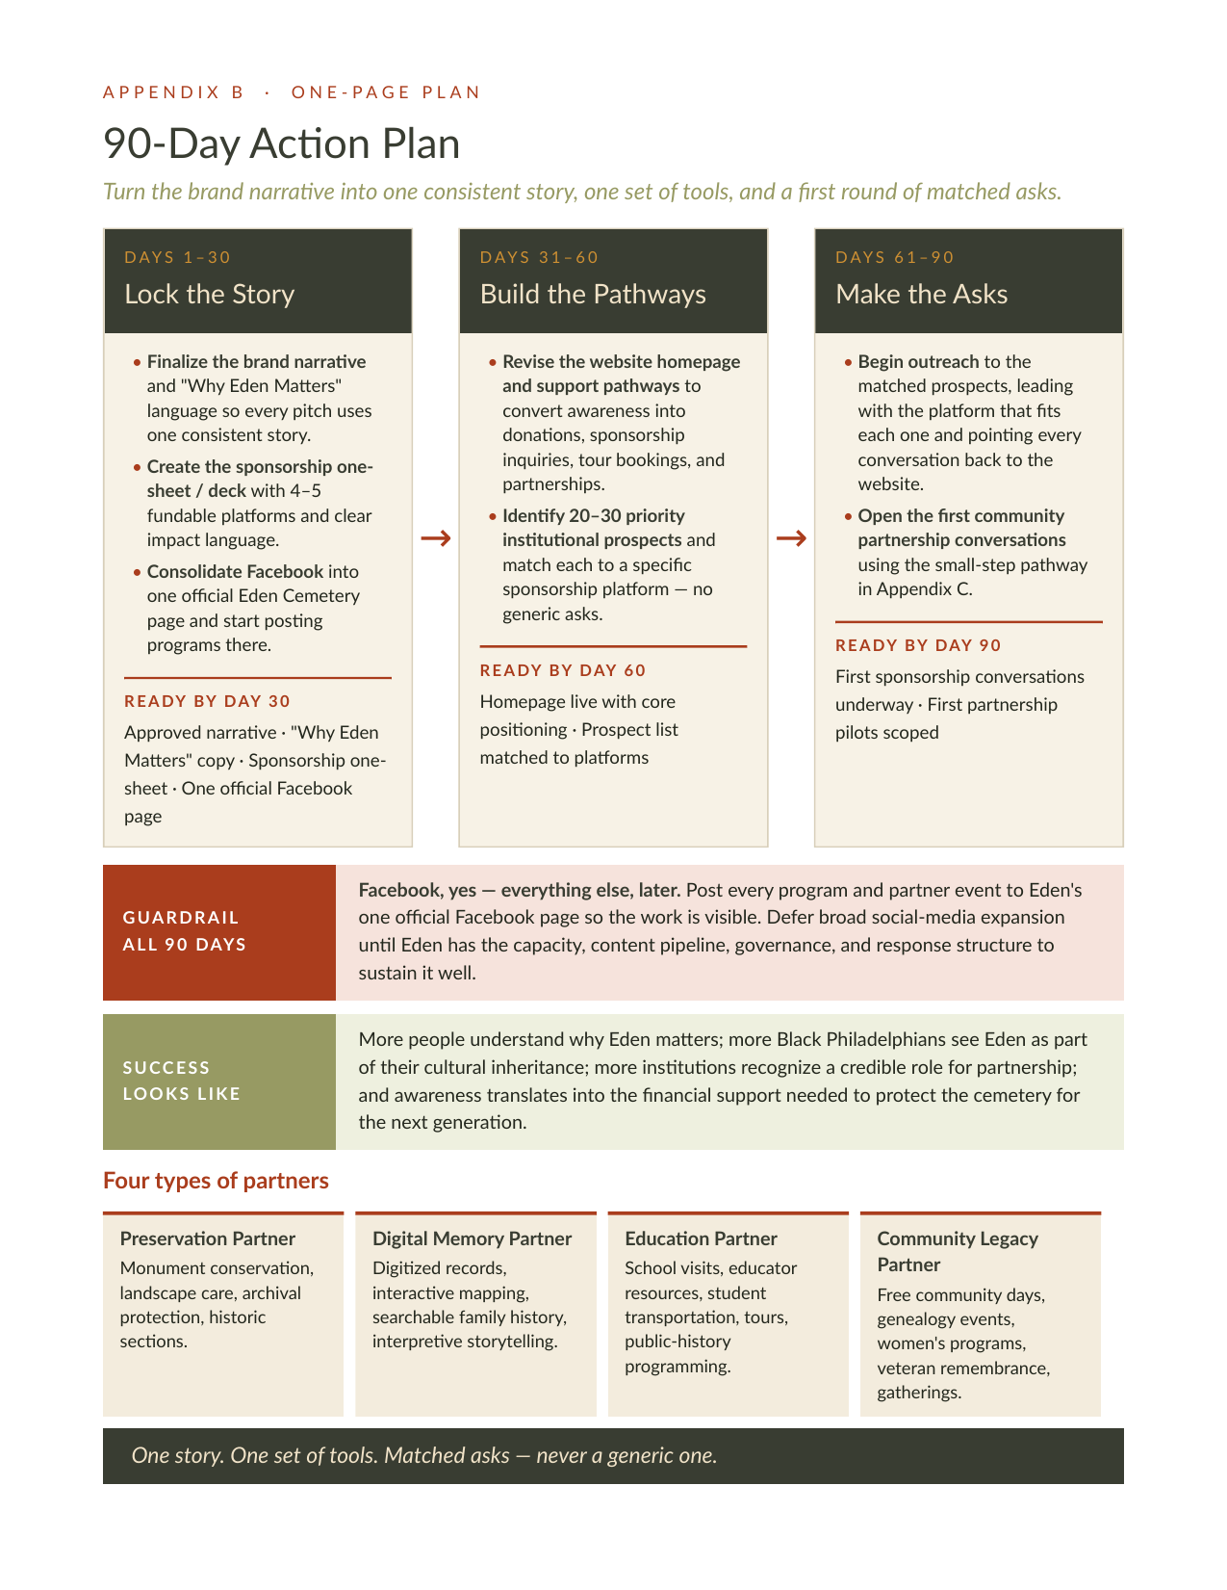

Appendix C — Partnership Pathway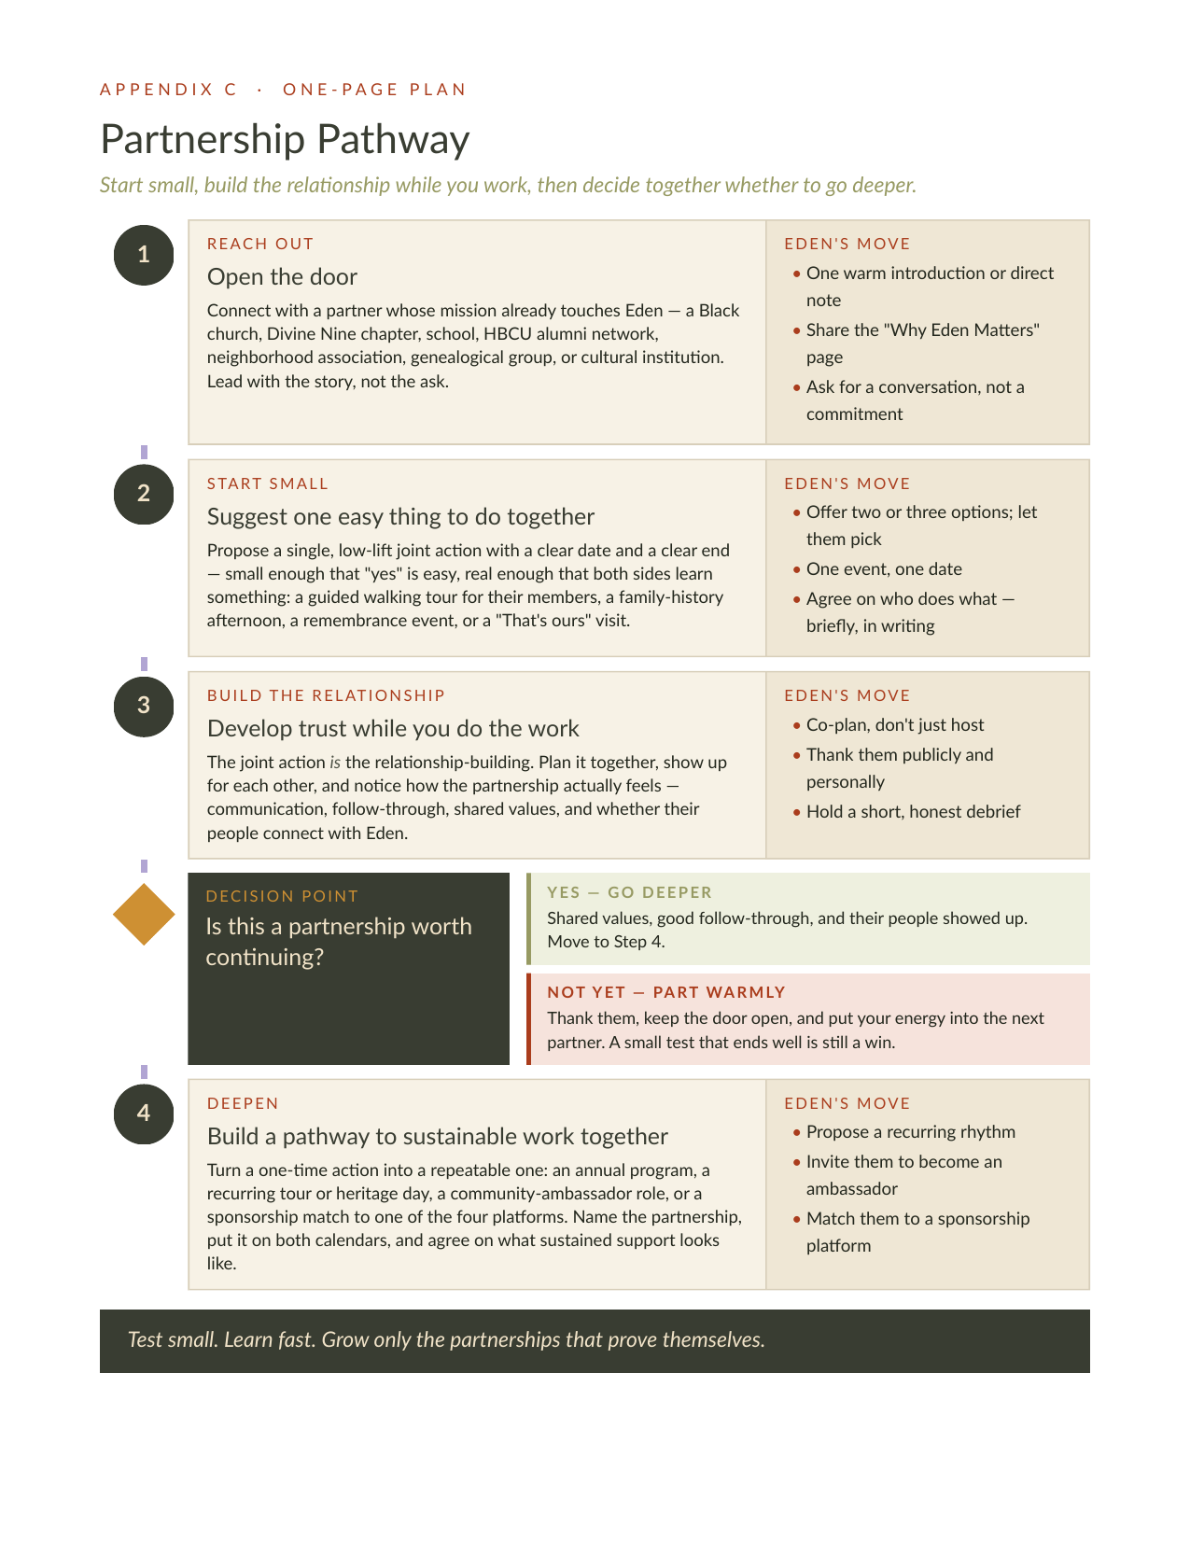

Section 2

Tour
Learning Black History Through Burial Grounds: A Walking Tour of Eden.

PREPARED FOR 1838 BLACK METROPOLIS × HISTORIC EDEN CEMETERY · 2026
THE QUESTION THE TOUR ASKS
How does Eden preserve generations of Black life, institution-building, and displacement?

The Tour
The walking tour brings Section 1's narrative onto the grounds. It is organized by Eden's section names — Celestine, Richard Allen, Lehmann, Lebanon, John Brown, Bowers, Olive — because each name is itself a piece of history: a person, a lost cemetery, or an allegiance. Visitors move through the cemetery the way the community's story moved through Philadelphia: from exclusion, to institution-building, to displacement, to a chosen resting place for later generations.
The tour exists in two forms that share one script. A self-guided version lives on the website, with a "Where am I?" plan view, a panel for every stop, and a one-page print sheet. A guided version is written for Eden's volunteer guides, with timings, gestures, optional deep dives, and research notes about what can and cannot yet be said in public.
Two formats
 | Full Tour | Short Tour
Length | 90–120 minutes | About 60 minutes
Stops | 8 — Celestine, Richard Allen, Lehmann, Lebanon, John Brown, Bowers, Olive, and a return to Celestine | 4 — Richard Allen, Lehmann, Lebanon, John Brown
Audience | General audience; visitors able to walk and stand for a longer period | General audience, including visitors with limited mobility; short distances, seated interpretation points, portable chairs welcome
Start / end | Springfield Road entrance; ends at John Brown or returns to the entrance | Parking area; to be confirmed on the ground
Content advisory | Discussion of grave disturbance, racism, and reinterment.
Guide materials | Printed route sheet, section map, timer, emergency contact.
Where to find it
Full Tour (self-guided): https://1838blackmetropolis.github.io/Eden-Cemetary/tour-long.html
Short Tour (self-guided): https://1838blackmetropolis.github.io/Eden-Cemetary/tour-short.html
Print sheets: https://1838blackmetropolis.github.io/Eden-Cemetary/tour-long-print.html
https://1838blackmetropolis.github.io/Eden-Cemetary/tour-short-print.html
The self-guided pages are part of the website described in Section 3: self-contained, hosted alongside the notables map and the Find a Lot locator, and requiring no maintenance. The guide scripts — Full Tour 60–120 min and Short Tour 45–60 min — are delivered as Word documents with the project files.
Key themes
Four threads run through every stop. Guides can lead with whichever one the group responds to.
Theme 1 — Black control over burial
From the Free African Society of 1787 to Eden's charter in 1902, Black Philadelphians built the institutions — churches, mutual-aid societies, a woman-led undertaking business, a cemetery company — that let them care for their own dead when white institutions would not.
Theme 2 — Displacement and reinterment
Lebanon and Olive were Black cemeteries in Philadelphia, robbed, condemned, and erased. Their names survive as sections at Eden, and their dead were carried here. Some remains, like Absalom Jones's, moved through four places.
Theme 3 — Building Eden
A first burial that white residents tried to stop; five founders who secured a charter, land, legal protection, and records. The cemetery is an act of institution-building, not just a resting place.
Theme 4 — Continuity across generations
Forten to Still to Catto; Whipper to Fauset; Cole, Marian Anderson, and Blockson choosing Eden decades later. Each section holds both people who were moved here and people who were buried here directly — a history of loss and a continuing community.
Burial-status key
Every person on the tour is introduced with how they arrived at Eden. The distinction is the tour's central teaching device.
- Transferred — moved to Eden with an earlier cemetery (Lebanon 1903, Olive 1923).
- Direct burial — buried at Eden after the section was established.
- Elsewhere now — former Eden interment or memorial; remains are now elsewhere.
- Unconfirmed — exact burial sequence still requires confirmation in Eden's registers.

The Route: Eight Stops
The Full Tour follows the stops below; the Short Tour uses stops 2, 3, 4, and 5, with Celestine and Lehmann's founders told in the introduction. Each stop's section name is explained first, then the people, then the connection to another stop.
Stop | Section | What it holds | Central people
Start | Springfield Road entrance | Eden chartered June 20, 1902; ~53 acres in Collingdale. Two urgent needs: dignified burial in the face of segregation, and a resting place for remains displaced from older Black burial grounds. | Eden's founders, collectively
1 | Celestine | Named for Eden's first burial. Celestine Moseley Cromwell died August 8, 1902; white residents and borough officials tried to block her funeral procession. She was buried August 14, after her remains were held for about thirty-six hours. | Celestine Moseley Cromwell
2 | Richard Allen | Honors the AME Church's founder, who is not buried here. In 1787 Allen and Absalom Jones founded the Free African Society, making care for the sick and the dead a shared duty. The Bethel Burying Ground of 1810 now lies beneath Weccacoe Playground. | Richard Allen; Absalom Jones
3 | Lehmann | Named for Martin J. Lehmann (1859–1924), cigar maker and treasurer — one of the five founders who obtained the charter, acquired land, defended the cemetery legally, and kept the records. | Martin J. Lehmann; John C. Asbury, Charles W. Jones, Daniel W. Parvis, Jerome Bacon
4 | Lebanon | Preserves the name of an 1849 Philadelphia cemetery: body-snatching exposed in 1882, condemned in 1899, thousands of remains brought to Eden in 1903. The tour's longest stop — displacement and continuity side by side. | James Forten; William Still; Octavius Catto; Caroline LeCount; Caroline Still Anderson; James J. G. Bias; the Mossells; Laura Wheeler Waring
5 | John Brown | Named for the abolitionist, who is not buried here. Frances Ellen Watkins Harper chose burial here in 1911 — a section name as political memory. Optional: United States Colored Troops and Civil War remembrance. | Frances Ellen Watkins Harper; Black veterans
6 | Bowers | Death care and a Black woman's business leadership. Henrietta Bowers Duterte, identified as America's first Black woman undertaker; her brother John C. Bowers (d. 1873), transferred from Lebanon. | Henrietta Bowers Duterte; John C. Bowers
7 | Olive | A second displaced cemetery — West Philadelphia, 1849, linked to Stephen Smith; its remaining burials came to Eden in 1923. From nineteenth-century reform to the Harlem Renaissance. | William Whipper; Jessie Redmon Fauset; Stephen Smith; Arthur Huff Fauset
8 | Celestine, revisited | Return to where the story began to see what Eden became: the chosen resting place of later generations, 1922 to 2023. | Rebecca J. Cole; Matthew Anderson; Marian Anderson; Charles L. Blockson
Close | Stewardship | Brings the story to the present — caring for Eden, contested reinterment, and unresolved responsibility. | MOVE children; First African Baptist remains; Morton Collection individuals

How the Tour Was Built
The tour is not a list of famous graves. It is an argument about how Black Philadelphians secured, lost, and re-secured control over their dead — told through the ground itself. Six design decisions shape every stop.
01 1902 is the pivot
The tour does not move in a straight line through time. It opens at Eden's founding, flashes back a century, returns to 1902, then walks forward to the present. The organizing date is 1902: the year Eden was chartered, William Still died, and Celestine Cromwell's funeral was resisted. Every stop is placed in relation to it — before Eden existed, the moment it was built, or after it became the community's chosen ground.
Stop | Chronological span | Where it sits relative to 1902
Celestine | 1902–1976 | The founding moment — a first burial that white residents tried to stop
Richard Allen | 1787–present | Flashback: Black religious control of death and burial before Eden
Lehmann | 1859–1924 | Return to 1902: creating and administering the cemetery
Lebanon | 1818 – twentieth century | Displacement, reinterment, and dense intergenerational networks
John Brown | 1911 | Abolition and Civil War memory; a section name as politics
Bowers | 1873– | Death care as a Black business and a woman's leadership
Olive | 1849–1983 | A second displaced cemetery; from reform to the Harlem Renaissance
Celestine, revisited | 1922–2023 | Eden as the chosen resting place of later generations
Closing | Today | Stewardship, contested reinterment, unresolved responsibility
02 "Transferred" or "buried here" is the teaching device
The single distinction visitors carry away is between an ancestor who was moved to Eden when an older cemetery was destroyed and one who was buried at Eden directly, after the section already existed. Every person is introduced with that status, and the sections are read as holding both histories at once: displacement and continuity, side by side.
Two pairings make the point without a lecture. Octavius Catto was moved here in 1903 because Lebanon Cemetery was condemned; his fiancée Caroline LeCount was buried beside him twenty years later by choice. Catto represents displacement; LeCount represents return. And Absalom Jones — buried at St. Thomas, moved to Lebanon, moved to Eden, and in 1991 returned to St. Thomas — shows that reinterment was rarely a single event. Some Black remains traveled through four burial landscapes as churches moved, cemeteries closed, and the city changed.
03 Connections, not stops
The route is built so that no person stands alone. Each stop introduces someone, then connects them to a person at another section — with a gesture toward that ground whenever it is visible. Guides carry short memory cues so the network holds together across a ninety-minute walk:
Jones helped build religious independence. Forten connected religious, educational, and abolitionist work. Bias joined medicine to abolition and political organizing. Whipper and Smith connected reform to business and economic power.
- Forten → Whipper (Lebanon → Olive): the American Moral Reform Society; two generations of Black reform.
- Still → Harper (Lebanon → John Brown): Philadelphia's abolitionist and Underground Railroad network.
- Still → Catto → LeCount (within Lebanon): the campaign to desegregate the city's streetcars.
- The Still–Anderson family (Lebanon → Celestine): William Still, abolition; Caroline Still Anderson, medicine and education; Matthew Anderson, Berean Presbyterian Church.
- Waring → Fauset → Marian Anderson (Lebanon → Olive → Celestine): a painter, the writer she traveled with, and the singer she painted — literature, visual art, and music joined across three sections.
04 Say only what the archive confirms
Every line of the guide script is tagged. Confirmed material is ready to say aloud. Optional detail is confirmed but expendable when time is short. A research note is promising but not yet ready for public interpretation. The tiering keeps the tour honest while Eden's own registers are still being read — and gives guides a clear answer when a visitor asks a question the archive cannot yet support.
- Guides do not say that Eden was William Still's first burial place until the 1902 interment register confirms it; until then he is simply "buried here."
- Guides do not say Martin Lehmann is buried in the Lehmann section until his grave location is confirmed; the documented fact is that the section was named for him.
- Cole, Anderson, and the Mossells are described as an overlapping medical network, not as confirmed friends or collaborators.
- Section naming dates are stated only where the National Register nomination supports them; a section may have been named after burials began.
05 Two walks, one script — designed for who shows up
The Full Tour assumes visitors who can walk and stand for ninety minutes or more. The Short Tour was designed separately for a limited-mobility audience: short distances, a seated interpretation point wherever possible, portable chairs welcome, terrain conditions stated plainly at the start, and fewer stops with richer stories rather than a trimmed version of the long route. Celestine and Lehmann are told in the introduction so the group never has to reach them; Lebanon, the densest section, is where the time goes.
Both walks carry the same content advisory — grave disturbance, racism, and reinterment are discussed directly — and the same guide kit: printed route sheet, section map, timer, emergency contact.
06 The walk ends in the present
The closing returns to Celestine to meet the people who chose Eden after 1902 — Rebecca Cole, Matthew Anderson, Marian Anderson, Charles Blockson — and then steps into the present: who cares for Eden now, and what remains unresolved. The script names contested reinterments in Philadelphia's recent memory — the MOVE children, the First African Baptist Church remains, the individuals in the Morton Collection — so the question the tour opened with is left with the visitor, not answered for them: who has the authority to decide where Black bodies rest, and whether those places will be protected?
How each stop is told
The guide script uses the same six-beat structure at every section, so the tour stays consistent whoever is leading it.
01 How the section got its name. What or whom it commemorates; whether the namesake is actually buried there; when the section came into use, if known.
02 A few people buried there, each introduced by how they arrived: who they were, where they were first buried, and whether they were transferred, buried directly, or later removed.
03 A connection to another stop — "Still worked with Harper, whom we will meet in John Brown" — with a gesture toward the section whenever it is visible.
04 One or two more people who deepen the network or extend the chronology.
05 If time permits: a lesser-known person, a theme (medicine, education, religion, art, fraternal life), or a larger issue (body-snatching, cemetery displacement, scientific racism, commemoration).
06 Transition: why the group is moving to the next section.

Section 3

Technical Architecture
What has been delivered, and a low-cost, low-maintenance digital foundation for Eden Cemetery going forward.

PREPARED FOR 1838 BLACK METROPOLIS × HISTORIC EDEN CEMETERY · 2026

Summary of Work
Three pieces of work were completed for Eden under this project: a new website, a searchable lot map, and the cleaned data that powers both. Together they give Eden a modern public face and, for the first time, a digital record of where its people rest.
01 Design of the new Eden Cemetery website
A new website was designed and built with branding consistent with the narrative, voice, and visual identity established in this project. It carries the core positioning onto every page — "Come sit with your ancestors," the 1902 / 93,000 / 53-acre proof points, the Lebanon and Olive story, and the community's own words.
Live site: https://1838blackmetropolis.github.io/Eden-Cemetary/
The site includes:
- Home — the brand narrative, "Why Eden Matters," visiting information, and clear paths to the office, tours, and Friends of Eden.
- History — Beginnings (Lebanon, Olive, and the founders), the blocked gate of August 1902, Celestine Cromwell's first burial, and transcribed 1902 press coverage.
- Notable Residents — a searchable, filterable directory of the people on Eden's tour route, with section and lot for each, and feature pages for figures such as Marian Anderson and Octavius V. Catto.
- For Kids — "Letters to the Ancestors" from Jubilee School students, plus a printable "Find the Ancestors" kids' map.
- Map & Tours — an interactive notables map with search and category filters, visiting hours, and guided-tour information.
- Find a Lot — the lot locator described below.
- Cemetery Services, Friends of Eden, and Contact — burial and memorial services, the archival preservation ask, and a contact form that opens a ready-to-send email to the office.
02 Development of a searchable lot map
Eden's grounds were mapped lot by lot. Each of the cemetery's roughly 17,000 lots now has geographic coordinates, and the resulting lot map is published on the website as the Find a Lot locator. A visitor types a lot number, the map zooms to that parcel and opens its record — locations are accurate to within a few feet.
The locator is paired with simple instructions for the most common case: look up an ancestor on Find a Grave to get their section and lot number, then enter the lot number on Eden's map to pinpoint the exact location on the grounds. The interactive notables map draws on the same coordinates, so every notable on the tour route is placed precisely.
Lot locator (full screen): https://arcg.is/185PKD1
03 Delivery of source documents and data
Eden's physical records — the typed and handwritten lists of clergy, U.S. Colored Troops veterans, Citizens of Eden, and Lebanon reinterments — were scanned and transcribed. That transcription is the source for both the notables listing on the website and the lot map. All working files are delivered to Eden in the shared folder below and remain Eden's property.
Shared folder: https://drive.google.com/drive/u/0/folders/1iSXQth_0a3pwtehL7UQyQozYeoEEPkTD
Document | What it is
Original Database from Scanned Word Documents (.xlsx) | The first full transcription of the scanned physical lists, with every entry kept exactly as written alongside its source page, so any record can be checked back against the scan.
Cleaned Database from Scanned Word Documents (.xlsx) | The same records after cleanup — standardized names, sections, lots, and dates, ready for use.
Cleaned Notables Database for Website (Google Sheet) | The notables listing as published on the website: name, dates, category, biography, section and lot. Editing this sheet is how the notables directory is updated.
Cleaned Full Lot Index with Coordinates (Google Sheet) | Eden's complete lot index with geographic coordinates for every lot — the data behind the Find a Lot locator and the notables map.

Technical Architecture Recommendation
The problem we are solving
Eden Cemetery carries extraordinary historical weight — documented Underground Railroad connections and roughly 93,000 burials across some 17,000 lots — including United States Colored Troops veterans and generations of Philadelphia's Black community. But the organization is operating under real financial strain.
A digital plan for Eden cannot be judged by how impressive it is. It has to be judged by one question: can Eden keep it running with almost no money and almost no dedicated technical staff? Every recommendation below is built around that constraint. The goal is a digital presence that is dignified, useful, and — most importantly — sustainable without ongoing cost or technical upkeep.
The core principle is a division of labor between two kinds of digital space:
A powerful, immersive, informative website that is low cost and low maintenance — and social interaction and events that leverage existing free social tools.
Keep the permanent, reference material on a website that requires no maintenance. Put everything that changes — events, announcements, conversation, partnerships — on free tools Eden's audience already uses. Never pay to update something you could update for free.
01 A self-contained website Eden owns outright
We have built Eden a new website that is rich and interactive for the people who visit it, yet self-contained and maintenance-free for the organization that runs it. Those two things sound like they should be in tension — they aren't, and that distinction is the heart of this recommendation.
Immersive for the visitor. This is not a plain brochure page. Visitors will explore a clickable map of the grounds, search and filter the notables buried at Eden, follow the self-guided walking tours, and move through the history in interactive ways. It should feel useful, modern, and alive — a real destination, not a placeholder.
Self-contained for Eden. All of that interactivity happens in the visitor's browser. Behind the scenes, the site is a self-contained package that simply sits on Eden's existing web address and runs on its own. There is no content management system to log into, nothing to patch, and no monthly software bill. Once it is in place, it can keep working for years without anyone editing it.
What "self-contained" really means — and why it beats Squarespace or Wix. On a platform like Squarespace or Wix, every change means someone has to know how to log into that platform and edit the site — and Eden keeps paying the monthly fee for the privilege. We recommend the opposite: build everything Eden needs into the site now, then get off Squarespace entirely. No subscription, no login, no one on the hook to maintain it. The site holds Eden over comfortably for the next year — long enough to stop paying for a platform it can't currently staff.
Live content without touching the website. The one thing that genuinely changes over time is events — and those don't need a website edit at all. Eden can run its events calendar on Facebook and have it feed into the website automatically. The live content updates itself from somewhere else; the website never has to be opened up and edited to stay current.
The one recurring cost. Realistically, the only ongoing expense is the annual web hosting / domain fee Eden likely already pays. There is no separate software subscription layered on top.
What the website must make obvious. Because the site is a reference point rather than a conversation, its most important job — beyond the history and maps — is to tell every visitor, clearly and immediately, how to reach Eden and how to get involved. A visitor should never have to hunt for how to contact the organization, how to donate, or where the community is active. Wherever possible, that path should point outward to Facebook, where Eden's living presence will be.
02 Facebook as Eden's living hub
Everything that does change belongs on Facebook, not the website. When Eden wants to promote an event, share news, or celebrate a discovery from the archives, the instinct is to "add it to the website." We recommend resisting that instinct every time. Updating a website costs time and often money. Posting on Facebook is free and takes minutes.
Start by consolidating. Today Eden's Facebook presence is scattered across roughly five pages, several of them tied to individuals' personal accounts. The first step is one official Eden Cemetery business page — owned by the organization, not by any one person — with the older pages pointed to it or retired. One page, one name, one place to send everyone.
Then post the work as it happens. Every program, tour, cleanup day, and partner event goes on that page, with the partner tagged. This is the exception to "build social later": a single official Facebook page is not a social-media expansion, it is the minimum Eden needs to look as active as it actually is. When a funder, reporter, or descendant looks Eden up, they should see things moving.
Facebook is the right home for Eden's active presence for several concrete reasons:
- The audience is already there. Eden's core community — descendants, local residents, history and genealogy enthusiasts — is disproportionately active on Facebook. Meeting them where they already are is far more effective than asking them to visit a website.
- Events are built in and free. Facebook's Events feature handles invitations, reminders, RSVPs, and sharing at no cost. This is the direct answer whenever Eden asks about putting events "on the site."
- It is where partnerships form. As the brand marketing plan identifies organizations and allies for Eden to connect with, most of that relationship-building — tagging, sharing, co-promoting — happens naturally in social spaces, not on a static website.
- It is a two-way channel. People can message, comment, and respond. The website tells people how to reach Eden; Facebook is one of the places they actually do.
Connecting the two. Events created in Facebook can be surfaced on the website by pulling them over — so the website can display Eden's upcoming events without anyone ever hand-editing the site. Facebook remains the single place Eden updates; the website simply reflects it.
03 One post, two platforms — Instagram via Meta
Because Facebook and Instagram are both owned by Meta, they are connected. Eden can cross-post from Facebook to Instagram automatically, reaching a younger and more visual audience without any extra work.
This matters for a resource-strapped organization: the walking-tour photography and archival images we are developing become content that serves both platforms from a single post. There is no separate Instagram workflow to staff — it is a setting, not a second job. Instagram is a secondary channel: simply switch cross-posting on so Eden gets the added reach for free, while keeping all real activity centered on Facebook.
04 One volunteer role: social media
The single most valuable thing Eden can add to this system is one person who owns social media — and only social media.
This does not need to be a paid staff member. We recommend Eden recruit a dedicated social media volunteer whose entire, well-defined job is to keep Facebook active: post events, share news, respond to messages and comments, and nurture the partnership connections the brand plan sets up. Narrow scope is the point. "Manage all of Eden's digital everything" is a job no volunteer will sustain. "Post to Facebook and answer messages" is a job someone can actually hold.
This role is what makes the whole architecture work, and it is deliberately the only ongoing human commitment the system requires. The website needs no one. Facebook needs one focused volunteer.
05 Repurpose the contract's 50 hours to cover the site this year
Eden's current contract with 1838 includes 50 hours of writing support. Because the brand marketing plan moves Eden's ongoing communication onto Facebook, that writing time is no longer where the value is. We propose repurposing those 50 hours into website support for the coming year.
Practically, this means Eden does not have to learn to edit the site or hire anyone to do it. Whenever a small change is needed — a correction, a new photo, a tweak to the tours or notables — 1838 makes it directly, drawn from the 50 hours already in the contract. There is no new cost, and no new burden on Eden. The hours are already budgeted; we are simply pointing them at the more useful task.
This is deliberately scoped to small changes. It is not open-ended redevelopment — it is enough hands-on support to keep the site accurate and current while Eden spends this year focused on what matters most: brand awareness and getting people involved with Eden. And it carries Eden cleanly to the point where longer-term help arrives.
06 A clear path to Penn Praxis next year
Within roughly a year, Eden is expected to receive support from Penn Praxis at the University of Pennsylvania. This architecture is designed to hand off to those students cleanly.
Because the website is a self-contained package, it is an ideal project for student developers to extend when that help arrives — adding features, deepening the maps, or building richer ways to explore the burial records. Nothing in the current setup locks Eden in or has to be undone first.
The sequencing is deliberate: stand up the sustainable system now, let 1838 keep it current through the 50 hours this year, and let Penn Praxis build on it next year. Eden gets a working, dignified presence immediately, at almost no cost, and a natural on-ramp for skilled help exactly when the budget and the partnership are ready for it.
What this costs Eden
Component | Ongoing cost | Who maintains it
Self-contained website (clickable map, notables search, walking tours) | Annual hosting / domain fee only | No one — it just runs
One official Facebook page & events | Free | One social media volunteer
Instagram (cross-posted from Facebook) | Free | Automatic — no extra work
Small site changes this year | No new cost — covered by contract | 1838, via repurposed 50 hours
Future development | Deferred | Penn Praxis, in ~1 year
The entire recurring financial commitment is the web hosting fee Eden likely already pays. Everything else is free technology Eden's audience is already using.
THE SHIFT, IN ONE SENTENCE
Stop treating the website as the place where Eden happens. Let the website be the immersive, self-running front door — beautiful, interactive, and maintenance-free — and let Facebook be the living room where the community gathers, events are announced, and partnerships grow. It costs almost nothing, it meets Eden's people where they already are, and it is built to survive the organization's current constraints rather than add to them.

