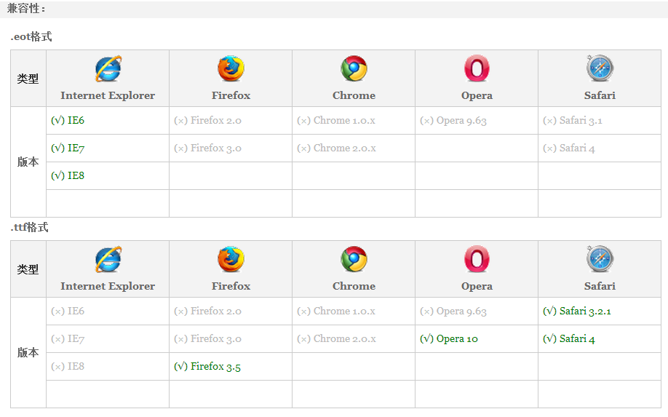

Notice: Internet Explorer 9 only supports .eot fonts

