**Instructions for getting started with problem sets in GitHub**

1. Get a Git account if you don’t have one already: <https://github.com/join>.
2. Once you have an account, you need to ‘fork’ the ‘parent’ repository. That’s Git speak for make your own copy of my main folder. To do that, first go to the main folder: <https://github.com/ASDS-TCD/StatsI_Fall2023>. Then, click the button in the top right that says ‘fork’.  
     
   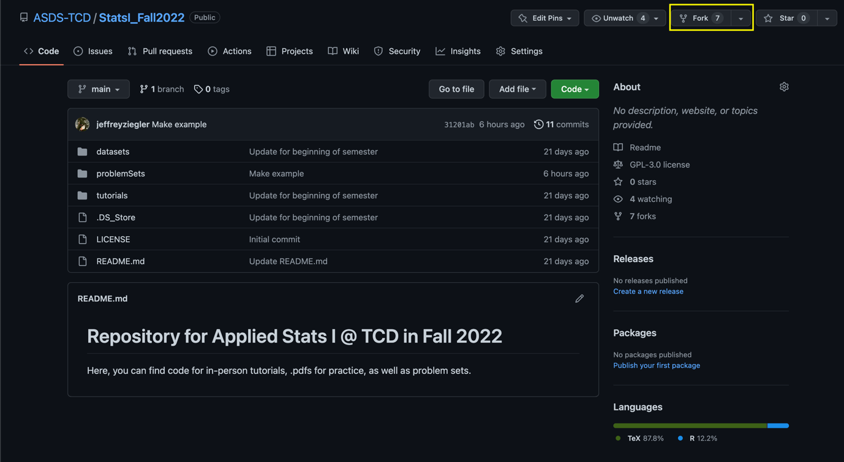
3. Now, you’ll have your own repository that you control online via your own GitHub account that’s linked to mine. Let’s make sure that you can sync the files on your online folder with the files you’ll be working on for your homework (likely on your local drive/computer). To do this, we’ll need to first download GitHub desktop to make it easier. You could do this manually through the command line or Terminal, but trust me, you’ll want to do it this way. You can download the program/app here: <https://desktop.github.com/>.
4. With the desktop version downloaded, let’s now link your online repository with your local repository. You’ll want to do this by click the green ‘Code’ button, and then selecting to open it in GitHub desktop.  
     
   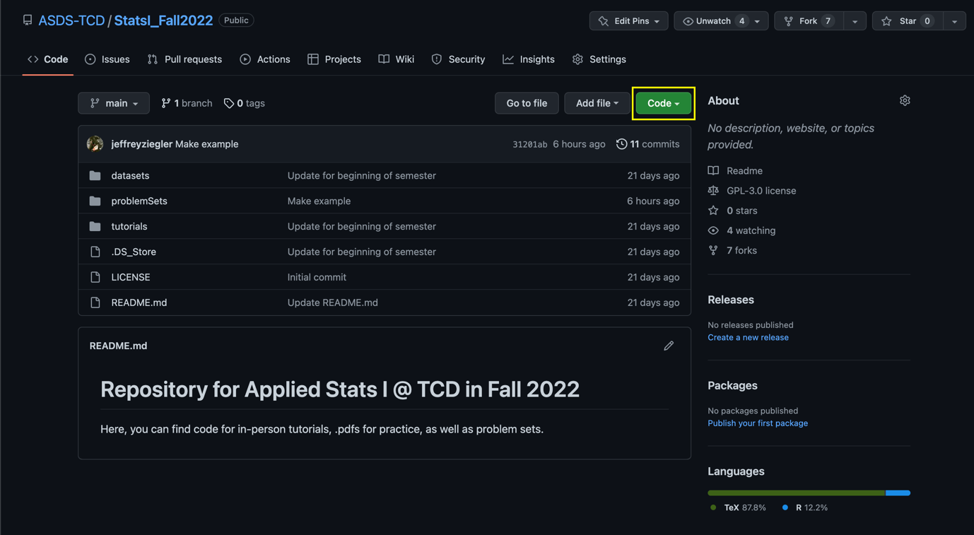
5. You’ll then be transferred over to GitHub desktop. You need to make sure that your folder is placed in “Documents > GitHub > StatsI_Fall2023”, which should be the default. Then click ‘clone’. Note: If you’re asked, you want to only use this for your purposes, you DO NOT want to contribute to the parent directory (i.e. you can’t contribute to my repository, only I can add files to yours, more on that later). Now you have a completely up-to-date version of my files from the parent directory, and a synchronized folder between your local files and your online repository.  
     
   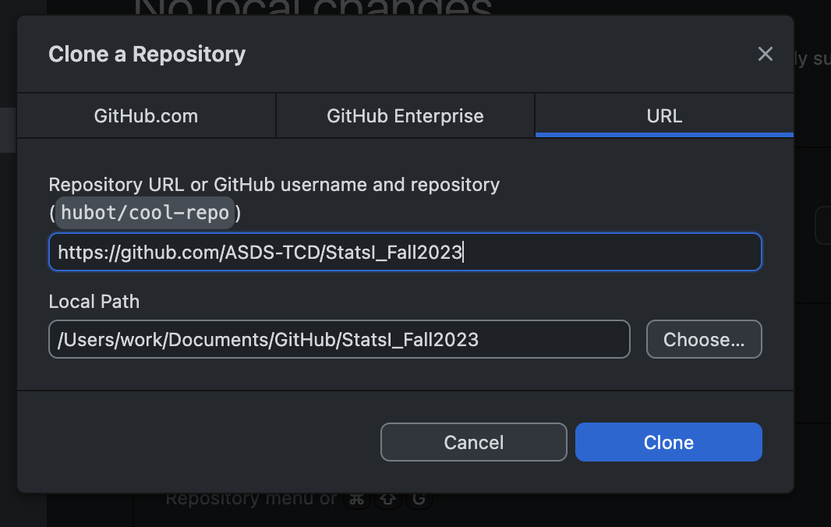
6. Let’s say you finish your homework, and you now want to post your answers to GitHub. Assuming that you’re editing your files in your local GitHub folder, GitHub desktop will automatically recognize changes that you have made to files in the folder. All you need to do is write a summary (which as you can see on the bottom left side is required). Once you write something, anything, to remind yourself of what changes you’ve made (maybe like ‘Post PS01’), then you’ll ‘commit to main’.  
     
   Graphical user interface, text

   Description automatically generated
7. That will put your changes in Git purgatory, so you need to finish by ‘pushing to origin’. This is the final stage in syncing your local files with your online files. To convince yourself everything worked, you can check your online repository in your web browser.  
     
   Graphical user interface, application

   Description automatically generated
8. That’s great, now you’ve handed in your first problem set. You have more to turn in, so how do you get new files? Well, I will first have to add them, but once I have you’ll notice that it says that your online repository is ‘behind’ the main parent directory. This means that I have files that you don’t, so you need to sync (which should be in the same line but doesn’t show up for me obviously). This will only make sure your online repository is up-to-date with my online repository. We then need to use GitHub desktop to sync your online repository with your local files.  
     
   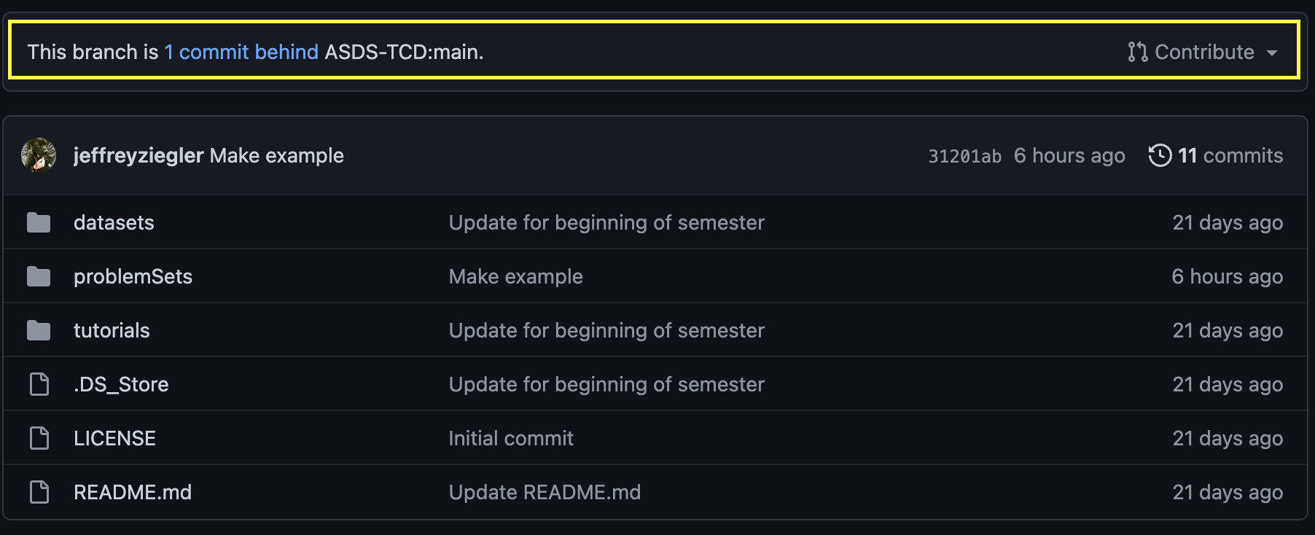
9. Switching over to GitHub desktop, we have to initiate the sync by clicking ‘fetch origin’, which is just Git speak for ‘check to see if there are differences between my local and online files’.

1. Once you ‘fetch’ from origin, it will notice that there are files (in this instance, 4) that are different. You just need to click ‘pull origin’, which will add the missing files from your online repository to your local folder. You can convince yourself that it worked by checking your ‘Documents’ folder where your local GitHub files are located.  
     
   Graphical user interface, application, Teams

   Description automatically generated

Now, you know how to get assignments and turn them in using GitHub! If you’d like more detailed guides, please check out GitHub’s amazing resources: <https://docs.github.com/en/>.