**The distribution of *Musa balbisiana,*** [**Colla**](https://en.wikipedia.org/wiki/Luigi_Aloysius_Colla)**1820and future predictions for 2070**

**Current state**

*Musa balbisiana* is a wild banana species native to the South-East Asia. The first occurrence dates from 1848 on Java (<https://www.gbif.org/species/2762950>). During the first 50 years of the 1900s, *M. balbisiana* has spread across the Canton region in South-east China and has a single occurrence in Northern France, which is either a mistake or the specimen has been brought by a collector. In the last 50 years *M. balbisiana* has spread through South-East Asia extending to New Guinea and India as well as a few occurrences in Hawaii and Central America. In the last sixteen years there have only been eight new occurrences, 3 in South East Asia, one in Germany, and four spread throughout South America. Most of these areas in the world have a few things in common. They are tropical, get a lot of precipitation throughout the year and the temperature is warm throughout the year. The current distribution can be seen in figure 1.

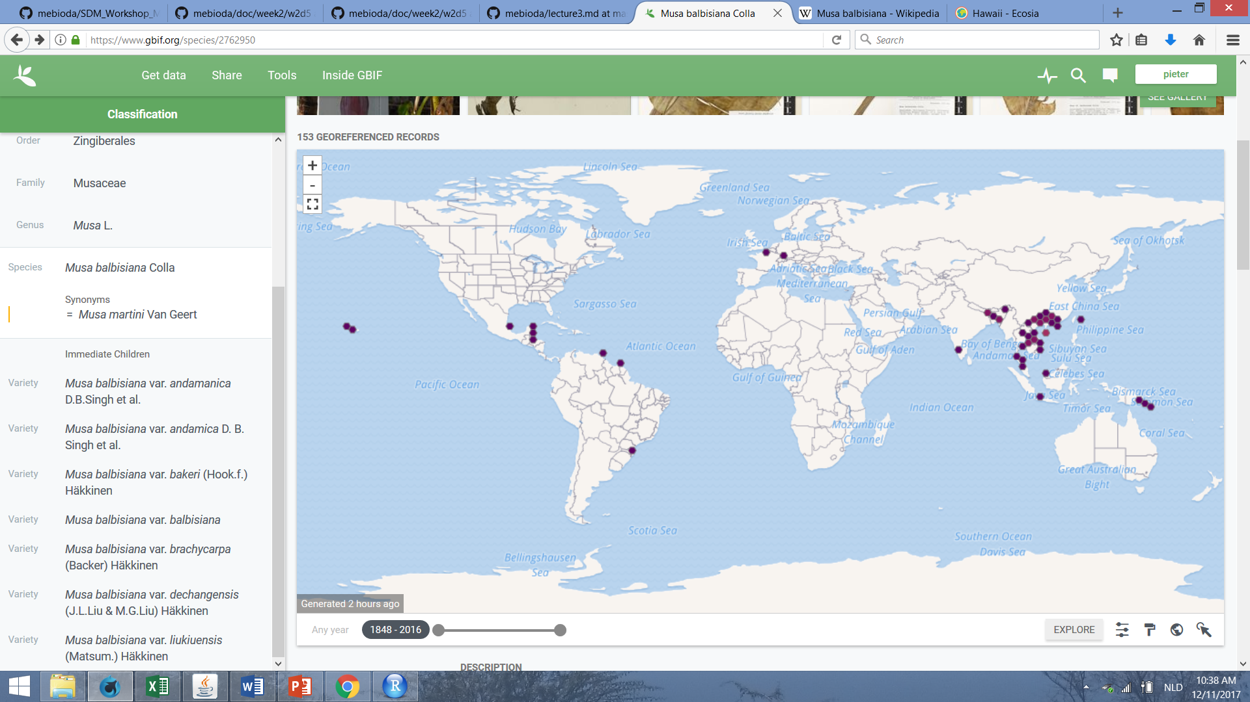

Figure 1. Occurrence of M. balbisiana from 1848-2016 by Gbif.org - each purple dot is a single occurrence.

**Methodology**

**R Variables**

*Annual Mean Temperature* *(AMT)* correlates with a lot of other temperature variables, this could mean that it is an important variable, hence it was decided to leave it in. The only two temperature variables that *AMT* doesn’t correlate with, are *Mean Diurnal Range (Mean of monthly (max temp - min temp))* and *Temperature Annual Range (Max temp of warmest month – Min Temp of Coldest Month*, hence we leave them in.

For Moisture, just two variables are kept in: *Precipitation of Wettest Month* and *Precipitation of Driest Month*, where I would assume that the latter influences the data the most in biological sense. The precipitation in the driest month could be a real threshold as *M. balbisiana* needs moist soil all year around.

Taking these variables out is validated as none of them are correlated (correlation test R.).

**MAXENT variables**

All features are selected: Linear, Quadratic, Product, Threshold and Hinge as we want every kind of variable or proportion to be close to observed values or proportion.

**WorldClim Variables**

For current conditions, bio 5m was taken. For future conditions, rcp4.5 bi (HadGEM2-ES) 2070 was taken.

**Model Output**

**Present & Future Distribution Maps**

The present distribution (Figure 2.) build by the model is a combination of the occurrences of GBIF and the suitable environments provided by WorldClim. The two occurrences in Europe probably caused the program to mark southern Europe orange, as the Mediterranean is warm and moderately wet, but not optimal. However, we have strong feelings that one specimen is kept in a botanical garden because one occurrence on GBIF is located in Paris northern France near though not in a botanical garden. The other is in southern Germany and in both places is the Mediterranean climate not present.

South-East Asia is best suitable, and as these present and future distribution (Figure 3.) are almost not distinguishable, we assume the future conditions don’t change this.

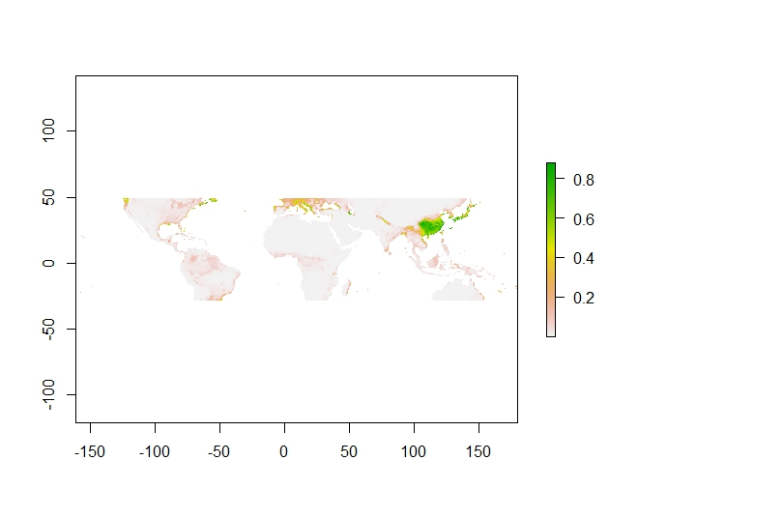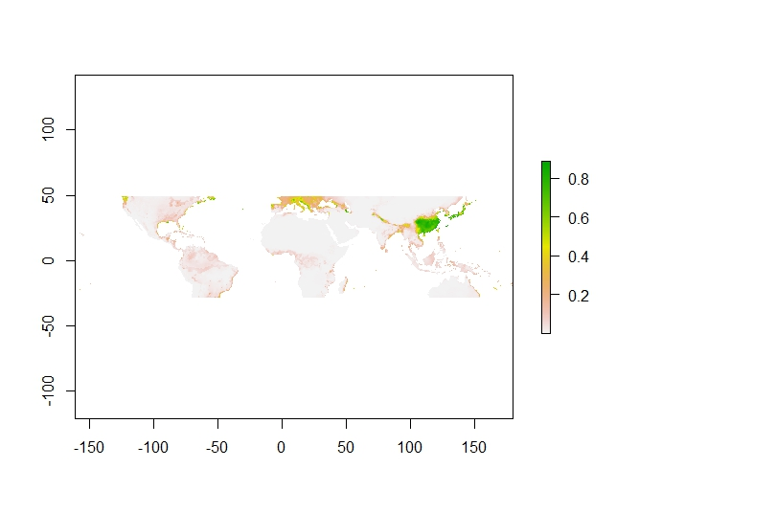

Figure 3. Future distribution of M. balbisiana

Figure 2. Present distribution of M. balbisiana

**Model performance – AUC**

To validate the SDM, we use the Area Under the Curve (AUC) of the Receiver Operator Curve (ROC). Our AUC is not even close to the Random Prediction (AUC = 0.5) (Figure 4.). An AUC of 0.937 means that there are almost none pseudo-absences seen as true absences, which is extremely great. Our SDM can be considered to be extremely reliable.

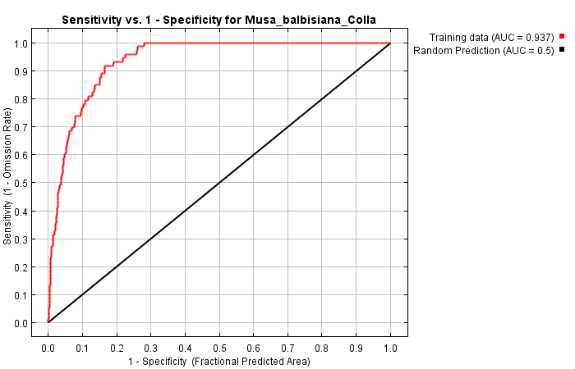

Figure 4. AUC graph for M. balbisiana

**Variable Importance Table**

The variable importance table shows that the Mean Diurnal Range followed by the Precipitation Wettest Month have the most influence on the distribution patterns (Table 1.). The biological interpretation of these results can be supported by the response curves given by MAXENT. In this case Bio2 stands for Mean Diurnal Range. The curve shows that there is a point where the logistic output of *M. balbisiana* drops at a given Mean Diurnal Range, which means it is not suitable for the species to live there (Figure 5.). I would assume that the bigger the Mean Diurnal range, the less suitable environment it is for the Banana species.

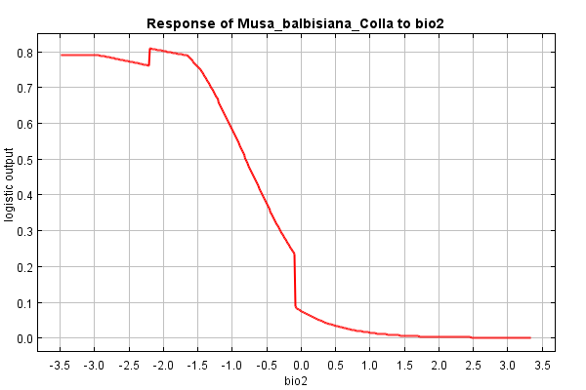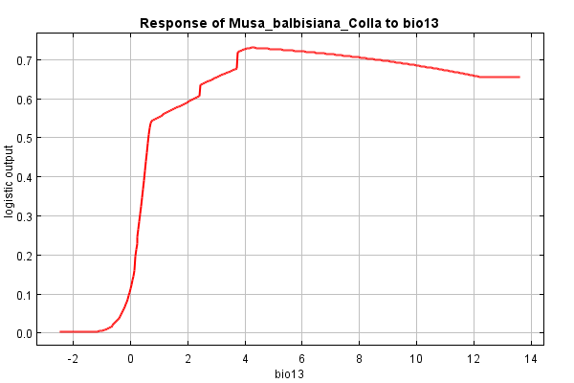

Figure 5. Response of M. balbisiana to Mean Diurnal Range

Figure 6. Response of M. balbisiana to Precipitation Wettest Month

The precipitation of the wettest month follows in percent contribution. The curve shows that more precipitation gives a greater logistic output, and it curves off gradually after meeting the 0.7 point (Figure 6.). The biological interpretation could be that the wettest month is a threshold where the M. balbisiana is influenced a lot if it isn’t wet enough.

The other variables seem to have minor contribution to the MAXENT predictions.

Table 1. Percent contribution of biological variables to MAXENT future predictions on M. balbisiana distribution

|  |  |
| --- | --- |
| **Variable** | **Percent contribution** |
| Mean Diurnal Range | 39.9 |
| Precipitation Wettest Month | 33.1 |
| Temp. Annual Range | 17.2 |
| Precipitation Driest Month | 6.2 |
| Annual mean Temp. | 3.5 |

**Response to future scenario**

The future scenario of 2070 has a minor impact on the distribution of *M. balbisiana* compared to the present scenario (Figure 7.). Areas in Europe are lost but were never suitable as the occurrences were probably not in nature. The South-East part of Asia remains suitable and almost no areas are gained. 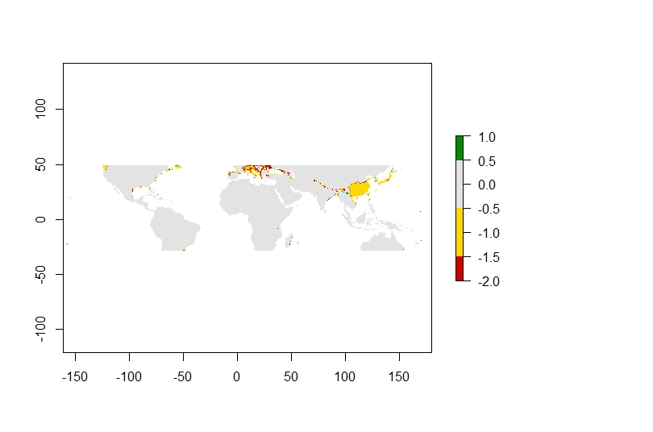

Figure 7. Distribution range of M. balbisiana under scenario RCP 45 for 2070. Grey is never suitable, yellow remains suitable, red is lost and green is gained.

**Biological interpretation**

The worldwide change for scenario RCP 4.5 is: +4.5 W/m2 (radiative forcing) in 2100. The global annual greenhouse gas emission would peak in 2040 and then decline. The temperature increases between 1.4°C and 1.8°C. The global mean sea level would increase with 0.26 to 0.47 m (means of two time periods are taken as 2070 does not fall within a given time period) (<https://en.wikipedia.org/wiki/Representative_Concentration_Pathways>).

The future distribution is not expected to change dramatically under scenario RCP 4.5 for 2070 (Figure 8, 9). The temperature rise and increase of sea level do not have a big influence on the species distribution according to our model. The distribution of *M. balbisiana* will not change according to our model under this threshold, and has probably little meaning for the species. It will remain in South-East Asia. Despite having a few occurrences in Latin America, our model does not predict any further distribution through Latin America as one would give it a bigger chance than Europe.

Figure 9. Distribution area after RCP 4.5 scenario

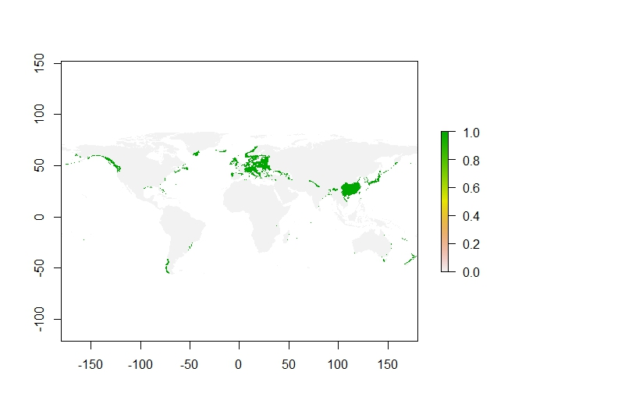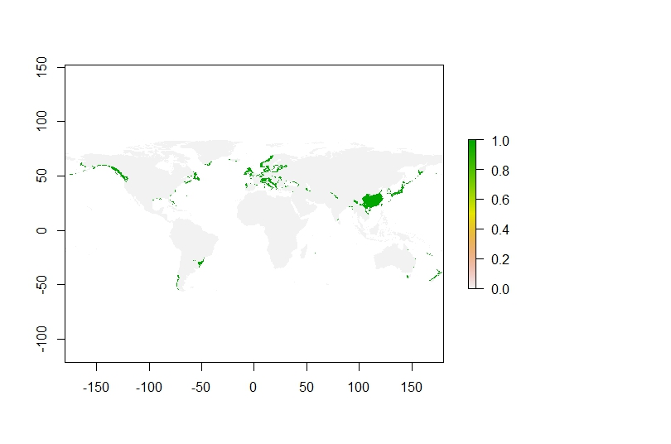

Figure 8. Distribution area before RCP 4.5 scenario

The model is validated and it shows that there is little to worry about when it comes to *M. balbisiana* and climate change. The limitations of this model are that it took into account data which is not reliable. The occurrences in Europe should have been checked and taken out as the specimens probably would not survive there naturally. Also I am certain the database shows not all existing specimens and that the difference between a single occurrence and an area where multiple specimens are located has not been made. It is almost certain that specimens found in Hawaii and Latin America are introduced by humans and it could be possible that distinguishing these data points in two separate groups would influence our model and create different results.

As for this model I think the data could have been better, but the model is reliable.

You want as much coverage between the Training data line and the Random Prediction line. The AUC of 0.932 means that there are almost none pseudo-absences seen as true absences, which is extremely great.