*Oryza sativa* species distribution modelling

## Introduction

*Oryza sativa* is the cultivated rice species known and eaten worldwide, particularly in Asian countries (Fairhurst & Dobermann, 2002). A lot of people rely on cultivated rice as a basic food source. According to GBIF data over 140,086 occurrences with coordinates are available for the crop, with most occurrences in Asia (GBIF *Oryza sativa L*. Occurrences, 2017). Rice can be cultivated in wet and dry fields. It is heavily dependent on water for optimal production. With the climatic changes in the nearby future, grain production has to be ensured for the increasing world population. Due to precipitation changes by climate change, the raining pattern can change and rice yields could be severely impacted, leaving communities without the staple crop (Dou, Soriano, Tabien, & Chen, 2016).   
To give insight in future predictions, species occurrence distributions were made with retrieved GBIF data of *Oryza sativa*.

Figure 1 Occurrence Data Overview Oryza sativa from GBIF

## Methodology

RCP 4.5 HadGEM2-AO (The RCP4.5 is a scenario that emissions will stabilize eventually and not rise)  
Maxent settings: Linear and Quadratic functions   
Variable selection:   
Bio2: Mean diurnal Range (Mean of monthly (max temp – min temp))   
Bio8: Mean temperature of Wettest Quarter   
Bio9: Mean temperature of Driest Quarter   
Bio16: Precipitation of Wettest Quarter   
Bio17: Precipitation of Driest Quarter

These variables from Bioclim were chosen, because there was no correlation between them. Furthermore temperature and precipitation were chosen because rice cannot be cultivated in frosted areas and precipitation is needed to fuel rice growth.

## Model Output

Below two figures are presented showing present and future distribution maps of *Oryza sativa*.

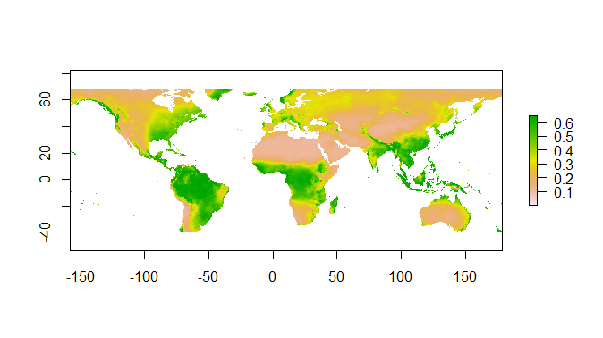

Figure 2 Present Distribution Map Oryza sativa

Figure 2 presents the distribution map showing in which places *Oryza sativa* could occur taken the five variables into account. This distribution differs from GBIF-data occurrences map (figure 1), because figure 2 is a prediction and not the actual distribution.

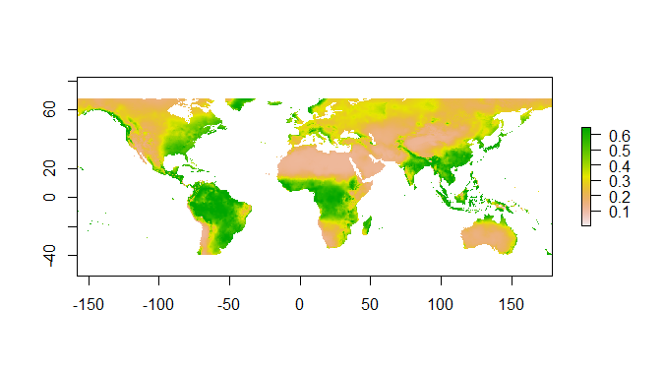

Figure 3 Future Distribution Map Oryza sativa, RCP4.5 2050

Figure 3 shows the predicted future distribution map of *Oryza sativa*.   
When comparing the present and future distribution maps, it can be concluded that the distribution of the species does not change all that much, considering the five variables. *Oryza sativa* can occur slightly more in 2050 taken the RCP4.5 scenario into account. Distribution also shows occurrences in Greenland in both maps, which does not correlate with GBIF-data. This is explained by the fact the prediction is almost only based on the precipitation.

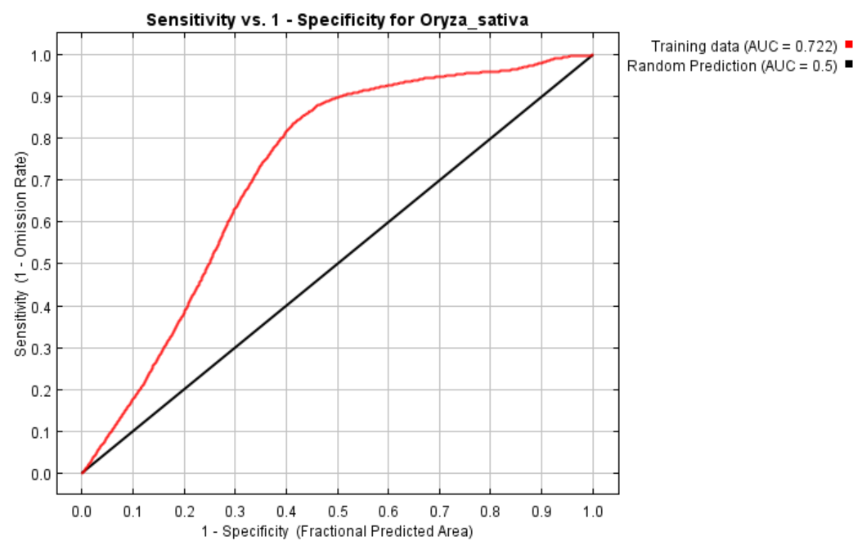

Figure 4 AUC graph Oryza sativa

Figure 4 shows the model performance: The Area Under the Curve (AUC) graph. The AUC has a value of 0.722. A value of 0.7 is seen as fair but not as good as a value higher than 0.8 (Mandrekar, 2010).

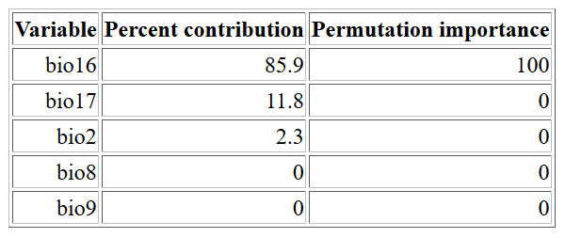Table 1 Variable Importance Table Oryza sativa

In table 1 the variable importance table with the chosen variables for *Oryza sativa* is shown. It can be noted that the main driver of the distribution pattern of 85,9% is bio16, which is precipitation of the wettest quarter. Bio8 and bio9 are not contributing to the model at all. These variables included the mean temperature of the driest and wettest quarter.

## Response to future scenario

## 

Figure 5 Future Distribution Range Change map Oryza sativa, RCP4.5 2050. Habitat change indication; Grey: never suitable habitat, yellow: remains suitable habitat, red: loss of habitat, green: gained habitat

Figure 5 shows the range change of *Oryza sativa* in the future. A lot of habitat range remains the same for the species. There will be more habitat gain in mainland Asia but the islands will have more losses to deal with. There is also expected to be more loss in Europe.

## Biological interpretation

The distribution for the *Oryza sativa* is not expected to change a great deal according to the used model for the maps. This could mean that *Oryza sativa* is not much affected by climate change considering the RCP4.5 in 2050 with the chosen five variables. Other factors are driving the species distribution more.   
  
The model is semi useful, it only shows which change is the biggest driver of the chosen variables (precipitation and temperature) and shows that it will not affect the species distribution that much. It should also be considered that *Oryza sativa* is a cultivated rice species. Humans can mimic areas suitable for rice fields where there are no occurrence of the species prior at all.   
Moreover there are other factors that are not included in this model and severely limit the model. The model does not take soil quality and circumstances of the area in consideration. Factors like land use change are also not taken in consideration. Land could change due to nuclear treats, tsunamis and earthquakes. The decreasing soil quality due to pesticides and lack of stable ecosystems in rice fields, can make it impossible to farm rice. Other anthropogenic factors are also not taken in account, for example change in infrastructure and urbanization reaching farm areas. In conclusion, species distribution modelling should be critically assessed and other factors should be taken into account that are not considered by the model.

## Bibliography

Dou, F., Soriano, J., Tabien, R., & Chen, K. (2016). Soil Texture and Cultivar Effects on Rice (*Oryza sativa, L*. Grain Yield, Yield COmponents and Water Productivity in Three Water Regimes. *PLoS ONE, 11*(3), e0150549. doi:10.1371/journal.pone.0150549

Fairhurst, T., & Dobermann, A. (2002). Rice in the Global Food Supply. *Better Crops International, 16*.

*GBIF Oryza sativa L. Occurrences*. (2017, December 10). Retrieved from GBIF: https://www.gbif.org/occurrence/species?has_coordinate=true&has_geospatial_issue=false&taxon_key=2703459

Mandrekar, J. (2010). Receiver Operating Characteristic Curve in Diagnostic Test Assesment. *Journal of Thoracic Oncology, 5*(9), 1315-1316.