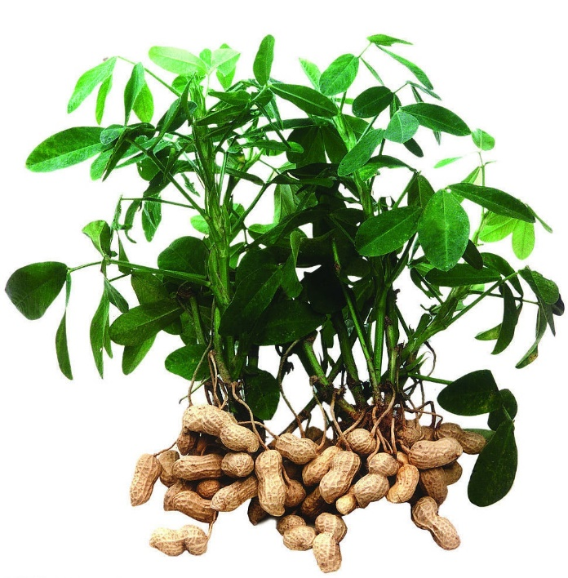

Methods in Biodiversity

Analysis

Species distribution modelling of the peanut(*Arachis hypogaea*)

By Amy Montanje (S1640631)

12-12-2018

**Introduction to the species**

*Arachis hypogaea* commonly known as the peanut or groundnut is an annual herbaceous plant in the Fabaceae (bean or legume) family. Due to their high percentage of oil (50%) and protein content it is largely cultivated on a worldwide scale. The peanut is mostly grown in tropical and warm-temperate regions around the equator as can be seen in figure 1 (peanutbase.org; GBIF.org). China and India are the leaders in groundnut cultivation with 60% of the total production (Nautiyal, 2002). Notable is that this crop has never been found uncultivated in the wild before and is therefore restricted in its range to cultivation areas. In order to cultivate groundnuts properly, reasonably warm weather throughout the year is required. However it has been stated that the current increase of temperature has and will further have a detrimental effect on the cultivation of peanuts (Prasad et al., 2003). Also, peanuts grow best in loose, well-drained soils, so precipitation is very important (Jauron, 1997). It is very important that the groundnut cultivation remains flourishing because of the high demand, especially in developing countries. The goal of this small study was to analyze the influence of abiotic factors in regards to climate change on the habitat suitability range for *Arachis hypogaea* worldwide.

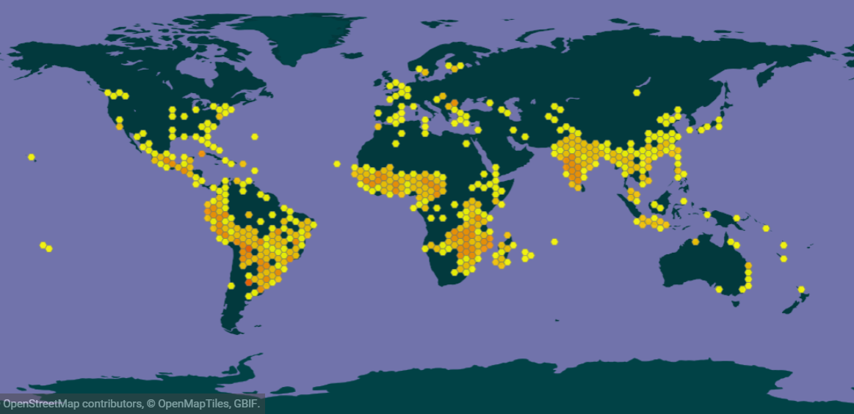**Methodology**In order to produce and analyze Species Distribution Models two software programs were used: MaxEnt (maximum entropy method for species) and R-studio. The distribution data of the species *Arachis hypogaea* was retrieved from GBIF.org. There were 13,455 data points of species with coordinates. The bioclimatic variables were retrieved from worldclim.org. The bio5m, HadGEM2-AO rcp45 scenario was chosen, for the year 2050. This year was chosen in order to have a look at the short term effects of climate change on the distribution of the peanut. Some bioclimatic variables will be correlated with each other. Which is why variables with a correlation higher than 0.7 or lower than -0.7 were deleted from the selection. Correlations were determined with the Spearman’s correlation test in R-studio. The optimal growth conditions of the groundnut were also taken into account during the selection of the variables. Because groundnuts are well cultivated in warmer climates but are harmed due to the further increase in temperature, the focus lay on suitable temperature variables ranging from the minimum temperature to the maximum temperature. Furthermore the precipitation is very important as has been mentioned above. This led to the selection of the following bioclimatic variables: (Bio2) Mean diurnal range, (Bio5) Max Temperature of the Warmest Month, (Bio6) Min Temperature of the Coldest Month, (Bio16) Precipitation of the Wettest Quarter and (Bio17) Precipitation of the Driest Quarter.

Figure 1: Current distribution of Arachis hypogaea (data from GBIF.org 2018)

The Species Distribution Model was created with this selected subset of variables in the program MaxEnt. The output format was set to logistic and the jackknife to measure variable importance was turned off, the maximum number of background points (pseudo-absences) was set to 10,000. In the analysis the auto features is checked on, this means that all the features are combined in the process.

**Model performance and output**

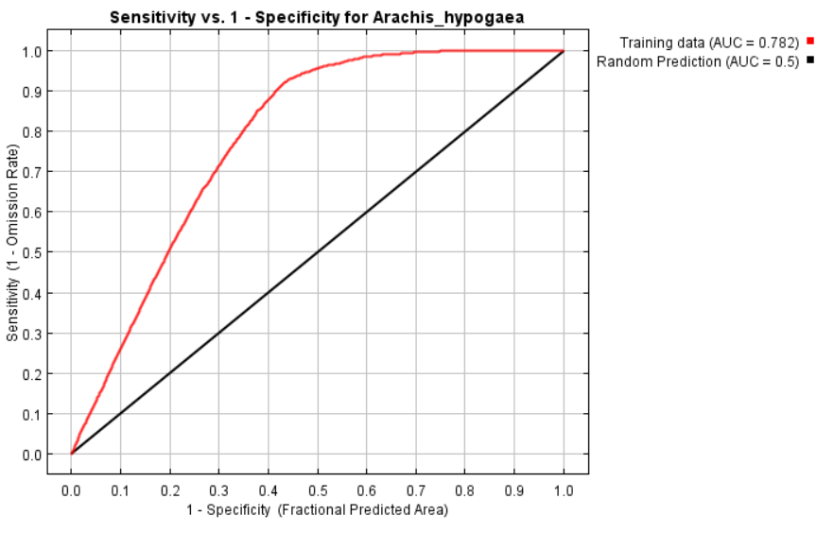The receiver operating characteristic (ROC) curve gives an Area Under the Curve (AUC) value of 0.782 (Figure 2). Overall an AUC value of 0.5 indicates that the model accuracy is not better than random (black line) and a value of 0.7 is considered to be reliable and 0.8 as good. The model can thus be seen as fairly reliable. The logistic threshold for maximum training sensitivity plus specificity of the model is 0.369.

Figure : Receiver Operating Characteristic curve with the AUC value of the model retrieved by the MaxEnt analysis.

The analysis in MaxEnt for the variable contributions resulted in the table below, showing the contribution of each variable to the distribution pattern. In this case it shows that the precipitation of the wettest quarter (52.5) and the minimum temperature of the coldest month (41.9) are the main drivers of the distribution pattern of *Arachis hypogaea* which will be shown on the next page.

Table : Contributions of the variables retrieved with the MaxEnt analysis

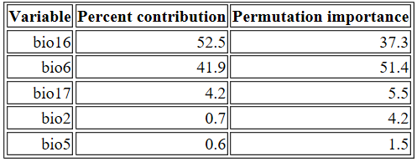

The analyses resulted in different maps of the present and predicted future distribution of suitable habitat for the groundnut (*Arachis hypogaea)* as can be seen in figure 3 and 4. Only minor differences between the present and future distributions can be observed, suggesting that climate change has no large effect on the distribution in the RCP4.5 2050 scenario when using this model. There is a small increase in suitable habitat on the northern border of the present area in Africa. A small decrease is predicted across the world at the edges of the pre-existing areas, which is hardly noticeable.

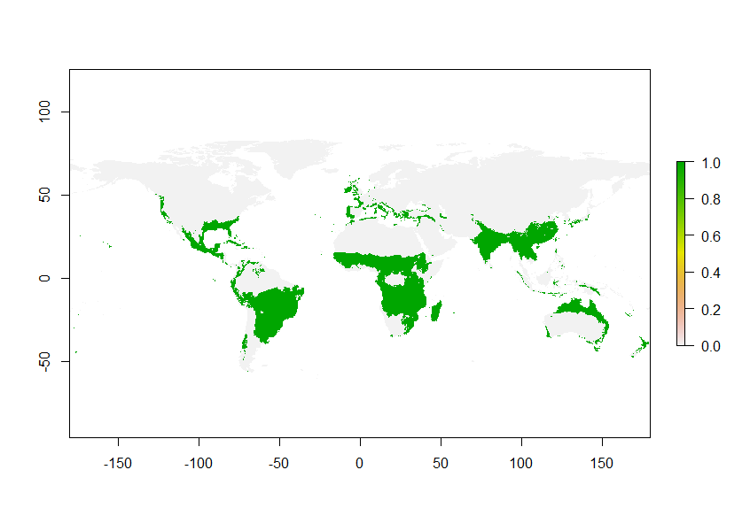

Figure : Present distribution of suitable habitat for Arachis hypogaea

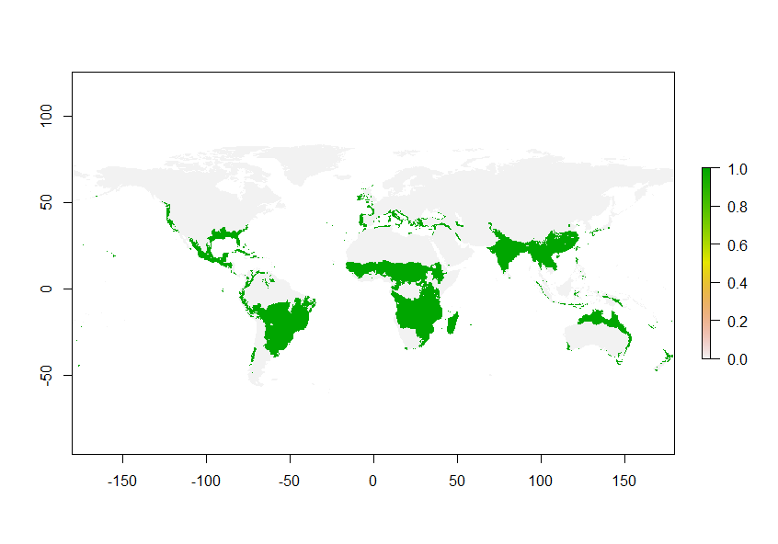

Figure 4: Future predicted distribution of suitable habitat for Arachis hypogaea

**Response to future scenario**

As mentioned above, there are only small differences in the present and future habitat suitability. In figure 5 and figure 6 the differences in habitat suitability for the predicted future discussed above are projected in more detail. As stated before, in this model climate change appears not to have a major effect on the distribution possibilities for the groundnut under the RCP 4.5 2050 scenario.

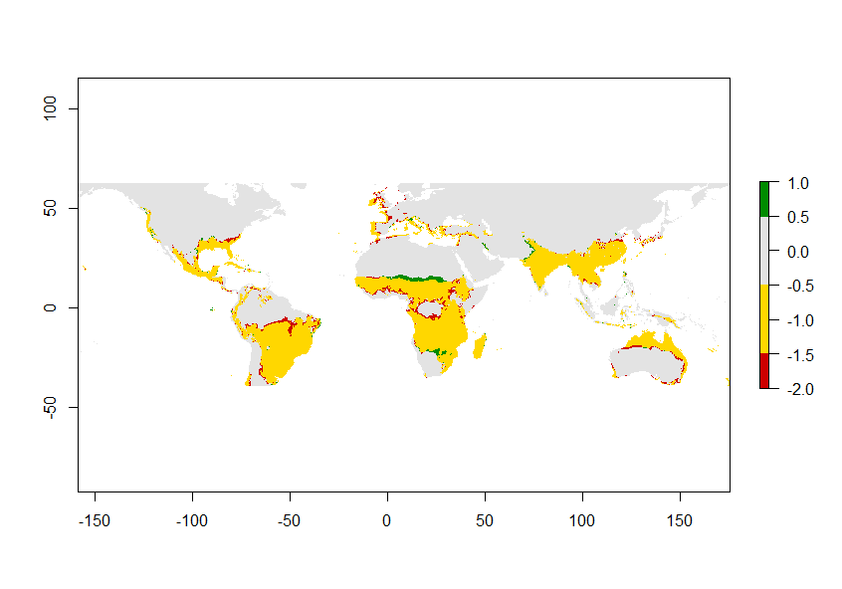

Figure 5: Differences between present and future suitable habitat. Red= no longer suitable, Yellow= remains suitable, grey= never suitable, green= becomes suitable.

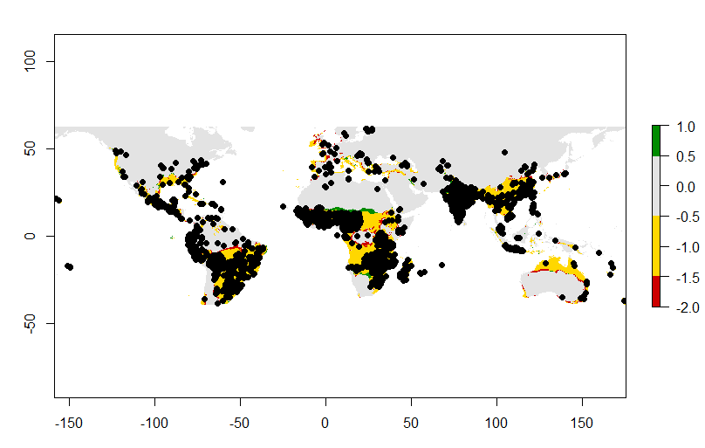

Figure 6: Difference between present and future suitable habitats including the occurrences of Arachis hypogaea

**Biological interpretation and model limitations**

According to the model built in this study almost no change is expected in the distribution of the cultivated peanut. There appears to be no to a little effect of climate change under the RCP4.5 2050 scenario for the peanut. According to this model it is expected that the cultivation of the peanut can continue at approximately the same localities as it does nowadays. Only around the edges of a lot of suitable habitat areas is are small decreases predicted, except for the border of the northern area of Africa and small places in South Africa and India where there is an increase in suitable area predicted. The precipitation of the wettest quarter is the most contributing variable to the distribution of the peanut. Which is somewhat surprising. Because peanuts need well-drained soil, it is noteworthy that surprisingly the precipitation of the driest quarter has little to no effect. Also the minimum temperature of the coldest month had a relative large effect on the predicted distribution, which was to be expected as the groundnut develops the best during warm weather all year around. However, according to previous studies increasing temperatures should have a negative effect on the distribution of peanuts, but the maximum temperature of the warmest month variable had only little (the least) contribution. It might be that a long term exposure to heat is more damaging than the maximum temperature of the warmest month, therefore the variable mean annual temperature is maybe more important.

According to the AUC value the model is pretty reliable. However, the AUC uses presence-only data. The consequence is that the maximum AUC value can’t reach one anymore, while the random prediction still corresponds to the value of 0.5. Therefore the standard thresholds of AUC values indicating SDM accuracy do not apply and the species distribution models retrieved this way should be considered with caution and preferably be tested against a null model. This was not done in this small study.

Only five of the 19 bioclimatic variables were taken into account by making this model due to correlations. If the selection was performed differently and different choices were made during the selection the model could very well be different. It is therefore better to make different models from different perspectives to see how the different variables contribute to the distribution.

Other limitations of this model is that it only takes abiotic factors into account for the prediction of the distribution of the crop. It is well known that the occupation area of a species is a combination of abiotic factors, biotic factors and accessibility. The last two factors are not taken into account which is why the predicted future distribution might differ from reality. For example, biotic interactions can be about pollination mismatches due to for example climate change and/or competition with other species. The accessibility can affect the real future distribution. For example, the peanut doesn’t occur in the wild but only in cultivated settings. The distribution and thus the accessibility to suitable areas are therefore limited and can affect the true distribution.

Besides these limitations of the model, the groundnut is successfully cultivated across the world which indicates that it can grow in quite different environments and that the distribution is dependent on human influences. This might be the reason for the small changes predicted for the future. This model could be quite correct in its prediction when looking from this perspective.

**References**

GBIF.org (05 December 2018) GBIF Occurrence Download <https://doi.org/10.15468/dl.ogw1gw>

<https://peanutbase.org/organism/Arachis/hypogaea> Retrieved on December 10, 2018.

Jauron, R. (1997, February 5). Growing Peanuts in the Home Garden. Retrieved December 10, 2018, from <https://hortnews.extension.iastate.edu/1997/5-2-1997/peanuts.html>

Nautiyal, P. C. (2002, 7 juni). GROUNDNUT Post-harvest Operations. Retrieved on 10 December 2018, from <http://www.fao.org/fileadmin/user_upload/inpho/docs/Post_Harvest_Compendium_-_Groundnut.pdf>

Prasad, P. V., Boote, K. J., Hartwell Allen Jr, L., & Thomas, J. M. (2003). Super‐optimal temperatures are detrimental to peanut (Arachis hypogaea L.) reproductive processes and yield at both ambient and elevated carbon dioxide. *Global Change Biology*, *9*(12), 1775-1787. Retrieved on December 10, 2018.