**METHODS IN BIODIVERSITY ANALYSIS – WEEK 2 Lois van Laere (s1500309)**

**Introduction**

The species *Cucurbita pepo* L. belongs to the genus *Cucurbita*, and the family of the gourds, the Cucurbitaceae. Species of *Cucurbita* can be divided into two groups: annual mesophytic vines, and xerophytic perennial species. Mesophytic species are known to require a continuous amount of water supply or precipitation, whereas xerophytic species are better at tolerating arid conditions. *Cucurbita pepo* is a mesophytic species, with great morphological variation, numerous subspecies and a broad geographical range. It is debated as one of the oldest species to be domesticated, providing us with multiple edible (or decorative) products: among others, zucchini, the famous orange jack-o-lantern pumpkins, ornamental gourds, acorn squash and spaghetti squash.

The oldest known location and origin of *Cucurbita pepo* is found in southern Mexico (8,000-10,000 years ago), after which it believed to have extended north to Texas and Illinois, east to Florida and further south into northern parts of South America. The global occurrence distribution map generated by GBIF (Figure 1) shows the broad geographical range of C. pepo, with a high concentration of observations in Mexico, southern regions of the United States and Europe (mainly consistent of cultivar observations). *C. pepo* is also found in Australia, South America, Africa, New-Zealand and middle and northern Asia (Figure 1).

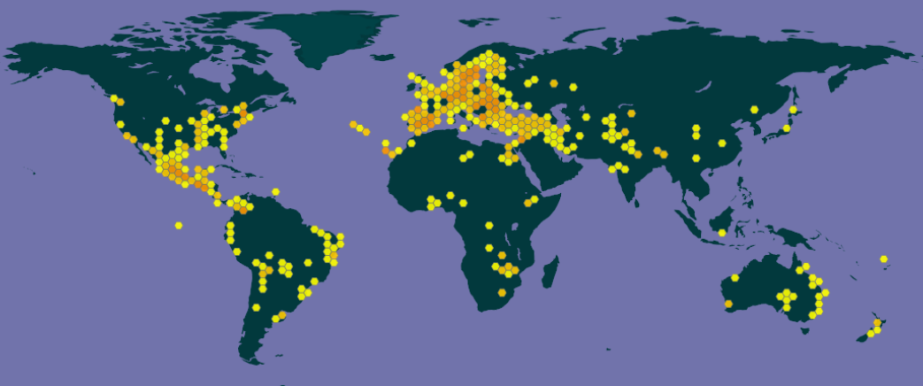

*Figure 1: Current global distribution map of* Cucurbita pepo*, based on georeferenced records on GBIF.*

**Methodology**

Georeferenced species distribution data of *Cucurbita pepo* from GBIF (10.15468/dl.epefok ) was used for species distribution modelling in Maxent and R (and R Studio). The dataset, consisting of 6861 observations, was edited in Microsoft Excel: all columns except species name, longitudinal and latitudinal data were removed. The settings that were used for model building in Maxent are shown in Figure 2.

For assessment of future changes in distribution as a result of changing climatic conditions, global climate layers for current climatic conditions and predicted climatic conditions of 2050 (RCP 4.5, HadGEM2-AO) obtained from WorldClim were used. The following bioclimatic variables from these layers were selected for assessment of change in distribution patterns of *Cucurbita pepo*: Bio10 (Mean Temperature of Warmest Quarter), Bio15 (Precipitation Seasonality), Bio18 (Precipitation of the Warmest Quarter).

Various species of *Cucurbita pepo*, like the pumpkin (*C. pepo* var. *pepo*), the straightneck squash (*C. pepo* var. *recticollis*) and the acorn squash (*C. pepo* var. *turbinata*), perform best in mild to warm weather, and fruit and plant health may be decreased by colder temperatures: mainly below 18 °C, since frost can be especially harmful. Because of this, seeds are planted when the risk of frost has passed and the temperature of the soil is high enough. The distribution patterns of *Cucurbita pepo* are thereby expected to be affected most by a change in temperature in the warmer periods of the year (Bio10: Mean Temperature of the Warmest Quarter).

*Cucurbita pepo* is classified as a mesophytic species, meaning that it requires a relatively continuous amount of precipitation (Bio15: Precipitation Seasonality) and it is not particularly well adapted to either really moist or arid conditions. Since *C. pepo* species are not grown in the colder periods of the year, the precipitation in the warmer months and quarters are of higher relevance (Bio18: Precipitation of the Warmest Quarter).

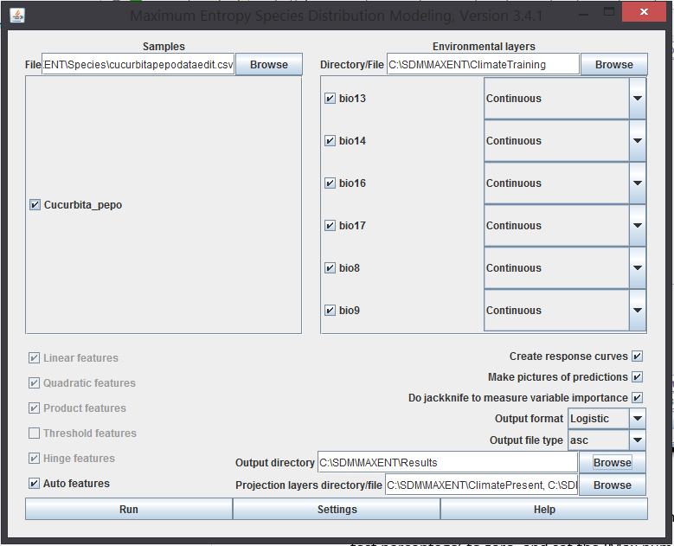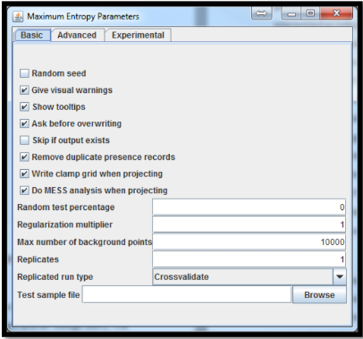

*Figure 2: Settings in Maxent.***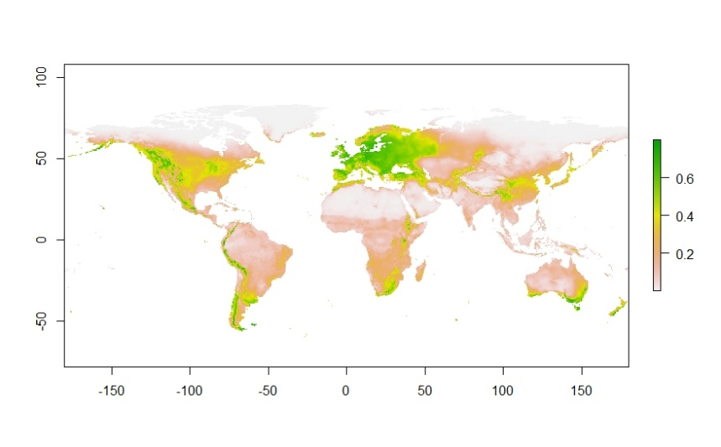**

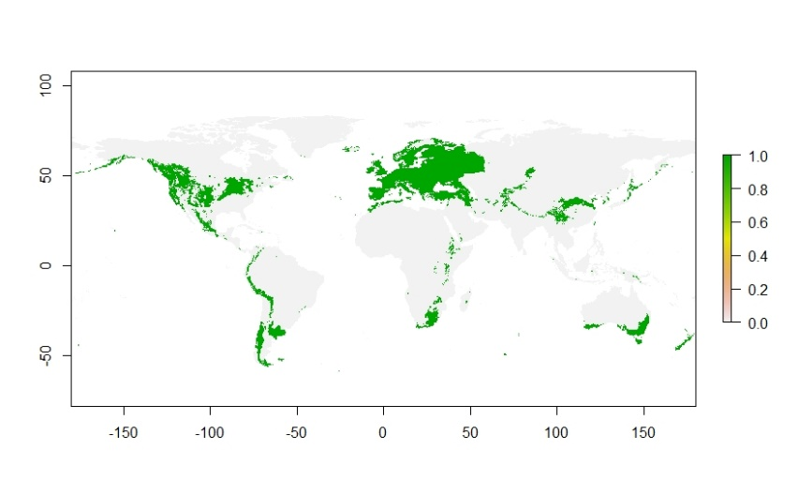

*Figure 3 & 4: Current global distribution map of* Cucurbita pepo *& threshold binary map using Maximum training sensitivity plus specificity threshold of 0.358.*

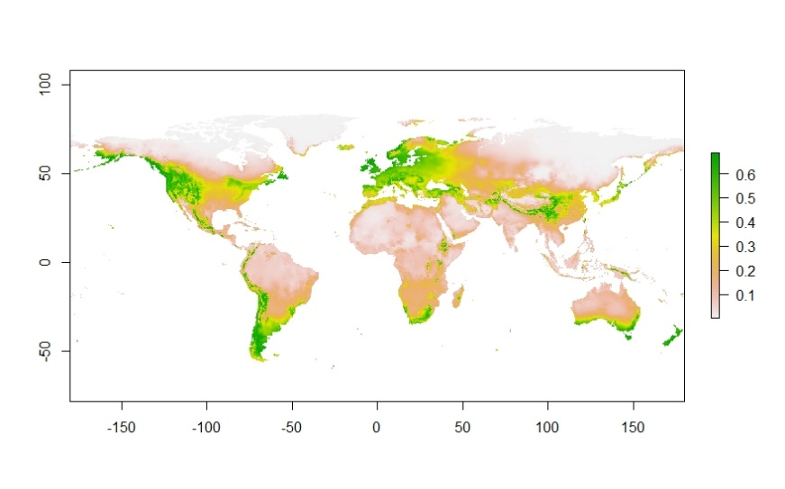

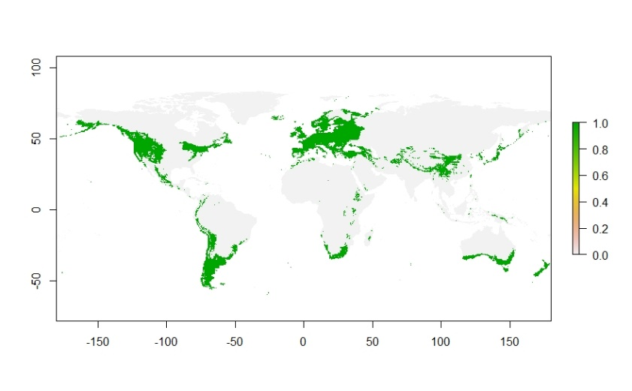

*Figure 5 & 6: Future global distribution map of* Cucurbita pepo *& threshold binary map using Maximum training sensitivity plus specificity threshold of 0.358.*

The species distributions models generated by Maxent were visualized in R Studio (Figure 3&4, Figure 5&6, Figure 7 Figure 9). An ROC (receiver operating characteristic) curve showed an AUC-value of 0.832.

Bio18 (Precipitation of the Warmest Quarter) contributes most to the Maxent model when compared with the other environmental variables used (Bio10 & Bio15), followed by Bio15 and Bio10. Bio15 and Bio10 show similar levels of relative contribution (Table 1).

The environmental condition that showed the highest gain in information when being used in isolation is Bio10 (Mean Temperature of the Warmest Quarter), meaning the variable contains the most information on itself. Bio15 (Precipitation Seasonality) was found to decrease the gain the most when omitted, indicating that is contains the most information that is missing within the other climatic variables (Figure 8).

*Table 1: Estimates of relative contribution of environmental variables to the Maxent model.*

|  |  |  |
| --- | --- | --- |
| **Variable** | **Percent contribution** | **Permutation importance** |
| bio18 | 52.8 | 56 |
| bio15 | 24 | 39.9 |
| bio10 | 23.2 | 4.1 |

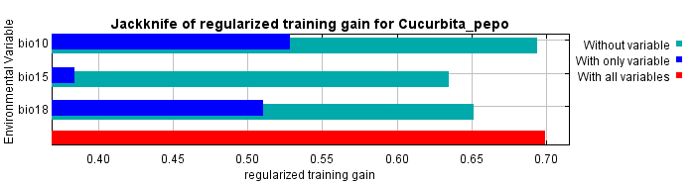

*Figure 8: Results of the Jackknife test of variable importance*

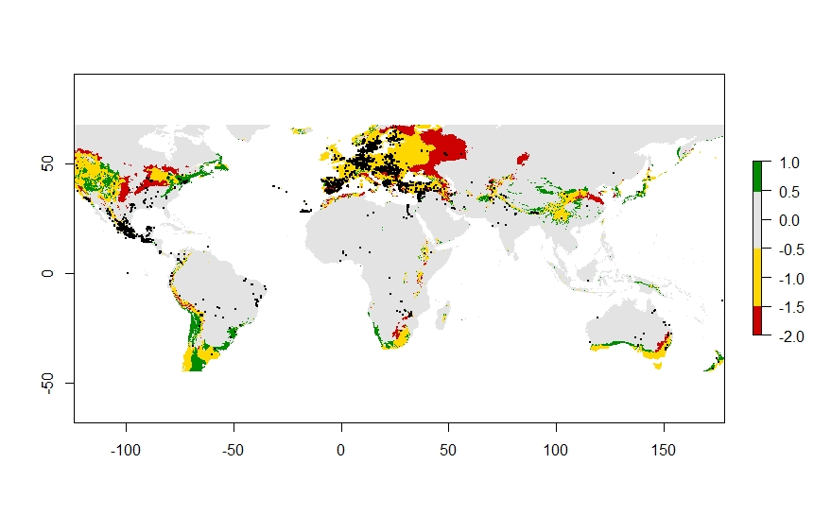**Biological interpretation**

*Figure 9: Predicted change in occurrence of* Cucurbita pepo *based on predicted change in climatic variables.*

Our composed future species distribution model shows the main threat of climatic change is focused on cultivars (in Europe). The native area (Mexico) is not negatively impacted in response to climatic change for variables representative for *Cucurbita pepo*. This is probably due to the fact that most *C. pepo* varieties thrive in mild to warm weather, so a predicted increase in temperature would probably not negatively affect the species much.

In regard to the reliability and usefulness of the model, it should be noted that subspecies are not taken into account. Different cultivars or breeds of *Cucurbita pepo* could have very different ranges of adaptation capability to different environmental conditions. The morphological differences can be so great, the various cultivars and subspecies of *C. pepo* have been misidentified often in the past. It also should be mentioned that whether most varieties thrive under mesophytic conditions, subspecies of *C. pepo* are found in both arid and moist regions. Because of this, direct effect of a change in precipitation seasonality, for example, will not have an equal effect on all *Cucurbita pepo* varieties, providing us with an unreliable model. The same problem is applicable for the effect of a temperature increase on *C. pepo* distribution: some cultivars and varieties do better in warm weather, whereas others perform best in mild temperatures. It is hard to pinpoint the exact response of *C. pepo* to climatic change, when the numerous differences in response between all subspecies are not taken into account.

Because of the large genetic and ecological variation within *Cucurbita pepo*, and the predicted changes in relevant climatic conditions being largely in favor of *C. pepo* requirements, the species is not expected to be heavily affected or threatened by climatic change.