**Modelling the global distribution of *Zea mays* for 2050 with species distribution modelling**

***Name: Surendra Balraadjsing (1559362)***

# **Introduction**

Since the advent of agriculture about 10.000 years ago, cereal grains have been cultivated by humans and have played an important role in human nutrition ever since (FAO, 2016). Cereal grains (maize, rice, wheats, barley etc.) are the most produced and most valuable crops worldwide, making up about 60% of the total world crop production in 2016 (FAOSTAT, 2018). In addition to being used for human consumption, cereals also serve as an important food source for livestock and is furthermore used in the production of biofuels. However, with the growing human population and increases in livestock and biofuel productions, the food demand is expected to increase as well (FAO, 2018b). It is expected that the world annual demand for cereals will reach 3.3 billion tons by 2050, about 800 million tons more than what is being produced currently (FAO, 2016).

Among the cereals, maize (*Z. mays* L. *mays*) was the most produced (1.06 billion ton) in 2016 alone, the second highest cultivated crop that year (FAOSTAT, 2018). Maize belongs to the grass family, Gramineae, which consists of four species within its genus *Zea*: *Z. luxurians*, *Z. perennis*, *Z. diploperennis* and *Z. mays* (Li et al., 2018). *Zea mays* is furthermore comprised of four subspecies (*Z. mays* L. *mays*, *Z. mays* L. *mexicana*, *Z. mays* L. *parviglumis*, *Z. mays* L. *huehuetenangensis*) with *Z. mays* L. *mays* being the well-known cultivated species that was domesticated about 9000 years ago from the wild grass, *Z. mays* L. *parviglumis* in Mexico (Li et al., 2018; Mammadov et al., 2018).

With the demand for cereals, including maize, expected to increase in the near-future, achieving higher yields will become a difficult task (FAO, 2016). One of those difficulties will be due to climate change which is predicted to have a negative effect on both agricultural outputs and productivity (Dwivedi et al., 2018). As a result of climate change, the rising temperatures and precipitation trends observed since the 1980s have lowered maize yields by 3.8% globally compared to what it would have been under a stable climate (FAO, 2016). This number is expected to increase further by 2050 as a result of climate change, threatening food safety (FAO, 2016).

To find out more about how the effects of climate change will affect the distribution of *Z. mays* worldwide by 2050, a species distribution model for *Z. mays* was created to look at its range change in a future situation.

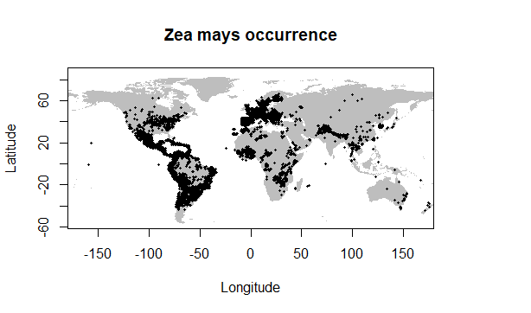

**Figure 1. The global distribution of *Z. mays* from the GBIF data.**

# **Methodology**

The methodology used for generating the species distribution model and the settings used in Maxent is as described in “Exercise: Model your chosen species’ habitat suitability under present and future climate conditions”.

Data used for modeling included *Z. mays*’ occurrence data with coordinates and global climate data with bioclimatic variables (GBIF, 2018; WorldClim - Global Climate data, 2018). In the occurrence data, coordinates occurring at latitude of -90° were regarded as incorrect data and were subsequently removed. For the future global climate data, data generated by the HadGEM2-AO climate model was chosen along with the RCP 4.5 climate scenario for the year 2050. RCP 4.5 is a climate scenario that predicts radiative forcing to stabilize at 4.5 W/m² in 2100 and assumes the imposition of emission mitigation policies (Thomson et al., 2011). The HadGEM2-AO climate model consists of several troposphere, land surface, hydrology, aerosols, ocean and sea-ice processes that are used in simulating a future climate (Baek et al., 2013).

Several variables were excluded from the distribution model due to high correlations (correlations > 0.7) with each other, implying redundant information. Of the 19 bioclimatic variables only four were included in the species distribution model: Bio 1 (annual mean temperature), Bio 2 (mean diurnal range), Bio 12 (annual precipitation) and Bio 15 (precipitation seasonality). *Z. mays* is grown in climates ranging from tropic to temperate requiring daily temperatures between 15 and 45°C (FAO, 2018a). While *Z. mays* is able to tolerate hot and dry conditions as long as there is sufficient water available, it is also susceptible to waterlogged soils (FAO, 2018a). These make the chosen bioclimatic variables important factors in determining their global distribution.

# **Model output**



**Figure 2. The global distribution of *Z. mays* under the current climate data. Green areas indicate the suitable habitats for *Z. mays* and grey areas represent unsuitable habitats.**



**Figure 3. The global distribution of *Z. mays* under the predicted 2050 climate data. Green areas indicate the suitable habitats for *Z. mays* and grey areas represent unsuitable habitats.**

The ROC plot exhibits an AUC of 0.627 which is just above the threshold of 0.5 and implies that the quality of the model is fairly acceptable although not reliable (Appendix A). However, this value should be taken with some caution as a drawback of using AUC values is that when using presence-only data, the maximum achievable AUC is 1-a/2 instead of 1. Furthermore, the model resulted in a logistic threshold of 0.442 for maximum training sensitivity plus specificity (Appendix A). This threshold was used in determining the *Z. mays* occurrence globally (Fig. 2 & 3).

Table 1 shows the importance of the bioclimatic variables that were used with bio 1 (annual mean temperature) and bio 12 (annual precipitation) acting as the strongest drivers for the distribution patterns that are observed.

**Table 1. The contributions of the four climatic variables used in the species distribution model**

|  |  |  |
| --- | --- | --- |
| **Variable** | **Percent contribution** | **Permutation importance** |
| Bio 1 | 73.2 | 60.4 |
| Bio 2 | 1.1 | 3.1 |
| Bio 12 | 25.2 | 34.6 |
| Bio 15 | 0.5 | 1.9 |
|  |  |  |

# **Response to future scenario**



**Figure 4. The change in *Z. mays*’ global distribution when comparing both the current and 2050 distribution scenarios. Red areas indicate a loss of suitable habitat, yellow areas indicated no change between both scenarios (habitats remain suitable) and green areas indicate a gain in suitable habitat.**

# **Biological interpretation**

Currently, *Z. mays* occurs on all continents with the exception of Antarctica with vast densities seen in Europe, Middle-America and South-America (Fig. 1). The species distribution model predicts some loss in suitable habitat mainly around the 20° and -20° latitudinal range which includes Africa, South-America, Southern Asia, Southern Europe and Australia (Fig. 3 & 4). In contrast, the model also predicts some gain in suitable habitat in the Northern hemisphere mainly towards East-Europe and in North-America (Fig. 3 & 4). Furthermore, some suitable habitats also pop up scattered around South America and Asia. The current existing suitable habitats are predicted to remain suitable by 2050 under the RCP 4.5 climate scenario.

These results imply that *Z. mays* being cultivated currently will be able to tolerate the effects of climate change under a 4.5 RCP scenario for the most part. Most of the climate change effects that will affect *Z. mays* negatively is expected to happen around the 20° and -20° latitudinal range.

It should be noted that this model gives an indication of what may happen under the specific conditions that were included in the model. The chosen 2050 climate data based on certain a certain climate model that takes into account a limited amount of climatic processes. Other climatic models using other processes are likely to give different outcomes. Furthermore, the 2050 climate data was also based on an RCP 4.5 climate scenario, with other RCP climate scenarios also likely to give different species distribution outcomes. Moreover, the bioclimatic variables are only based on temperature and precipitation but other abiotic factors are not taken into account which may be equally important to the distribution of *Z. mays*. Lastly, while abiotic factors are likely to play a big role in species’ distribution, biotic factors are not taken into account in this model. More factors should be included in a future model to increase the accuracy and quality of the model.

# **References**

Baek, H. J., Lee, J., Lee, H. S., Hyun, Y. K., Cho, C., Kwon, W. T., … Byun, Y. H. (2013). Climate change in the 21st century simulated by HadGEM2-AO under representative concentration pathways. *Asia-Pacific Journal of Atmospheric Sciences*, *49*(5), 603–618. https://doi.org/10.1007/s13143-013-0053-7

Dwivedi, S. L., Siddique, K. H. M., Farooq, M., Thornton, P. K., & Ortiz, R. (2018). Using Biotechnology-Led Approaches to Uplift Cereal and Food Legume Yields in Dryland Environments. *Frontiers in Plant Science*, *9*, 1249. https://doi.org/10.3389/fpls.2018.01249

FAO. (2016). *Save and Grow in practice Maize-Rice-Wheat: A guide to sustainable cereal production*. Rome. Retrieved from http://www.fao.org/3/a-i4009e.pdf

FAO. (2018a). Maize Crop Description and Climate. Retrieved December 9, 2018, from http://www.fao.org/land-water/databases-and-software/crop-information/maize/en/

FAO. (2018b). *World Food and Agriculture Statistical Pocketbook 2018*. Rome. Retrieved from http://www.fao.org/3/CA1796EN/ca1796en.pdf

FAOSTAT. (2018). FAO statistical database. Retrieved December 9, 2018, from http://www.fao.org/faostat/

GBIF. (2018). GBIF Occurrence data. https://doi.org/https://doi.org/10.15468/dl.qko5um

Li, X., Han, Y., Yan, Y., Messing, J., & Xu, J. H. (2018). Genetic diversity and evolution of reduced sulfur storage during domestication of maize. *Plant Journal*, *94*(6), 943–955. https://doi.org/10.1111/tpj.13907

Mammadov, J., Buyyarapu, R., Guttikonda, S. K., Parliament, K., Abdurakhmonov, I. Y., & Kumpatla, S. P. (2018). Wild Relatives of Maize, Rice, Cotton, and Soybean: Treasure Troves for Tolerance to Biotic and Abiotic Stresses. *Frontiers in Plant Science*, *9*(June). https://doi.org/10.3389/fpls.2018.00886

Thomson, A. M., Calvin, K. V., Smith, S. J., Kyle, G. P., Volke, A., Patel, P., … Edmonds, J. A. (2011). RCP4.5: A pathway for stabilization of radiative forcing by 2100. *Climatic Change*, *109*(1), 77–94. https://doi.org/10.1007/s10584-011-0151-4

WorldClim - Global Climate data. (2018). WorldClim version 1.4. Retrieved December 7, 2018, from http://worldclim.org/version1

# **Appendix A: Maxent model outputs**

The graph below shows the ROC curve for the data with its AUC value

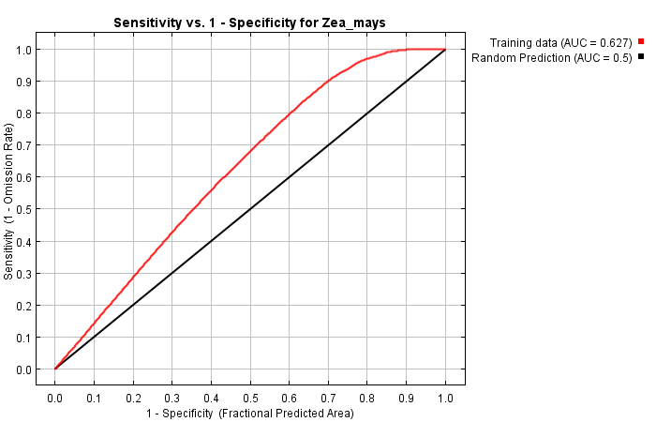

The table below shows some common logistic threshold and corresponding omission rates

|  |  |  |  |  |
| --- | --- | --- | --- | --- |
| **Cumulative threshold** | **Logistic threshold** | **Description** | **Fractional predicted area** | **Training omission rate** |
| 1.000 | 0.194 | Fixed cumulative value 1 | 0.879 | 0.005 |
| 5.000 | 0.332 | Fixed cumulative value 5 | 0.784 | 0.038 |
| 10.000 | 0.418 | Fixed cumulative value 10 | 0.715 | 0.088 |
| 0.003 | 0.003 | Minimum training presence | 0.988 | 0.000 |
| 11.228 | 0.428 | 10 percentile training presence | 0.700 | 0.100 |
| 41.332 | 0.516 | Equal training sensitivity and specificity | 0.418 | 0.418 |
| 13.386 | 0.442 | Maximum training sensitivity plus specificity | 0.676 | 0.123 |
| 0.698 | 0.158 | Balance training omission, predicted area and threshold value | 0.891 | 0.004 |
| 1.542 | 0.221 | Equate entropy of thresholded and original distributions | 0.861 | 0.009 |

The graph below shows the marginal response curves which show how each environmental variable affects the Maxent prediction

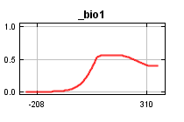 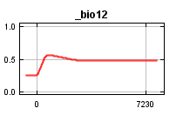 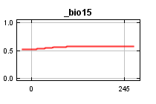 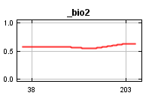

The response curves below represent a different Maxent model created using only the corresponding variable

