**SDM report** Ramón van Doorn

S1712675

Introduction

*Musa acuminata*, or the banana, has been cultivated for a long time. Somewhere between 5000 and 8000 BCE farmers in Southeast Asia already started domesticating the banana1. Around 1000 BCE, cultivation also started in Africa2. In the Middle East it was likely introduced in the 9th century. Even in Europe records can be found of banana cultivation. When Portugal and Spain colonised the Americas, they brought their bananas with them. Here they were cultivated in the Caribbean, Central America and Brazil3. Today cultivars of *Musa acuminata* can be found all over the world, but they are mostly found in tropical countries4. From these countries, an estimated $12.4 billion on bananas was exported in 20175. This makes it one of the most important export products in the world. It is therefore important to map the effects of climate change on the distribution of *M. acuminata*. 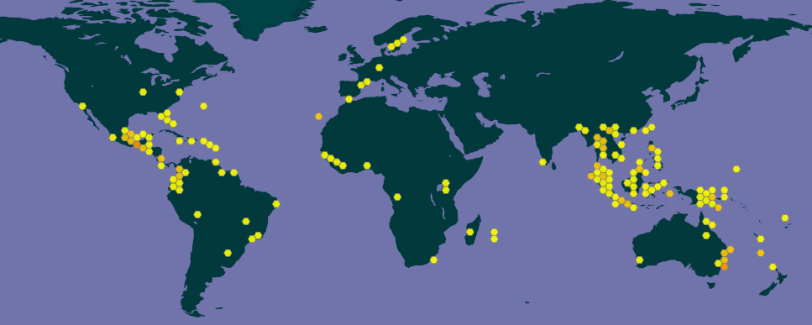

Methodology

To test the future distribution of *M. acuminata* Maxent was used with the following settings.

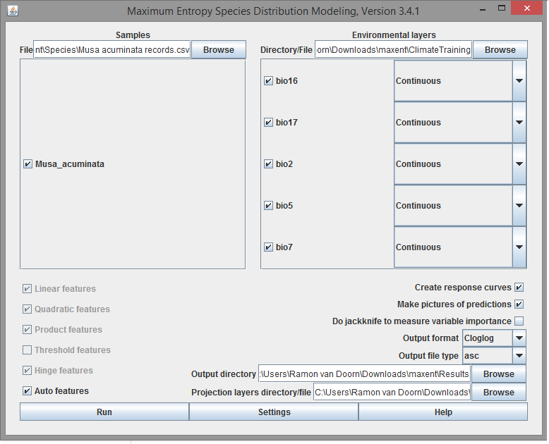

The variables on the right side of the program were chosen by first removing the variables with the most correlation. Bio1, bio3 and bio11 were removed first. From the second subset variables bio4, bio6, bio10, bio12 and bio14 were removed. This was done three more times, and in the last subset the only correlation was between bio16 and bio18, and between bio17 and bio19. This meant that a choice had to be made between precipitation in the wettest quarter and precipitation in the warmest quarter. As extreme values are most likely to be important in the survival of species in certain locations, the precipitation in the wettest quarter was chosen. The same reasoning was used to choose precipitation in the driest quarter over the precipitation in the coldest quarter. The other three variables (mean diurnal range, max temperature of warmest month and the temperature annual range) were chosen as they were not correlated with any other variables. And as bananas mostly grow in tropical countries, it is logical to assume that the temperature range and the maximum temperature are very important.

Model output

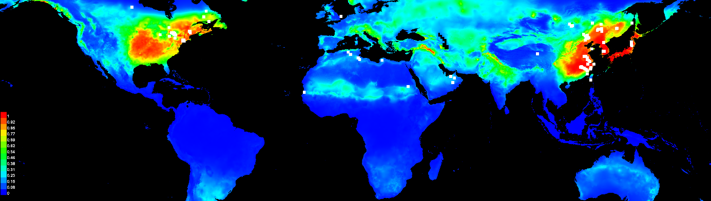

Present distribution model. There are some differences with the species distribution map, like the lack of red in Southeast Asia and the Caribbean. The red regions in this map are more to the north.

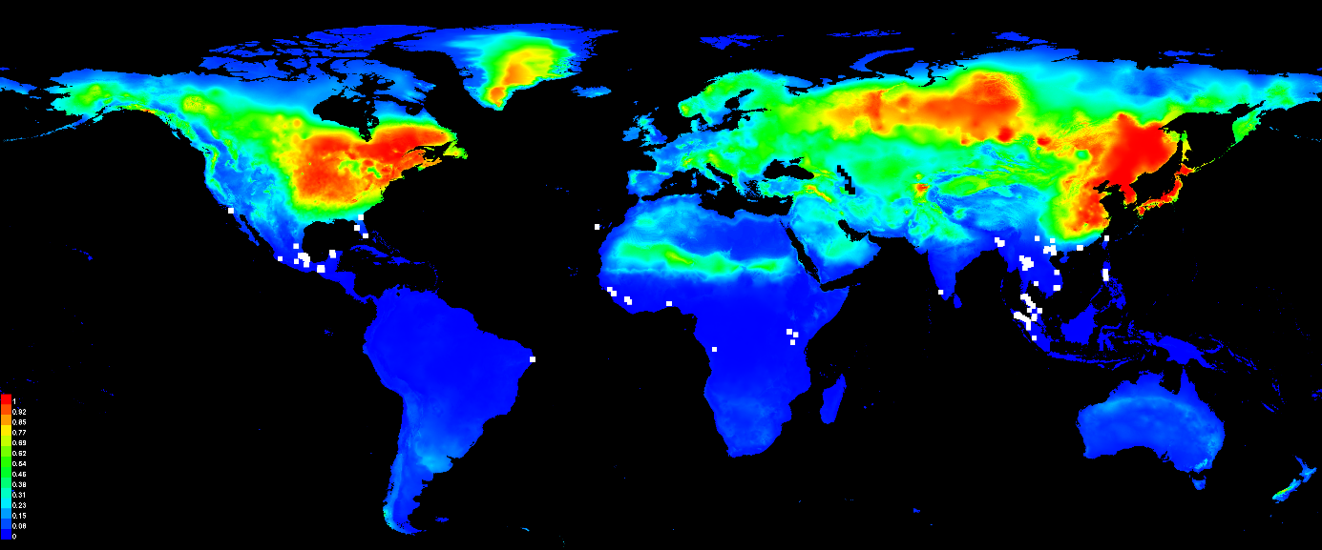

Future distribution model. In the future, *M. acuminata* occurrences will increase. The distribution compared to the present is even more concentrated in the north, even in Greenland.

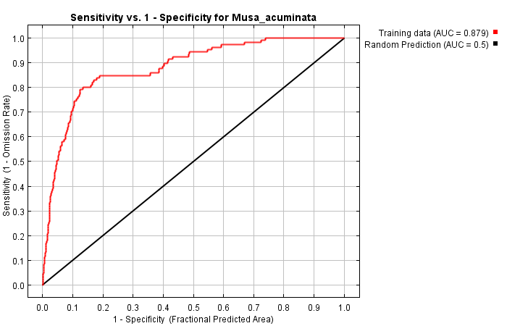

Model performance. The AUC value is 0.879, which means that the model performs well.

|  |  |  |
| --- | --- | --- |
| **Variable** | **Percent contribution** | **Permutation importance** |
| bio2 | 49.4 | 51.2 |
| bio7 | 17.2 | 20.5 |
| bio17 | 15.8 | 15.1 |
| bio5 | 15.6 | 12 |
| bio16 | 2 | 1.3 |

Variance importance table. The most important variable is mean diurnal range. This can also be seen on the distribution map, as the red regions have a small diurnal range. There is a big difference between the most important variable and the second most important variable, annual temperature range. Only precipitation in the wettest month has a small importance.

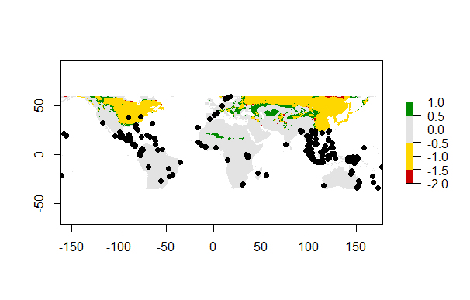

Future change. As seen on the plot, the largest area will face negative change. Although it seems like the occurrence points will face no change. Parts of the Middle East, the Sahara and North America will change positively.

Biological interpretation

If the models are to be believed, the species will not be threatened in the near future. There might however be a shift to the north. This might cause big repercussions, but not really for the bananas themselves. The real winners can be the countries that decide to invest in this important economic resource. It might however be a very big problem in tropical countries that rely on banana export for their economies. As bananas are an enormously important food source, the real problems may be economic instead of ecological. However, questions may arise as to whether the model is accurate enough. The actual occurrences are not properly represented in the present distribution plot, which is strange. It seems that the chosen variables do not favour the tropic regions, even though the bananas can be found mostly in those regions. For the future distribution, even with climate change it is unlikely for the distribution of bananas to change from countries around the equator to countries like Greenland and the Scandinavian countries. Also finding tropical plants in Siberia might seem unrealistic. A reason for this inaccuracy could be missing data on minimum temperatures in the model. For the variables chosen now in this model, the northern hemisphere may seem like the ideal distribution. This could change with minimum temperature variables added to future models.

References

1. [doi](https://en.wikipedia.org/wiki/Digital_object_identifier):[10.1126/science.1085255](https://doi.org/10.1126%2Fscience.1085255)
2. [doi](https://en.wikipedia.org/wiki/Digital_object_identifier):[10.1006/jasc.1999.0447](https://doi.org/10.1006%2Fjasc.1999.0447)
3. <https://www.webcitation.org/6C3gSxUtN?url=http://www.botgard.ucla.edu/html/botanytextbooks/economicbotany/Musa/index.html>
4. <https://doi.org/10.15468/dl.5vbbc7>
5. <http://www.worldstopexports.com/bananas-exports-country/>