*Name: Kyriakopoulou Niki*

*Student number: 2315653*

**Construction of a species distribution model (SDM) for *Olea europaea* subsp. *europaea* L.. Habitat suitability in the present and the future.**

**Introduction**

*Olea europaea* subsp. *europaea* L. (commonly known as olive tree) belongs to the family Oleaceae, that consists of approximately 25 genera and 688 species distributed in many temperate and tropical regions around the world. The subspecies comprises of the cultivated olive tree (*O. europaea* L*.* subsp. *europaea* var. *europaea*) and the wild Mediterranean olive tree (*O. europaea* subsp. *europaea* var. *sylvestris* (Mill.) Leh. *O. europaea* subsp. *europaea* is native in some parts of Africa, temperate Asia and Europe, with the cultivated olive having been the most representative tree of the Mediterranean basin for thousands of years (Besnard et al., 2018). The subspecies has also been introduced in several countries outside of its natural range and has become invasive in Australia, New Zealand and Hawaii, USA (**Fig. 1**). Hundreds of olive tree varieties are cultivated to produce high-quality olive oil and table olives as well as wood and cattle fodder, both in the natural and invaded range. The habitats where the olive tree occurs naturally are semi-arid to sub-humid warm-temperate regions, where rainfall mostly occurs in the winter and the summers are hot and dry ([www.cabi.org](http://www.cabi.org)).

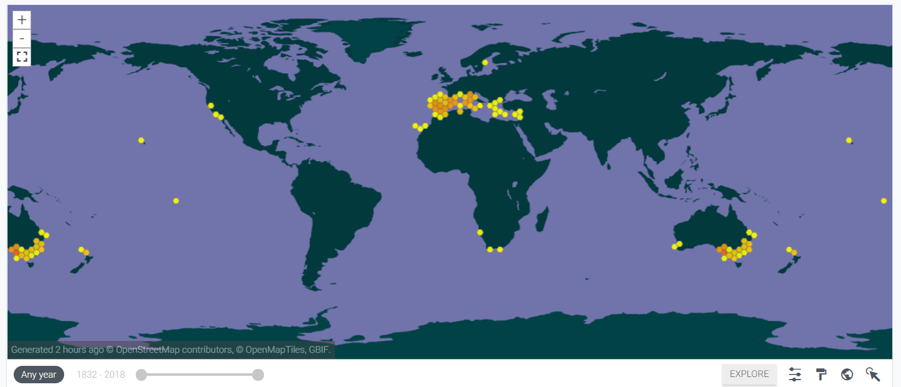

**Figure 1:** Present distribution of *O.* *europaea* subsp. *europaea* L. (source: GBIF, [www.gbif.org](http://www.gbif.org)).

**Methodology**

In total, 3,178 spatially referenced occurrence records for *O. europaea* subsp. *europaea* were downloaded from the Global Biodiversity Information Facility (GBIF, [www.gbif.org](http://www.gbif.org)) as a csv file. The relevant link is [DOI10.15468/dl.my49cn](https://doi.org/10.15468/dl.my49cn). A number of 98 occurrences were extracted from the database from which, 14 were recorded as *O. europaea* subsp. *sylvestris* (Mill,) Rouy ex Hegi and 84 didn’t have specified coordinates. 19 bioclimatic variables at 5 minutes resolution for the present (period ~ 1960-1990) and future (2050, RCP 4.5, HadGEM2-AO) respectively, were downloaded from [www.worldclim.org](http://www.worldclim.org). They were imported in R and Spearman's rank correlations followed. After the correlations, the variables that are considered important for the distribution of the species were selected keeping in mind that the olive tree is adapted to drought and warm climate conditions. The variables that correlated with them were gradually removed from the analysis (correlation coefficient > 0.7). This process went on until there were no correlations among variables. The variables that were finally incorporated in the model are the following: Bio7 (Temperature Annual Range, BIO5-BIO6), Bio9 (Mean Temperature of Driest Quarter), Bio12 (Annual Precipitation) and Bio14 (Precipitation of Driest Month).

MaxEnt software was used for the species distribution model of the olive tree. The csv file with the occurrence data of *O. europaea* subsp. *europaea* was imported in the “Samples” tab. “ClimateTraining”, “ClimatePresent” and “ClimateFuture” folders created in R, were imported in “Environmental layers” and “Projection layers directory/file” tabs respectively. The last two were used as the projection layers for the present and the future (**Fig. 2**).

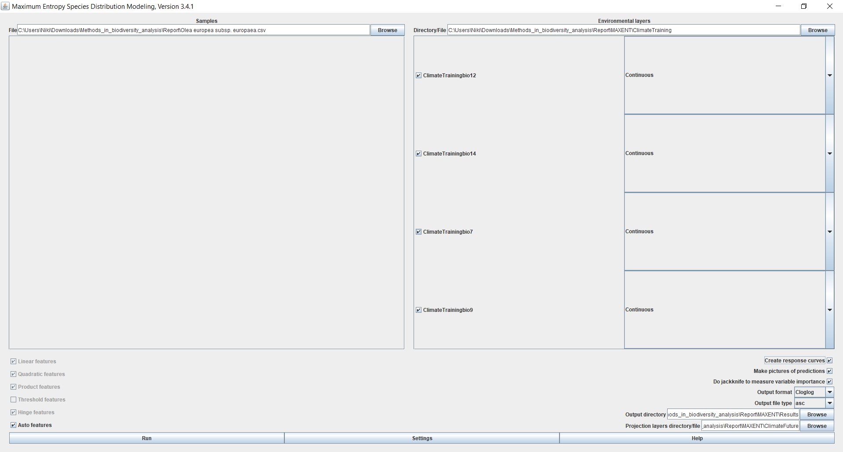

**Figure 2:** MaxEnt environment after the input of data.

**Model output**

**Figures 3** and **4** show areas with suitable conditions for *O.* *europaea* subsp. *europaea* in the present and the future. Green areas represent the most suitable habitats for the studied subspecies. Comparing these maps, we conclude that there are no striking differences between the present and the future habitat suitability.

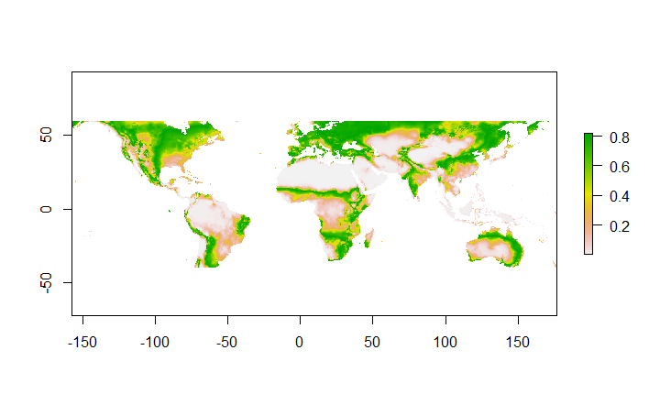

**Figure 3:** Clip projection raster depicting the present habitat suitability for *O. europaea* subsp. *europaea*.

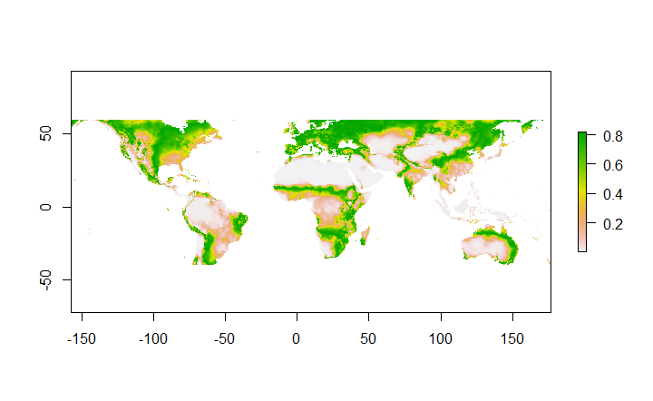

**Figure 4:** Clip projection raster depicting the future habitat suitability for *O. europaea* subsp. *europaea*.

Habitat suitability is much greater when the climatic variables are the only factors taken into consideration (**Fig. 3 & 4**) in comparison with the actual occurrence of the subspecies (**Fig. 1**). Other factors that can influence and limit its distribution are soil conditions, land-use changes, water availability, herbivory, diseases and potential competition for resources as well as anthropogenic activity.

The value of AUC (Area Under the Curve) of the Receiver Operator Curve (ROC) (**Fig. 5**) is equal to **0.782** meaning that the SDM for *O. europaea* subsp. *europaea* contains useful data. The “Maximum training sensitivity plus specificity” is 0.**467**.

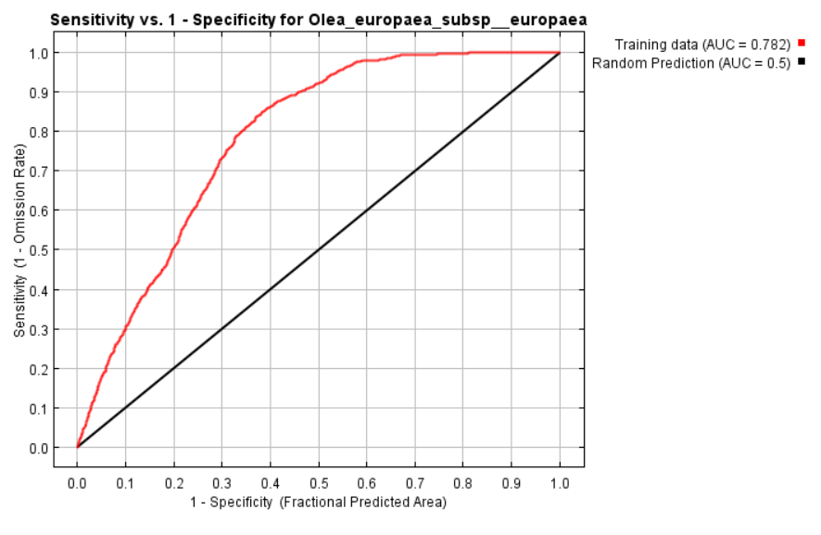

**Figure 5:** The Receiver Operating Curve (ROC) produced by MaxEnt.

The following table (**Table 1**) gives the estimated relative contributions of the selected environmental variables to the MaxEnt model and the responsive curves. Bio12 (Annual Precipitation) clearly has a major contribution (but this doesn’t have a clear ecological meaning since the variables are scaled).

**Table 1:** Contribution of selected variables to the model and the responsive curves.

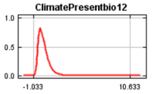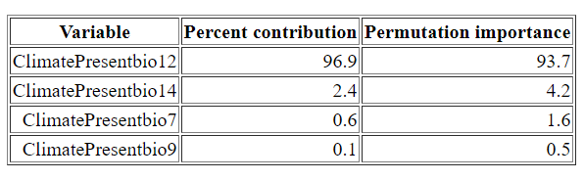

**Response to future scenario**

The following map (**Figure 6**) shows the future distribution changes of *O. europaea* subsp. *europaea*. In general, the species distribution seems to remain the same in most areas.

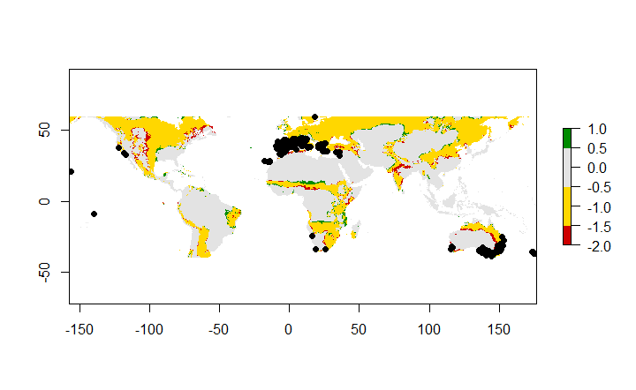

**Figure 6:** Future distribution change map of *O. europaea* subsp. *europaea*. Black dots represent the occurrences of the subspecies. Grey areas are never suitable, yellow ones remain suitable, red regions represent lost habitats and green ones gained habitats.

**Biological interpretation**

**Figures 3**, **4** and **6** show no apparent changes in habitat suitability for the olive tree. However, **Figure 6** depicts small gains and losses in suitable habitats as a result of climate change but not to a great extent. This can be explained by the fact that olive trees can withstand drought and high temperatures.

As we mentioned before, the resulting model has an AUC value of 0.782 and is considered to contain useful information. The usefulness of the model increases as a result of the high number of occurrences that were used (~3,100). On the other hand, the reliability is debatable since the occurrence records need to be checked for misidentifications. Furthermore, the model needs to be run more times in order to have accurate results.

**References**

[Besnard](javascript:;) G, [Terral](javascript:;) JF & [Cornille](javascript:;) A (2018) On the origins and domestication of the olive: a review and perspectives. [Annals of Botany, 121(3): 587-588.](https://academic.oup.com/aob/article/121/3/587/4829892) <https://doi.org/10.1093/aob/mcy002>

Centre for Agriculture and Bioscience International: [www.cabi.org](http://www.cabi.org)

Global Biodiversity Information Facility (GBIF): [www.gbif.org](http://www.gbif.org), [DOI10.15468/dl.my49cn](https://doi.org/10.15468/dl.my49cn)

### WorldClim - Global Climate Data: [www.worldclim.org](http://www.worldclim.org).