Report of the SDM practical  
Cas Dekker s1649353 9-12-2018

Introduction:  
Pineapple or botanically known as *Ananas comosus*(from here on referred to as *A. comosus*)is part of the plant family Bromeliaceae and is regarded is the most important edible member of the family(Morton, J. ,1987).

The genus Ananas is characterized by foliaceous scape bracts which are less successful in attracting pollinators like the conspicuous, non-foliaceous ones of other members of the bromeliaceae family.   
Because of this sexual reproduction will be reduced. Therefore, a well-developed apical coma has evolved in the genus Ananas, which acts as an additional vegetative propagule for vegetative reproduction(Matuszak-Renger, et al. 2018).

Vegetative reproduction doesn’t spread the offspring far from the parent. The current observed distribution of *A. comosus* (Fig. 1.) is therefore influenced by other factors, the domestication and trade of this valuable plant. The Brazil and Paraguay area is the only place where wild relatives of *A. comosus* occur(Morton, J. ,1987).

*Fig. 1. Observations of Pineapple(A. comosus) around the globe. Data source: GBIF.org (5th December 2018) GBIF Occurrence Download* [*https://doi.org/10.15468/dl.dz5phm*](https://doi.org/10.15468/dl.dz5phm)

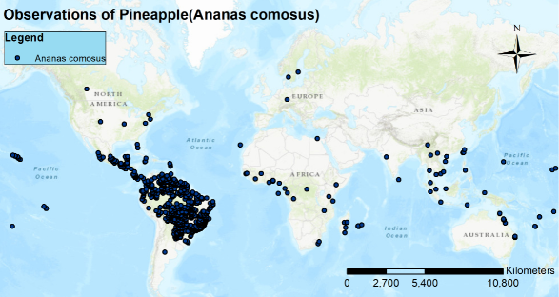

Methodology:  
MAXENT Settings  
  
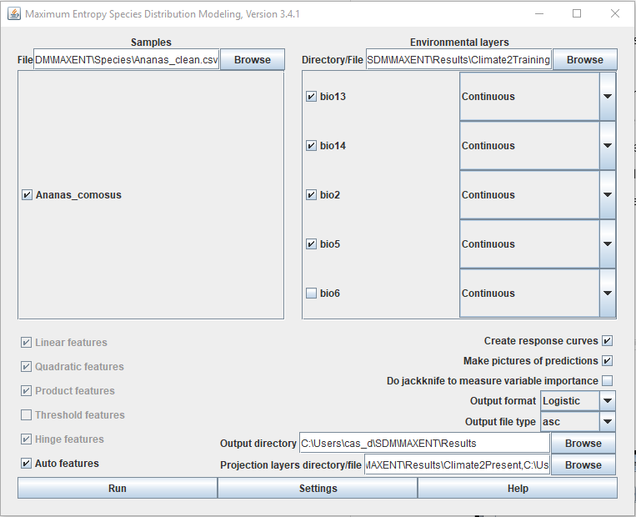

*Fig. 2a. MAXENT settings for the analysis*

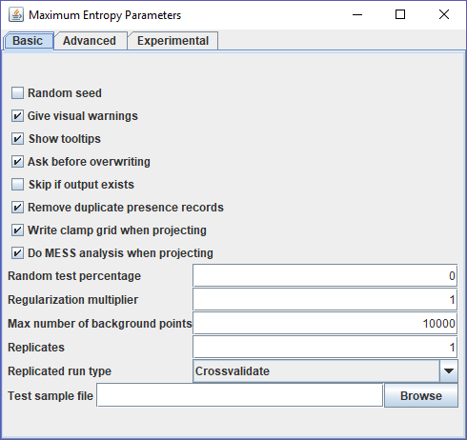

*Fig. 2b. MAXENT settings for the analysis*

Variable selection

As a climate model MIROC5(from worldclim.org) was chosen with a spatial resolution of 5 min and RCP45. The distribution prediction was done for the year 2070.

The Bioclimate variables((from worldclim.org) chosen to be inside the climate model include:  
-Mean diurnal range(bio2),  
-Max temperature warmest month(bio5)  
-Min Temperature coldest month(bio6)  
-Precipitation of wettest month(bio13)  
-Precipitation of driest month(bio14)

The precipitation variables were chosen because plants are dependent on water for survival and most plant need a constant supply of water to survive.   
The temperature variables were chosen because a lot of plants have an optimum for their temperature range which should lay in between the maximum and minimum of a month and day(24 hour cycle).   
Plant are also are sessile organisms so they can’t move if conditions turn out to become unsuitable.

Min Temperature coldest month(bio6) had different dimensions than all other variables. Evidently something went wrong in the Rscript but rerunning the script didn’t solve it. Since MAXENT doesn’t run when variables have different dimensions I consulted 2 assistants and we made the decision to leave Min Temperature coldest month(bio6) out of the analysis(Fig. 2a.)

Model output:

Present + future distribution map

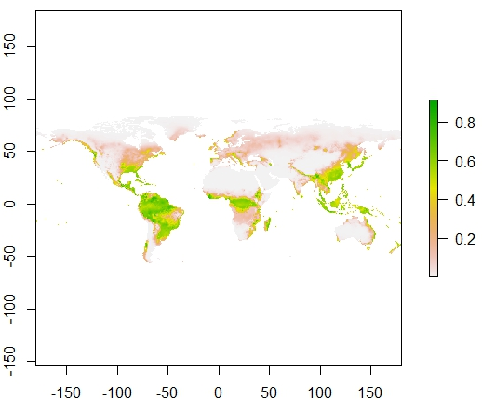

*Fig. 3a. The present potential distribution of A. comosus between 2060-2080*

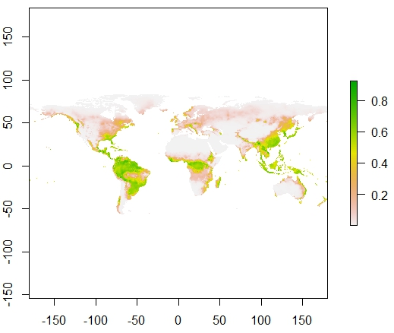

*Fig. 3b. Future potential distribution of A. comosus between 2060-2080*

At first sight there doesn’t seem to be major distribution shifts from 1960-1990(Fig. 3a.) to 2060-2080(Fig 3b.)

Model performance

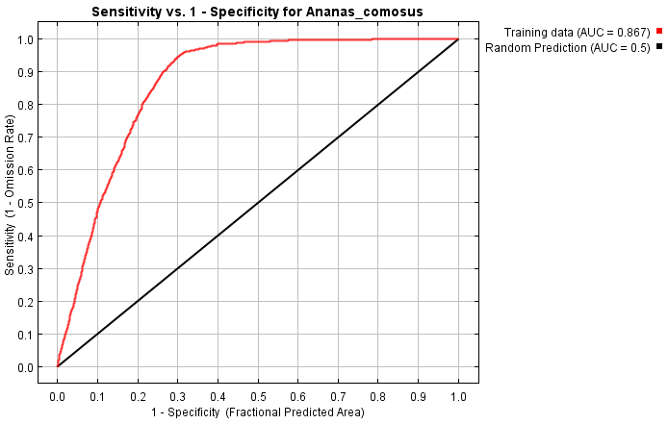

*Fig. 4. AUC model performance*

The AUC(Fig. 4.) is about 0.867 which is a relatively high score meaning we can have a confidence in its predictions.

AUC is actually not a good measure for the precision of the model. For a good measure of the precision you would need to run tests of our model against a null-model and get a p-value as a sign for significance but this would take too much time to do in this practical.

Variable importance table

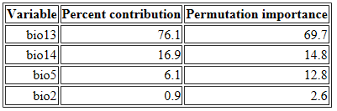

*Tab. 1. Individual contribution of the variables ranked by importance high to low.*

We can clearly see that, in absence of the Minimum temperature coldest Month(bio6) variable, the Precipitation of the wettest Month(Bio13) and Precipitation of the driest Month(Bio14) variables are on top in the importance table(Tab. 1.) for explaining the distribution of *A. comosus*.  
The variation in temperature during the day expressed by the variable Mean diurnal range(bio2) seems to be the least important in this selection.

Future distribution change map

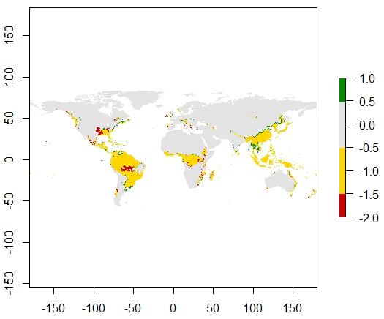

*Fig. 5. Change in suitable habitat between 1960-1990 and 2060-2080.  
Red = Loss of suitable habitat, Yellow = remains suitable habitat, Green = gain of suitable habitat, Grey = never suitable habitat.*

We see that the most loss of suitable habitat for *A. comosus* is in its native area Brazil in the southern part of the Amazon rain forest. In the North-Amerika there is also a net loss of suitable area.   
In the African tropics the amount of suitable habitat seems to be slightly declining. In comparison  
East-Asia seems to be doing a much better job in the future in terms of suitable habitat for *A. comosus.* Especially China and Thailand will have a better chance of housing *A. comosus*(Fig. 5.).

Biological interpretation

The distribution(Fig. 5.) is expected to change to most in North- and South-Amerika and East Asia. In North-and South-Amerika the changes to the suitable habitat are foremost negative with huge areas of suitable habitat loss in the period 1960-1990 to 2060-2080. East Asia is the only place where *A. comosus* will find more suitable habitat in the future(2060-2080) than it did in the past(1960-1990).  
Fortunately there are also major areas where the habitat will remain suitable.

The variables regarding precipitation were found most important by the model to project the future distribution range of *A. comosus*. Temperature was a whole lot less important(Tab. 1.).

As mentioned in the introduction the distribution of A. comosus is heavily influenced by trade.   
Because it is traded it has value for humans and the value A. comosus represents to humans might also be the best dispersal capability it has. *A. comosus* won’t find itself threatened in the future as much as other “non-valuable” species might.

The model with an AUC of 0.867 was an overall model we can put confidence in(Fig. 4.). Some of the downsides of this Species distribution model(SDM) might be that it only takes into account the climatic variables. In reality there is a lot more to SDM’s. An area might have suitable habitat but if there is no place to grow because there are already a lot of other plants, there are herbivores that eat the seeds or the organism face other strong competitive forces it might never start to prosper.   
If the area is suitable and the plant can actually maintain a population, we should also take into account the accessibility of the area and if the dispersal capacity of the plant is up to par to reach the area.   
So while this model can predict where *A. comosus* can occur based on climate is doesn’t tell you the places *A. comosus* will actually settle down.

Bronnen:  
- Dataset Gbif: GBIF.org (5th December 2018) GBIF Occurrence Download <https://doi.org/10.15468/dl.dz5phm>  
- Matuszak-Renger, Sabine & Paule, Juraj & Heller, Sascha & M. C. Leme, Elton & M. Steinbeisser, Gerardo & Barfuss, Michael & Zizka, Georg. (2018). Phylogenetic relationships among Ananas and related taxa (Bromelioideae, Bromeliaceae) based on nuclear, plastid and AFLP data. Plant Systematics and Evolution. 10.1007/s00606-018-1514-3.  
- Morton, J. 1987. Pineapple. p. 18–28. In: Fruits of warm climates. Julia F. Morton, Miami, FL.