Step 2: Preparing your environmental data:

1. Download climate variables: <https://www.worldclim.org/>

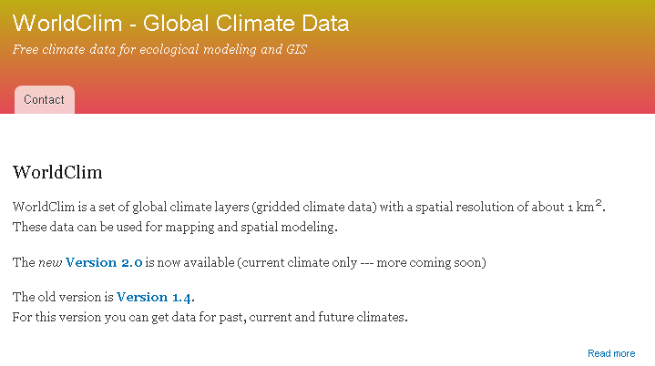

1. Select the version you want to use (we opted for version 2.0)

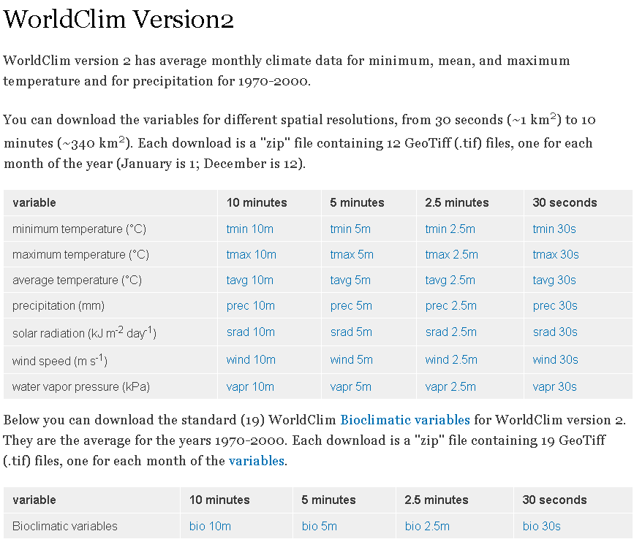

* 1. There are various variables available, the bioclimatic variables represent a “standard” obtained from each of the above. Use these ones for your modelling exercise.
     1. 10m, 5m, 2.5m, 30s refers to the spatial resolution at the equator in the WGS84 projection
        1. 30s is 1 Km data
        2. 5m is 10 Km resolution (download this one)

1. What are the bioclimatic variables?

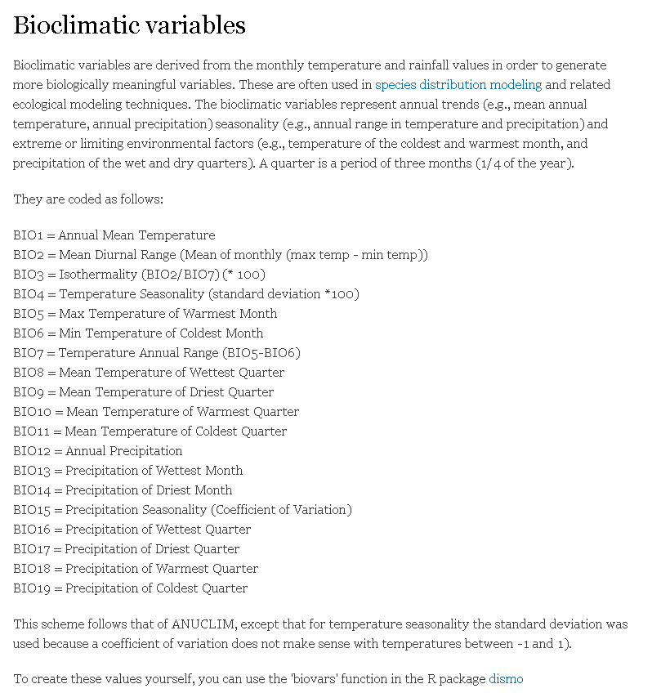

1. Download the future scenario data
   1. The future scenario is only available on section 1.4

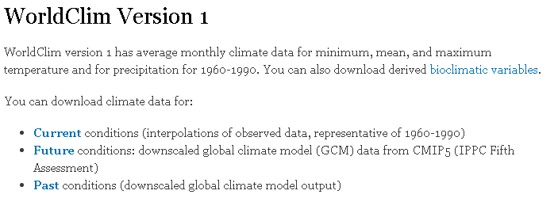

* 1. Select the same resolution as before (5 minutes in the case of this tutorial)

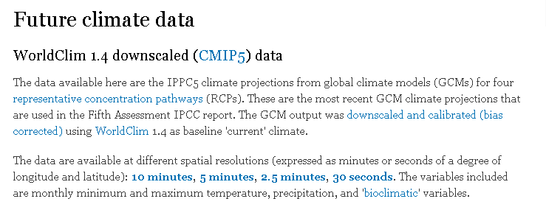

1. Future climate scenarios:
   1. Each scenario will have different assumptions
   2. For this tutorial we downloaded the HadGEM2-ES (code HE)
      1. More info @ <https://portal.enes.org/models/earthsystem-models/metoffice-hadley-centre/hadgem2-es>

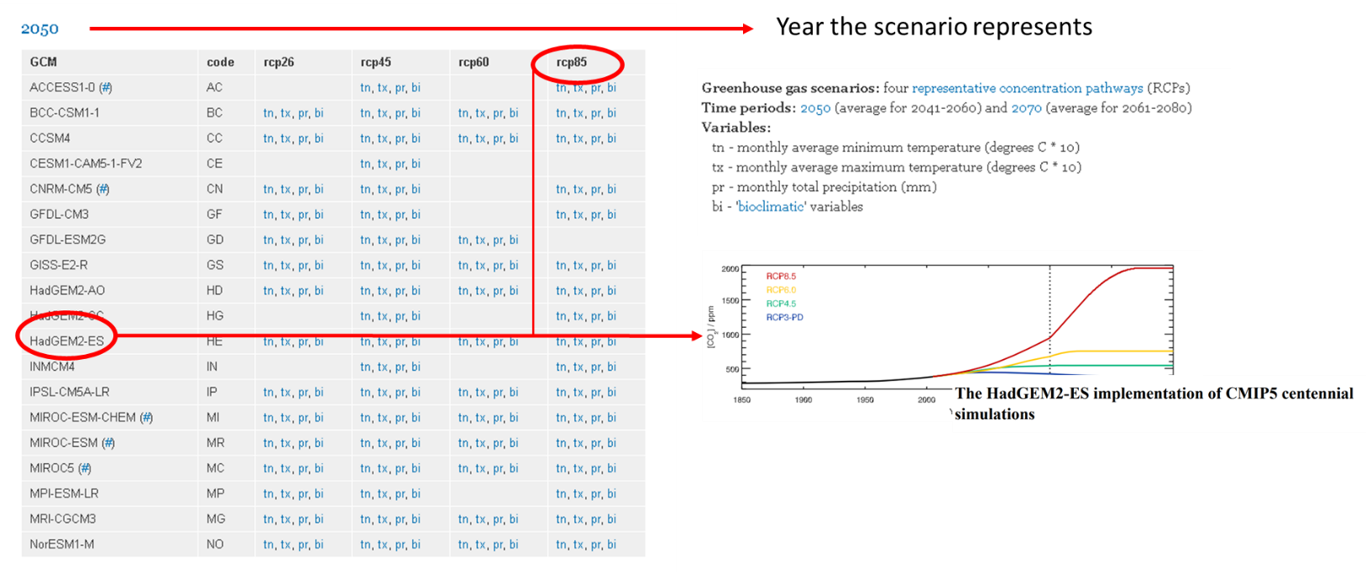

* 1. To download the bioclimatic variables, select “bi” on each of the scenarios you want to use. We used all 4 in our case.
     1. Download them to your downloads folder

1. Unzip all the data (Present and future scenarios) to appropriate folders created in the beginning:
   1. Present
   2. Future
      1. One subfolder per each scenario
   3. Note: if you decide to explore this data in ArcGIS, the software will create some auxiliary files which might make your R scripts stop working. Just erase these auxiliary files or create another folder for exploring the environmental data to avoid this.