1. Projecting species distribution models to future and past climate scenarios, and to different geographical regions

In the previous chapters you learned how to a) create the species presence file, b) download and prepare your environmental datasets, and c) to develop species distribution models. Species distribution models identify the relationship between the presence-only species records and the environmental data, and interpolate these relationships to your research area. Once the relationships are identified they can also be projected to environmental data of other time periods, i.e. the last glacial maximum of future IPCC climate change scenarios. Before you can start using these data you’ll have to download them, or construct them yourself.

## Future and past climate data

Future climate datasets are widely available nowadays. Important sources are the ‘Downscaled GCM Data Portal -’ <http://www.ccafs-climate.org/data/> and ‘Worldclim ‘datasets <http://www.worldclim.org/CMIP5>. Future datasets of Worldclim provide data as \*.tiff which is not compatible with DIVA-GIS. For past climate scenarios data are more scarce but data is available from <http://www.worldclim.org/past>. You can also develop your own future climate data by assuming i.e. a temperature rise of 5 degrees as is explained below.

1. Open the DIVA-GIS file you developed in Chapter 3.
2. Download the 19 Bioclim variables from the ‘Downscaled GCM Data Portal -’ <http://www.ccafs-climate.org/data/>. Select, on the left, under File Set ‘Delta Method IPCC AR5’ (Intergovernmental Panel on Climate Change fifth Assessment Report), under Scenario ‘RCP 4.5’ (Reprensentative Concentration Pathways with 4.5 Wm2 radiative forcing, CO2 ppm 650, Temp 2.4 °C), under Model ‘mohc-hadgem2-es’ (Met Office Hadley Centre - Hadley Global Environment Model 2 – Earth System), then above, under Extent ‘Global’, under Format ‘ASCII Grid Format’, under Period ‘2050s’, under Variable ‘Bioclimatics’, and under Resolution ‘5 minutes’, then press Search. Select the zip file, provide your details and download via the appearing link at the bottom. These files are in ASCII format.
3. Import the grid data-layers for the future climate data from the .zip file. This dataset spans the entire Southeast Asian region. Also import the alt\_borneo.grd from chapter 2. Make a stack of the future climate data and use the alt\_borneo.grd to cut the future climate data to the extent of Borneo. Add the cut future climate data-layers.

Now we have all data-layers cut to the extent of Borneo for both current and future climatic conditions. The next step will be to model the *Macaranga* species models and project them on the future dataset. The only requirement of Maxent is that the file names for corresponding data-layers need to have the same file names. So, we’ll have to export the data-layers as ESRI ASCII files and rename all future climate data-layers to alt\_borneo.asc, bio1\_borneo.asc, etc.

1. Make a folder named ‘Maxent\_current’ and copy all current climatic data-layers to this folder.
2. Make a folder ‘Maxent\_future’ and copy all future renamed climate data to this folder. Also add a copy of alt\_borneo.asc. Both folder should have the same file names now.
3. Check whether all headers are the same of the future climate data-layers. Open the alt\_borneo.asc and bio1\_borneo.asc. As you can see in Fig. 18 they are almost the same but not exactly. The headers of all data-layers in one set must be the same. Copy the header of bio01\_borneo.asc to alt\_borneo.asc.

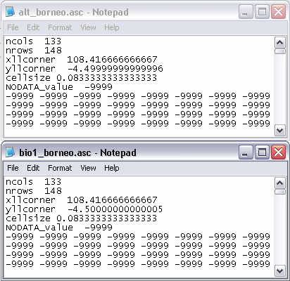

Figure 18. Small but important difference in the headers.

1. Open Maxent and load the species file, the current data-layers, the Output directory and finally browse to the folder ‘Maxent future’ with the ‘Browse’-button next to the field ‘Projection layers directory/file’. Click ‘Run’ (Fig. 19).

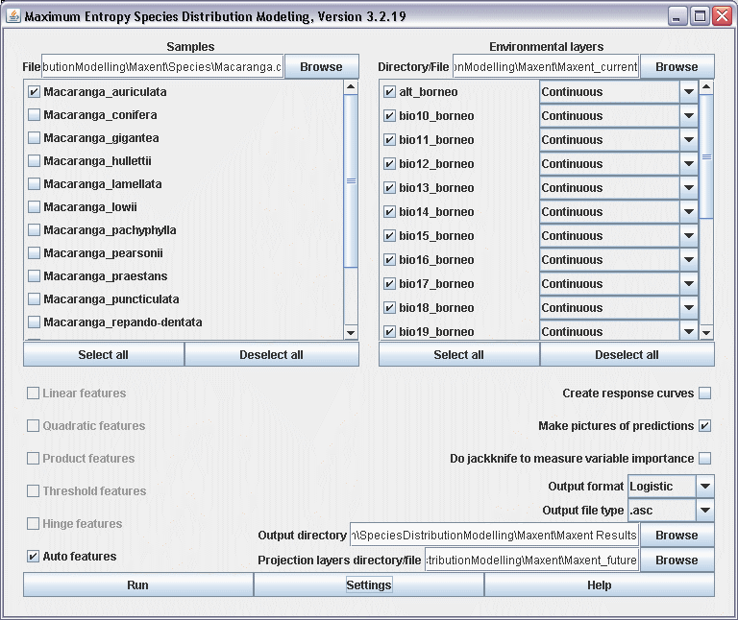

Figure 19. Projection a Maxent model to a future climate dataset.

1. Open the Macaranga\_auriculata.html file and check the future distribution of *M. auriculata* (Fig. 20).

|  |  |
| --- | --- |
| Macaranga_auriculata | Macaranga_auriculata_Maxent_future |

Figure 20. The present and future distribution of *M. auriculata.*