# MultipleFacesProcess

Process multiple faces powered by ArcSoft SDK (V3.0)

How to use it：

1. Make sure the following packages are installed in your windows system
2. Visual C++ Redistributable Packages for Visual Studio 2013（x64）

(<https://www.microsoft.com/en-us/download/details.aspx?id=40784>)

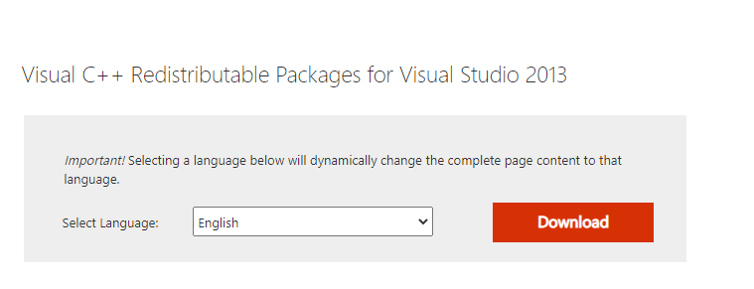

1. .Net 5 （x64）SDK (Yes, it is newest .net5, better than core 3.1)

（<https://dotnet.microsoft.com/download/visual-studio-sdks>）

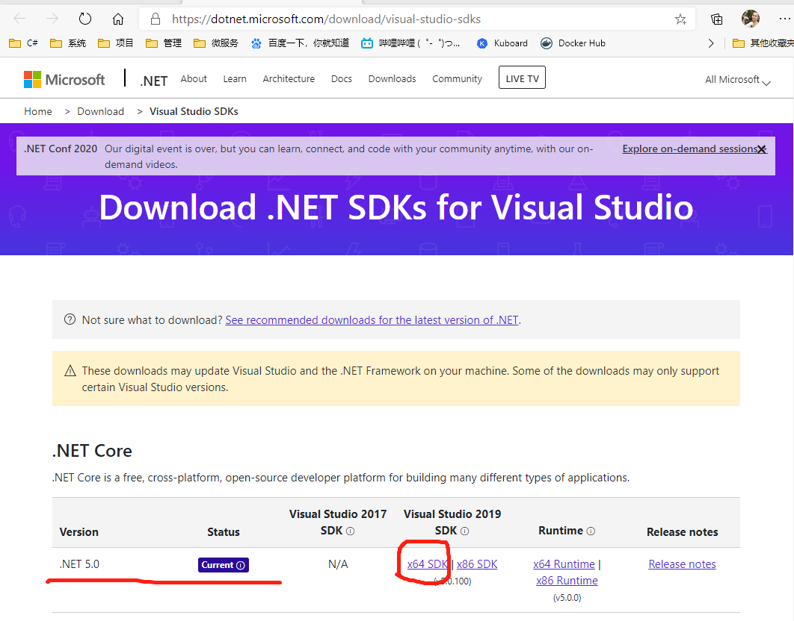

1. Register an user account on ArcSoft office web.

(<https://ai.arcsoft.com.cn/ucenter/resource/build/index.html#/reg>)



1. Create a custom project and download the Windows x64 C++ SDK.



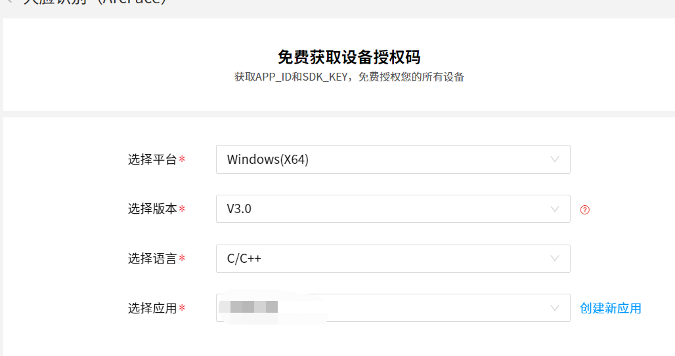

1. Unzip the SDK and copy the 2 dll from lib folder.

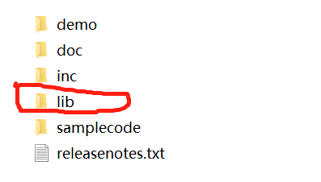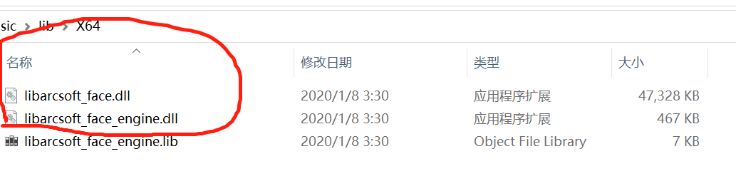

1. Download the code from GitHub and open with VS2019. Put the 2 dlls into the ArcSoft library projects. (Choose “always copy” to avoid dll-missing mistake)

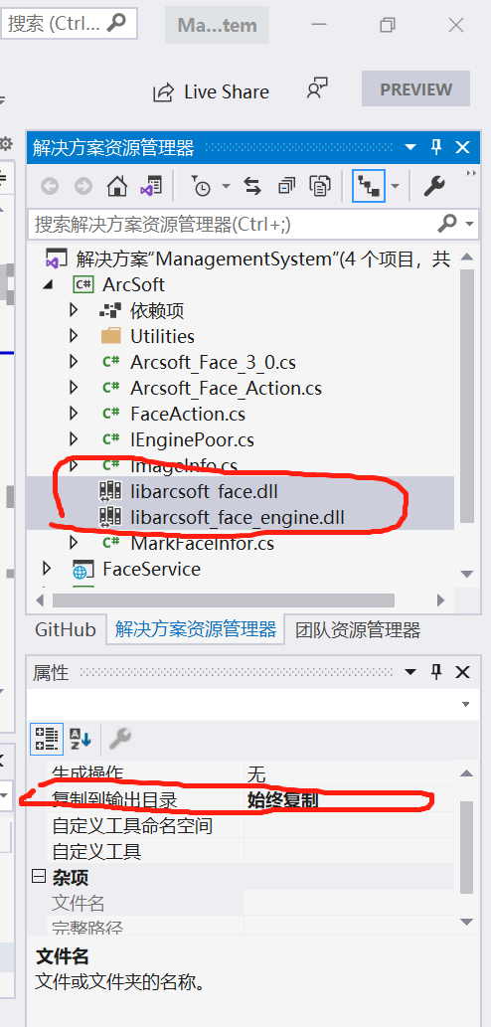

1. Go back to ArcSoft office web and get your own “APP_ID” and “SDK_Key”. Copy them to “appsettings.json” both in “FaceService” and “Video Client”

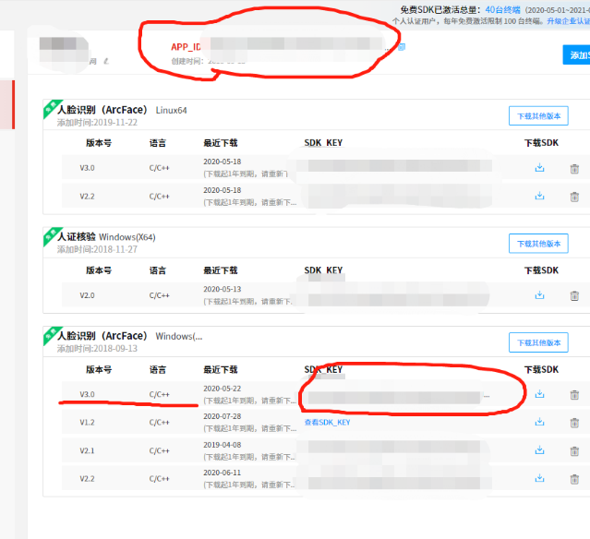

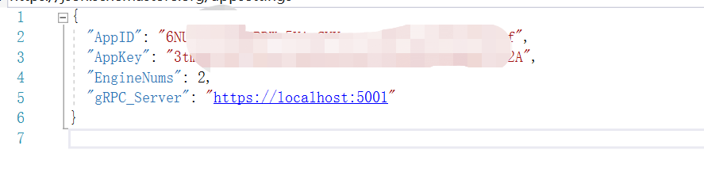

1. Put a folder named “Test” in your d Drive(This is hard code in FaceService for test use) and put some face photos(jpg format) inside. And start “FaceService” firstly.

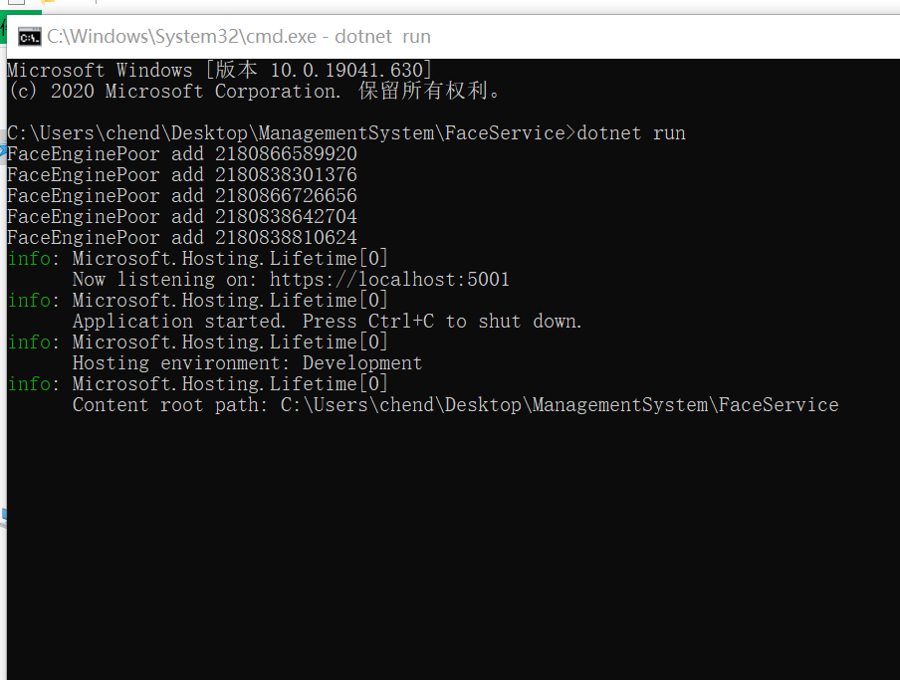

Then you can open “Video Client” for test.

