**横向扩展架构**

# 架构

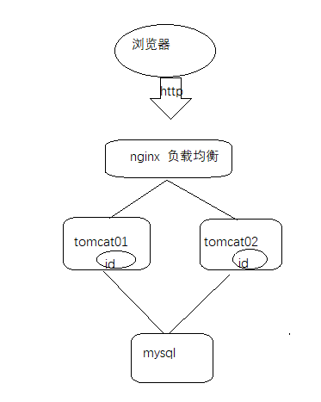

# 反向代理

**Windows 下的命令**

查看nginx的版本号：nginx -v

启动nginx：start nginx

快速停止或关闭nginx：nginx -s stop

正常停止或关闭nginx：nginx -s quit

配置文件nginx.conf修改重装载命令：nginx -s reload

# 登录问题

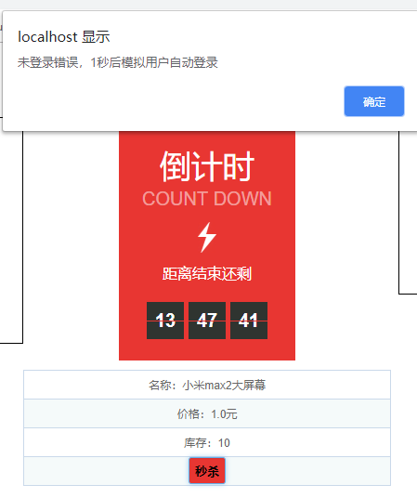

# 分布式

Spring session：解决分布式session问题

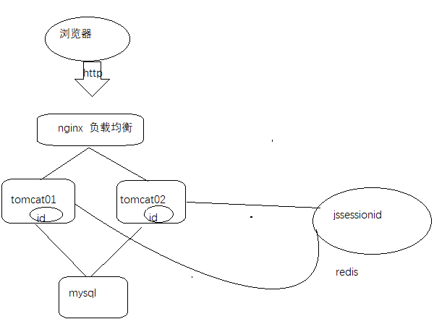

## 依赖

|  |
| --- |
| <dependency>  <groupId>org.springframework.session</groupId>  <artifactId>spring-session-data-redis</artifactId>  </dependency>  <dependency>  <groupId>redis.clients</groupId>  <artifactId>jedis</artifactId>  </dependency> |

## 配置

|  |
| --- |
| #spirng session  spring.session.redis.flush-mode=on-save  spring.session.redis.namespace=spring:session  spring.session.redis.cleanup-cron=0 * * * * *  spring.session.store-type=redis  spring.session.timeout=1800  spring.redis.jedis.pool.max-active=8  spring.redis.jedis.pool.max-wait=10  spring.redis.database=0 |

## 可选

|  |
| --- |
| //监听session失效删除  @Component  **public** **class** SessionEventListener **implements** ApplicationListener<SessionDeletedEvent> {  @Override  **public** **void** onApplicationEvent(SessionDeletedEvent event) {  Session session = event.getSession();  User user = (User) session.getAttribute("user");  System.***out***.println("invalid session's user:" + user.toString());  }  } |

## 效果

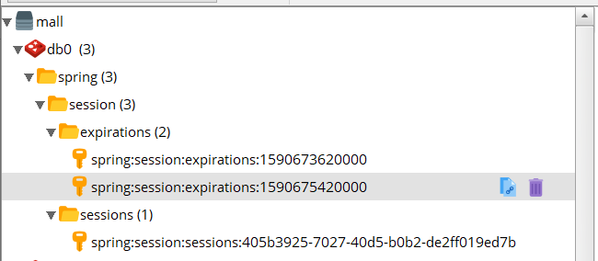

# 总结

入门：<https://blog.csdn.net/gaohe7091/article/details/90765213>

总结：<https://blog.csdn.net/qq_39669058/article/details/90235990>

# 进阶

## 序列化

|  |
| --- |
| /**  * 自定义序列化方式为json格式 叫这个默认名字：springSessionDefaultRedisSerializer  *  * **@return**  */  @Bean  **public** GenericJackson2JsonRedisSerializer springSessionDefaultRedisSerializer() {  **return** **new** GenericJackson2JsonRedisSerializer();  } |

## 跨域

|  |
| --- |
| /**  * 实现跨域  *  * **@return**  */  @Bean  **public** CookieSerializer defaultCookieSerializer() {  DefaultCookieSerializer serializer = **new** DefaultCookieSerializer();  serializer.setCookieName("JSESSIONID");  serializer.setCookiePath("/");  //serializer.setDomainNamePattern("^.+?\\.(\\w+\\.[a-z]+)$");  serializer.setDomainName("go8.com");  //取消站点限制  //serializer.setSameSite(null);  **return** serializer;  } |