
专题五 介词和介词短语

介词是一种虚词，用来表示词与词、词与句之间的关系的词。在句中不能单独作句子成分。介词可与名词或相当于名词的其它词构成介词短语。介词短语可在句中作定语、状语、表语和宾语补足语。


知识梳理

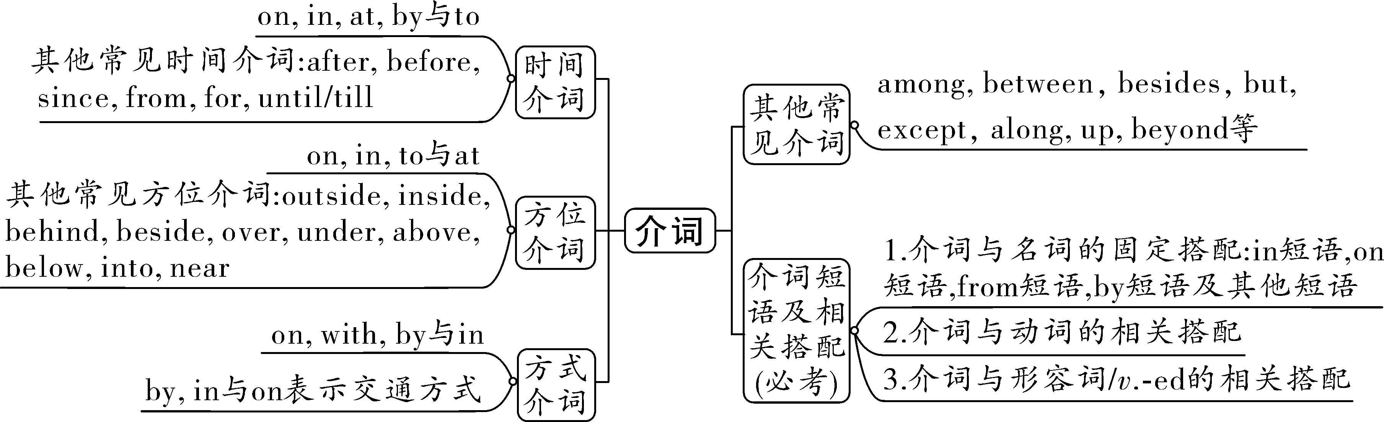

第一部分 介词
考点一：时间介词
★★★一、at、in与on
时间介词 | 用法 | 例子
at | 用于具体的时间点（钟点时刻）前 | at 6：00在六点 at noon在正午 at night在晚上
in | 用于年、月、世纪、季节或泛指一天的上午、下午、晚上等前 | in May 在五月 in summer在夏天 in the morning在早上  in the twenty­first century 在21世纪
on | 用于具体日期或具体某天的早上、下午、晚上前，星期或节日前 | on August 1st last year在去年的八月一号  on the evening of June 22nd在六月二十二号晚上  on the second Sunday在第二个星期天  on Women’s Day 在妇女节
【注意】在以this, that, next, last, every等开头的表示时间的词或词组前不用介词
如：I will go shopping with Tom this Sunday. 这个星期天我将和汤姆去购物。
【知识拓展】in还用于表示“在多久以后”，构成“in+时间段”结构，常用于一般将来时态。
如：They will finish the work in an hour. 一个小时后他们将完成这项工作。
二、by与to
时间介词 | 用法 | 例子
by+时间点  “到…为止” | by+将来的时间点，用一般将来时 | We will learn 300 words by the end of this term.
 | by+过去的时间点，用过去完成时 | My father had read three novels by last month.
to | 表示时间范围，通常与from连用，意为“ 从……到…… ” | from 5:00 to 9:00 从5点到9点  from Monday to Friday 从周一到周五
三、after与before
时间介词 | 含义 | 例子
after | 在……之后 | Shall we go for a walk after supper?晚饭后我们去散步好吗？
before | 在……之前 | Please wash our hands before meals.饭前请洗手。
★四、since、from与for
时间介词 | 用法 | 例子
since | 意为“ 自从 ”，表示从过去某时直至现在，后接过去的时间点或从句（一般过去时），主句用 现在完成 时 | We have learned English since five years ago.  I have lived here since I was four years ago.
from | 说明开始的时间，不说明某动作或情况持续多久 | I began to learn dancing from five years old.
for | 表示动作延续贯穿整个过程，后接时间段，主句用 现在完成 时 | I have studied in this school for two years.
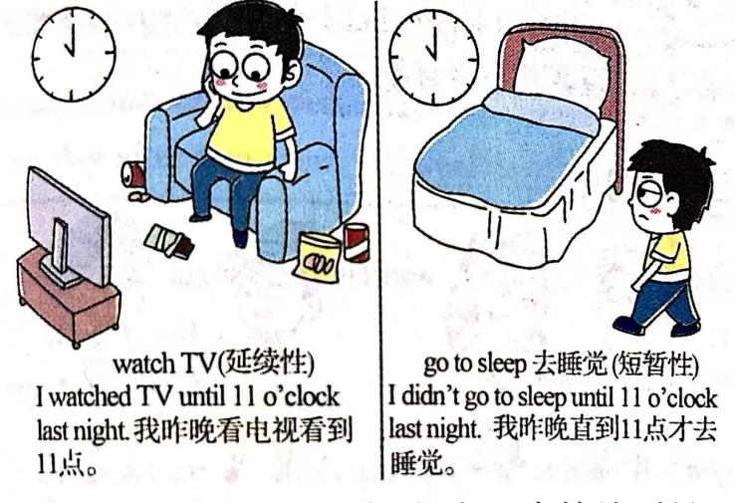
★★五、until/till
（1）用在肯定句中，表示“直到……为止”，句中（主句）的谓语动词用延续性动词，表示该动作或状态一直持续到till/until所表示的时间为止。
（2）用在否定句中，句中（主句）的谓语动词用短暂性动词，表示该动作直到till/until所表示的时间才发生。常用于not...till/until结构，表示“直到……才”。
【特别提醒】till不能用于句首，也不能用在以not开头的短语或从句里，而until可以。
Eg.Until now I have always lived alone. 直到现在我仍一直独自生活。
Not until 9:00 yesterday evening did we finish the work. 直到昨晚9点，我们才完成这项工作。
基础练习

一、用at、in、on、for、since填空
1.Jim was born _____on______ August 23rd, 2012.
2.Sam has been like this _____for______ three days.
3.Dick has been in China ____since______ 2021.
4.Grandma Wang usually gets up ____at_______ six o’clock.
5.It’s warm and windy in my hometown _____in______ spring.
二、单项选择
1.There is going to be an English movie in our school ____D_____ the evening of June 30.
A. at B. in C. for D. on
2.Let’s meet ____C____ 4 o’clock ________ Sunday afternoon.
A. at; in B. in; in C. at; on D. in; on
3.____C____ July this year, the 31st World University Games will start in Chengdu.
A. At B. On C. In D. By
4.Mum won't let Simon go out unless he promises to be back____B____10 o'clock tonight.
A. till B. before C. as D. since
5.Don't stay inside A such a sunny morning. Let's go out to enjoy the gentle wind and sweet flowers.
A. on B. in C. from D. at
真题演练

一、单项选择
1.(2023·云南中考)—Hi,Mike.When is the Space Day of China?
—It falls___C___April 24 every year.
A.at B.in C.on D.for
2.（2023·重庆八中校考模拟）___D____ June 1st, kids ________ 14 usually dress up to celebrate Children’s Day.
A．In; over B．In; under C．On; over D．On; under
3.（2023·河北秦皇岛·统考三模）—Could you tell me when the play starts today?
—It starts ___D____ 8:00 p.m.
A．on B．in C．by D．at
4.（2023·辽宁盘锦·校联考三模）People usually admire the moon ___A____ the night of the Mid-Autumn Festival.
A．on B．in C．at D．to
5.（2023重庆八中三模）Tian Zhou 6 spaceship was successfully sent up into space ___D____ 21:22 pm, on May 10th.
A．in B．during C．for D．at
考点二：方位介词（短语）
★★一、at、in、on与to的“位置”不同
介 词 | 用 法 | 举 例 | 图 解 记 忆
at | 用于较小的场所前 | We like staying at home on weekends. | 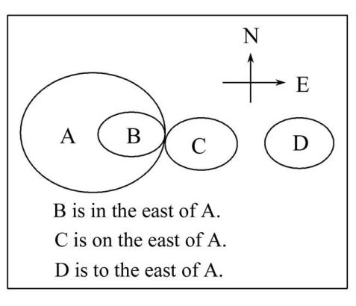
in | 表示“ 在......范围之内 ” | We had a day out in the country.
 | 表示两者是“包含”关系 | Japan is in the east of Asia.
on | 表示“ 在......（表面）上 ” | There is a book on the desk.
 | 表示两者是“相切”关系 | Canada lies on the north of America.
to | 表示“ 到/向...... ” | This road leads to London.
 | 表示两者是“相离”关系 | Japan is to the east of China.
二、outside与inside
介 词 | 用 法 | 举 例
outside | 表示“ 在外面 ” | Ben could hear strong winds outside his home in Alabama.
inside | 表示“ 在里面 ” | Then they heard an old woman’s voice from inside the house.
★三、表示“附近”的beside、near和next to
介词(短语) | 用 法 | 举 例
beside | 表示“在……旁边”,指较近的距离 | He stood beside the entrance.
near | 表示“在……附近”,指较近的距离,但一般比beside所指的距离远 | My house is near the railway station.
next to | 表示“靠近,紧挨着,贴近”,它所指的距离最近 | Our house is next to the post office.
【特别记忆】上述几个词(短语)从近到一般近到最近的顺序为： near > beside > next to
四、表示“在……上方”的over、above与on
介 词 | 用 法 | 举 例 | 图 解 记 忆
over | 在物体的正上方，反义词是“ under ” | There is a bridge over the river.  在河上有一座桥。 | 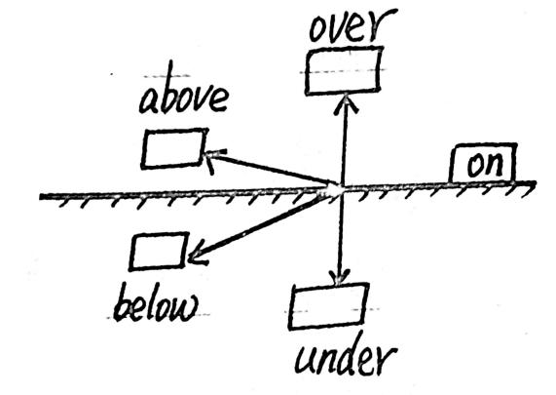
above | 在……上方，不一定垂直，反义词是“ below ” | The plane is flying above the clouds.  飞机在云层上飞行。
on | 在……上面，两个物体是接触的 | There is a pen on the desk.  桌子上有一支钢笔。
★★五、across, over与through“穿越”有别
介 词 | 用 法 | 图 解 记 忆
across | 从物体的 表面 （表面/内部/上方）穿过，“横过;穿过” | 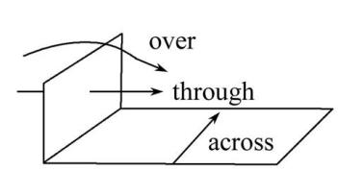
over | 从物体的 上方 （表面/内部/上方）穿过，“越过;跨过”
through | 从物体的 内部 （表面/内部/上方）穿过，“穿过;通过”
►Be careful when you go across the street. 过马路时要小心。
►Jack told me that he could jump over the desk. 杰克告诉我他能跨过桌子。
►The sunlight comes through the window. 阳光透过窗户照射进来。
★六、between与among“在……之间”的数量不同
介 词 | 用 法 | 举 例 | 图 解 记 忆
between | 一般用于两者之间,常构成“between...and...”结构 | Mary sits between Lucy and Lily.玛丽坐在露西和莉莉之间。 | 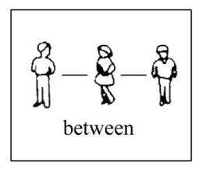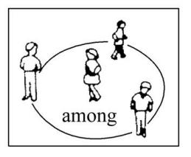
among | 一般用于三者或三者以上之间 | The teacher stands among the students. 老师站在学生们中间。
七、in front of与in the front of“在……前面”的空间范围不同
【记忆口诀】“有the在内，无the在外”
介词短语 | 用 法 | 举 例 | 图 解 记 忆
in front of | 在物体 外部 （内部/外部）的前面 | Mary stands in front of the bus. 玛丽站在公交车前。 | 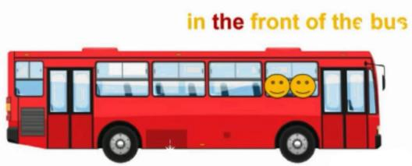  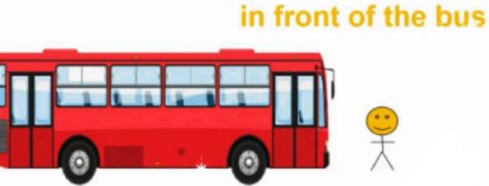
in the front of | 在物体 内部 （内部/外部）的前面 | Mary and Lucy sit in the front of the bus.玛丽和露西坐在公交车前面。
基础练习

一、选词填空（可重复使用）
across, through, over

1.Do you think light can pass ___through____ water?
2.The thief ran away ____over_____ the wall.
3.Grandma Wang is walking _____across_____ the street.
4.The boys went ____through_____ the forest quickly.
between, among

1.There is a small house ____among_____ the trees.
2.I sits ___between______ Jack and Jim in the classroom.
to, in, on

1.There is a big tree ____on______ the top of the mountain.
2.Hebei Province is _____on_____ the northwest of Shandong Province.
3.The team stayed _____in_____ space for six months.
4.We’ll stay _____in______ Beijing for a week.
5.All roads lead _____to______ Rome.
6.Shanghai is _____to_______ the east of Nanjing.
二、单项选择
1.—Where is Tom?
—He is playing football _____C______ the playground.
A. of B. to C. on D. from
2.The high­speed train_____D_____Qingdao and Beijing travels faster now. The train ride takes only about three hours.
A. from B. among C. in D. between
3.To my great joy, my family is always A me whatever I decide to do.
A. behind B. to C. from D. against
4.A woman stood D the window, watching the children playing games in the garden.
A. past B. through C. across D. beside
真题演练

一、单项选择
1.（2023·四川凉山·模拟预测）—It is known to us all that Taiwan is an important part of China.
—Yes, it lies ___C____ the southeast of China.
A．on B．to C．in D．at
2.（2023·重庆一中校考三模）With the sunshine shining ___B____ the window, everything in the room looks so bright.
A．against B．through C．across D．between
3.（2023·辽宁铁岭·校联考一模）Mingming is taller than me and he sits ___D____ me in the classroom.
A．among B．from C．between D．behind
4.（2023·云南昆明·统考二模）Giant panda Ya Ya arrived ___C____ Shanghai Pudong International Airport ________ April 27th, 2023 from Memphis, Tennessee.
A．in; in B．on; at C．at; on D．in; on

★★考点三：方式介词（by、in、on与with）
介词 | 意义或用法 | 举 例
by | by+表示交通工具的名词,意为“乘,坐” | He goes to school by subway.
 | by+v.-ing形式,表示“通过……方式” | I learn English by reading.
in | in+语言类名词, 表示“用……语言” | The novel is written in English.
 | in+颜色,表示“穿……颜色的衣服”
on | on+radio/TV等通讯工具,表示“通过……” | He likes to watch soccer games on TV.
with | with+某种工具、身体部位名词,表示“用……” | We see with our eyes and listen with our ears.
基础练习
一、用恰当的介词填空
1.Can you sing Happy Birthday _____in______ Chinese?
2.Pony Ma, the Chairman of Tencent Company, has made much money _____on______ the Internet.
3.Maria lives far from her school. So she usually goes to school _____by______ bus.
4.Cut it ____with______ a knife.
真题演练

一、单项选择
1.（2023·浙江·模拟预测）Oh, it’s you, Ella! Your voice sounds quite different ____C____ the phone. What’s happening?
A．from B．in C．on D．by
2.（2023·福建省福州铜盘中学校考模拟预测）—How do you relax in your free time?
—___A____ doing sports and watching movies.
A．By B．At C．On
3.（2023·甘肃武威·统考模拟预测）After work, we can relax ourselves ___D____ eating watermelons and we can cut watermelons ________ knives.
A．by; by B．with; by C．with; with D．by; with

考点四：其他常见介词
★一、besides与except
介词 | 意义或用法 | 举 例
besides | 表示“除……之外(还有)”,含有“加”的意思 | We’ll all visit the museum besides Jim.
except | 表示“除……之外”,从整体中除去一部分,含有“减”的意思 | We are all here except Jim because he is ill.
★★二、with与without
介词 | 意义或用法 | 举 例
with | 表示伴随,意为“和……一起” | He often plays soccer with his friends.
 | 表示“具有;带有” | The Smiths live in a big house with a small garden.
without | 表示“无;没有” | We can’t live without water.
三、其他介词
介词 | 意义或用法 | 举 例
as | 意为“作为;以...的身份”,后常接职业、职务等名词 | As a student, you should study hard.
for | 表示对象、用途等,意为“给;对;供” | It’s a book for children.
 | 表示目的,意为“为了” | Let’s go for a walk.
against | 意为“反对;倚,靠;与.......对抗” | We will play basketball against Class 3.
like | 意为“像......;跟......一样” | The little girl looks like her father.
about | 意为“关于;大约” | At present, the world has about 6,800 language.
toward(s) | 意为“朝;向” | Mary walks towards me.
基础练习
选词填空（可重复使用）
with, as, besides, for, except, without

1.All the students went home ____except_____ Tony because he didn’t finish his homework.
2.The woman ____with______ two children was Mrs Green.
3.Simon got up late this morning. He hurried to school ____without_____ breakfast.
4.____Besides_____ John, we also went to Hongxing Farm.
5.Here’s a birthday gift _____for______ you, Bob.
6.He works in this company _____as______ a secretary（秘书）.
7.The teacher came in the classroom ____with______ a smile on her face.
8.All the students took part in the sports meeting ____except______ Tom.
9.Wild animals are our friends. We shouldn’t kill them _____for_______ food or clothing.
真题演练

- 单项选择
1.（2023·山东东营）Bees (蜜蜂) can help plants grow. ___D____ bees, we wouldn’t have enough food.
A．From B．Like C．Except D．Without
2.(2023·连云港) The instrument EyeHarp is specially designed___C____disabled people to play music with eyes.
A.in B.as C.for D.over
3.(2023·武汉中考) Please bring Ms Steen to the welcome party___C____telling her so that she can be surprised.
A.about B.from C.without D.for
4.（2023·安徽）Do whatever you can for the community, ___C____ looking after the old or teaching kids art.
A．with B．under C．like D．over
5.（2023·福建）The toy is ___A____ my little brother. I bought it yesterday.
A．for B．from C．by

第二部分 介词短语
考点一：in常考短语
in silence 沉默地，无声地 in surprise 吃惊地 ____in time____ 及时
__in trouble__ 处于困境中 in total 总共 in common 共同的
in class 在课堂上 __in danger__ 处于危险中 in a hurry 匆忙地
___in fact____ 事实上 __in the end__ 最后 in general 一般而言
in the way 挡道，妨碍 in need 在危难中；在危急中 in order 整齐；井然有序
in pain 处于痛苦中 __in person__ 亲自 __in public__ 公开地
in front of 在……前面(指外部) in the front of 在……前面(指内部)

考点二：on常考短语
on business出差 on duty 值日 on foot 步行
on sale 出售；降价出售 on the phone 在电话中 __on time___ 准时
__on the way__ 在路上 on TV 在电视上 on purpose故意

考点三：from常考短语
across from 在……对面 from now on从今/此以后；今后
from...to... 从……到…… from then on从那时起

考点四：by常考短语
_by accident__ 偶然地 by chance偶然
___by hand___ 亲手 __by mistake__ 错误地

考点五：of常考短语
ahead of 在……前面 __because of__ 因为；由于 __first of all__ 首先
hundreds of 成百上千；许多；大量 __instead of__ 代替；而不是 kind of稍微；有点儿
lots of大量；许多 millions of数以百万计 of course当然；自然
plenty of很多的；足够的 the symbol of...……的象征 the number of... ……的数量

考点六：to常考短语
__according to__ 根据；按照；据……所说；视……而定 close to 接近
next to紧靠……的旁边；贴近；最接近 __thanks to____ 幸亏；由于；因为
to be honest(作插入语)老实说；说实在的 to one’s surprise 令某人惊喜/吃惊的是……

考点七：与动词的相关搭配
buy...for... 为……买…… fill...with 用……填满 ___talk with__ 与……交谈
regard...as 把……当作…… put...into...把……放进…… happen to 偶然发生
speak to 与……讲话 prefer to... 更喜欢…… _play a role in_ 在……中扮演角色

考点八：与形容词的相关搭配
be absent from 缺席 be different from 与……不同 be separated from 和……分开
_be afraid of__ 对……害怕 be short of短缺 be certain/sure of对……有把握
be fond of喜欢 be full of充满 _be proud of__ 对……感到自豪
be tired of 对……感到厌倦 be anxious about对……感到焦虑 be crazy about对……热衷
be sure about_ 对……有把握 be worried about对……担忧 be mad at对……愤怒
_be good at__ 在……方面擅长 _be similar to_ 与……相似 be angry with对……生气
be famous/known/well­known for因……而著名 be/get ready for为……做好准备
_be good for__ 对……有好处 __be late for__ 迟到 be sorry for为……感到遗憾
be thankful for对……心存感激 be thirsty for渴望 be interested in 对……感兴趣
be weak in在……方面薄弱 be good to对……好 be kind to对……和蔼
be busy with忙于…… be filled with充满…… be satisfied/pleased with对……感到满意
_be patient with_ 对……有耐心 be strict with sb.对某人要求严格

基础练习
一、短语翻译
1. When the leaves of the tea plant are ready, they are picked by hand and then are sent for processing.(手工)
2. In order to get much more information, you need to get in touch with them in time .(及时)
3. If you can't be there in person , the best way is to watch the match on TV.(亲自)
4. He was so kind and gave me a lot of help when I was in trouble . (处于困境中)
5. There is something wrong with Tom's leg， so we should send him to hospital at once .(立刻)
6. There are lots of clothes on sale in the supermarket. Let's go and have a look. (在促销)
7. When we were holding a party at home, my father was on duty in the company.(在值班)
8. We should try to finish our tasks ahead of time, so that we can have a rest. (在……前面)
真题演练

一、单项选择
1.(2022·贺州中考)___C___ my opinion, we should be proud of our country.
A.For B.At C.In D.Of
2.（2023·辽宁丹东）____A____ the teacher’s help, I have made much progress.
A．Thanks to B．As for C．Such as D．Up to
3.（2023·辽宁营口）The newly-built teaching building provides the students ___C____ a comfortable learning environment.
A．for B．to C．with D．in
4.（2023·黑龙江）It is impolite to speak loudly ___B____.
A．in danger B．in public C．in person
5.（2023·四川凉山）There are a lot of ways to keep healthy. ___C____, we can do more exercise and eat less junk food.
A．To our surprise B．In the end C．For example

