

专题三 冠词

冠词本身不能独立使用，只能放在名词前帮助说明名词所指的人或事物。冠词可分为不定冠词、定冠词和零冠词。


知识梳理

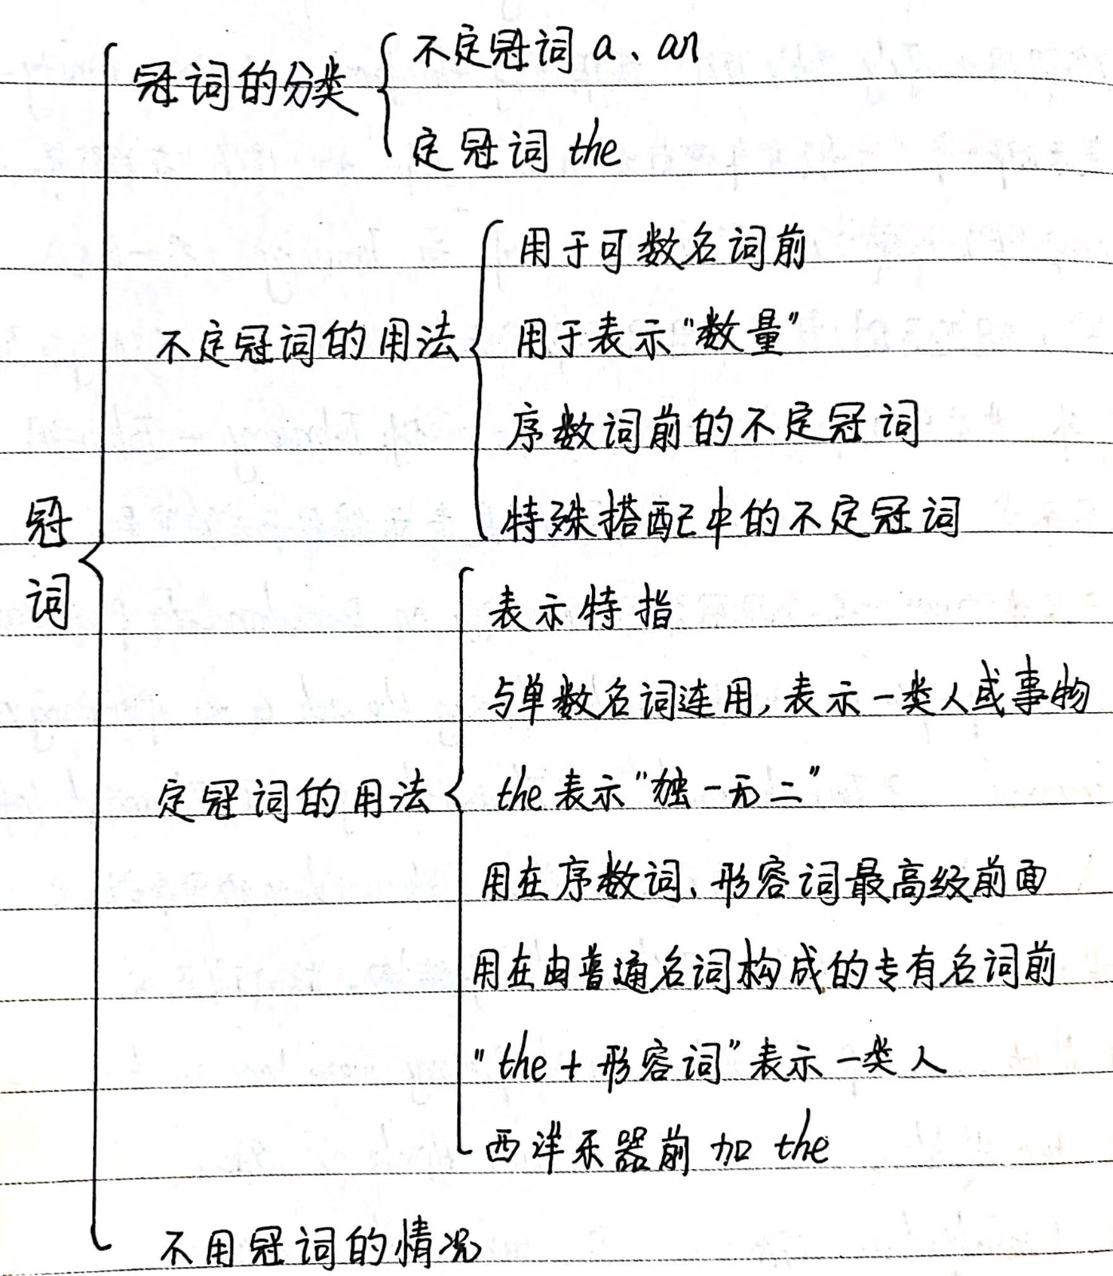
注：看发音，而不是看字母，元音字母不等同于元音音素
考点一：不定冠词a/an
一、不定冠词a/an的区别
a：用于以 辅音 音素开头的单数可数名词前 如：一个男孩 a boy 一只小狗 a dog
an：用于以 元音 音素开头的单数可数名词前 如：一个苹果 an apple 一个鸡蛋 an egg

【提示】即使单词拼写以辅音字母开头，如果词的读音是元音音素开头，也要用an。反之,即使拼写以元音字母开头，但读音是辅音音素开头，要用a。
【特例】
特殊情况 | 用法 | 例子
以“e”字母开头的单词 | e字母不发音 | a European country 一个欧洲国家
以“u”字母开头的单词 | u字母发/ʌ/ | an umbrella 一把雨伞 an unusual thing 一件不寻常的事
 | u字母发/ju:/ | a university 一所大学 a useful book 一本有用的书  a usual man 一个平凡的男人
以“h”字母开头的单词 | h字母不发音 | an hour 一小时 an honor 一项荣誉  an honest boy 一个诚实的男孩
二、不定冠词a/an的用法
用 法 | 举 例
泛指人或事物的类别 | A plane is a machine that can fly.
泛指某人或某物 | A boy is waiting for you.
表示数量“一” | He is an honest boy.
用于固定搭配中 | a lot have a rest a little in a hurry
用于序数词前，表示“又一；再一” | I have read the book twice，but I want to read a third time.

考点二：定冠词the
【记忆口诀】“独 旧 双 方 级 乐 序，姓 形 山河 惯 建筑”
用 法 | 举 例
特指某(些)人或某(些)事物 | The girl in a hat is my sister.
用于世界上独一无二的事物前 | The moon goes around the earth.
指上文已经提到的人或事物 | Here is a book. The book is Jim’s.
指谈话双方都知道的人或事物 | Open the door, please.
用在方位名词的前面 | The sun rises in the east.
用在最高级的前面 | She is one of the best students in our class.
用在西方乐器名词的前面 | He often plays the violin after school.
用在序数词的前面 | The third truck carries the fewest of all.
用在姓氏复数的前面表示“一家人或夫妇” | The Greens are watching TV.
用在形容词的前面表示“一类人或事物” | The young should respect the old.
用在普通名词构成的专有名词前 | the Yellow River, the Great Wall
用在习惯用语中 | in the morning, at the foot of
【拓展延伸】在一些短语中，有无定冠词含义不同
①$\left\{\begin{matrix}at school 在上课 \\ at the school 在学校里\end{matrix}\right.$ ②$\left\{\begin{matrix}at table 在吃饭 \\ at the table 在桌旁\end{matrix}\right.$
③$\left\{\begin{matrix}in hospital 住院 \\ in the hospital 在医院里\end{matrix}\right.$ ④$\left\{\begin{matrix}by sea 乘船 \\ by the sea 在海边\end{matrix}\right.$
⑤$\left\{\begin{matrix}in class 在上课 \\ in the class 在班级里\end{matrix}\right.$ ⑥ $\left\{\begin{matrix}in front of 在（……外部的）前面 \\ in the front of 在（……内部的）前面\end{matrix}\right.$
基础练习
用a、an或the填空
1.We had _____a______ good time in the park.
2.____The_____ story of Three Visits to the Hut is about Liu Bei and Zhuge Liang.
3.____The_____ boy riding a bike is Jim.
4.____The_____ sun goes down in the west.
5.There is _____an_____ orange on the table. ____The_____ orange smells very sweet.
6.Linda is practicing playing _____the_____ piano.
7.There’s _____a______ black pencil on the desk.
8.I had _____an_____ apple and two eggs for breakfast.
9.Mrs Smith bought _____an_____ umbrella for her daughter yesterday.
10.The student who is singing is _____a______ European girl.

考点三：零冠词“/”或“不填”
不用冠词的情况(零冠词) | 举 例
名词前已经有物主代词、指示代词、不定代词或所有格修饰时 | This is my book.  That is Jim’s book.
用在不可数名词和复数名词前 | They are workers.
在表示球类、学科、语言和三餐的名词前 | We often play basketball or learn Chinese after breakfast.
在某些专有名词前,如国名、人名、地名等 | Mr Brown is from America.
在季节、月份、星期等名词前 | Spring comes after winter.
在称呼、头衔、职务前 | Where’s my bag, Mum?
在公共节日、假日名词前 | March 8th is Women’s Day.
用在与by连用的交通工具名词前 | Did you come by train or by ship?
在一些习惯用语中 | go to school, at night
基础练习
用适当的冠词填空，不必填处画“/”。
1. I fell at school today while I was playing / volleyball.
2. I really want to learn to play the guitar. But my parents ask me to lot to get good grades.
3. Mary doesn’t really want to spend an hour or more traveling on the train. And she doesn’t need such a big house.
4. There are many animals living on the earth, and they should have a place here just like humans.
5. I would advise you to do some exercise there at / least twice a week.
6.Thanks for listening and hope you have a good time here in Sea World.
7. I went to a university in New Zealand. The university was set up in early twentieth century.
8. I’ve read a lot about the Great Wall. Now that I come to China, it's a good chance for me to visit it.
9. Kevin is a boy willing to help those in / trouble.
10. China is the largest country in population.
真题演练

一、单项选择
1.(2023·连云港中考)China is___B___country with a history of more than 5,000 years.
A.the B.a C.an D./
2.(2023·滨州中考)—What do you think of the guide book Lonely Planet?
—Oh,it is really ___C___useful one.You can always find ______information you need while traveling.
A.a;a B.an;an C.a;the D.an;the
3.(2023·绥化中考) Bob is my brother.He likes playing__B___basketball,but he doesn’t like playing______piano.
A.the;a B./;the C.an;the
4.（2023·天津中考）My mother is making ___C____ apple pie and I want to try ________ piece.
A.a; an B.a; 不填 C.an; a D.an; 不填
5.（2023·湖南岳阳·统考中考真题）Hangzhou will hold ____C____ 19th Asian Games in 2023.
A．a B．an C．the
6.（2023·云南玉溪·统考一模）It took my sister half ____B____ hour to play ________ piano yesterday.
A．a; the B．an; the C．a;/ D．an; /
7.（2023·云南文山·统考一模）—Many of my classmates were ill these days. Most of them had ____A____ fever.
—So did my classmates. We must pay attention and take care of ourselves.
A．a B．an C．the D．/
8.（2023·云南昆明·统考一模）Kunming, ___C___ capital of Yunnan, is called “Spring City”.
A．a B．an C．the D．/
9.（2023·云南·统考一模）—I can’t imagine life without Wi-Fi. It’s convenient.
—Sure. Wi-Fi is ___B____ important invention. It makes our mobile phones more powerful.
A．a B．an C．the D．/

