
专题十二 动词的语态

语态问题是中考高频考点，考生在备考时应注意熟练掌握各种时态下的被动语态所表示的意义、其结构和相关的时间状语。解答此类题时，可根据具体语境、时间标志词、从句和主句的时态搭配、固定句型等判断出正确答案。常以单项选择、语法选择、语法填空、词语运用等考查。


知识梳理
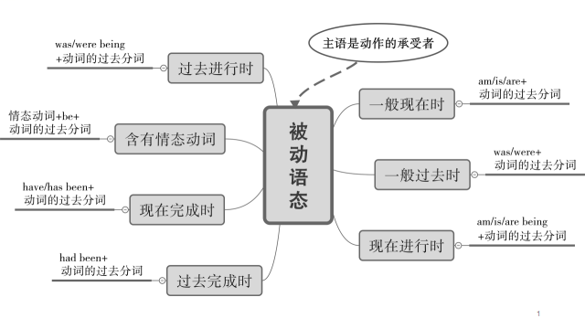
考点一：被动语态的定义及结构
一、被动语态的定义
语态是动词的一种特殊形式，用来说明主语与谓语动词之间的关系。所以英语的语态是通过动词形式的变化表现出来的。
英语中有两种语态：即主动语态和被动语态。
当主语为动作的执行者（即某人做某事）时，谓语的形式为主动语态；
当主语为动作的承受者（即某事被做）时，谓语的形式为被动语态。
二、被动语态的结构
被动语态由“助动词 be +及物动词的过去分词（be + done）”构成。它和主动语态一样有人称、数和时态的变化，主要通过助动词be的变化来体现。
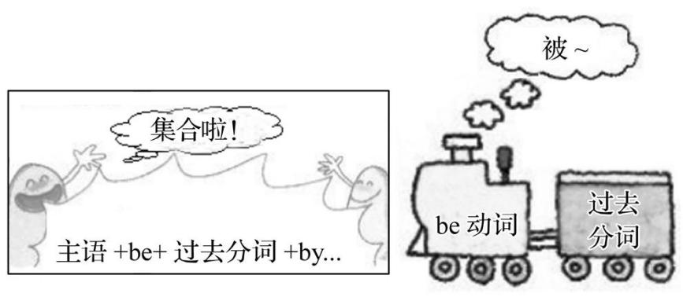
【注意】（1）有时 by短语可以省略。
（2）主动语态的时态是由谓语动词来体现的，而被动语态的时态是由be动词来体现的。

主动语态
I clean my room.
动作的执行者（主语）
谓语动词
动作的承受者（宾语）
被动语态
My room is cleaned by me.
动作的承受者（主语）

be+动词的过去分词
by +动作的执行者（宾语）

三、被动语态的句型
1.肯定句：主语+ be +过去分词( + by... ) 如：English is spoken everywhere. 到处有人说英语。
2.否定句：主语+ be + not +过去分词( + by...) 如：English isn’t spoken by people here. 这里的人不说英语。
3.一般疑问句：Be +主语+过去分词(+ by...)? 如：—Is English spoken everywhere? 到处有人说英语吗？
—Yes, it is./No, it isn’t. 是的，到处有。/不，没有。
4.特殊疑问句：特殊疑问词+ be +主语+过去分词(+by...)? 如：Why was this bridge destroyed by the government? 政府为什么要拆毁这座桥?

考点二：被动语态的用法
被动语态的主语是动作的承受者，主要用于以下几种情况：
1.不知道动作的执行者是谁。
如：The window was broken last night. 昨晚窗户被打破了。
2.没有必要指出动作的执行者是谁。
如：Rice is grown in the south of China. 中国南方种水稻。
3.需要强调或突出动作的承受者。
如：Chinese is spoken by more and more people in the world. 世界上越来越多的人讲汉语。（强调汉语广泛使用）
4.动作的发出者不是人。
如：Many houses were washed away in the flood. 在洪水中许多房子被冲走了。
考点三：常见不同时态的被动语态及其构成
几种常见时态的主动语态和被动语态的结构形式：
句型 | 主动语态 | 被动语态 | 例句
一般现在时 | ①am/is/are  ②do/does | am/is/are +过去分词 | This kind of bag is made in China.
一般过去时 | ①was/were  ②did（V.-ed） | was/were +过去分词 | The task was completed by us yesterday.
一般将来时 | will/be going to + do | will/be going to + be +过去分词 | A new road will be built next year.
现在进行时 | am/is/are + doing | am/is/are + being +过去分词 | A novel is being read by him.
过去进行时 | was/were + doing | was/were + being +过去分词 | The problem was being discussed.
现在完成时 | have/has + done | have/has been +过去分词 | The work has already been finished by us.
过去完成时 | had + done | had + been +过去分词 | A new hotel had been built when I got there.
含情态动词 | 情态动词+ v. | 情态动词+ be +过去分词 | English can be spoken by him.
基础练习
一、用括号内所给动词的适当形式填空。
1. Our classroom ___is cleaned____(clean) every day.
2. Gunpowder ___was invented___ (invent) by Sun Simiao.
3. Our new library may ___be finished____(finish) next month.
4. My car __is being driven___(drive) by Jack now.
5. My homework __will be done___(do) tomorrow.
6. Dinner __has been prepared___(prepare) for us by now.
7. She said these flowers ____had_____ already __been watered__(water) .
8. The girl said she _was being interviewed_(interview) at the time yesterday.
二、单项选择
1.Wang Yaping, who took part in the Shenzhou X mission in 2012, ___D____ for Shenzhou XⅢ in December 2019.
A. selected B. have selected C. is selected D. was selected
2.Breakfast ____C___ every day for people aged over 60 for free in this village.
A. provides B. provided C. is provided D. was provided
3.Mike wasn’t at home yesterday. He ___D____ to help with Jenny’s English.
A. was asking B. is asked C. is asking D. was asked
4.The 2024 Paris Olympic Games ____C____ between July 26th and August 11th, 2024.
A. hold B. will hold C. will be held D.held
5.Our headmaster said that our classroom must ___D____ by the student who is on duty everyday.
A. clean B. has been cleaned C. be cleaning D. be cleaned

考点四：主动语态和被动语态的转换
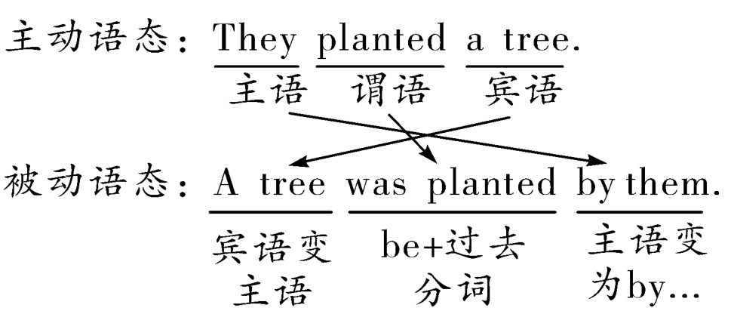

一、主动语态变被动语态“三步骤”
（1）宾变主：主动语态的宾语变为被动语态的主语；
（2）变谓语：主动语态的谓语动词变为与被动语态的主语保持一致的被动结构；
（3）主变宾：主动语态的主语变为“by+宾语”并置于被动语态的句末。“by+宾语”在口语中常省略。
二、主动语态变为被动语态的两个特殊点
含双宾语的主动句变被动句 | 常把间接宾语变为被动句的主语，直接宾语位置不变
 | 直接宾语作被动句的主语时，间接宾语前有时加介词to或for
含复合宾语的主动句变被动句 | 由形容词、名词作宾语补足语的主动句变被动句时，只需将宾语变为主语
 | 在主动句中，不定式用作动词一感（feel），二听（hear、listen to），三让（have、make、let），四看（look at、see、notice、watch），半帮助（help）等的宾语补足语时，需省略不定式符号“to”，但变为被动句时，必须加上“to”
如：My mother gave me a pencil. 妈妈送给我一支铅笔。
→I was given a pencil by my mother.
→A pencil was given to me by my mother.
I saw him cross the road and enter the shop. 我看到他穿过马路走进了商店。
→He was seen to cross the road and enter the shop(by me).
基础练习

1.I saw a stranger enter our library.（改为被动语态）
__A stranger was seen to enter our library by me___________.
2.We can find a lot of differences between the two languages.（改为被动语态）
__A lot of differences between the two languages can be found by us.
3.My father bought me a new bike.（改为被动语态）
__A new car was bought for me by my father./I was bought a new car by my father.
4.English is spoken by many people all over the world.（改为主动语态）
__Many people all over the world speak English____________.
真题演练

1.（2022·上海·统考中考真题）The research group discovered a new kind of insect last week.（改为被动语态）
A new kind of insect was discovered by the research group last week.
2.（2022·江苏南通·统考中考真题）They sell a lot of things in Oxfam shops to help people in need. (改为被动语态)
A lot of things are sold in Oxfam shops to help people in need.
3.（2022·贵州黔西·统考中考真题）Schools usually don’t allow students to wear their own clothes at school. (改为被动语态)
Students are usually not allowed to wear their own clothes at school.
4.（2023·上海浦东新·统考三模）We can see paper cutting in many parts of China during the Spring Festival.(改为被动语态)
Paper cutting can be seen in many parts of China during the Spring Festival.
5.（2023·上海青浦·统考二模）With the help of the recording pen, I’ve written down all the information I need. （改为被动语态）
All the information I need has been written down with the help of the recording pen.

考点五：主动结构表被动意义的情况
1.open，lock，write，read，sell，clean，watch，cut，burn，drive等词作不及物动词时，若主语为物，可用主动结构表被动意义。
如：This kind of pen writes very smoothly. 这种钢笔写起来很流畅。
This kind of shirt sells well here. 这种衬衫在这里卖得很好。
2.look， sound， taste， smell， feel等感官动词用主动结构表被动意义。
如：Light music sounds very soft. 轻音乐听起来很柔和。
Mooncakes taste very delicious. 月饼尝起来很好吃。
3.be worth doing sth.“值得做某事”，用主动形式表被动意义。
如：This book is worth reading. 这本书值得一读。
4.want/need/require＋doing相当于want/need/require＋to be done，to be done为不定式的被动结构。
如：My bike needs repairing.＝My bike needs to be repaired. 我的自行车需要修理。
真题演练

1.（2023·安徽滁州·统考二模）—What do you think of the graduation ceremony（典礼）?
— Oh, excellent, it’s worth ___C____ forever.
A．to remember B．be remembered C．remembering D．remembered
2.（2023·黑龙江绥化·校考二模）This pair of trousers ___A____ smooth because they are made of Chinese silk.
A．feels B．feel C．is felt
3.（2023·浙江·模拟预测）The machine doesn’t work. It needs mending/to be mended . (mend)
【核心提示】两步解决语态题：
Step 1：判定语态
1. 观察是否有被动语态的标志词by；
2. 看动词与主语的关系，主语是动作的承受者时，用被动语态；
3. 如果是“物”作主语，有可能用被动语态。
Step 2：确定时态
寻找时间状语或上下文暗示时态的词，确定具体用什么时态。

基础练习
一、单项选择
1.The villagers expect that the building of the bridge ___C____ before the rainy season comes.
A. is completed B. was completed C. will be completed D. has been completed
2.A baby's first month birthday is a special event in China and ___B____ with a special party.
A. celebrates B. is celebrated C. was celebrated D. will celebrate
3.Gina went to the doctor's yesterday and she ___C____ about the importance of good living habits once more.
A. told B. is told C. was told D. has told
4.A new club ___D____ in our school at the beginning of this year and now it has many members.
A. starts B. is started C. has started D. was started
5.—I haven't finished my report yet.
—You'd better hurry up. It must ___C____ to our teacher tomorrow.
A. handed B. hand C. be handed D. be handing
二、用所给词的适当形式填空
1.The new book will be sold (sell) on the Internet next month.
2.The children were taught (teach) to skate last year and now they can skate very well.
3.I was really moved (move) by the fighting spirit of my classmates in the sports meeting.
4.You need to brush (brush) your teeth after eating.
5.The book, Cha Jing, describes how tea plants are grown (grow) and used to make tea.
真题演练

一、单项选择
1.（2023·内蒙古）—Students in our school ___C____ to swim in the rivers or lakes alone.
—That’s true. After all, safety must come first.
A．allow B．don’t allow C．aren’t allowed D．is allowed
2.（2023·辽宁大连）The Qatar World Cup ___C____ from November 21 to December 18 last year.
A．holds B．held C．was held D．is held
3.（2023·江苏连云港）To make the environment much better, more trees ___D____ next year.
A．plant B．will plant C．are planted D．will be planted
4.（2023·辽宁营口·统考二模）There are so many places of interest in our country that are worth ___B____.
A．visit B．visiting C．to visit D．to be visited
5.（2022·甘肃定西·统考二模）—Do you need any help?
—No, thanks. We ___B____ a lot of support since last year.
A．have offered B．have been offered C．were offered D．are offered
6.（2023·辽宁丹东）Tea is very popular in the world. It ___C____ in many different areas in China now.
A．produces B．produced C．is produced D．was produced
7.（2022·湖北黄石）—Do you think junior high school students ___D____ to get their ears pierced?
—No, I don’t think so. It is against the school rules.
A．should allow B．allow C．have allowed D．should be allowed
8.（2022·四川凉山·统考模拟预测）The tickets for Fantastic Beasts: The Secrets of Dumbledore ___D_____ well, and they will _________soon.
A．are sold; sell out B．are sold; be sold out
C．sell; sell out D．sell; be sold out
9.（2023·辽宁营口·中考真题）—Students ___B____ a few open questions in Ms. Li’s class, did you notice that?
—Yes, I think she wanted to train their ability of creative thinking.
A．are asked B．were asked C．will be asked D．should be asked
10.（2023·安徽中考）Computers have had a great influence on learning methods since they___D____ into schools.
A. introduce B. introduced C. are introduced D. were introduced
二、用所给词的适当形式填空
1.（2023·西藏日喀则·统考二模）A lot of trees were planted (plant) by the volunteers last spring.
2.（2023·甘肃兰州·一模）Lanzhou Olympic Sports Center was completed (complete) in 2022 and now is open.
3.（2023·湖南永州·统考一模）Tina can’t be allowed (allow) to go out with friends at night.
4.（2023·甘肃白银·统考二模）In the future, many difficult tasks will be done (do) by smart robots.
5.（2023·江苏淮安·校联考二模）The documentary China in the Classics is well worth watching (watch).
6.（2023·内蒙古包头·包钢第三中学校考三模）Mr. White said his children were not allowed to use mobile phones before the age of 13. (allow)
7.（2023·甘肃酒泉·统考二模）In order to live in a better place, the natural environment must be protected(protect) by all the people.
8.（2023·江苏无锡·统考一模）Billions of coffee cups are thrown (throw) away in the UK each year. A change in recycling is necessary.
9.（2022·江苏无锡·统考中考真题）My brother’s flight was canceled (cancel) because of the bad weather.

