
专题七 形容词和副词



知识梳理

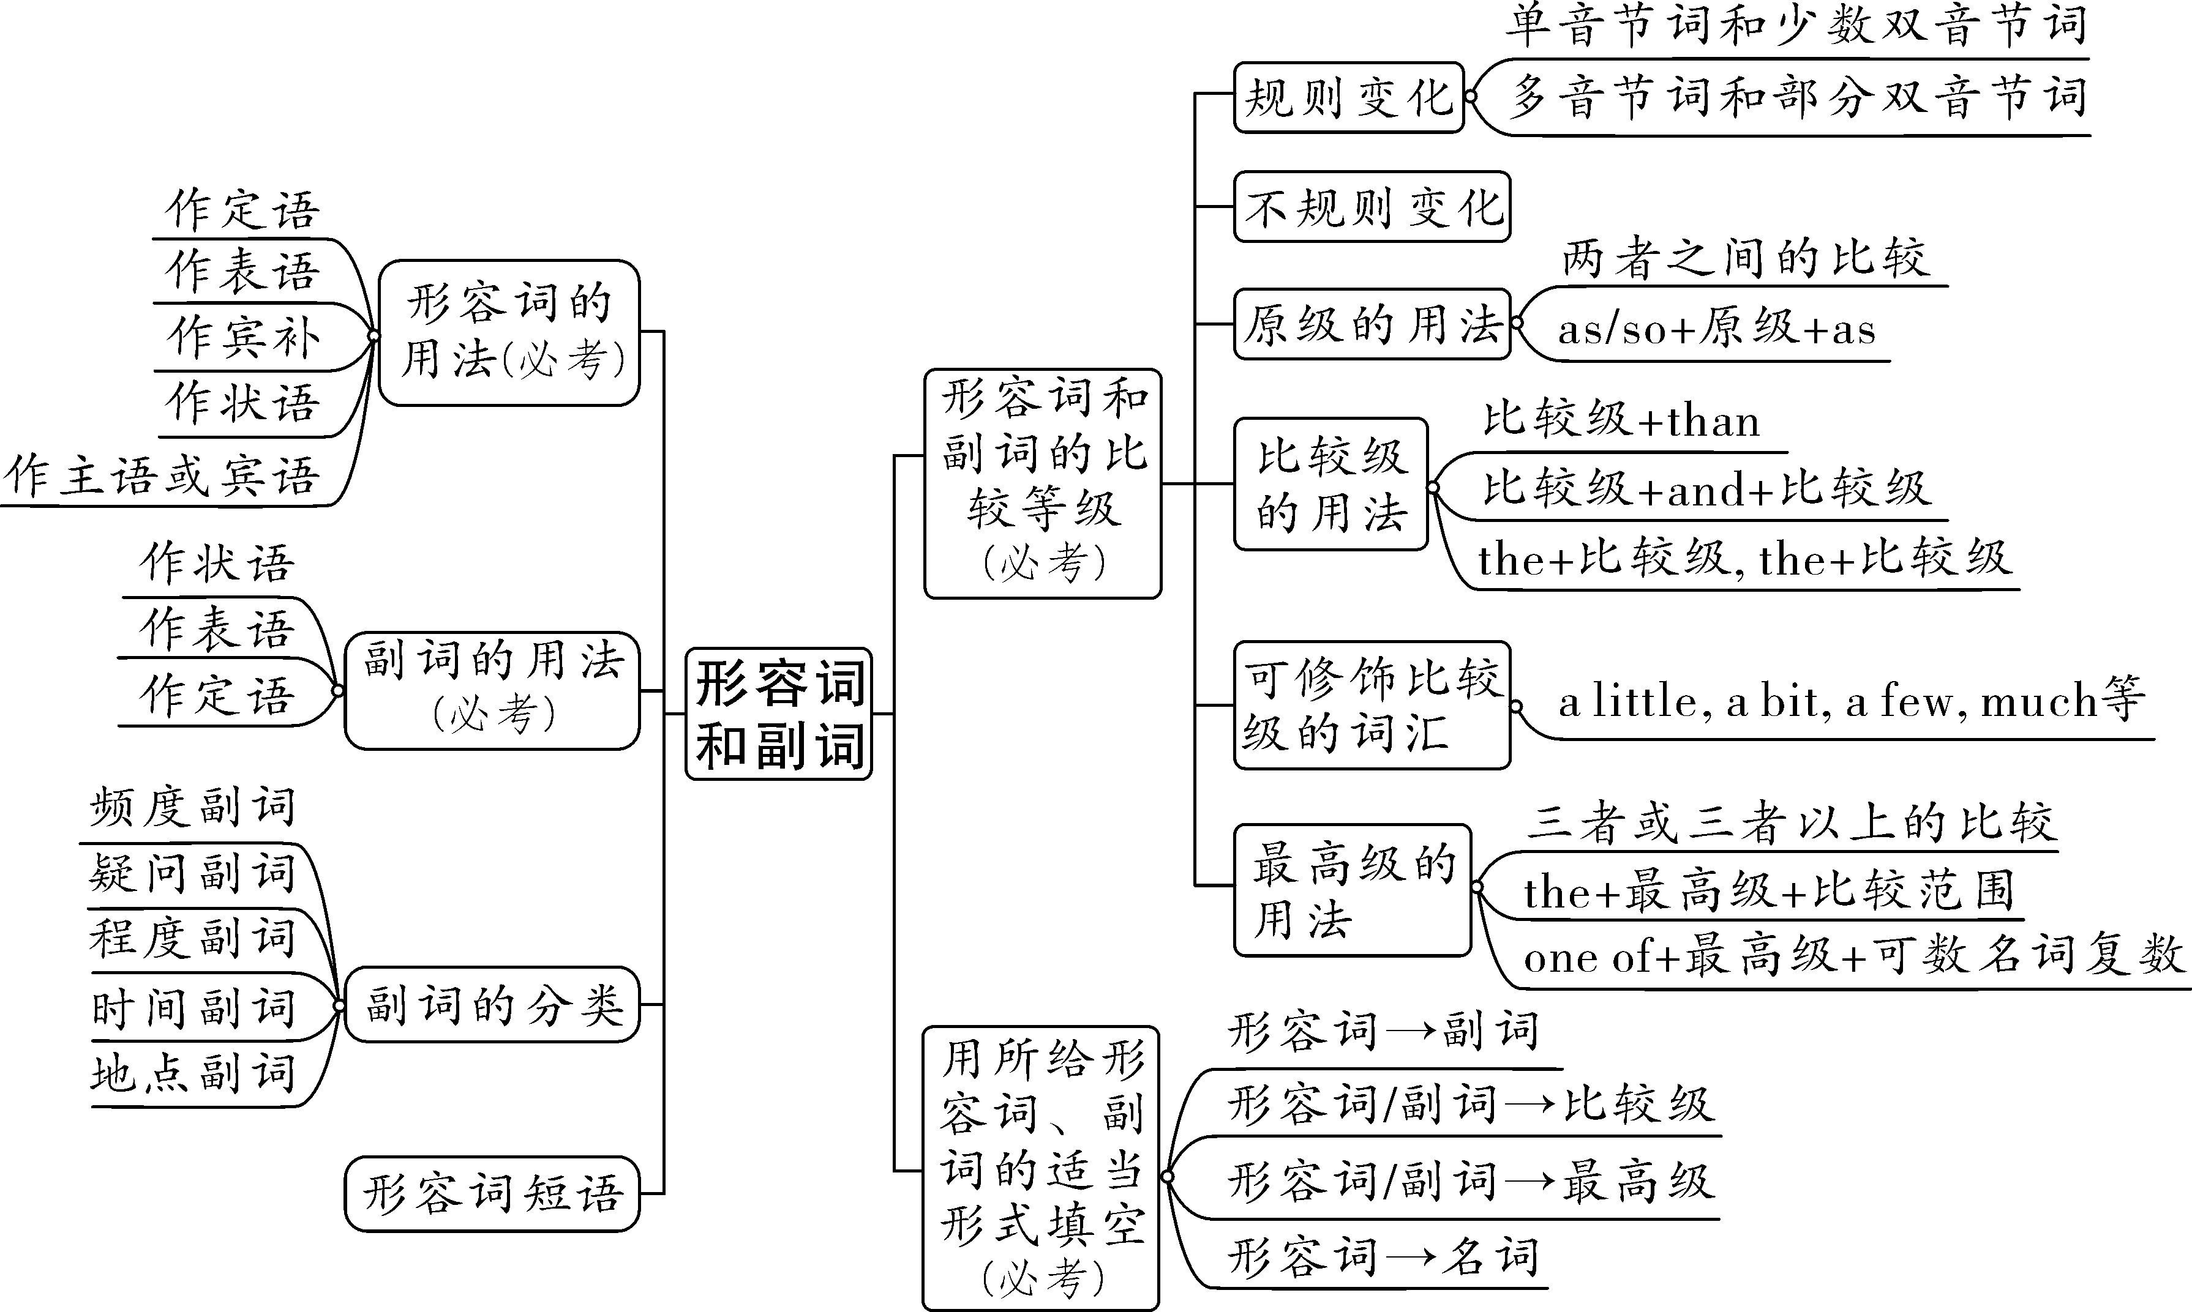

第一部分 形容词和副词
考点一：形容词的定义、用法及位置
一、形容词的定义
形容词是用来说明人或事物特征、性质和状态的词，常用来修饰名词或不定代词。在句中可作定语、表语和宾语补足语。
二、形容词的用法
1.形容词作定语：放在 名词 之前， 复合不定代词 之后。
如：This is an interesting story. 这是一个有趣的故事。
Did you do anything special yesterday? 昨天你做了什么特别的事吗？
【知识拓展】多个形容词作前置定语修饰一个名词时，其先后顺序一般遵循的规律：描绘性形容词（大小+长短+形状+年龄或新旧+长幼+颜色）+地区或产地+材料+用途+名词。我们可以简记为：描、形、年、颜、地、材、途。
如：There is a beautiful round new black Russian wooden table in my house.我家里有一张漂亮的又圆又新的黑色俄罗斯木桌。
2.形容词作表语：放在 系动词 之后，构成系表结构。
如：My English is pretty good. 我的英语十分好。
This kind of food smells bad but tastes delicious. 这种食物难闻但很好吃。
3.形容词作宾语补足语：放在宾语之后，常与make、keep、leave、find等动词连用。
如：It’s cold outside. Please keep the window closed. 外面很冷，请让窗户关着。
I find it difficult to learn English well. 我发现学好英语很难。
This story made me very sad. 这个故事使我很伤心。
4.形容词作状语：用来说明主语的情况，表示原因、结果、伴随、时间、条件或方式，可位于句首、句中或句末，一般用逗号将其与其他部分隔开。
如：The boy went to school, cold and hungry. 那个男孩又冷又饿地去上学了。
5.形容词作主语或宾语：主要用于“the+形容词”，表示一类人或事物，这种形容词已名词化了。
这些常见的形容词有：good/bad; rich/poor; young/old; deaf/blind; black/white; living/dead
如：We should respect the old and love the young. 我们要尊老爱幼。

考点二：副词的定义、用法及位置
一、副词的定义
副词是用来说明时间、地点、程度、方式等概念的词，主要修饰动词、形容词、副词或句子。在句中作状语、表语和定语。
二、副词的用法
1.副词作状语：修饰动词、形容词、副词，有时也可修饰整个句子。
如：The visitors were warmly received by the hosts.【修饰动词，位于动词 前 （前/后）】
I can’t walk quickly. Because I hurt my leg yesterday. 【修饰动词，位于动词 后 （前/后）】
This book is really interesting.【修饰形容词，位于形容词 前 （前/后）】
They can draw very well.【修饰副词，位于副词 前 （前/后）】
Luckily, no one was hurt. 【修饰句子，常用逗号与后面的句子隔开】

2.副词作表语：用来表明状态和位置。
如：I must be off now.我现在得走了。
My mother has been away for a week.我母亲外出已有一个星期了。
3.副词作定语：时间副词now、then以及一些地点副词可放在名词后面作定语。
如：Women there lived a terrible life in the 1920s. 在二十世纪二十年代那儿的妇女过着可怕的日子。
People now often have their festival dinner at restaurants. 现在的人们经常在餐馆里吃节日晚宴。
三、副词的分类
类别 | 位置 | 例词
频度副词 | 一般放在 be动词 、 情态动词 、 助动词 之后， 实义动词 之前 | always > usually > often > sometimes > hardly ever > seldom > never; once（一次）、twice（两次）
疑问副词 | 放在句首，用于对句子进行提问 | how、when、where、why、how often、how long、how far、how soon等
程度副词 | 修饰动词、形容词或副词时，放在动词、形容词或副词 前 （前/后），但是enough位于“ 名 前 形副 后” | too、very、much、so、such、quite、enough、almost、little、really、only等
时间副词 | 一般放在句首或句尾 | today、tomorrow、now、ago、before、already、then、just、after、still等
地点副词 | 一般放在句尾，但here、there可放在句首 | here、there、home、everywhere、inside、outside、upstairs、downstairs等

★★【知识拓展一】由how构成的特殊疑问词组的用法：
how词组 | 含义 | 用法 | 答语
how far | 多远 | 提问距离 | It’s + 5 meters/10 minutes’ walk等表距离的词语
how long | 多久  多长 | 提问时间 | for/about+时间段
 |  | 提问物体长度 | 10km等表示长度的词语
how soon | 多久以后 | 提问时间（常用于一般将来时） | in+时间段，表示“在多久以后”
how often | 多久一次 | 提问频率 | once, twice, always等表示频率的词语
how old | 多大 | 提问年龄 | 12 years old等表示年龄的词语
how many | 多少 | 对 可数 名词的数量进行提问 | 100等具体的基数词或several等修饰可数名词的词语
how much | 多少 | 对 不可数 名词的数量进行提问 | a lot of, 3 glasses (of)等用于表达不可数名词的量的词语
 | 多少钱 | 提问价格 | 5 dollars, 2 yuan a kilo等表示价格的词语

★【知识拓展二】四个“也”的用法：
副词 | 用法 | 例句
too | 用于 肯定 句，位于句 末 ，用逗号和前面句子隔开 | I am a teacher, too. 我也是个老师。
also | 用于 肯定 句，位于句 中 （实前be情助后） | I am also good at English. 我也擅长英语。  I can also swim. 我也能游泳。
either | 用于 否定 句，位于句 末 | I can’t speak English either.  我也不会说英语。
as well | 用于 肯定 句，位于句 末 | He speaks English, and he knows French as well. 他说英语，也懂法语。
基础练习

一、单项选择
1.-I can't stand swimming in cold rivers in winter.
-But it’s A for your health. You know I often swim in rivers in different seasons.
A. helpful B. harmful C. painful D. careful
2.The coach thinks D of Mary's sports talents, for she jumped very at the sports meeting.
A. high; high B. highly; highly C. high; highly D. highly; high
3.The cake tastes C and it is really delicious.
A. well B. badly C. good D. bad
4.-I D eat vegetables.
-But they are good for your health! We should eat them every day.
A. often B. usually C. always D. seldom
5.I fell off the bike on my way to school. A , I wasn't hurt.
A. Luckily B. Suddenly C. Politely D. Recently
二、用所给词的适当形式填空
1.He put on his coat and went out quickly (quick).
2.Mobile phones are widely (wide) used in most of the cities in China.
3.My purse was stolen on the bus yesterday. Fortunately ( fortunate), there was no money in it.
4.A lot of Chinese people are proud (pride) of Ma Long, a famous table tennis player.
5.It’s snowing hard. You must drive carefully (careful).
真题演练

一、单项选择
1.（2023·西藏）Chinese folk music sounds ___C____. I like it very much.
A．bad B．badly C．beautiful D．beautifully
2.（2023·内蒙古）After the 2022 Spring Festival Gala, dance-poem drama Thousands of Miles of Mountains and Rivers（《只此青绿》）became ___B____ known all over China.
A．wisely B．widely C．wide D．wise
3.（2023·西藏）Wu Jing is a famous actor in China. He does Chinese kung fu ___B____.
A．good B．well C．great D．bad
4.（2022·辽宁沈阳）People should ___D____ pick up the rubbish whenever they see it.
A．never B．seldom C．sometimes D．always
5.（2022·山东滨州）—Bill, I planned to give you the card on Saturday, but I ___A____ forgot.
—That’s OK. I won’t use it until next weekend.
A．completely B．recently C．quietly D．clearly
6.（2022·四川达州）—Jessica, it’s raining ___A____ outside.
—Oh, you should be ________ when you drive to work.
A．hard; careful B．hardly; careful C．hard; carefully D．hardly; carefully
7.（2023·辽宁鞍山）Alice felt ___B____ in her new school, so she joined some clubs to make new friends.
A．sleepy B．lonely C．interested D．excited

第二部分 形容词和副词的比较等级
大多数形容词和副词有三个等级： 原级 、 比较级 和 最高级 。比较级表示“更……”，用于两者之间的比较，后面用连词 than 连接另一个所比较的人或事物，说明“前者比后者更……”。最高级用于三个或三个以上的人或事物之间的比较；常用of/in来说明比较的范围；形容词和副词前要加定冠词 the ，副词最高级前的the有时可省略。

★★★考点一：形容词和副词比较等级的变化规则
一、比较等级的规则变化
类别 | 构成 | 原级 | 比较级 | 最高级
单音节词和少数双音节词 | 一般在词尾 加-er/-est | tall  slow | taller  slower | tallest  slowest
 | 以字母e结尾 加-r/-st | large  late | larger  later | largest  latest
 | 以重读闭音节结尾，如末尾只有一个辅音字母(辅元辅),则双写末尾辅音字母，再加-er/-est | big  hot | bigger  hotter | biggest  hottest
 | 以“辅音字母+y”结尾的词,  变y为i再加-er/-est | easy  happy | easier  happier | easiest  happiest
多音节词和部分双音节词 | 所有多音节和部分双音节词, 在词前加more/most | interesting  important | more interesting  more important | most interesting  most important

二、比较等级的不规则变化
原级 | 比较级 | 最高级
good, well (好) | better | best
bad, badly, ill (坏) | worse | worst
many, much (多) | more | most
little (小;少) | less | least
old (老) | older | oldest
 | elder | eldest
far (远) | farther | farthest
 | further | furthest
基础练习
用所给词的适当形式填空
1.Rose's father is the busiest (busy) in the hospital, because he is an excellent doctor.
2.Sometimes keeping silence is much cleverer (clever) than speaking out straight.
3.My sister is a ninth grade student and she is three years older (old) than me.
4.Thomas is the shortest (short) player in the basketball team but he is the best.
5.Gold is much more expensive (expensive) than iron.
6.She is better (good) than Li Ping at swimming.
7.I buy books on the Internet, because they are cheaper (cheap) than those in the bookshop.
8.London has lots of beautiful parks and gardens, but its air pollution is the worst (bad) in Europe.
9.We study math, English, Chinese, history and music at school. But I like history best (well).
10.The earth we live on is bigger (big)than the moon.

★★考点二：形容词和副词比较等级的常考句型及用法
类型 | 结构 | 意义 | 举例
原级 | as+形容词/副词原级+ as | 和……一样 | She is as tall as her mother.
 | not as/so+形容词/副词原级+as | 不如……那样 | The weather here is not as/so hot as that in Wuhan.
比较级 | 比较级+than | 比…… | My brother is taller than me.
 | 比较级+and+比较级  多音节和部分双音节词用  “more and more+原级” | 越来越…… | My home town is becoming more and more beautiful.
 | the+比较级，the +比较级 | 越……，  就越…… | The more friends I have, the happier I feel.
最高级 | one of the+最高级+名词复数 | 最……之一 | His grades are the best of all in our school.
【注意】当表示一方超过另一方的“程度”时，可以用much, a lot, a little, a bit, even, far等来修饰形容词比较级。注意：比较级不能用very, so, too等修饰。
Eg.He is much more serious than his brother. 他比他弟弟稳重多了。
This book is even more useful than that one. 这本书甚至比那本更有用。
Can you come to school a little earlier tomorrow morning? 明天早上你能早点来学校吗？
【记忆口诀】两多（much, a lot）两少（a little, a bit）一甚至（even），还有一个远（far）去了。
基础练习
根据汉语完成句子,每空一词
1.我们的教室和他们的教室一样干净。
Our classroom is _____as______ ____clean______ _____as______ theirs.
2. 我们的国家正变得越来越强大。
Our country is becoming ___stronger______ ____and______ ____stronger_____.
3.你练习得越多,就会犯越少的错误。
____The______ ____more_____ you practice, _____the_____ ____fewer_____ mistakes you will make.
真题演练

一、单项选择
1.（2023·内蒙古呼和浩特）The air has been much ___D____ these years. Governments are taking action against pollution.
A．badly B．worst C．bad D．worse
2.（2023·四川雅安）—Mike plays basketball well. Do you know him?
—Sure. He is also one of ___D____ basketball players in our class.
A．tall B．the taller C．tallest D．the tallest
3.（2022·山东济南）Although Lingling studies online at home, she studies ___B____ than before.
A．hard B．harder C．hardest D．the hardest
4.（2023·云南昭通·统考一模）—Will you go to the airport by bus?
—I’d rather take a taxi. It’s much ___B____.
A．fast B．faster C．fastest D．the fastest
5.（2022·云南临沧二模）—The Chinese women’s football team won the 2022 AFC Women’s Asian Cup title.
—Great! ___B____ you know about the Chinese women’s team, ________ you’ll love the girls.
A．The more; the most B．The more; the more
C．The most; the more D．The most; the most

第三部分 用所给形容词、副词的适当形式填空
用所给形容词、副词的适当形式填空包括形容词变副词、形容词/副词变比较级、形容词/副词变最高级、形容词变名词。
考点一：形容词变副词
一、形容词变副词的变化规则：
形容词 | 构成方法 | 举例
一般情况 | 直接在词尾加ly | quick→ quickly slow→ slowly
以“辅音字母+y”结尾 | 变y为i再加ly | happy→ happily heavy→ heavily
以le结尾 | 去e加y | terrible → terribly possible→ possibly
元音字母+e结尾 | 去e加ly | true → truly
特殊变化 |  | good→ well
二、填副词的判断方法如下：
1.动词＋副词/副词＋动词
如：ask for help politely (polite)
He quickly (quick) laid out her favorite fruits.
2.句子＋副词
如：The little girl is running after a butterfly happily (happy) in the garden.
3.副词＋形容词
如：One needs three things to be truly (true) happy in life.

考点二：形容词/副词变比较级
填比较级的判断方法如下：
1.标志词than， much， even， far等修饰（“两多两少一甚至，还有一个远去了”）
如：much faster (fast) than 4G network；feel even sadder (sad) ；play chess even better (good) than humans；
have much less (little) private time
2.the＋比较级...， the＋比较级...
如：The harder (hard) you study, the greater (great) progress you will make.
3.比较级＋and＋比较级
如：more and more (much) beautiful
考点三：形容词/副词变最高级
填最高级的判断方法如下：
1.标志词 in China， in the world， of all
如：Spring Festival is the biggest (big) festival in China；use the Internet most (much) in the world
2.one of＋the＋最高级+名词复数
如：one of the most popular (popular) players
3.固定搭配中
如：try my best
4. the＋序数词＋最高级
如：It is the second tallest (tall) building in the world
5.上下文语境
如：Beipanjiang Bridge in my hometown is the coolest (cool) one I have ever seen.

考点四：形容词变名词
一、填名词的判断方法如下：
1.a number of/the number of＋名词复数
2.形容词性物主代词＋名词
3.固定搭配（the+名词+of）
二、常考的“形容词变名词”的形式如下：
构成 | 示例
形容词＋ness | happy→ happiness kind→ kindness shy→ shyness
形容词＋ty/ity/y | safe→ safety difficult→ difficulty
形容词 (以t结尾的)  去掉­t＋ce | confident→ confidence patient→ patience important→ importance  different→ difference
其他 | foreign→ foreigner true→ truth wonderful→ wonder

基础练习
用所给词的适当形式填空
1.In summer, it often rains ___heavily_____(heavy) with strong wind in Southern China.
2.Lucy used to be ___really_______(real) shy. So she took acting classes to deal with her shyness.
3.The higher we climbed, the ____thinner____(thin) the air became.
4.Many classic poems are ___widely______(wide) spread in the world.
5.The library is between the school and the hospital. You can find it ____easily_____(easy).
6.The nurse always treats the sick and the wounded with ___kindness____(kind).
7.To achieve our dreams, we must take every choice ___seriously_____(serious).
8.Some people believe water yoga really helps people keep away from ___illness_____(ill).
9.For your ___safety_____(safe), smoking is not allowed during the whole flight.
10.We certainly meet many ___difficulties___(difficult) in our life, but we must learn to overcome them.
11.__Recently____(recent), he has made progress in playing the piano with the help of his teacher.
12.The earlier kids learn to be independent, the ____better_____(good) it is for their future.
13.In order to keep safe, my mother always tells my father to drive ___slowly____(slow) on roads.
14.My daughter is much ____taller______(tall) now. The jeans she wore last year are already too short.
15.Actions are more important than words. People who knows most always says ____least_____(little).
真题演练
用所给词的适当形式填空
1.（2023·云南昆明·昆明八中校考二模）We __gradually____ understand that moms know best and they only want the best for us. (gradual)
2.（2023·云南玉溪·统考一模）As a good student, he is ___widely____ known in our school. (wide)
3.（2023·云南玉溪·统考一模）Having enough sleep, I feel much ___stronger___ and can have a long run. ( strong)
4.（2023·云南昭通·统考一模）As we all know, Mozart was one of the greatest __musicians__ (music) all over the world.
5.（2023·云南·统考一模）Yunnan is full of flowers and animals. That is one of the __most important___(important) reasons why COP 15 was held here.
6.（2023·云南昭通·统考一模）The boy was so clever that he solved that problem ___easily____(easy).
7.（2023·云南临沧·统考一模）The birds are singing ___happily____ in the tree outside. (happy)
8.（2023·云南昆明·统考一模）I’m ___truly____ thankful for all your help. (true)
9.（2023·云南昆明·统考一模）For me, ___happiness___ means enjoying life and not caring about unimportant things. (happy)
10.（2022·云南曲靖·统考一模）It is important for us to know how to make our own choices ___wisely___. (wise)

