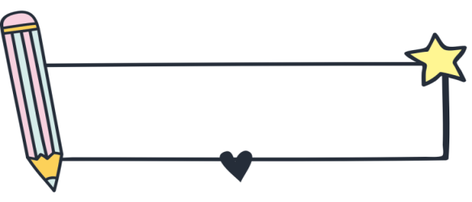
专题九 情态动词

情态动词是表示能力、义务、命令、猜测等说话人的语气或情态的动词。情态动词本身有各种意义，但不能单独作谓语，只能和实义动词一起构成谓语，表示说话人的语气和情态。


知识梳理

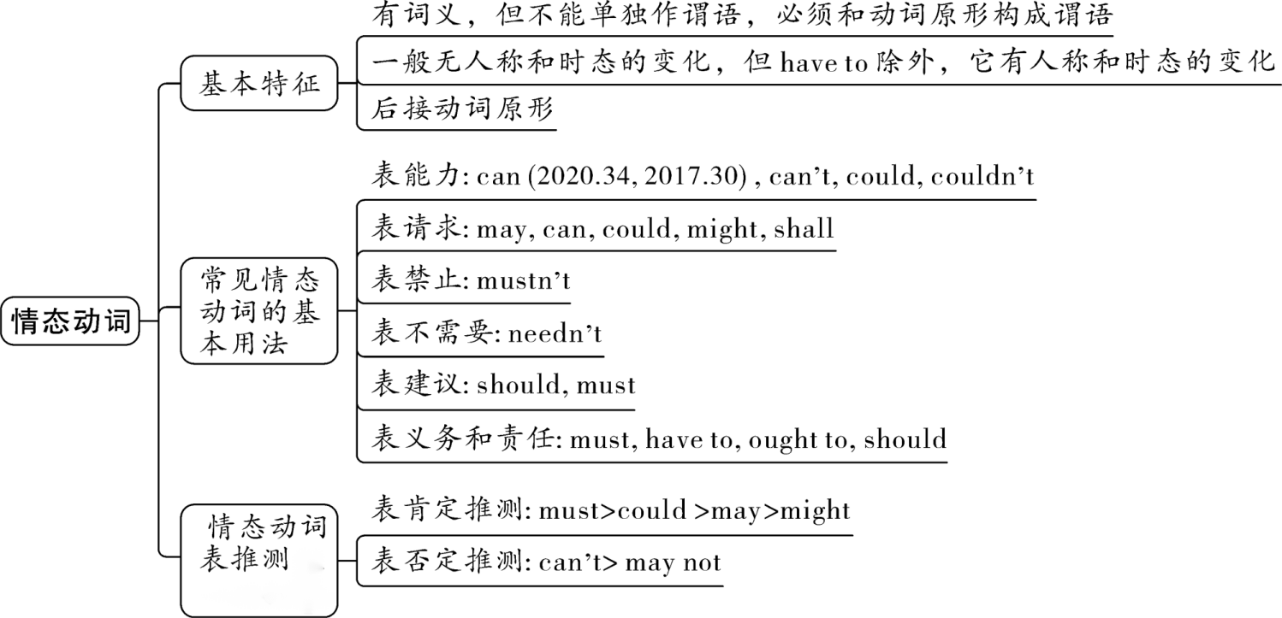
考点一：情态动词的类型和基本特征
一、情态动词的类型
1.只作情态动词的有：must; can (could); may (might)；
2.可作情态动词也可作实义动词的有：need；
3.可作情态动词也可作助动词的有：will (would); shall (should)；
4.具有情态动词的某些特征的有：have to; ought to
二、情态动词的基本特征
1.情态动词本身词义不完全，不能单独作谓语，必须和动词 原形 连用构成谓语；
2.无人称和数的变化 （have to例外，用于第三人称单数时用has to）。
如：We must stay here. /He must stay here. 他必须呆在这儿。
We have to walk home. /He has to walk home. 他不得不步行回家。
3.后接动词原形
如：She may lose her way. 她可能迷路了。
4.具有助动词的作用，可用来构成否定句、疑问句及用于简明答语。（情态动词的否定式一般在其后面加not构成，一般疑问句通常将其提到句首。）

考点二：常见情态动词的基本用法
情态动词 | 含义及用法 | 例句
can | 表示能力，意为“能、会”，可与be able to互换 | I can say “nihao” in different languages.
 | 表示请求、允许，意为“可以” | Can you give me a hand? I lost my way here.
can’t | 表示能力，意为“不能，不会” | I can play the piano, but I can't sing or dance.
 | 表示 否定 推测，语气强烈。意为“不可能”，可能性几乎为零 | Miss Gao can’t be in the classroom. I just saw her in the supermarket.
could | can 的过去式，意为“能，会”，表示过去的能力 | My father could speak ten languages.
 | 在疑问句中表示委婉的请求，回答时只能  用 can ，不用could | Could you take a message for me?
couldn’t | could的否定式，意为“不能，不会” | I couldn’t believe it.
must | 表示主观看法，意为“必须，一定” | You must clean your bedroom every day.
 | 表示 肯定 推测，意为“一定，肯定”，表示非常有把握的肯定推测，100%的可能性 | Most agree that the position of the stones must be for a special purpose.
 | 由must引导的一般疑问句：  肯定回答：Yes, 主语＋must  否定回答：No, 主语＋needn't/don’t have to.  不能用mustn't回答 | —Must I clean the classroom now?  —Yes, you must.  No, you don’t have to. /No, you needn’t.
mustn’t | must的否定式，意为“ 禁止 ”，是说话人强有力的劝告 | You mustn’t play football on the road.
may | 表示请求、许可，意为“可以”，还可表示祝福和愿望 | You may sit here if you want.
 | 表示不确定推测，意为“有可能”，用于肯定句 | Jim may be sleeping now.
may not | 表示否定推测，语气不确定，意为“可能不” | It may not be my pen.
might | may的过去式 | He asked if he might go home.
 | 表示请求、许可，语气比may更委婉 | Might I read aloud here?
 | 表推测，意为“有可能，也许”，可能性低于may | She might be very busy now.
在回答may和might引导的一般疑问句时，  肯定回答：Yes, 主语+ may/can.  否定回答：No, 主语+ mustn’t/can’t. |  | —May/Might I go now?  —Yes, you may. / No, you mustn’t.
have to | 意为“ 不得不 ”，多表示客观必要，否定式为：don’t have to意为“不必”，相当于needn’t | I have to study for a math test.
should/  ought to | 意为“ 应该 ”，表示要求和命令，也可以表示劝告或建议 | You ought to give up smoking.
 | 表示征求意见，常用于疑问句中 | Should I take my temperature?
shouldn’t | should的否定式，意为“不应该” | We shouldn't depend so much on our parents.
need | need作情态动词，无人称变化，后接动词原形，意为“需要” | He needn’t do that.
 | need作情态动词，在回答need引导的一般疑问句时，肯定回答用must，否定回答用needn’t。 | —Need you go now?  —Yes, I must. / No, I needn’t.
 | need可用作行为动词，用法与其他的行为动词一样。常用结构： need to do sth. 需要做某事 | We need to think it over.
needn’t | need的否定形式，意为“不必，无需” | You needn’t come so early.
will | 表示询问、请求，用于疑问句中，常用于第二人称 | Will you pass me the book?
would | will的过去式，表示自愿做或主动提出做什么，如意志、愿望或决心等 | Would you please pass the English-Chinese dictionary on to Mary?
shall | 表示请求或征求对方意见，多用于第一、三人称，构成疑问句 | Shall we get each of them a card and gift to say “thank you”?
had  better | 意为“最好”。多用于第二人称，否定形式为had better not，常用结构：had better (not) do sth.最好（不要）做某事 | You had better not be late for school.
【知识拓展】
情态动词表示推测时，无时态区别，只有语气区别。表示推测的情态动词的语气强弱顺序如下（由强到弱）：
must > can > could > may > might
基础练习
单项选择
1.—Must I water the flowers now, mum?
—No, you C . You do it later.
A. mustn’t; must B. mustn’t; may C. needn’t; may D. needn’t; must
2.I ___A___ follow you. Would you please repeat it?
A. can’t B. mustn’t C. needn’t D. shouldn’t
3.—Excuse me, may I keep the book a little longer?
—Sorry. You ___A____ return it today.
A. must B. mustn’t C. can D. can’t
4.—Mum, I've signed for the box. What's in it?
—I'm not sure. It ___C____ be a present from your uncle.
A. need B. must C. may D. will
5.Please don't make so much noise. I ___C____ hear the speaker very well.
A. needn't B. mustn't C. can't D. shouldn't
6.—I forgot to bring my dictionary. Could I use yours?
—Yes, you ___A____.
A. can B. must C. could D. should
7.You ___B____ drive your car so fast. It's very dangerous.
A. wouldn't B. shouldn't C. couldn't D. mightn't
8.There's enough time for you to go to the airport. You ___B____ hurry now.
A. should B. needn't C. must D. can't
9.I'm doing a study about students' hobbies. ___C____ I ask you some questions?
A. Must B. Should C. May D. Need
10.You are not allowed to play with fire in the forest. It ___A____ kill plants, animals and even people.
A. might B. might not C. should D. shouldn't
真题演练
单项选择
1.（2023·河北）If we ___A____ find a better way, we’ll finish the job faster.
A．can B．can’t C．must D．mustn’t
2.（2023·湖北武汉）—Excuse me, but we ___D____ wait in line to get on the subway.
—I’m sorry.
A．might B．would C．could D．should
3.（2023·山东滨州）—The paper cutting is pretty lively. Who made it?
—It ___B____ be Mary. None of us except her is able to do it.
A．can B．must C．need D．might
4.（2023·吉林长春）—Look! That is Nancy.
—That ___B____ be her. She has gone to Yunnan with her family.
A．might B．can’t C．must D．could
5.（2023·辽宁锦州）—When? Monday? I’m afraid Monday ___D____ be a problem for me.
—But why? I know you are free on Monday.
A．need B．needn’t C．might not D．might
6.（2023·江苏宿迁）According to the traffic rules, people ___A____ ride e-bikes without wearing helmets.
A．mustn’t B．needn’t C．may not D．might not
7.（2023·北京）—Must I stay here and wait for you?
—No, you ___A____. You can go home now.
A．needn’t B．can’t C．mustn’t D．shouldn’t
8.（2023·辽宁抚顺）The lovely boy ___B____ ride the bike at the age of six.
A．must B．could C．need D．should
9.（2023·辽宁）—Is this red jacket Tony’s?
—No, it ___A____ be his. He doesn’t like red.
A．can’t B．mustn’t C．needn’t D．wouldn’t
10.（2023·湖北荆州）—You ___B___ take the subway to the airport, for I can drive you there directly.
—That’s very kind of you.
A．can’t B．needn’t C．mustn’t D．shouldn’t

