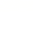

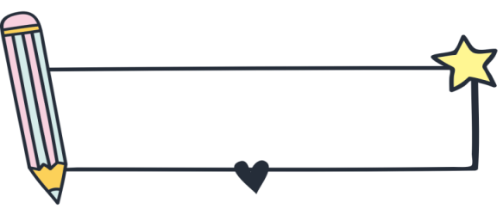

知识梳理
专题四 数词

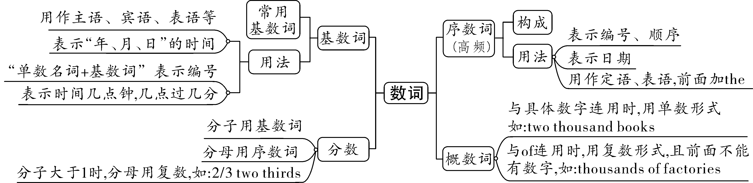
★★★考点一：基数词和序数词
一、基数词的构成：表示数目多少的词称为基数词。
数字 | 基数词形式 | 举例
1~12 | 独立词 | one,two,three,four,five,six,seven,eight,nine,ten,eleven,twelve
13~19 | 个位数+ -teen (13,15,18稍有变化) | three—thirteen,four—fourteen,five—fifteen
整十数 | 个位数+-ty(20,30,40,50,80稍有变化) | two—twenty,three—thirty,four—forty,six—sixty
几十几 | 整十数加“-”再加个位数 | 21: twenty-one, 55: fifty-five
几百几 | ...hundred + and +... | 288: two hundred and eighty-eight
二、序数词的构成：表示顺序的词称为序数词。
- 基数词变序数词的规则：
（1）1~3的序数词为不规则变化
one— first two— second three— third
（2）4~19的序数词由“基数词+th”构成
four—fourth seven—seventh sixteen—sixteenth
►其中第五、第八、第九、第十二为特殊形式
five— fifth eight— eighth nine— ninth twelve— twelfth
（3）整数第几十的序数词形式为把y变成ie，再加th
twenty— twentieth thirty— thirtieth
（4）从“二十一”以后的基数词在变序数词时，只需将个位数变成序数词 twenty—one → twenty-first
【记忆口诀】
基变序，有规律，后面th加上去。
1,2,3，特殊记，8加h，9去e；
ve要用f替，见y变成i和e；
若是遇上几十几，只变个位就可以！

- 序数词的缩写形式：“阿拉伯数字 + 序数词最后面的两个字母”。
例如:first→1st; seventeenth→17th; twenty-second→22nd; thirty-third→33rd。
三、基数词的用法
用途 | 举例
表示数量 | twelve floors 十二层楼 1,250 students 1250个学生
表示年龄 | sixteen years old 十六岁
表示编号（名词+数字） | Lesson One 第一课 Room 802 802号房间
表示年份、年代 | in nineteen ninety-eight 在1998年
表示时间 | June the first(6月1日), at six o’clock(在6点钟)
【知识拓展】
1. in one’s+整十基数词的复数形式，表示“在某人多少岁时”，如： in my twenties 在我二十多岁时
2. 复合形容词：（1）基数词+名词（单数） 如：a two-month holiday 两个月的假期
（2）基数词+名词（单数）+形容词 如：a 100-metre-long bridge 一座100米长的大桥
3. 时间表达法：
时间类型 | 表示法 | 例 | 读法
整点 | 基数词+o’clock | 1:00 | one o’clock
>30分钟 | 分钟+past+小时 | 2:10 | ten past two
=30分钟 | half+past+小时 | 3:30 | half past three
<30分钟 | （60-分钟）+to+（小时+1） | 4:40 | twenty to five
分钟逢15  （即一刻钟） | a quarter | 5:15  6:45 | a quarter past five  a quarter to seven
顺读法 | 小时+分钟 | 7:50 | seven fifty
四、序数词的用法
序数词前通常要加定冠词“the”，但有形容词性物主代词或名词所有格时不加“the”

用途 | 举例
表示顺序 | the twenty-first century 第21世纪 my second car 我的第二辆车
表示日期 | on Oct. 1st , 2008 在2008年10月1日
表示数量（a/an+序数词+名词）“又一；再一” | Please give me a second chance.  请再给我一次机会。
基础练习

用所给词的适当形式填空
1.Jim won the ___first_____ (one) prize in the writing competition.
2.This is my ___third_____ (three) visit to Beijing.
3.We will have the ___eighth____ (eight) lesson in ten minutes.
4.January 21 is the _twenty-first__(twenty-one) day of January.
5.Next Friday is my grandfather’s __seventieth__ (seventy) birthday.
6.My grandfather likes taking exercise. He still keeps running in his ___sixties___(sixty).
7.In the U.S.A. , Thanksgiving Day falls on the___fourth____(four)Thursday in November.
8.Tomorrow will be my sister’s___twelfth____(twelve) birthday and we’ll have a party to celebrate it.
9.Billy is fourteen years old and in the____ninth____(nine) grade in a junior high school.
10.Although Zhang Guimei is already in her____sixties___(sixty), she still helps girls go to college.
真题演练

用所给词的适当形式填空
1.(2023·眉山中考改编)—Tim,how often do you visit your grandparents?
—___Once____(one)a week.I really enjoy staying with them.
2.(2023·白银、临夏州中考)Our home is the ___third_____(three)from the end on the left.
3.(2023·龙东中考) Harbin is a beautiful city.So __millions___(million)of people come here to enjoy snow every winter.
4.(2022·泰安中考改编)There are 5 people waiting for the bus in front of me.I am the ___sixth_____ (six) one.
5.(2022·盘锦中考)Look at the photo!The ___ninth_____ (nine) boy from the right is my best friend.
6.（2023·甘肃定西三模）It’s wonderful to live on the___twelfth____(twelve) floor. You can see the whole town.
7.（2023·上海杨浦三模）The___eighth____（eight）person from the right in the photo is my cousin, Linda.
8.（2023·云南昆明二模）China celebrated the___thirteenth___(thirteen) China Tourism Day on May 19th in Tengchong, Yunnan Province.
9.（2023·上海浦东新二模）Doctor Wang keeps running marathons even though he’s in his____sixties_____(sixty).
10.（2023·上海虹口二模）It is the___second____(two) time that my cousin and I have been to Beijing.

考点二：分数的表达法
基数
分数的结构为：
分子
分母
（ ）词
（ ）词
分子大于1，分母用 复数 （单数/复数）

序数

如：五分之一 one fifth 三分之二 two thirds
四分之三 three fourths/three quarters 六分之一 one sixth
【注意】一些特殊的分数表达法：a half 二分之一
a quarter =one fourth 四分之一
three quarters=three fourths 四分之三
【知识拓展】百分数的表达：“基数词+percent”（percent无复数形式）
如：five percent 5% twenty percent 20%

★★考点三：概数词
hundred（百）、thousand（千）、million（百万）、billion（亿）
表示具体数量：
基数词
＋
hundred
thousand
million
billion
不加s和of

表示不确切数量：
hundreds
thousands
millions
billions
＋
of
要加s和of

如：六百本书 six hundred books 数千人 thousands of people
两百万美元 two million dollars 数百棵树 hundreds of trees
基础练习
1.—How many birds can you see in the trees?
—I can see ___A____ birds in them.
A. hundreds of B. five hundreds C. hundred of D. five hundreds of
2.___B___black—headed gulls(红嘴鸥) come to Kunming to spend their winter every year.
A. Thousands B. Thousands of C. Thousand of D. Thousand
3.___C___ of the students in the classroom are girls.
A. Three four B. Three fourth C. Three fourths D.Third four
4.—___C____ volunteers took part in the Winter Olympic Games.
—They are very great. We are proud of them.
A. Thousand B. Thousands C. Thousands of D.Two thousands of
真题演练

一、单项选择
1.（2022·辽宁鞍山）—Did you watch the second “Tiangong lecture” (天宫课堂) on March 23, 2022?
—Yes, about two ___A____ students in our school watched it.
A．thousand B．thousands of C．million D．millions of
2.（2022·广西河池）Nowadays, ___D____ birds fly to the warm south in winter.
A．million B．millions C．two millions D．millions of
3.（2022·贵州黔东南）—___C____ is the population of Guizhou?
—It has more than ________ people.
A．How much; thirty-eight millions of B．How many; thirty-eight million of
C．What; thirty-eight million D．How large; thirty-eight millions
4.（2022·江苏宿迁）— People in our town planted ___D____ trees on Tree Planting Day.
— Good job! Everyone can do something to make our town greener.
A．hundred B．hundred of C．hundreds D．hundreds of
5.（2022·黑龙江齐齐哈尔）In our city museum, there are many old things from two ___C____ years ago on show.
A．thousands B．thousands of C．thousand
6.（2023·全国·九年级专题练习）About ___A____ of my classmates help their parents do housework on weekends.
A．two fifths B．second five C．second fifths

