
专题六 连词

连词是用来连接单词与单词、短语与短语、句子与句子之间的具体关系的词。连词是一种虚词，虽有意义，但在句中不能单独作成分，只起连接作用。它分为并列连词和从属连词。
【考情分析】连词是历年各省市中考必考知识点。从考查形式看，一般有单项选择、完形填空、词语运用等。所占分值通常为2～4分。从命题意图看，侧重考查考生的具体语言环境中使用连词的能力。


知识梳理

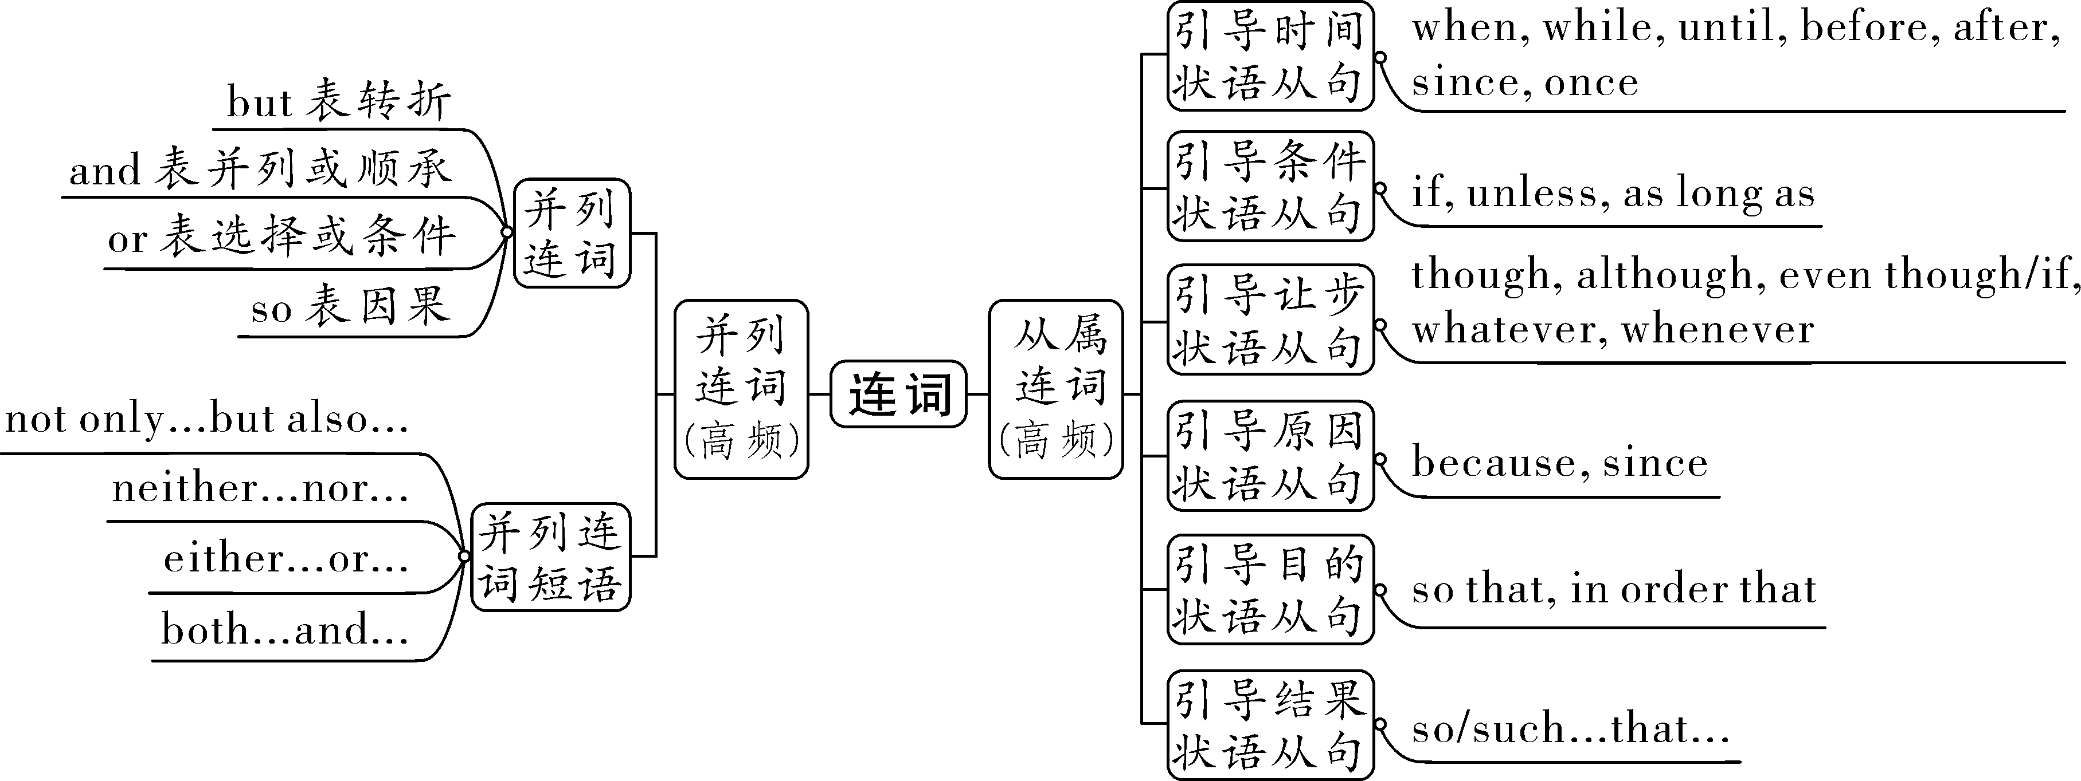

第一部分 并列连词
并列连词是指用来连接具有并列关系的单词、短语、或句子的连词(如and，but，or，so等)，可表示并列、转折、选择、因果等关系。
考点一：表示并列关系的连词（短语）
连词（短语） | 意义 | 例句 | 说明
and | 和；又 | She is kind and patient.她既友好又有耐心。 | 表并列，and前后的词意义相近，否定句中用or
 | 然后 | He came in and took off his coat.他进来然后脱掉外套。 | 表示动作先后。
 | 那么 | Be careful, and you will make fewer mistakes.细心点，你就会少犯错误。 | 祈使句＋and＋陈述句(前后是统一的)。
both...and... | 两者都…… | Both Linda and Amy like reading.  琳达和埃米都喜欢阅读。 | 连接并列主语时，谓语动词用  复数 （单数/复数）形式。
neither...nor... | 既不……  也不…… | Mr.Gao neither drinks nor smokes.高先生既不喝酒也不抽烟。 | 连接并列主语时，谓语动词的形式遵循“ 就近 原则”。
not only...  but also... | 不但……  而且…… | Not only he but also I am excited about the news.不但他而且我也对这个消息感到兴奋。
考点二：表示转折关系的连词
连词 | 意义 | 例句 | 说明
but | 但是 | The man is poor, but he is happy.这个人很穷，但他很快乐。 | 不能与 although/though 同时使用
while | 然而 | I like red while she likes blue.我喜欢红色而她喜欢蓝色。 | 强调对比关系。
however | 虽然 | Tina didn’t pass the final exam. However, she didn’t lose heart. 蒂娜没有通过期末考试，然而，她没有灰心。 | 置于句中时，其后要用逗号与后面的句子隔开
考点三：表示选择关系的连词（短语）
连词（短语） | 意义 | 例句 | 说明
or | 或者 | Who is taller，Sam or John? 谁更高，萨姆还是约翰? | 表示选择。
 | 否则 | Study hard, or you'll fail the exam.努力学习，否则你会考试不及格。 | 祈使句＋or＋陈述句(前后是对立的)。
either...or... | 或者……或者…… | Either milk or coffee is OK.  牛奶或咖啡都可以。 | 连接并列主语时，谓语动词的形式遵循“ 就近 原则”。
考点四：表示因果关系的连词
连词 | 意义 | 例句 | 说明
so | 因此；所以 | He was ill, so he didn't go to school.  他生病了，因此没有去上学。 | 不能与 because 同时使用。

基础练习
一、单项选择
1. D my brother my sister likes pop music. They often listen to it.
A. Both ; and B. Neither ; nor C. Either ; or D. Not only ; but also
2.We must get back to work, D we won't finish the task.
A. and B. but C. so D. or
3.—Bill, did you get full marks (满分) in your P.E. exam？
—No, I didn't. D I have tried my best.
A. And B. So C. Because D. But
4.My arm is still painful, A I'm going to see a doctor.
A. so B. for C. but D. or
5.I have only two tickets for my favorite singer's concert. A you he can go with me.
A. Either ; or B. Neither ; nor C. Both ; and D. Not only ; but also
真题演练

一、单项选择
1.（2022·湖南湘西）The smart phone is a good tool for communication, ___B____ using it too much is bad for our growth（成长）.
A．and B．but C．or
2.（2022·广西柳州）Lucy ___C____ Lily are classmates. They are in Class 1.
A．but B．or C．and
3.（2021·西藏）—Hello boys! Our school music festival is coming. Who can play the guitar?
—___A____ Sam ________ Tom can play it. They are good at playing the guitar.
A．Both；and B．Either；nor C．Neither；nor D．Between；and
4.（2021·山东济南）Little Kate is only 4 years old, ____C____ she can help with a lot of housework.
A．or B．so C．but D．because
5.（2023·四川达州·统考二模）—___B____ Sarah ________ her sister has enough courage to tell their mom the bad news.
—They may think she will be very sad about it.
A．Either; or B．Neither; nor C．Both; and

第二部分 从属连词
从属连词是用来引导从句的。中考主要考查引导宾语从句(if，whether)和状语从句(如when，because，until等)的连词。
考点一：引导时间状语从句的从属连词
连词 | 含义 | 用法 | 例句
when | 当……时候 | 从句后的谓语动词可以是瞬间动词也可以是延续性动词，主从句描述的动词可以同时，也可以先后发生 | When I arrived there, it was raining.
while |  | 从句后的谓语动词必须是延续性动词，侧重主从句动作同时发生 | While I was watching TV, my sister was doing her homework.
until | 直到…… | 常用在“not...until...”结构中，表示“ 直到……才…… ” | Don’t eat it until you get to the forest.
before | 在……之前 | 表示过去某一时间或动作之前已经完成的动作或存在的状态 | Before you speak too fast and in anger, count to ten, and if you are still angry, count again.
after | 在……之后 | 指的是以过去时间为起点的一段时间之后 | After I graduated, I became an English teacher.
since | 自从 | 主句用现在完成时，从句用一般过去时 | I realized that since my parents moved away, I’ve been afraid of being alone.
once | 一……就…… | 用于连接时间状语从句，相当于as soon as | Once they find people in need, they will try their best to help them.
考点二：引导条件状语从句的从属连词
连词 | 含义 | 用法 | 例句
if | 如果 | if引导的条件状语从句遵循“ 主将从现 ”原则 | If he or she blows out all the candles in one go, the wish will come true.
unless | 除非/如果不 | unless可以转化为“if...not...”结构。主从句时态同if一致 | He won’t finish the work unless he works hard.
as long as | 只要 | 引导的从句常用一般现在时，主句用一般将来时(时态) | Friends are like books—you don’t need a lot of them as long as they’re good.
考点三：引导让步状语从句的从属连词
连词 | 含义 | 用法 | 例句
though | 虽然；尽管 | 引导让步状语从句时，不能  与 but 同时使用 | Although/Though it is a very small country, it is very rich.
although
even though/if
whatever | 无论什么 | 等于 no matter what | Whatever happens, don’t forget to write.
whenever | 无论何时 | 等于 no matter when | Whenever I see him, he’s reading.
考点四：引导原因状语从句的从属连词
连词 | 含义 | 用法 | 例句
because | 因为 | 回答 why 引导的特殊疑问句，because和 so 不能同时使用 | Because I got up too late and didn’t catch the early bus.
since | 因为；既然 | 语气比because弱，表示对方已知的原因 | Since he says so, it must be true.
考点五：引导目的状语从句的从属连词
连词 | 含义 | 用法 | 例句
so that | 以便；为了 | 等于in order to，但in order to后接动词原形，不能接句子 | The teacher spoke loudly so that/in order that we could hear him clearly.
in order that
考点六：引导结果状语从句的从属连词
连词 | 含义 | 用法 | 例句
so...that... | 如此……  以至于…… | so后跟 形容 词或 副 词, 构成：so+adj/adv+that | He was so angry that he couldn’t say a word.
such...that... |  | such后跟 名 词,构成以下结构：  such+a/an+adj+n单+that  such+adj+n复/n不+that | It’s such a fine day that many people go to the park for fun.
【注意】当名词前有many/much/few/little修饰时，用so而不用such。（“多多少少要用so”）
【拓展延伸】too+adj+to do sth或（not）...enough+to do sth的结构同样可以表示结果。
Eg.He is so young that he can’t go to school.
= He is too young to go to school.
= He is not old enough to go to school.
基础练习
一、单项选择
1.Our business won't improve B we offer better services to our customers.
A. because B. unless C. after D. since
2. He could find the way home A he was only three years old.
A. though B. because C. where D. if
3.—Has the meeting begun yet？
—Not yet. We have to wait B everyone is here.
A. and B. until C. or D. but
4.—I'm afraid e­books might be bad for our eyes.
—Hmm, but they will be helpful for us B we put them to good use.
A. as soon as B. as long as C. even though D. so that
5.Our teachers have been with us for nearly three years C we came to junior high school. We should thank them for what they have done for us.
A. until B. before C. since D. while
6.Chinese government is making every effort to reduce pollution C we can live more happily and healthily.
A. as if B. even though C. so that D. because of
7.My grandparents wrote letters to keep in touch with others A they were young.
A. when B. since C. after D. before
8.—Do you still remember our primary school teacher Mrs. Liu?
—Yes, she always encouraged us and gave us support A we met difficulties.
A. whenever B. whatever C. however D. wherever
真题演练

一、单项选择
1.（2022·辽宁）Teenagers should do some housework ___C____ they finish their homework.
A．until B．but C．after D．unless
2.（2022·江苏徐州）Dad sometimes goes to the supermarket with us, ___C____ he hates going shopping.
A．because B．so C．though D．if
3.（2022·广西百色）Mr. Zhao has given much money to Project Hope ___B____ he is not so rich.
A．if B．though C．because D．unless
4.（2022·广西河池）Our classroom won’t be clean ___C____ we clean it every day.
A．after B．while C．unless D．because
5.（2022·内蒙古）—Too much work has made me tired these days, Mrs. Gao.
—That’s true. But a small tree won’t grow into a big one ___D____ it experiences lots of winds and rains.
A．if B．because C．when D．unless
6.（2022·黑龙江哈尔滨）—Happiness is about having each tiny wish come true.
—___A____ we work hard, we’ll make our life full of happiness.
A．If B．Unless C．Though
7.（2022·黑龙江）It’s necessary to learn English well, ___B____ it’s a little difficult.
A．unless B．although C．as
8.（2022·海南）According to the latest rules, everyone must have their temperature taken ___A____ they enter the school.
A．before B．though C．unless
9.（2022·福建）We are making a big cake ___A____ it’s Dad’s birthday today.
A．because B．until C．once
10.（2022·四川凉山）—Time to go home, Peter.
—Wait a minute. I can’t go home ___C____ I finish cleaning the hallway.
A．since B．after C．until

