
专题十 非谓语动词

非谓语动词包括不定式、动名词、现在分词和过去分词。它们没有人称和数的变化。在句中不能独立作谓语，但可以有自己的宾语、状语和逻辑主语等。考生要重点掌握动词不定式和动名词的用法。


知识梳理

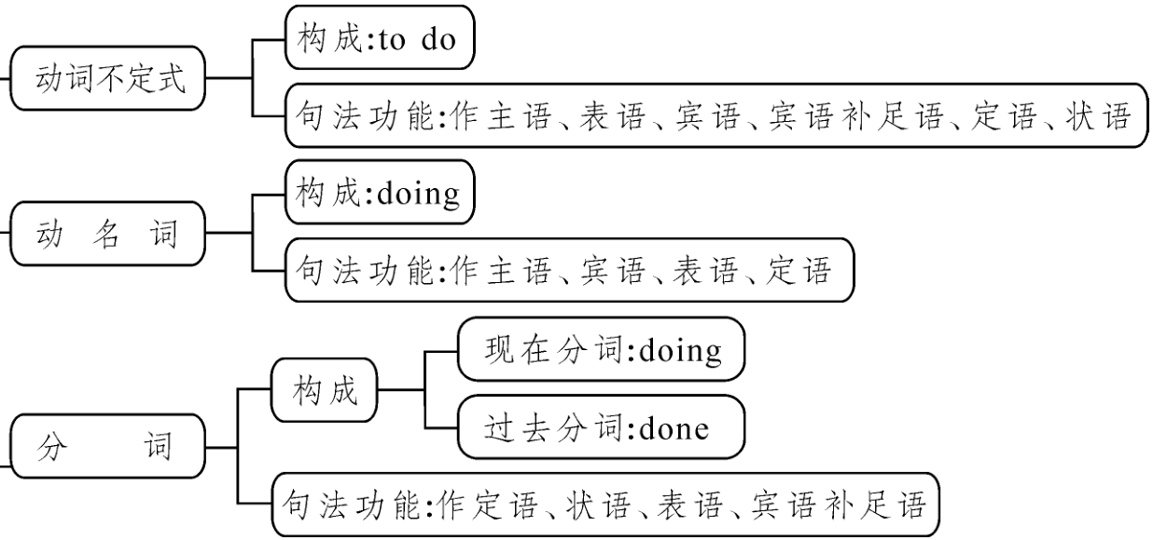
考点一：动词不定式
一、动词不定式的构成
动词不定式的基本形式为“ to +动词原形 ”，有时可以不用to，这里的to是不定式符号，本身无词义，其否定形式为 not to do sth. 。不定式没有人称和数的变化，在句中不能作谓语，但能保持动词的特点。
二、动词不定式的句法功能
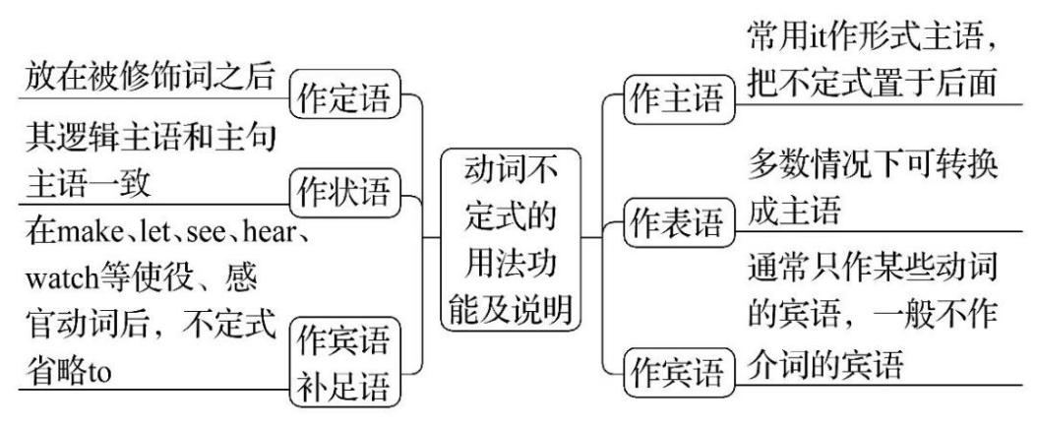
- 动词不定式作主语
动词不定式作主语时，常用it作形式主语，而将真正的主语置于句末，这样可使主语不至显得太长，避免头重脚轻的现象。动词不定式作主语的基本结构是：It + be +形容词(+for/of sb) + to do sth.
如：To learn English well is not easy. =__It___ ___is__ not easy ___to__ __learn__ English well.学好英语不容易。
【注意】在“It’s + adj + for/of sb to do sth”结构中，用for和用of的区别：
adj修饰to do，介词用for

adj修饰sb，介词用of

It’s + adj + for / of sb to do sth

▲for sb.句型前常用表示事物的特征、特点、客观形式的形容词。
如：difficult, easy, hard, important, impossible, necessary 等。
▲of sb.句型前常用表示人物的性格、品德、主观感情、态度、赞扬或批评的形容词。
如：careless, clever, good, foolish, honest, kind, lazy, nice, right, silly, stupid, wise, rude, brave等。
基础练习
用介词for、of填空
1.It’s important for us to protect the environment.
2.It’s difficult for Jim to learn Chinese well.
3.It’s very nice of you to help me.
【知识拓展】It takes sb.+ some time + to do sth.意为“做某事花费某人多长时间”，在该结构中，it同样作形式主语，真正的主语是后面的to do。
（翻译句子） It takes me two hours to do my homework . 做作业花了我两个小时的时间。
- 动词不定式作宾语
常见接动词不定式作宾语的动词的有(v.＋to do sth.)：
agree 同意 afford 负担 choose 选择 dare 敢于 decide 决定 expect 期望
help 帮助 hope 希望 manage 完成 offer 提供 plan 计划 prepare 准备
promise 许诺 refuse 拒绝 want 想要 wish 希望 would like 想要 volunteer 自愿
fail 失败 learn 学习 ask 要求 seem 好像 prefer 更喜欢 need 需要

【注意】动词不定式作宾语其后又有补足语时，常用it作形式宾语，而把真正的宾语即动词不定式后置。
常用于以下动词：主语+ feel/find/make/think + it +宾补(形容词/名词)+ to do sth.
如：I find it useful to learn English well. 我发现学好英语很有用。
- 动词不定式作宾语补足语
常见接动词不定式作宾语补足语的动词有(v.＋sb. to do sth.)：
advise建议 allow允许 ask请求 encourage鼓舞 expect期望 warn 告诫
invite邀请 tell告诉 want想要 teach 教 wish 希望 remind 提醒

【注意】使役动词（let, make, have）和感官动词（see, hear, watch, notice, feel等）后要用不带to的动词不定式作宾语补足语。但是，当上述动词变为被动语态时，其后的to要补上。（help后不定式的to可以省略，也可以保留。）
如：We often hear her sing. 我们经常听见她唱歌。→She is often heard to sing by us. 她唱歌经常被我们听到。
（hear sb. do sth. 听到某人经常做某事） →（sb. be heard to do sth. 某人经常被听到做某事）
【易错点】常考的几个易混固定搭配：
动词 | 基本结构 |  | 含义
使役动词 | 主动语态：make/have sb. do sth. |  | 让......做某事
 | 被动语态：make/have done sth. |  | 让......被做
感官动词 | see | see sb. doing sth. | 看见某人正在做某事（正在做）
 |  | see sb. do sth. | 看见某人经常做/做过某事（已做）
 | hear | hear sb. doing sth. | 听到某人正在做某事（正在做）
 |  | hear sb. do sth. | 听到某人经常做/做过某事（已做）
- 动词不定式作状语
（1）动词不定式作目的状语：表目的时，to do通常翻译为“为了……”，不定式可放在句子的前面也可放在句子的末尾。但在句子前面时，不定式常与句子用逗号隔开，而在句子末尾时一般不用逗号隔开。
如：To get there on time, we set out at five in the morning. 为了按时到那里，我们早上五点就出发了。
He goes there to enjoy the fresh air. 他去那里为了享受新鲜的空气。
（2）动词不定式作原因状语：不定式常跟在表示情感的形容词后，修饰形容词，作原因状语，不定式作原因状语的基本结构是：“sb.+ be + adj. + to do sth.”。能用于该结构的形容词有：angry, clever, careful, happy, lucky, nice, pleased, right, sorry, slow等。
如：I’m very glad to have the opportunity to work in your company. 我很高兴能有机会到你的公司工作。
（3）动词不定式作结果状语：多见于“too +形容词+ to do sth.”结构句中。
如：The T-shirt is too big for me to wear. 这件T恤对于我来说太大了而不能穿。
- 动词不定式作定语（须后置）
动词不定式作定语时，放在被修饰名词或代词的后面，作后置定语。
如：He needs time to do homework. 他需要时间做作业。
I have nothing to say on this question. 对于这个问题我没有什么要说的。
- 动词不定式作表语
动词不定式往往放在系动词be（become, sound, taste等系动词后面一般不接不定式）的后面作表语，表示将来的情况，说明主语的内容。
如：My wish is to be a teacher. 我的愿望是当一名教师。
- 动词不定式的特殊结构
（1）“疑问词＋不定式”结构：动词不定式可以和疑问词what、which、who、how、when、where等连用，构成不定式短语，相当于一个宾语从句。
如：I can’t decide where to go. 我不能决定去哪里？
（2）常见省略to的不定式的句型：
►had better (not) do sth. 最好（不要）做某事
►would rather do sth. than do sth. 宁愿做某事而不愿做某事
►prefer to do sth. rather than do sth. 宁愿做某事而不愿做某事
►Why not do sth.?＝Why don’t you do sth.? 为什么不做某事呢？
►Could/Would/Will you please (not) do sth.? 你能（不要）做某事吗？

基础练习

一、单项选择（要求：在每一题旁边标记动词不定式/动名词所作句子成分）
1.—Where is Mike?
作宾补
—I saw him B with Mr.Smith in the hallways just now.
A. to talk B. talking C. talked D. talks
2.He took off his expensive watch A the fact that he was rich.
作目的状语
A. to hide B. hid C. hide D. hidden
3.The government is setting up nature parks A protect pandas.
作目的状语
A. to help B. help C. helped D. helps
4.Miss Chen, my dear English teacher, often encourages me D the challenges in my study.
作宾补
A. face B. faces C. facing D. to face
5.I can't stay with you this weekend. My father and I planned C Beijing a long time ago.
作宾语
A. visit B. visiting C. to visit D. visited
6.Peter wonders if there's a good place A in Kunming.
作目的状语
A. to have fun B. having fun C. have fun D. to having fun
7.My friend invited me B the art club, and I accepted it with pleasure.
作宾补
A. join B. to join C. joined D. joining
8.—It's difficult for me A the homework in such a short time.
—Come on! I'm sure you can.
作主语
A. to finish B. finished C. finishing D. finish
9.I can't tell you what she said. I've promised B it a secret.
作宾语
A. keep B. to keep C. keeping D. kept
10.If all of us pull together, there must be something we can do B the environment.
作目的状语
A. improve B. to improve C. improving D. improved

考点二：动名词
一、动名词的构成
动名词由“动词原形+ing”构成，与现在分词的形式相同，动名词具有名词的特征，也有动词的特征，它可以有宾语，也可用状语来修饰。在句中可以作主语、表语、宾语和定语。
二、动名词的句法功能
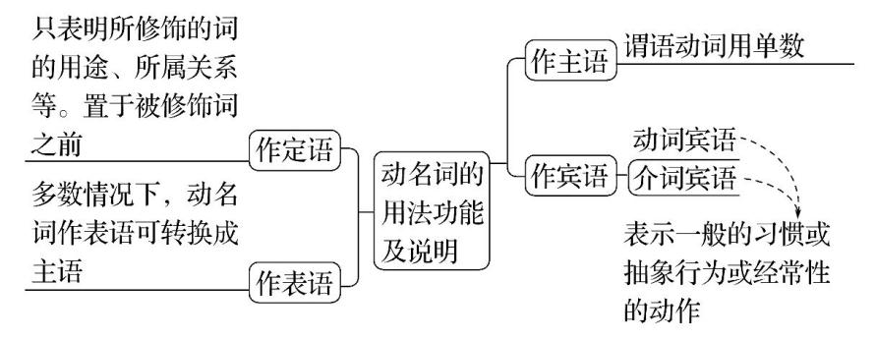
- 动名词作主语
动名词作主语时，谓语动词要用第三人称单数形式。
如：Playing computer games too much is (be) bad for your eyes. 过度地玩电脑游戏对你的眼睛有害。
- 动名词作宾语
动名词可用作动词或介词的宾语，表示一般的习惯、抽象的行为或经常性的动作。
常见接动名词作宾语的动词(组)有(v.＋doing sth.)：
avoid 避免 enjoy 喜欢 keep 保持 suggest 建议 finish 完成 feel like 想要
practice 练习 mind 介意 consider 考虑 imagine 想象 give up 放弃 be busy 忙于
be worth 值得 can’t help 情不自禁 look forward to 期待 pay attention to 注意

- 动名词作表语
多数情况下动名词作表语可以转换成作主语。
如：One of my duties is typing letters.= Typing letters is one of my duties. 我的职责之一是打信件。
- 动名词作定语
只表明它所修饰的词的用途、所属关系等。置于所修饰词之前。
如：We should improve our learning method. 我们应该改进学习方法。
- 动名词和不定式作宾语的区别
有些动词后既可接动词不定式又可接动名词作宾语，但表达的意义不同。常见结构有：
动词 | 结构 | 含义
stop | stop doing sth. | 停止做某事
 | stop to do sth. | 停下来去做另外一件事
try | try doing sth. | 尝试做某事
 | try to do sth. | 尽力做某事
need | need doing sth. | 需要做某事（被动含义）
 | need to do sth. | 需要去做某事（主动含义）
regret | regret doing sth. | 很遗憾做了某事（已做）
 | regret to do sth. | 很遗憾要去做某事（未做）
remember | remember doing sth. | 记得做过某事（已做）
 | remember to do sth. | 记得去做某事（未做）
forget | forget doing sth. | 忘记做过某事（已做）
 | forget to do sth. | 忘记去做某事（未做）
如：I’ll try to catch up with my class this term. 这一学期我将尽力赶上同学们。
I tried reading the text without consulting my dictionary. 我试着不查词典来阅读课文。
I remember seeing you somewhere before. 我记得以前在哪儿见过你。
Please remember to turn off the light when you leave. 离开时请记得关好灯。
基础练习
一、单项选择（要求：在每一题旁边标记动词不定式/动名词所作句子成分）
1.—Do you have any plans for the holiday?
作宾语
—Yes. I'm planning to travel to Jiuzhaigou. I'm looking forward to B the colourful lakes and amazing waterfalls.
A. see B. seeing C. sees D. saw
2.—Jimmy, I don't like my classmate Bob. He is so noisy.
作宾语
—Oh, so he is. But you cannot avoid C him. He sits next to you.
A. meet B. to meet C. meeting D. to meeting
3.I'll never forget B this piece of music for the first time. It's so sweet.
作宾语
A. to hear B. hearing C. heard D. hear
4.Thanks to the robots, the human reporters do not have to spend a lot of time A boring numbers and information.
现在分词作宾补
A. processing B. to process C. processed D. process
5.—Is this dictionary Ming's?
作宾语
—Yes. Please remember A it to him when you finish looking up the words.
A. to return B. returned C. return D. returning
6.I will try my best to stop my students from D the same mistake.
作宾语
A. make B. made C. makes D. making
7.—Have you read the book David Copperfield?
作宾语
—Yes. It's a famous book and really worth B .
A. to read B. reading C. to be read D. read
8. D in the river here is not allowed because it is quite dangerous.
作主语
A. To swim B. Swim C. Swam D. Swimming
9.A lot of students enjoy B with each other to solve the problems in class.
作宾语
A. discuss B. discussing C. to discuss D. discussed
10.When we heard the good news, we couldn't help C .We were so excited.
作宾语
A. jump B. to jump C. jumping D. jumped

考点三：分词（考试说明不做要求）
一、分词的构成
分词分为现在分词和过去分词两种。现在分词由“动词原形+ing”构成，有主动、进行之意，所修饰的人或物是动作的执行者；过去分词由“动词原形+ed”构成，有被动、完成之意，所修饰的人或物是动作的承受者。
二、分词的句法功能
现在分词和过去分词都具有形容词、副词的特征，在句中可作定语、状语、表语和宾语补足语。
功能 | 说明 | 示例
定语 | 现在分词作定语时，逻辑主语是其所修饰的词 | China is a developing country.
 | 过去分词作定语时，逻辑宾语是其所修饰的词 | America is a developed country.
状语 | 分词的逻辑主语为句子的主语 | Being sick, I stayed at home.
表语 | 现在分词表示主语的性质和特征 | The book is interesting.
 | 过去分词表示某种状态 | I’m interested in the book.
补足语 | 现在分词作补足语,与被补充说明的词之间是主动关系 | They kept me waiting for a long time.
 | 过去分词作补足语,与被补充说明的词之间存在被动关系 | The rabbit found his carrot stolen.
真题演练

一、单项选择
1.（2023·江苏宿迁）—Our school will invite Mr. Wang ___B____ us a talk on environmental protection next week.
—That’s wonderful!
A．give B．to give C．giving D．gave
2.（2023·吉林长春）We expect the world ___B____ China better after the 19th Asian Games in Hangzhou.
A．understanding B．to understand C．understood D．understand
3.（2022·毕节中考）Many people have lost their homes because of wars. It’s important for people ___C____ a peaceful world.
A. have B. had C. to have D. to be having
4.（2022·扬州中考）___B____ the people locked inside,the firemen broke down the door.
A. Reach B. To reach C. Reaching D. To reaching
5.（2022·贵州黔西）Most of the students are looking forward to ___D____ themselves after the exams.
A．work B．working C．relax D．relaxing
6.（2022·江苏南通）We should have a healthy diet, proper exercise and enough sleep ___B____ fit.
A．keeping B．to keep C．keep D．kept
7.（2022·贵州铜仁）—Mr. Chen, my kid is sleeping. Would you mind ___A____ your radio?
—Sorry. I’ll do it at once.
A．turning down B．turn down C．turning up D．turn up
8.（2022·广西百色）Our teacher often tells us ____D____ across the road when the traffic light is red.
A．go B．going C．don’t go D．not to go
9.（2022·西藏）___A____ too much sweet food will make people get fat.
A．Eating B．Eats C．Eat D．Ate
10.（2023·四川甘孜）Mike made faces to make his little brother ____B_____.
A．laughs B．laugh C．to laugh D．laughing
二、用所给词的适当形式填空
1.（2023·甘肃武威）Let me tell (tell) you about my favorite book.
2.（2022·江苏淮安）Miss Gao is preparing a talk on how to solve (solve) teenager problems.
3.（2022·贵州六盘水）Look! Jim is having fun skating (skate) in the snow. He thinks it’s good exercise.
4.（2022·江苏泰州）Our country has made laws to protect (protect) biodiversity(生物多样性) of the Yangtze River.
5.（2023·湖南永州）I’ve decided to stay (stay) away from fried food and soft drinks since I had my medical exam.
6.（2022·甘肃武威）More and more young people enjoy reading (read) poems.
7.（2022·内蒙古）Most of the Chinese chose to stay at home to prevent the COVID-19 from spreading (spread) around.
8.（2022·湖南常德）In the story of Chang’e, Pang Meng wanted to steal (steal) the medicine.
9.（2022·江苏无锡）—Lily, I have difficulty reading (read) comic strips in English.
—Don’t worry. Let’s read some together.
10.（2021·江苏淮安）It’s kind of you to help (help) the old cross the road.

