**Fairview Developments Private Limited**

101 Cecil Street #16-08 Tel : 6225 2488

Tong Eng Building Fax : 6225 3488

Singapore 069533 Email : fairview@singnet.com.sg

Date:02/03/2024

To:

(1) xx1 (ID No. 1)   
(2) xx2 (ID No. 2)   
(3) xx3 (ID No. 3)

Dear Sir/Madam

[ #01-01 ] BELGRAVIA DRIVE, BELGRAVIA ACE, Singapore (the “Property”)

**- Particulars, Documents and Information for Intending Purchasers of BELGRAVIA ACE (the “Housing Project”)**

1. In accordance with Rule 10(4) of the Housing Developers Rules, we hereby enclose the following particulars, documents and information relating to the Property and the Housing Project.

(a) Annex A: Information on Property

(b) Annexes B1, B2 and B3: Property Plans

(c) Annex C: Specifications of the Building

(d) Annex D: Amendments to the Prescribed Sale and Purchase Agreement

(e) Annex E: Conditions, Restrictions and Requirements Imposed by Authorities on Housing Project

(f) Annex F: General Description of Housing Project

(g) Track Record of Housing Developer

We have carried out and completed the following housing or other development project(s) in Singapore:-

|  |  |  |
| --- | --- | --- |
| Name of Housing or Other Development Project | Description and Location | Year in which Temporary Occupation Permit was obtained for all units in the Other Project |
| BELGRAVIA VILLAS  (the “Other Project”) | Strata Landed Housing Development Comprising of 100 units of 3 storey strata terrace house and 18 units of 3 storey strata semi-detached house (Total: 118 residential units) with basement carparks, roof terrace and communal facilities at Belgravia Drive. | 2018 |

2. In accordance with Rule 10(5) of the Housing Developers Rules, we hereby notify you as follows:

(a) Schedule of Strata Units

A copy of the Schedule of Strata Units for the Housing Project as filed with and accepted by the Commissioner of

Buildings is available for your inspection at Belgravia Ace Sales Gallery at Belgravia Drive, prior to your payment

of the booking fee.

## Please acknowledge receipt by returning to us the duplicate copy of this letter with the portion marked “PURCHASERS’ ACKNOWLEDGEMENT” duly signed.

Yours faithfully

______________________________________________

For and on behalf of

### FAIRVIEW DEVELOPMENTS PRIVATE LIMITED

**UEN: 197201600D**

enc.

### To: FAIRVIEW DEVELOPMENTS PRIVATE LIMITED

## PURCHASERS’ ACKNOWLEDGEMENT

I/We hereby acknowledge receipt of this letter and its enclosures and that you have complied with the requirements of the Housing Developers Rules.

Date : 02/03/2024

(For Individual)

|  |  |
| --- | --- |
| {{Sign Buyer1}} | {{Sign Buyer1}} |
| Name: | Name: |
| NRIC/Passport No.: | NRIC/Passport No.: |

OR

(For Company)

__________________________________

Name / NRIC or Passport No:

Designation:

For and on behalf of :

Company Stamp :



Date :02/03/2024

To :

|  |  |
| --- | --- |
| **=** |  |

Dear Sir/Madam

[ #01-01 ] BELGRAVIA DRIVE, BELGRAVIA ACE

**SINGAPORE (“Property”)**

**RESTRICTION ON RE-ISSUE OF OPTION TO PURCHASE FOR THE SAME UNIT TO SAME PURCHASER(S)**

We have been directed by the Controller of Housing to specifically draw your attention to the following new conditions in the Housing Developer’s Licence No. 1421 issued to Fairview Developments Private Limited (“New HDL Conditions”) which take effect from 16 November 2021.

**New HDL Conditions**

1. Not to, on or after 16 November 2021 (“the effective date of the condition”), enter into any agreement or arrangement not being an option to purchase prescribed under the Housing Developers Rules, and whether with or without the receipt of consideration, that gives or has the effect of giving any person (including an intending purchaser) a right or entitlement to be given an option to purchase any unit(s) in the housing project.
2. Not to, *without the prior written consent of the Controller of Housing*, give an option to purchase for the sale of a unit in the housing project to an intending purchaser ("the Intended Option Holder"), whether with or without other intending purchaser(s), *within 12 months* after the expiry of an earlier option to purchase for the same unit given to the Intended Option Holder, whether with or without other intending purchaser(s) and whether for the same or different purchase price. This condition shall not apply if the Intended Option Holder had been given an option to purchase the same unit before 16 November 2021 (“the effective date of the condition”).
3. Where Condition (2) applies, to notify any intending purchaser of Condition (2) and obtain the written acknowledgment of the intending purchaser that notice of Condition (2) was given before giving the intending purchaser an option to purchase for the sale of any unit in the housing project.

If you have any doubts as to the aforesaid, you should seek the advice of your solicitors.

Please acknowledge receipt of this letter on the duplicate copy.

Yours faithfully

____________________

FOR AND ON BEHALF OF

FAIRVIEW DEVELOPMENTS PRIVATE LIMITED

197201600D

**INTENDING PURCHASER’S(S’) ACKNOWLEDGMENT**

To: **FAIRVIEW DEVELOPMENTS PRIVATE LIMITED**

[ #01-01 ] BELGRAVIA DRIVE, BELGRAVIA ACE

**SINGAPORE (“Property”)**

**RESTRICTION ON RE-ISSUE OF OPTION TO PURCHASE FOR THE SAME UNIT TO SAME PURCHASER(S)**

/I / We, the Intending Purchaser(s) of the Property, refer to your above letter to me/us (“Letter”).

I / We hereby acknowledge that notice of the New HDL Conditions as set out in the Letter, in particular Condition (2), has been given to me/us prior to the grant of the Option to Purchase to me/us in respect of the Property.

Date:02/03/2024

(For individual)

|  |  |
| --- | --- |
| Sign Buyer1 | Sign Buyer2 |
| Name: | Name: |
| NRIC/Passport No.: | NRIC/Passport No.: |

**OR**

(For Company)

_________________________________

Name / NRIC or Passport No:

Designation:

For and on behalf of :

Company Stamp:

**Annex A**

**INFORMATION ON PROPERTY**

|  |  |  |  |
| --- | --- | --- | --- |
|  | Sign Buyer3 | Sign Buyer2 | Sign Buyer1 |

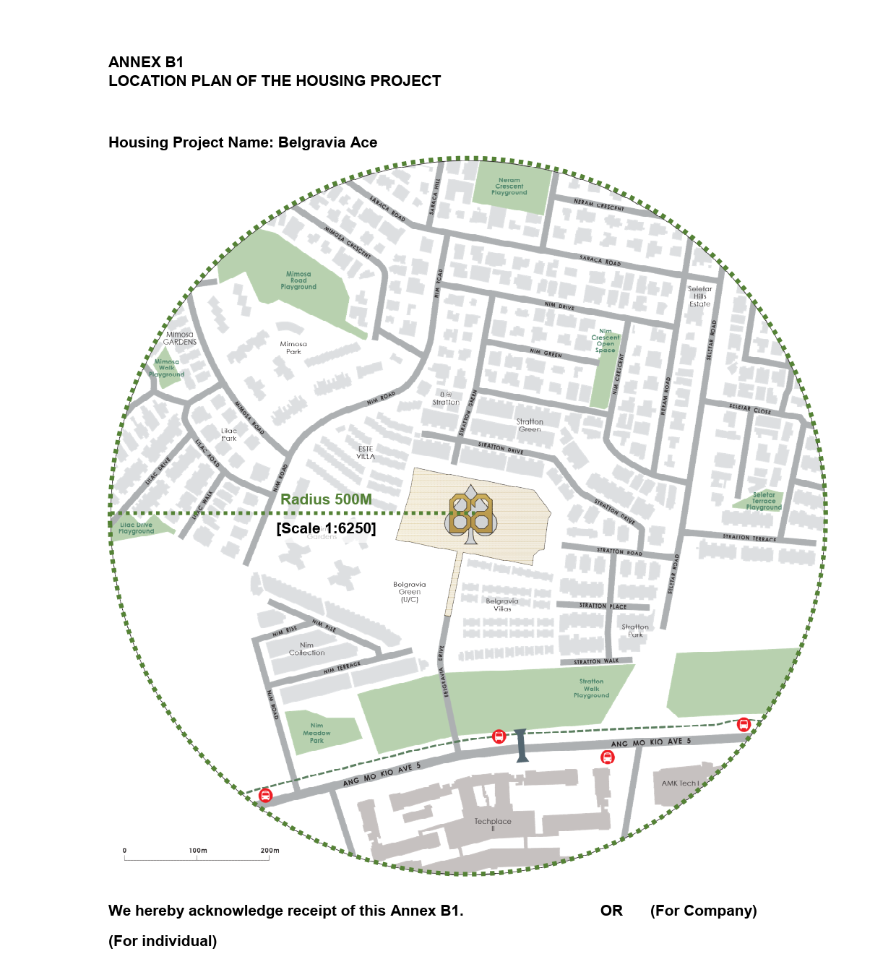

|  |  |  |  |
| --- | --- | --- | --- |
| Sign Buyer1 | Sign Buyer2 | Sign Buyer3 |  |

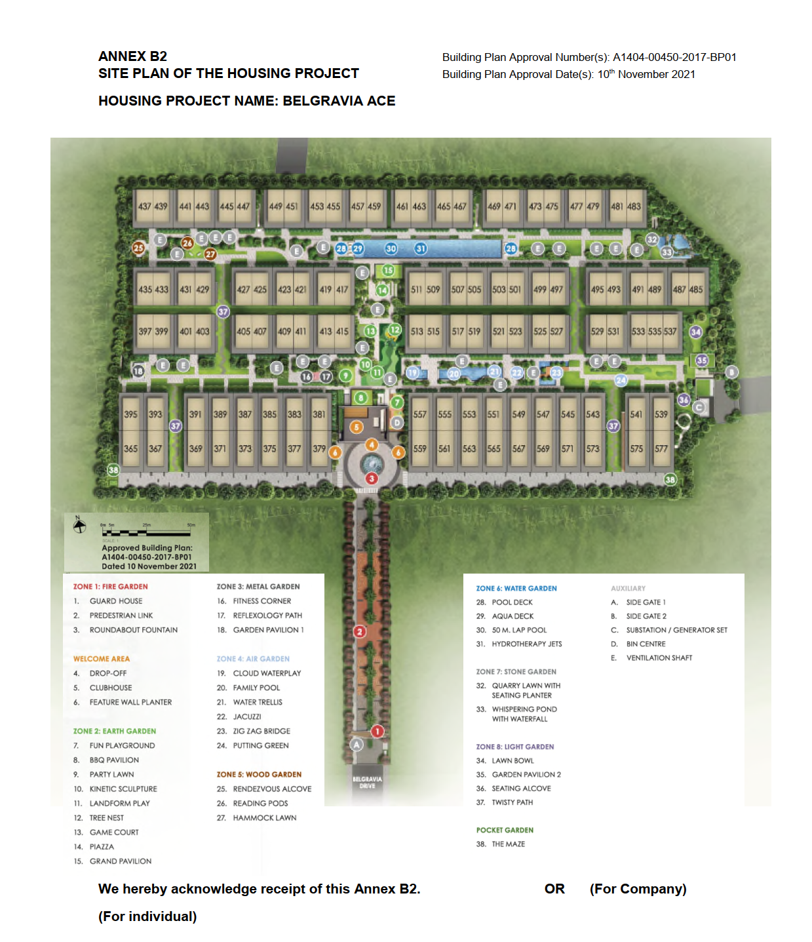

|  |  |  |  |
| --- | --- | --- | --- |
| Sign Buyer1 | Sign Buyer2 | Sign Buyer3 |  |

|  |  |  |  |
| --- | --- | --- | --- |
|  | Sign Buyer3 | Sign Buyer2 | Sign Buyer1 |



Date:02/03/2024

To:

Dear Sir/Madam

#01-01 BELGRAVIA DRIVE, BELGRAVIA ACE, SINGAPORE (the “Unit”)

**- CHOICE OF LAYOUT FOR BATHROOM**

1. Thank you for your interest in the Unit.

2.         As a gesture of goodwill, we are pleased to offer to you a choice to select between two options, for the following 3 items, two towel rails and 1 towel hook to be provided to you in loose form, or for the following 3 items, two towel rails and 1 towel hook to be installed, and this will modify the layout of one of the walls in the bathrooms (the “**Modification**”).

3.         Please note that if you choose to proceed with the Modification, the “**Modification**” shall include the following 3 items, two towel rails and 1 towel hook to be installed and modify the layout of one of the walls in the bathrooms.

4. We confirm that there will be no change to the strata area or the share value of the Unit as a result of the Modification.

5. Our offer herein is subject to the following terms and conditions:-

1. You shall have exercised the Option to Purchase for the Unit and signed the Sale and Purchase Agreement for the Unit (the “**Agreement**”) in accordance with the provisions of the Option to Purchase.
2. You shall not be in breach of the provisions of the Agreement.
3. Due to inherent constraints in the construction schedule, you shall make your selection by returning to us the duplicate copy of this letter with the “**SELECTION AND ACCEPTANCE OF TERMS/CONDITIONS**” duly completed and signed, **on or before the date of exercise of the Option to Purchase**.
4. Once your selection has been made, it shall be final and irrevocable and you shall not be entitled to make any changes thereto.
5. If we fail to receive the duly completed and signed “**SELECTION AND ACCEPTANCE OF TERMS/CONDITIONS**” or if you fail to make a proper selection **on or before the date of exercise of the Option to Purchase**, it shall be deemed that you do not wish to proceed with the Modification and that you accept that the Unit shall be constructed in accordance with the Original Plan.
6. Any M&E points that are affected as a result of the Modification will be relocated to location(s) determined at the sole discretion of our architect/consultants.
7. You agree to inform any sub-purchaser(s) to whom you may sell the Unit of your selection and you shall obtain the sub-purchaser’s(s’) written consent to your selection on or before completion of the sub-sale. In this respect, you shall fully indemnify and keep us indemnified against all proceedings, claims, demands, writs, summonses, actions, orders, damages, losses, expenses and costs of any nature whatsoever which we may suffer or incur arising from or in connection with your failing to inform such sub-purchaser(s) of your selection.

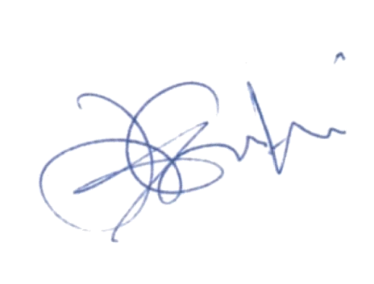

Yours faithfully

______________________________________________

For and on behalf of

**FAIRVIEW DEVELOPMENTS PRIVATE LIMITED**

**(UEN 197201600D)**

Enc.

### To: FAIRVIEW DEVELOPMENTS PRIVATE LIMITED

**SELECTION AND ACCEPTANCE OF TERMS/CONDITIONS**

#01-01 BELGRAVIA DRIVE, BELGRAVIA ACE, SINGAPORE (the “Unit”)

**- CHOICE OF LAYOUT FOR BATHROOM**

I/We refer to your letter to us regarding the above matter.

I/We, the Option Holder(s) under the Option to Purchase hereby make my/our selection as marked **“”** below:-

/ck1/ I/We want the Modification.

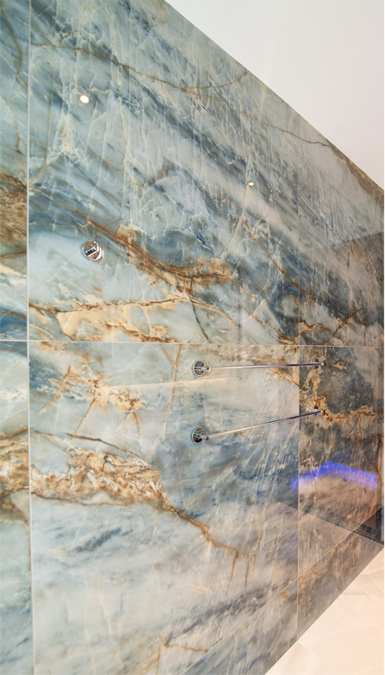

If I/we enter into a Sale and Purchase Agreement (the “**Agreement**”) with you for the Unit and I/we have indicated that I/we want the Modification, I/we confirm that this “**SELECTION AND ACCEPTANCE OF TERMS/CONDITIONS**” shall be treated as our consent to the Modification for the purposes of Clause 14 of the Agreement and that you need not notify me/us or seek our agreement again for the Modification pursuant to the said Clause 14.

I/We understand and agree to the terms and conditions set out in your said letter.

Date: 02/03/2024

(For individual)

|  |  |
| --- | --- |
| Sign Buyer1 | Sign Buyer2 |
| Name: | Name: |
| NRIC/Passport No.: | NRIC/Passport No.: |

OR

(For Company)

__________________________________

Name / NRIC or Passport No:

Designation:

For and on behalf of:

Company Stamp: