**DOCUMENTATION OF PYTHON GAME(ROCK,PAPER,SCISSOR)**

**About game:**

**Paper–scissors-rock** (also known as **scissors-rock-paper** or other variants) is a [hand game](https://en.wikipedia.org/wiki/Hand_game) usually played between two people, in which each player simultaneously forms one of three shapes with an outstretched hand. These shapes are "rock" (a closed fist), "paper" (a flat hand), and "scissors" (a fist with the index finger and middle finger extended, forming a V). "Scissors" is identical to the two-fingered [V sign](https://en.wikipedia.org/wiki/V_sign) (also indicating "victory" or "peace") except that it is pointed horizontally instead of being held upright in the air.

**STEPS TO PLAY:-**

**STEP:1**

**RIGHT CLICK ON MAIN.PY AND CLICK EDIT WITH IDLE.**

**STEP:2**

**PRESS F5 AND SIT ☺**

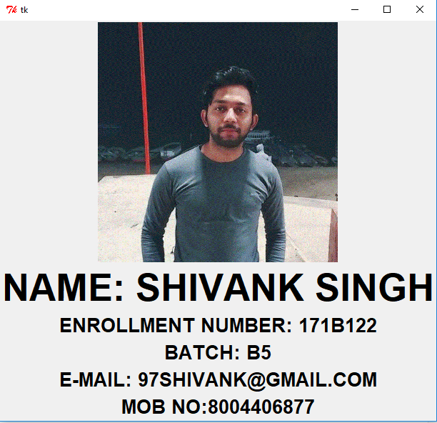

**THIS IS 1ST WINDOW THAT WILL BE OPEN.IT SHOWS MY PERSONAL DETAIL,PROJECT NAME AND BREIF INTRO ABOUT ME.NOW MOVE THE MOUSE IN ANY DIRECTION.**

**STEP:3**

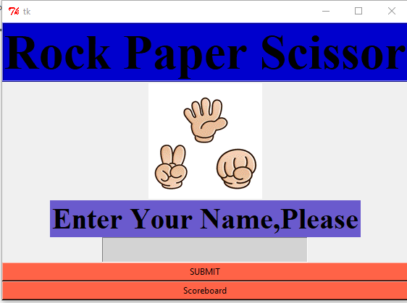

**NOW MAIN WINDOW OF GAME WILL OPEN.ENTER YOUR NAME IN GIVEN GREY BOX AND PRESS SUBMIT.**

**STEP:4**

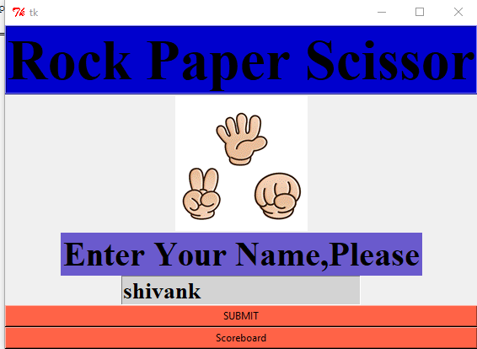

**THIS WINDOW WILL SHOW YOUR GIVEN NAME ENTERED.**

**STEP:5**

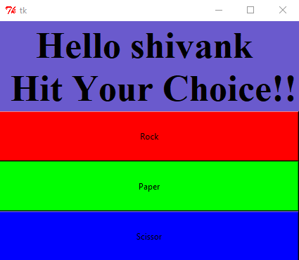

**NOW AFTER HITTING SUBMIT YOU WILL GEY THIS WINDOW.PRESS ANY OPTION FROM THE GIVEN.**

**STEP:6**

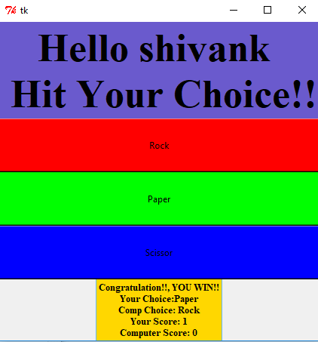

**I’VE PRESSED PAPER,SO THE RESULT IS SHOWN BELOW,WITH SCORES.**

**STEP:7**

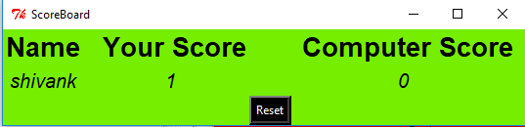

**NOW THIS IS WINDOW WHERE YOU WILL SEE YOUR SCORECARD.CLICK ON SOCREBOARD BUTTON BELOW SUBMIT BUTTON YOU WILL GET YOUR SCOREBOARD.**

**HOPE YOU WILL ENJOY IT PLAYING….IF ANY ISSUES CONTACT….**

**BY**

**SHIVANK SINGH**

**171B122**

**B-4**

**BY BATCH**