# 第一节：Introduction

## Introduction

What you will learn?

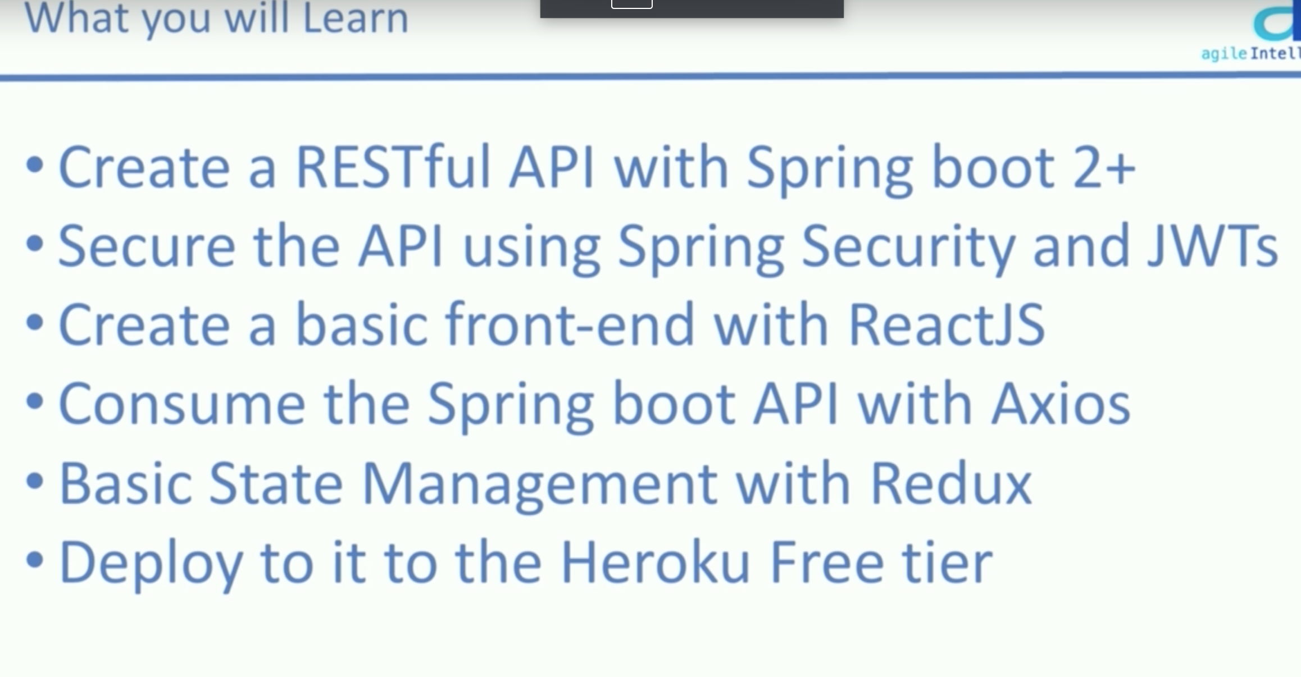

requirement

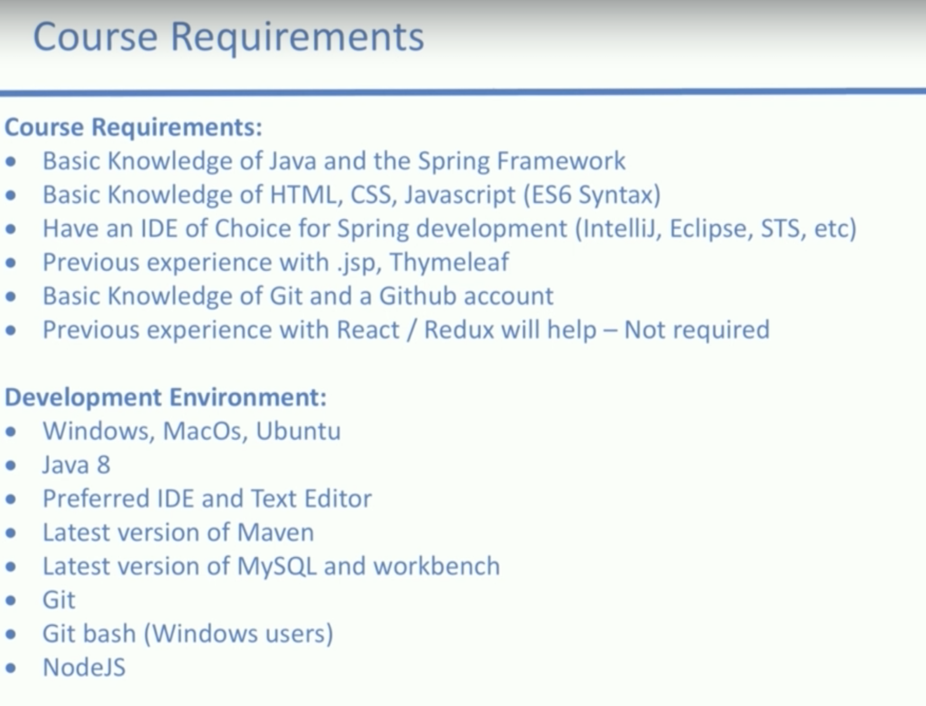

# 第2节: Spring backend – Basic CRUD operation – Project

## Folder structure and Github setup

First create a spring boot starter project wit the dependencies below

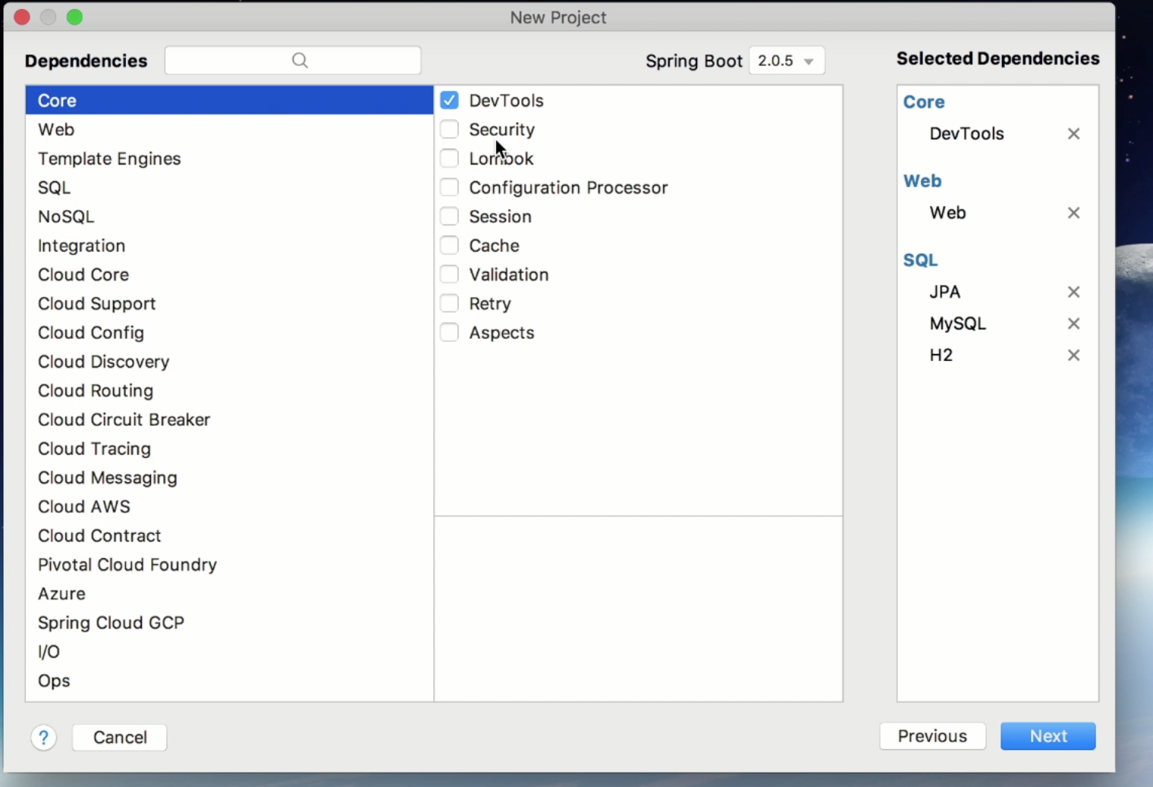

don’t forget to import Maven as well.

Then create a new project in your github account and make your first commit and push it.