The Experiment Report of Machine Learning



December 9, 2017

Grade:

Graduate

Student ID：

201721045312

Supervisor:

Mingkui Tan or Qingyao Wu

Author:

Haijun You

**SUBJECT:**SOFTWARE ENGINEERING

**SCHOOL:** SCHOOL OF SOFTWARE ENGINEERING

[1]

Linear Regression, Linear Classiﬁcation and Gradient Descent

Abstract—In this paper, linear regression and linear classification are introduced and performed with experiment, respectively.

# INTRODUCTION

This report is of the first experiment. This experiment contains two portions, which are as follows: a) linear regression and gradient descent are need performed with Housing data set in LIBCVM data; b) linear classification and gradient descent are applied in australian data set.

# METHODS AND THEORY

1. Initialization
2. linear regression and gradient: parameters of weight are set to zero , iteration is set to 100 and learning rate is set to 0.001.
3. linear classification and gradient descent: parameters of weight and basis are set zero,iteration is set to 500 and learning rate is set to 0.001
4. Loss function and gradient
5. linear regression and gradient:

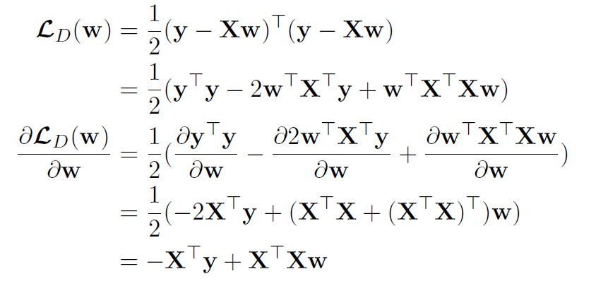

1. linear classification and gradient descent:

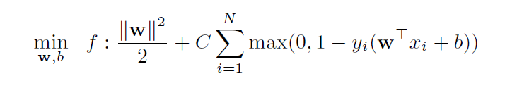

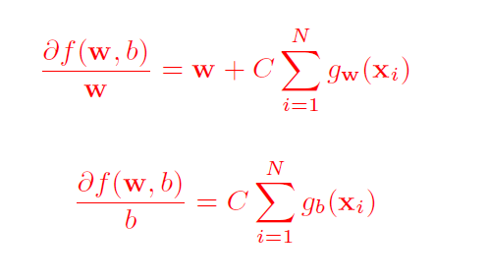

# Experiment

1. linear regression and gradient

The loss results of train and validation are drawn and shown in Figure 1.

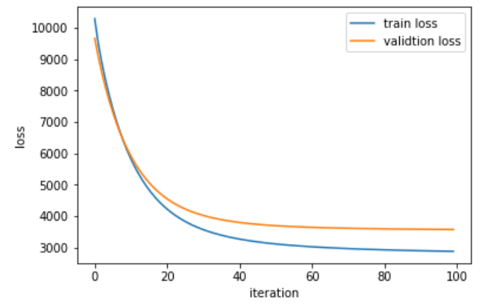

Figure 1 Loss results of linear regression

b)linear classification and gradient descent

The loss results of train and validation are drawn and shown in Figure 2.

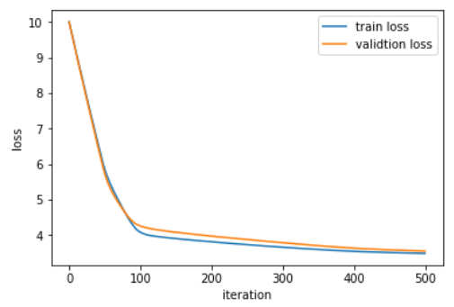

Figure 2 Loss results of linear classification

# conclusion

These two models apply gradient descent to match and classify.

The differences is the loss function, derivation function and gradient. The steady loss values were obtained of these two different approached in the end.

1.