The Experiment Report of Machine Learning



December 14, 2017

Grade:

Graduate

Student ID：

201721045398, 201721045374,

201721045312

Supervisor:

Qingyao Wu

Author:

Zilong Li, Di Liu, HaijunYou

**SUBJECT:**SOFTWARE ENGINEERING

**SCHOOL:** SCHOOL OF SOFTWARE ENGINEERING

[1]

Recommender System Based on Matrix Decomposition

Abstract—In this paper, recommender system based on matrix decomposition were realized using stochastic gradient descent(SGD) method. The details and experiments are shown in the following content.

# INTRODUCTION

This report is about the fourth experiment of machine learning course. This experiment gives two approaches to realize the recommeder system. And our group choose the second method named SGD to finish the task. The main steps of SGD method is shown in Figure 1.

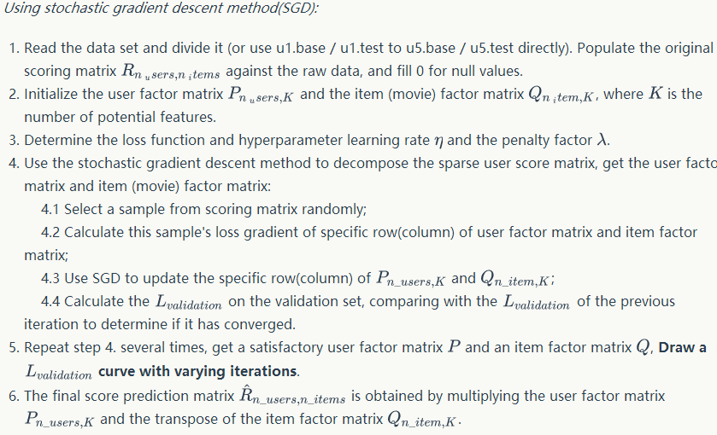

Figure 1 The steps of SGD

# METHODS AND THEORY

1. Initialization

In this paper, we select u1.base as the training set, and u1.test as the testing set.  is initialed with random value between  with size is , and  is initialed with random value between  with size is . Other parameters are set to ,and. 500 points were randomly selected in each iteration.

1. Loss function and gradient





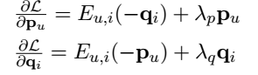

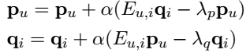

# Experiment

The total loss curve of training set is shown in figure 2. And the total loss curve of testing set is shown in figure 3.

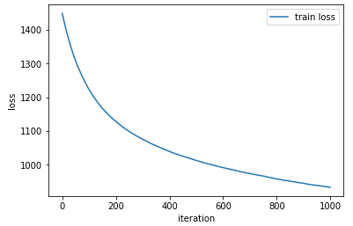

Figure 2 Curve of training set

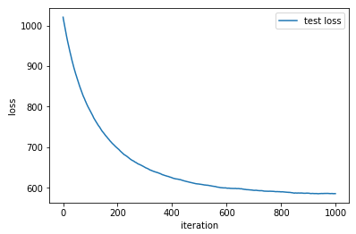

Figure 3 Curve of testing set

# conclusion

This paper realized the recommender system with SGD. The running time is long with SGD method, for the calculation of loss is time-consuming. So 500 updates of and  in each iteration to decrease the running time.

The performance of SGD is good and the convergence is obtained in the end. But there is a puzzled problem about this experiment. The decomposed matrix and  were calculated based on the training set to make  approximately equal the training matrix , but in this experiment  also was used to approximately equal the testing matrix.

1.