..

**Name :- Ayub Alam**

**Project Name :- Image- based sentiment**

**analysis**

**Image Based Sentiment Analysis**

This script uses the DeepFace library to analyze the emotion of a person in an image. It detects faces in the image, predicts the emotions associated with each face, and highlights the face with the highest predicted emotion.

**Prerequisites**

Before running the script, ensure you have the following libraries installed:

DeepFace

Matplotlib

OpenCV

You can install them using pip:



**Usage**

Import the necessary libraries:

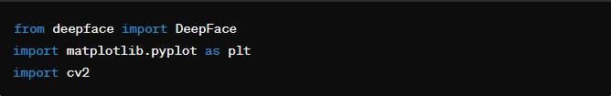

Define the path to the image you want to analyze:



Load the image using Opencv ;



Analyze the emotion of the image using DeepFace ;



Display the original image :

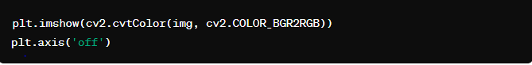

Find the face with the highest emotion accuracy :



Get the emotion with the highest accuracy :

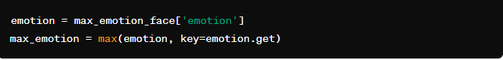

Get the bounding box coordinates of the face :

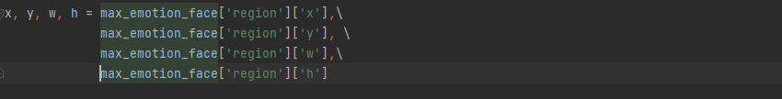

Draw a bounding box around the face :



Annotate the image the highest accuracy emotion :



Display the image with the bounding box and annotations ;

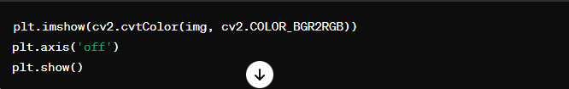

**Result :-**

**Input image:**

**Output image :**

The script will display the original image with a bounding box around the face detected as having the highest predicted emotion. An annotation will indicate the detected emotion and its confidence level.

**Limitations**

**Accuracy:** The accuracy of the emotion detection model used by DeepFace may vary depending on the complexity of the image and the clarity of the facial expressions. It may not always accurately capture subtle or nuanced emotions.

**Single Face:** The current implementation focuses on analyzing the emotion of only one face with the highest confidence. If there are multiple faces in the image, it will only analyze and display the emotion of the face with the highest predicted emotion.

**Dependency:** The script relies on external libraries such as DeepFace, matplotlib, and OpenCV. Any changes or updates to these libraries may impact the functionality of the script.

**Real-time Analysis:** The script is designed for analyzing emotions in a static image. It is not suitable for real-time emotion analysis in videos or live streams.

**Conclusion**

The script provides a simple and effective way to analyze the emotion of a person in an image using the DeepFace library. By highlighting the face with the highest predicted emotion and annotating the image with the detected emotion and its confidence level, it offers a visually intuitive way to understand the emotional content of an image.

While the script has some limitations, such as accuracy and dependency on external libraries, it serves as a useful tool for basic emotion analysis tasks. Future improvements could focus on enhancing the accuracy of the emotion detection model, supporting real-time analysis, and expanding the functionality to analyze emotions in videos.