***Investigation – Daniel Martin***

* I researched many possible systems I could implement for the use of my project. One of my previous ideas was a step counter, I was investigating the [benefits](https://blog.ultrahuman.com/blog/benefits-of-tracking-your-steps/) and possible ways of implementing them. I realised I had to discard this idea due to its popularity. However, I am happy with my idea of rep tracking. I came up with this idea while investigating [angle tracking](https://stackoverflow.com/questions/76160160/how-to-use-two-microbits-3-axis-magnetometers-to-track-an-articulated-arm) for another idea (bench press tracking). The system is activated by shaking the microbit, selecting the weight you would like to use, straping it to your arm, press B to activate the tracking. Once it is tracking it measures the angle of the microbit and transmits that into reps. This is sent to the database to be used for diagrams and comparison. The target audience for the system would be individuals who are interested in seeing improvement in their gym work.

**Describe how your research enabled you to identify the key factors you need to implement and the ones you can abstract away**

* **State the what if questions, what inspired them and how it will answer them.**

I hope to meet my basic requirements and implement my features into the project. My basic objectives are:

* To make a computer program that tracks the user’s reps and weight they used in a single workout.
* To transfer the data into a database to break down the total weight, total reps, and the time it was completed
* To meet my last basic requirement, I hope to transfer this data into a bar chart and have it display the weights used and total reps of the last 5 workouts.

This helps their wellbeing due to ….

(-------------------------------insert advanced here -------------------------------)

In the survey I conducted I got many responses represented by the graphs below: 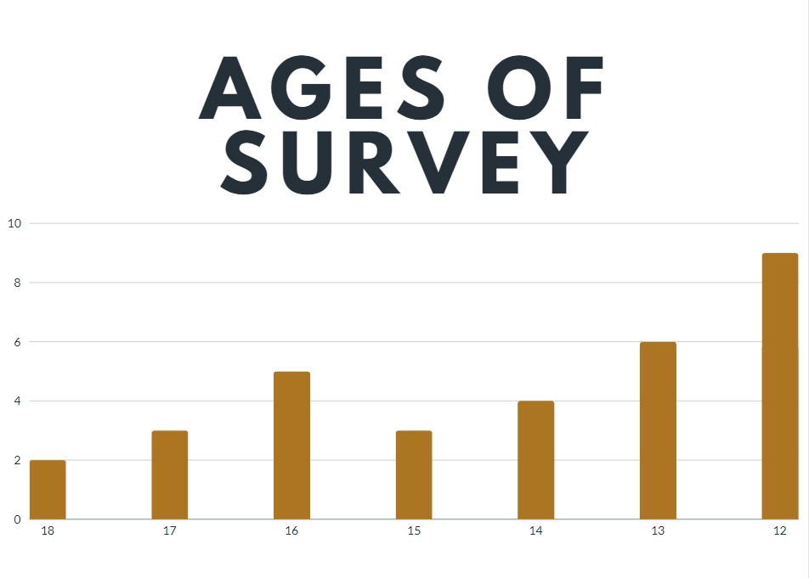

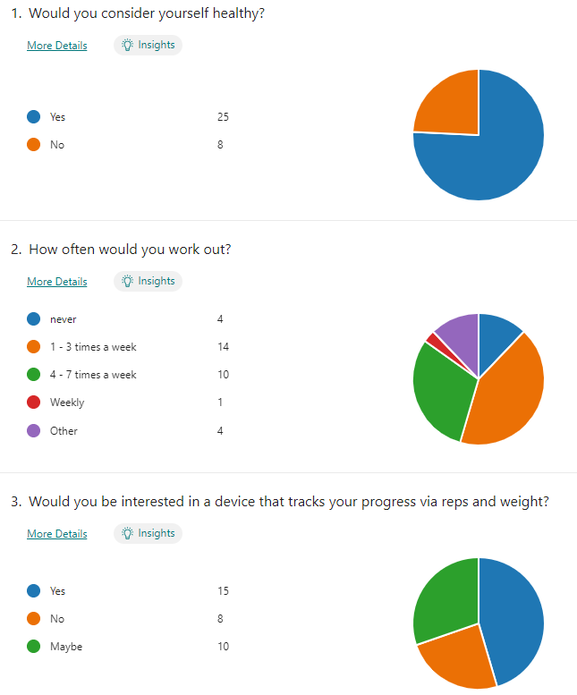

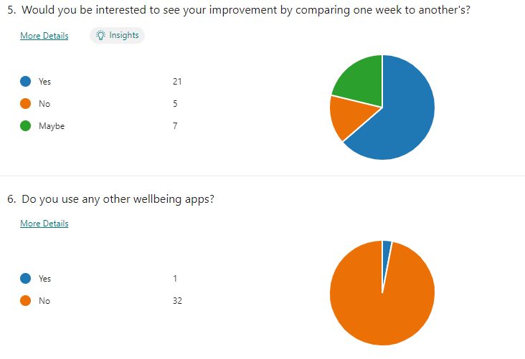

My market research showed that a majority of my target audience wanted a device with a calorie tracker built in. I used this information to try implement this feature. I will implement a calorie burned per minute by using the formula Men:

Calories burned per minute = (MET x body weight in Kg x 3.5) ÷ 200

*https://captaincalculator.com/health/calorie/calories-burned-curling-calculator/*

*Predicted METs = 14.7 − (0.11 × age); Women: Predicted METs = 14.7 − (0.13 × age).*

MET

https://www.researchgate.net/figure/Nomogram-to-calculate-percent-of-predicted-exercise-capacity-for-age-for-men-and-women_fig1_259171618#:~:text=Established%20using%20the%20following%20regression,%E2%88%92%20(0.13%20%C3%97%20age).&text=Coronary%20artery%20disease%20(CAD)%20is,of%20women%20and%20men%20worldwide.

* I have hypothesised I could use an angle tracker as an analog input, microbit sending the angle to thonny as an analog output, a typed thonny question (insert here) as a digitalinput, and LED scrolling text on the microbit as a digital output.