**Контрольная работа № 1. «Работа с файлами»**

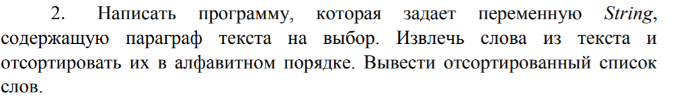

**Текст программы:**

**package** com.main;

**import** java.io.FileWriter;

**import** java.io.IOException;

**import** java.nio.file.Files;

**import** java.nio.file.Paths;

**import** com.task.WordsSorter;

**public** **class** Main {

**public** **static** **void** main(String[] args) {

String paragraph = *readStringFromFile*("file1.txt");;

String[] sortedWords = WordsSorter.*Sort*(paragraph);

// Write to 'File2.txt'

**try**(FileWriter writer = **new** FileWriter("file2.txt", **false**))

{

**for** (String word : sortedWords) {

System.***out***.println(word);

writer.append(word);

writer.append('\n');

}

writer.flush();

}

**catch**(IOException ex){

System.***out***.println(ex.getMessage());

}

// Write to 'File3.txt'

**try**(FileWriter writer = **new** FileWriter("file3.txt", **false**))

{

writer.write(paragraph);

writer.append('\n');

**for** (String word : sortedWords) {

writer.append(word);

writer.append('\n');

}

writer.flush();

}

**catch**(IOException ex){

System.***out***.println(ex.getMessage());

}

}

**private** **static** String readStringFromFile(String filePath)

{

String content = "";

**try**

{

content = **new** String ( Files.*readAllBytes*( Paths.*get*(filePath) ) );

}

**catch** (IOException e)

{

e.printStackTrace();

}

**return** content;

}

}

**package** com.task;

**import** java.util.List;

**import** java.util.Arrays;

**import** java.util.Collections;

**public** **class** WordsSorter {

**static** **public** String[] Sort(String str) {

String[] words = *SplitWords*(str);

List<String> list = Arrays.*asList*(words);

Collections.*sort*(list);

**return** list.toArray(**new** String[0]);

}

**static** **private** String[] SplitWords(String string) {

String[] words = string.split("\\s+");

**for** (**int** i = 0; i < words.length; i++)

words[i] = words[i].replaceAll("[^\\w]", "");

**return** words;

}

}

**Результат выполнения:**

