Reporting – Design 2

1. Upon selecting the reports main menu item, the user arrives at the default report interface.  *See* *figure 1.1*
   1. State selection

\*Note – Intellisense (typeahead) exists on the State input.

As the user types, the intellisense will suggest state names.

*See figure 1.2*

In this example, the user selects the state of Texas

*See figure 1.3*

*Figure 1.1*

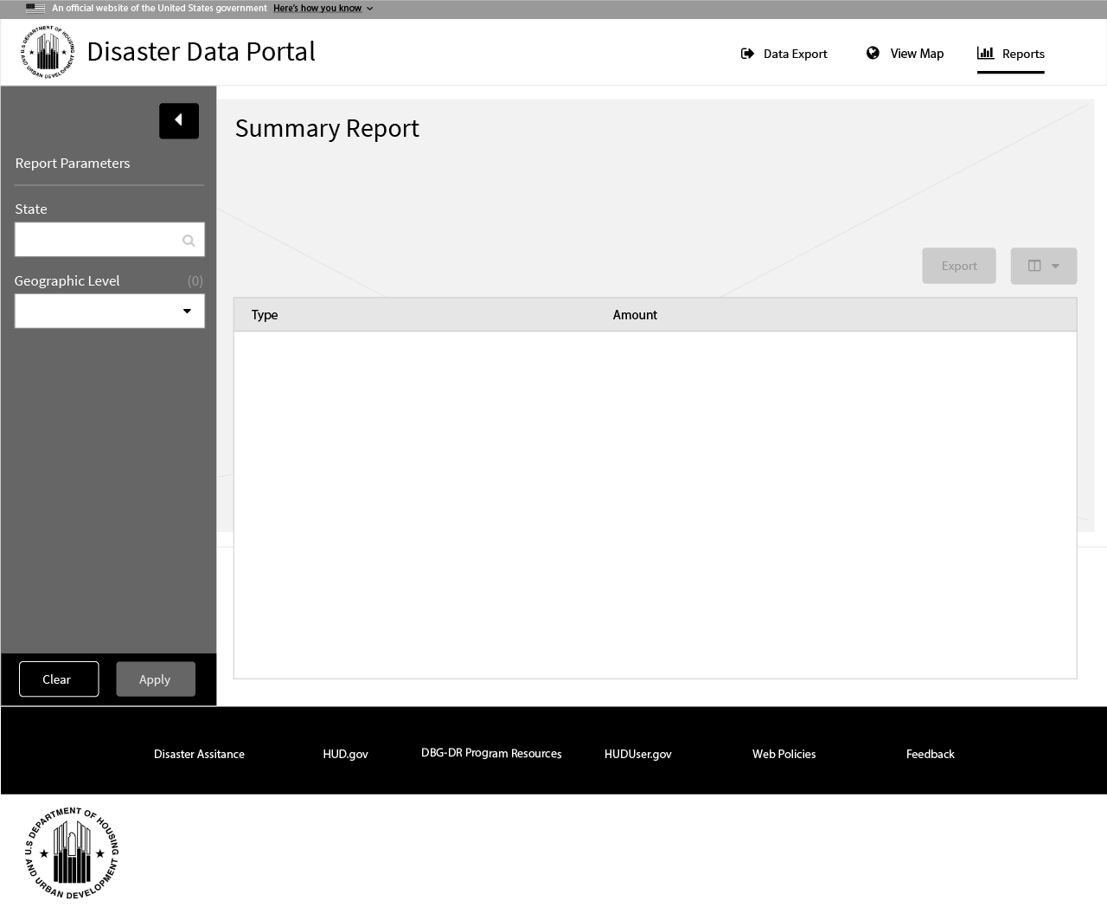

*Figure 1.2*

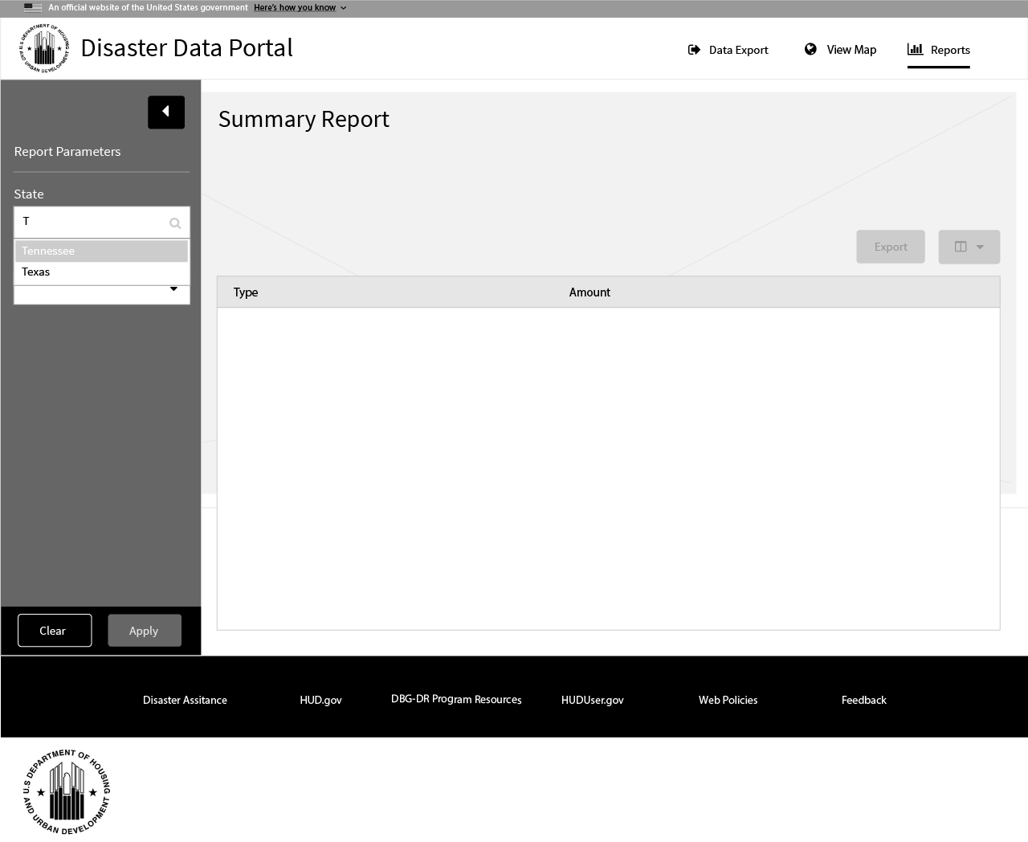

*\* NOTE – The action buttons (clear/apply) are locked to the bottom of the left hand screen. This allows scrolling down the page while keeping them in the user’s cognitive focus. (This also allows dynamic items to be placed in the left form which may exceed the height of the user’s current view)*

*Figure 1.3*

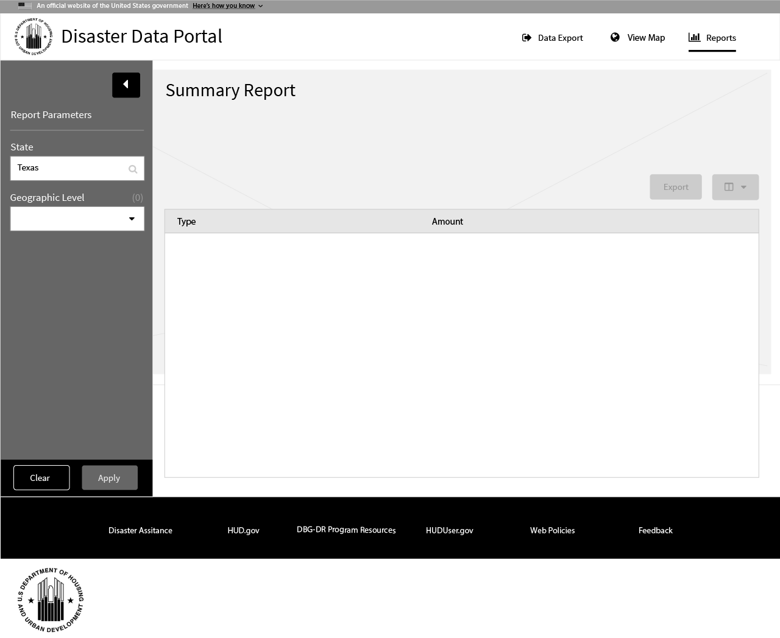

1. Geographical Level
   1. The user selects a geographical level
      1. City
      2. County
      3. Congressional District

*See figure 2.1*

*\* NOTE – Once the user has selected a geographical level it is displayed under the*

*Summary reporting title along with its corresponding data display text. For example, if the user had selected city as the geographical level, the display text would be “Displaying data for the following cities”.*

*Figure 2.1*

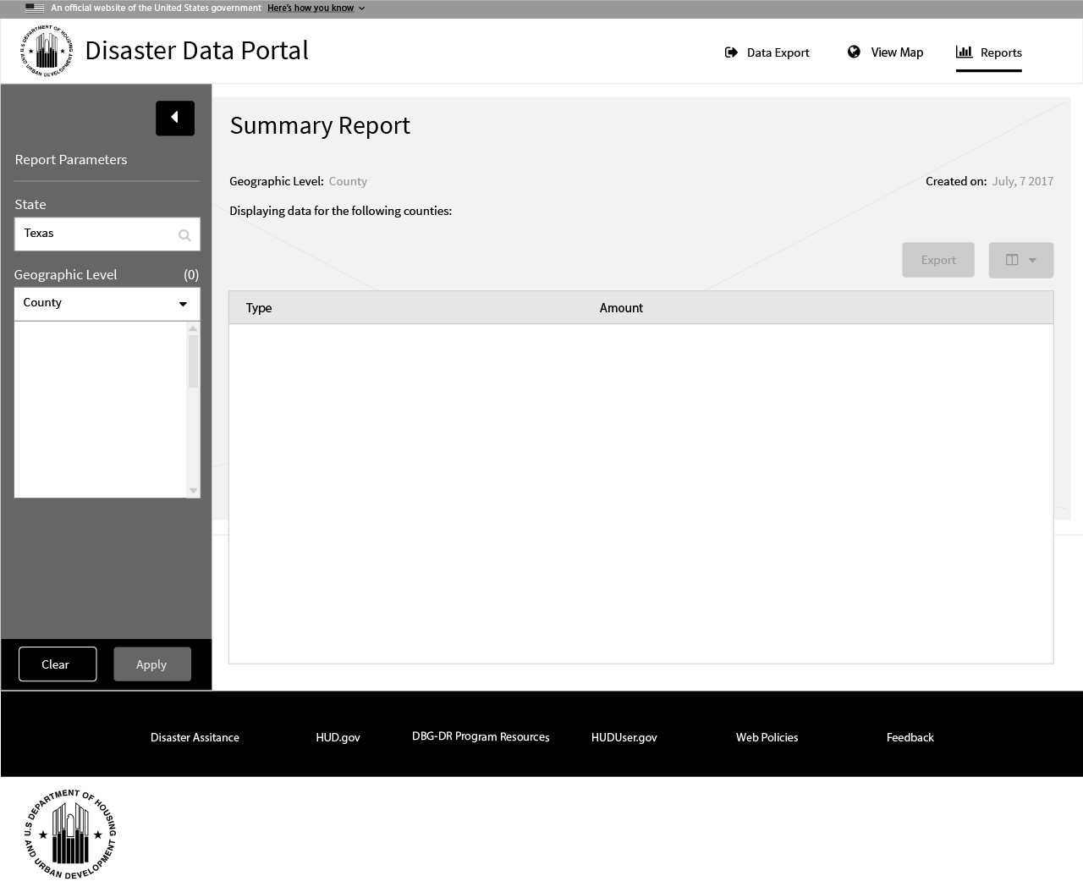

* 1. Once the user has selected a geographical level, a list box component is presented. As the user sets focus (click or tap), the cursor appears creating a new tag element. As the user types characters, the intellisense once again offers suggestions based off the State and Geographical selections. (In the example, counties in the state of Texas are suggested).

*See figure 2.2*

The user can enter as many tag elements desired.

*See figure 2.3*

*Figure 2.2*

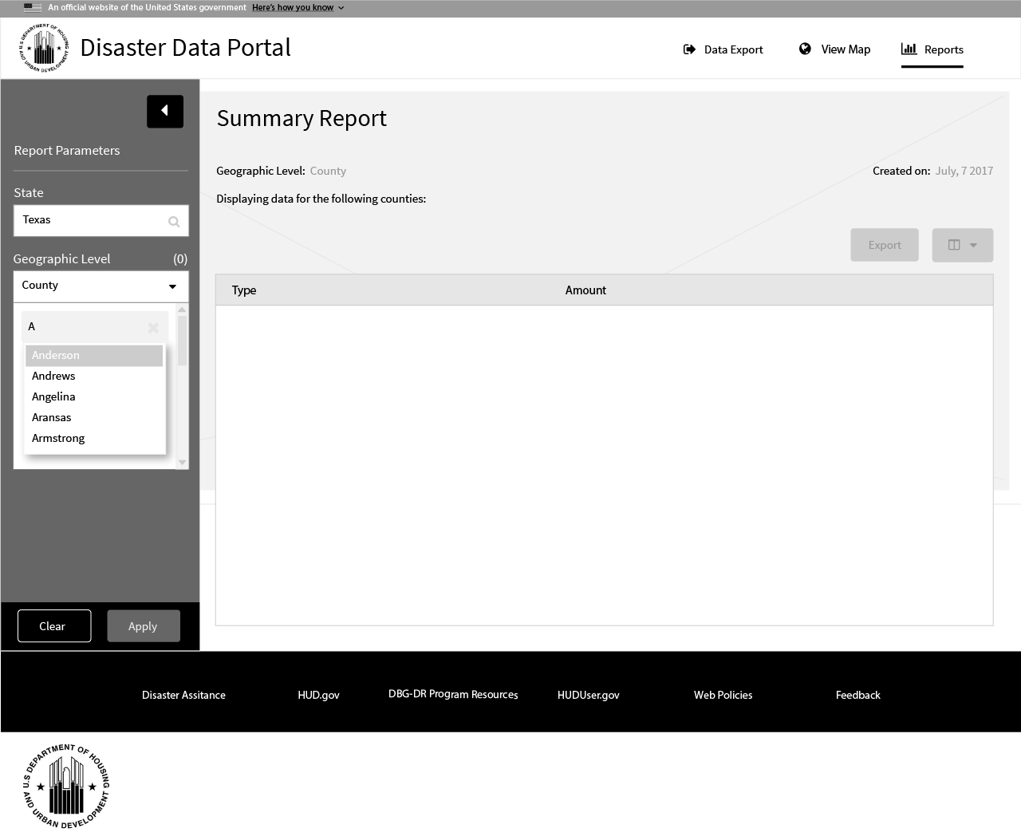

*Figure 2.3*

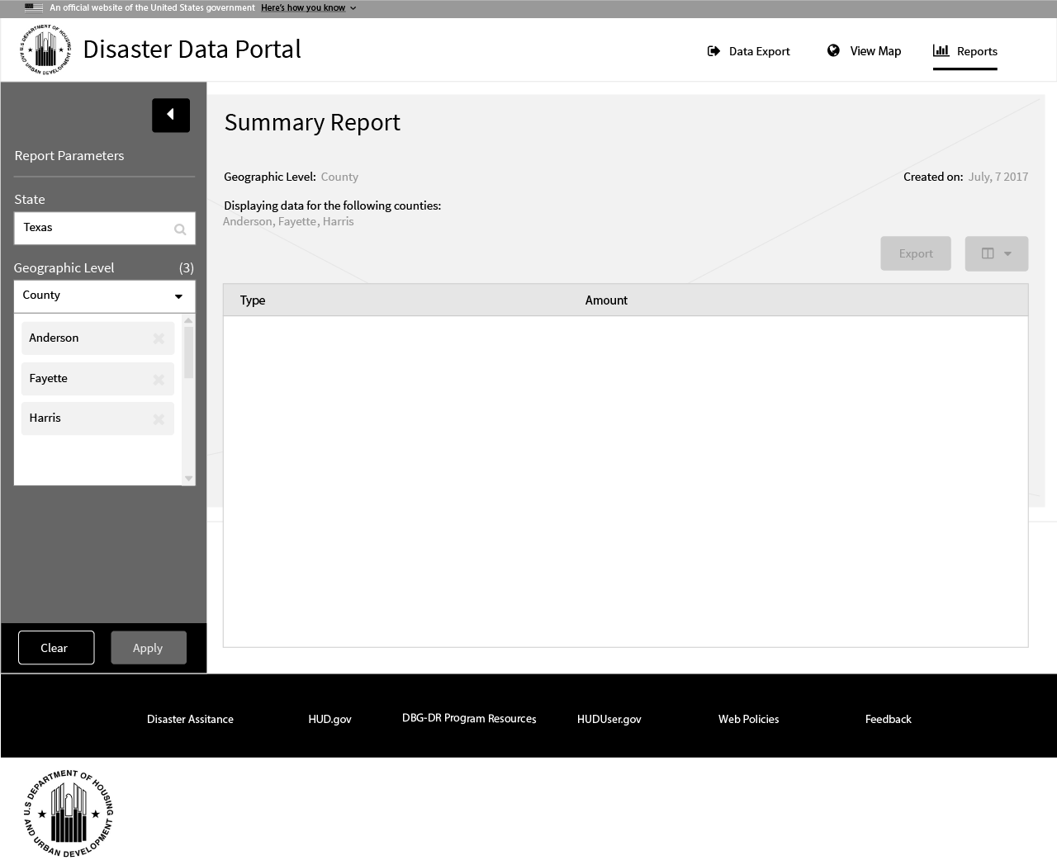

*\* NOTE – As the user creates tag elements in the geographical level list box component, a total count is displayed to the right of the title. This provide the user with a quick total of all tag elements.*

* 1. The user then has the option of either clearing the left form or applying the parameters to create the report. As the report is being generated, the user is presented with an animation.

*See figure 3.1 for animation*

*See figure 3.2 for report*

*Figure 3.1*

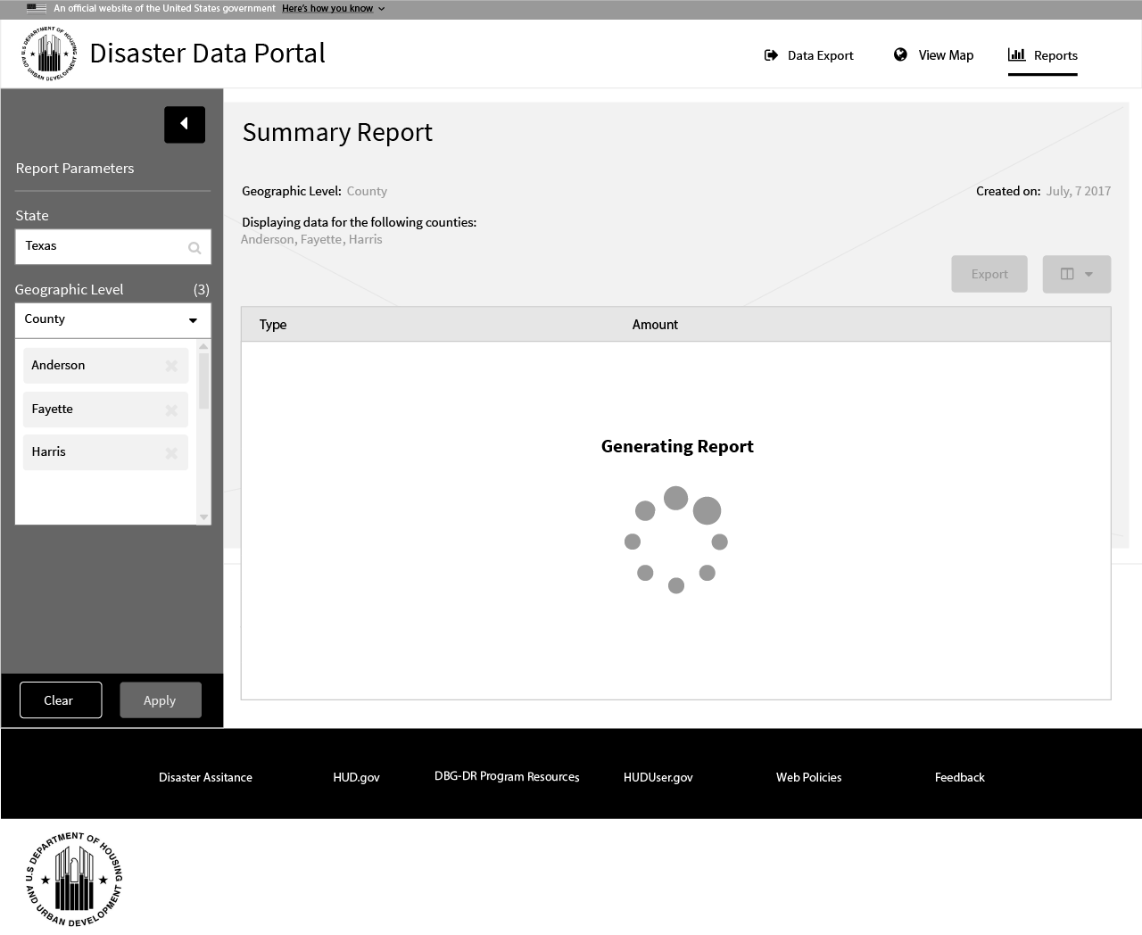

*Figure 3.2*

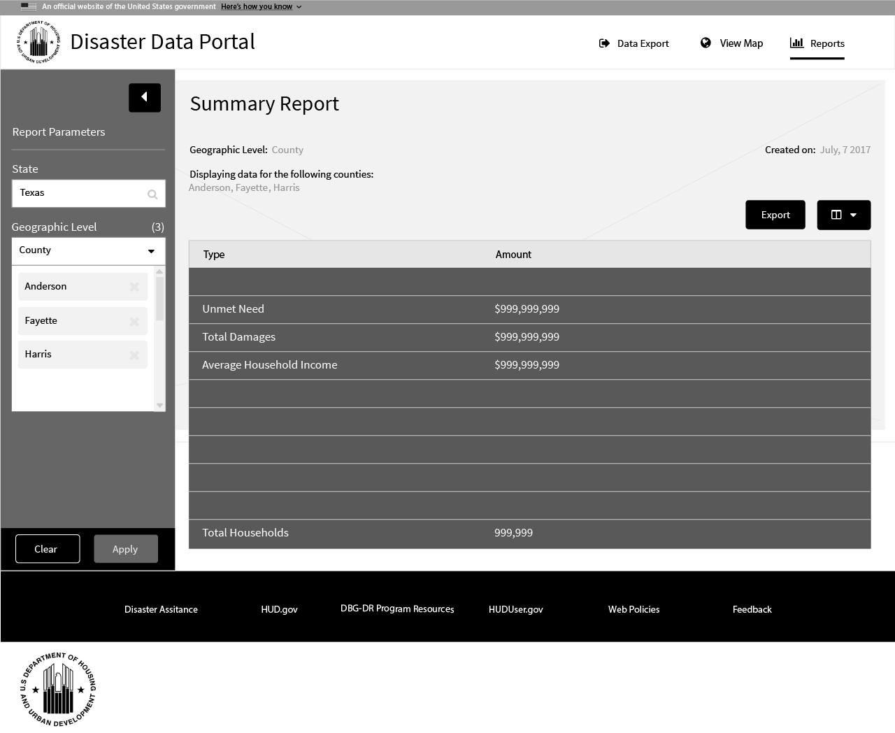

*\* NOTE – The EXPORT and column selection buttons are disabled until the form has completed generation and is presented to the user.*

* 1. Once the form has been generated, the user has the option of selecting values to be presented within the form. They may do so by clicking / tapping the value chooser drop-down button located at the top right of the generated form.

*\* NOTE – In this example, you can see the default values are selected within the pop-up. If the user selects another value to be included within the form, the report will be regenerated while displaying the loading animation.*

*The user may also at any time minimize the left menu to allow for more viewing room when required.*

*Figure 4.1*

