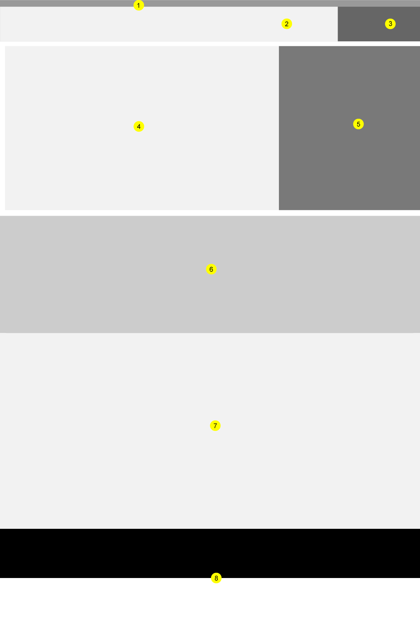

Landing Page Framework:

1. USWSD header – required by all US government websites
2. Header (a) – HUD Disaster Logo
3. Header (b) – reserved for user photo/options
4. Search component – default is 100% width / when #5 is displayed occupies 66% width
5. Search List component – selectable via tab
6. Reserved for tutorial or teaser stories
7. Optional Data Area
8. Footer (broken into 2 zones..top/bottom)

--------------------------------------------------------------------------------------------------------------

User Flow 2.1: **Single Item Export**

Screens:  
*landing.v2_01  
landing.v2_01.1  
landing.v2_01.2*

**User Action:**  
1. Navigates to screen. (*landing.v2_01*)  
2. Is presented with a search bar.  
3. Enters "DR-1" within search bar. (*Note - autocomplete triggers on 3rd character entry)  
4. Is presented with a list of possible suggested options (scrollable using typeahead). (*landing.v2_01*)  
 Option list may be broken into several categorized sections (disasters, counties, .etc)  
5. Selects an option and item is added to the search bar.  
6. Executes EXPORT.  
7. Is presented with a modal of export options. (.docx / .xslx / .csv / .pdf) (*landing.v2_01.2*)  
8. Selects an export option.  
9. Is presented with filename and location options.  
10. Data is exported.  
11. Is presented with successful/failure data export message.

--------------------------------------------------------------------------------------------------------------

User Flow 2.2: **Multiple List Item Export**

Screens:   
*landing.v2_02  
landing.v2_02.1  
landing.v2_02.2   
landing.v2_02.2.export*

User Action:

1. Navigates to screen. (landing.v2_02)

2. Is presented with a search bar.

3. At any time clicks tab on right side ("My Searches") to view search list.

a. *note - the EXPORT button on search bar is hidden when search list is shown.

4. Enters "WIL" within search bar. (*Note - autocomplete triggers on 3rd character entry) (landing.v2_02.1)

5. Is presented with a list of possible suggested options (scrollable typeahead)

6. Selects an option and drags to list on right side drop zone.

7. Item is added to list area. (landing.v2_-2.2)

8. Save button is now shown. User Can save search at any time.

a. *note - the save action will trigger validation on name creation in select/input box.

If no name or default text is present, warning is shown indicatiing the user must enter a name in order to save list.

7. Clear/Export buttons are active.

8. Executes EXPORT.

9. Is presented with a modal of export options. (.docx / .xslx / .csv / .pdf) (landing.v2_02.export)

10. Selects a export option.

11. Is presented with filename and location options.

12. Data is exported.

13. Is presented with successful/failure data export message.

--------------------------------------------------------------------------------------------------------------

User Flow 2.3:

Screens:

landing.v2_03

landing.v2_03.1

User Action:

1. Navigates to screen. (landing.v2_03)

2. Is presented with a search bar.

3. At any time clicks tab on right side ("My Searches") to view search list.

a. *note - the EXPORT button on search bar is hidden when search list is shown.

4. Selects dropdown for saved searches.

5. Is presented with a list of previously saved searches to choose.

6. Selects an option.

7. Search items are loaded into the search list area. (landing.v2_03.1)

8. Save button is now shown. User Can save search at any time.

a. *note - User has ability to change name within name input textbox.

9. Delete button is active.

a. *note - User has ability to delete saved search list. This action requires modal validation.

7. Clear/Export buttons are active.

11. Has the ability to add/delete more items to saved search list.

12. Executes EXPORT.

13. Is presented with a modal of export options. (.docx / .xslx / .csv / .pdf) (landing.v2_02.export)

14. Selects a export option.

15. Is presented with filename and location options.

16. Data is exported.

13. Is presented with successful/failure data export mess