Reporting – Design 1

1. Upon selecting the reports main menu item, the user arrives at the default report form screen.  *See* *figure 1.1*
   1. State selection

\*Note – Intellisense (typeahead) exists on the State input.

As the user types, the intellisense will suggest state names.

*See figure 1.2*

*Figure 1.1*

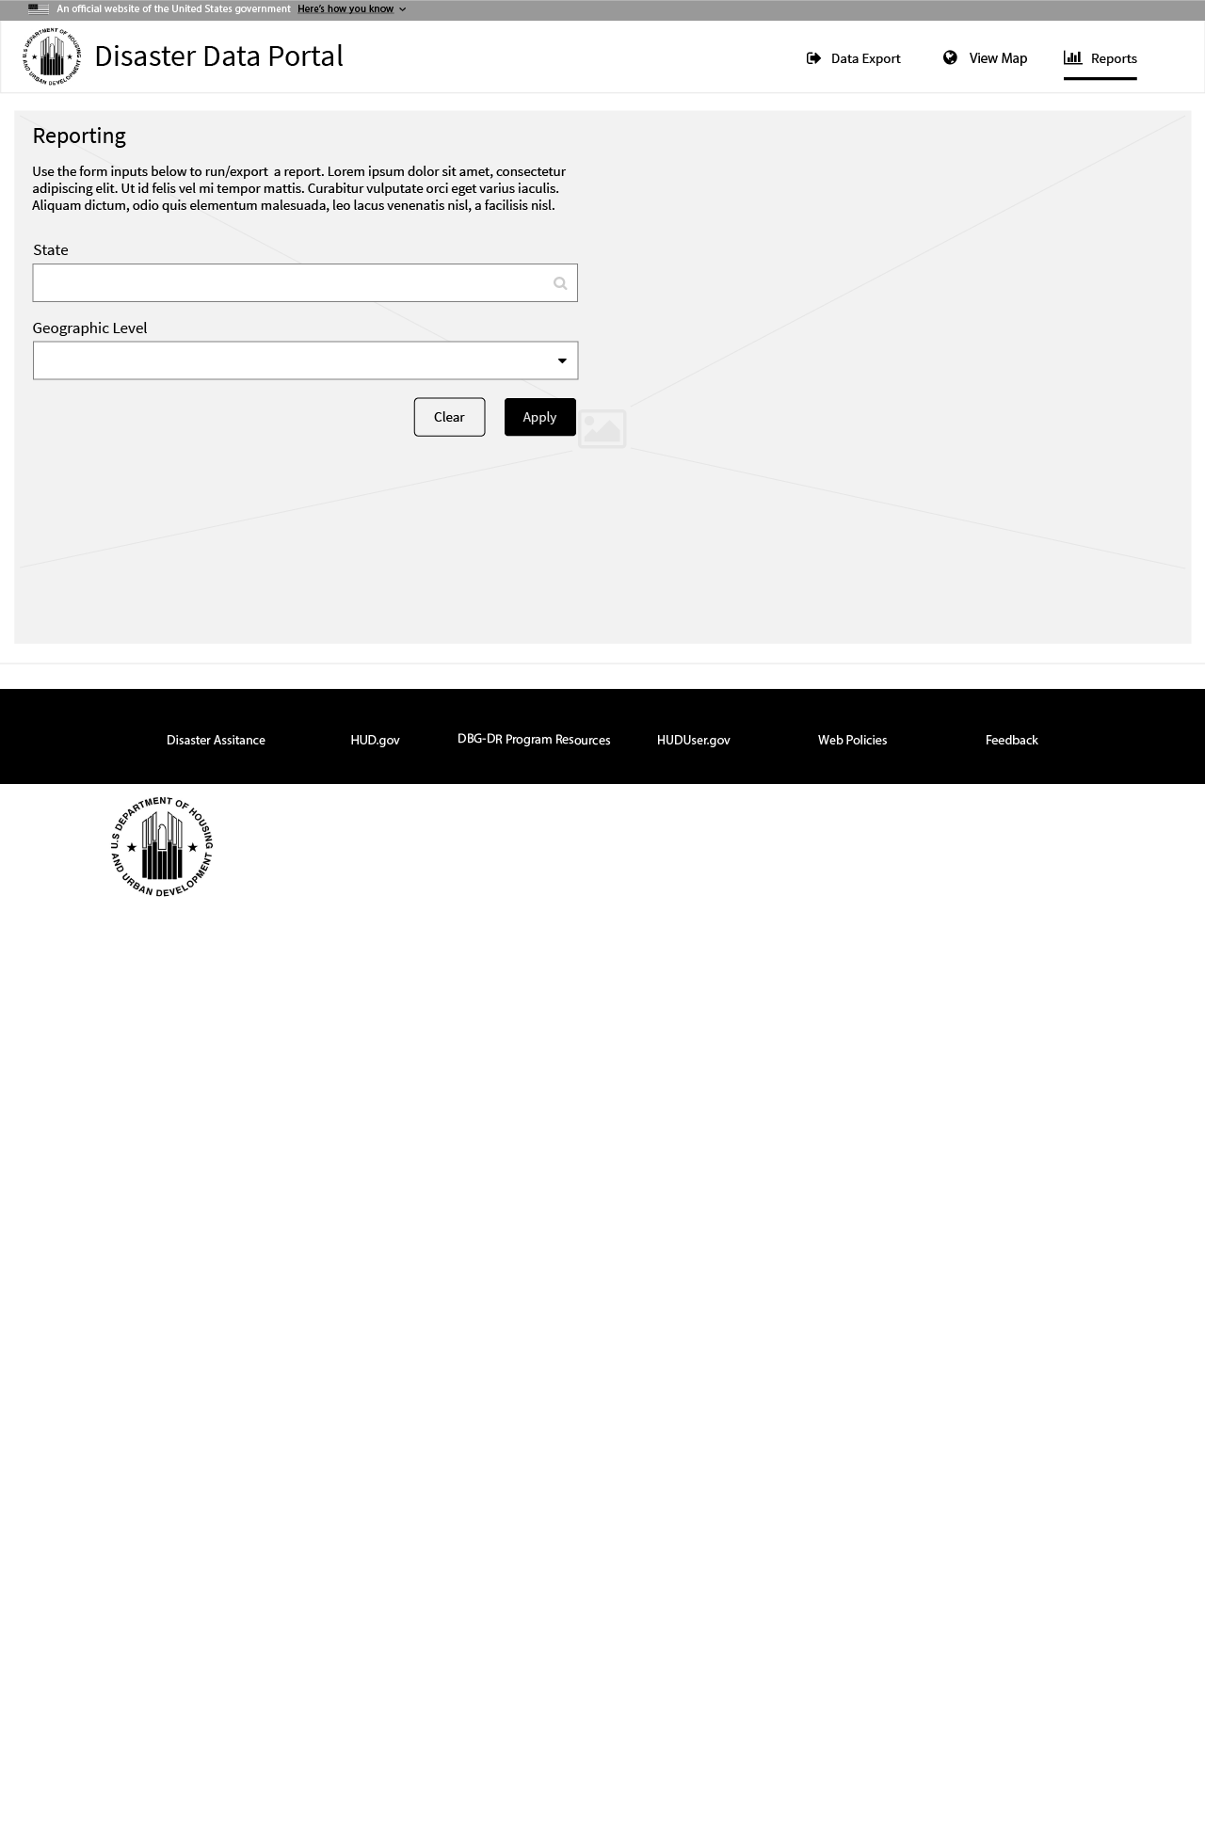

*Figure 1.2*

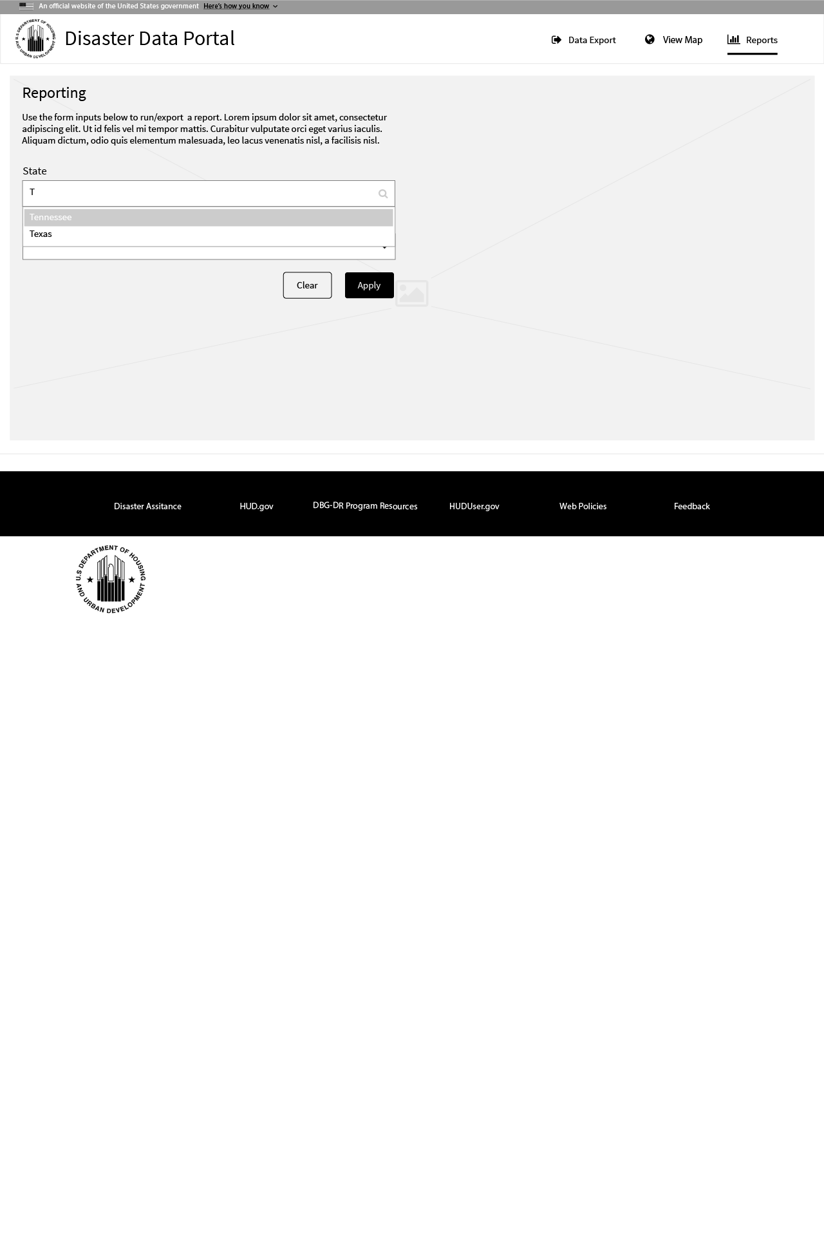

*Figure 1.3*

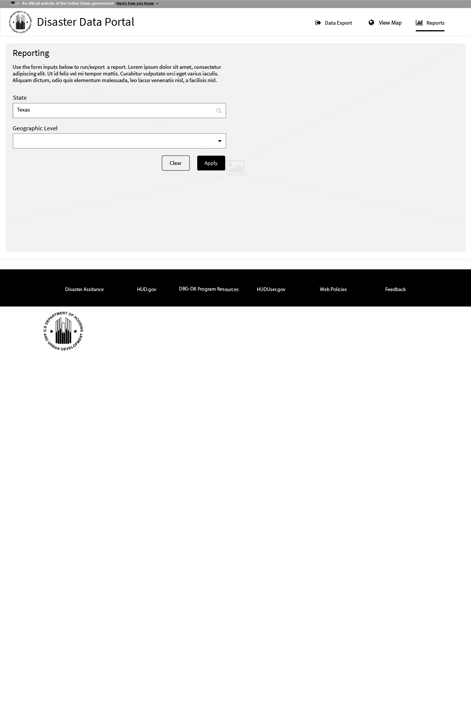

1. Geographical Level
   1. The user selects a geographical level
      1. City
      2. County
      3. Congressional District

*See figure 2.1*

*Figure 2.1*

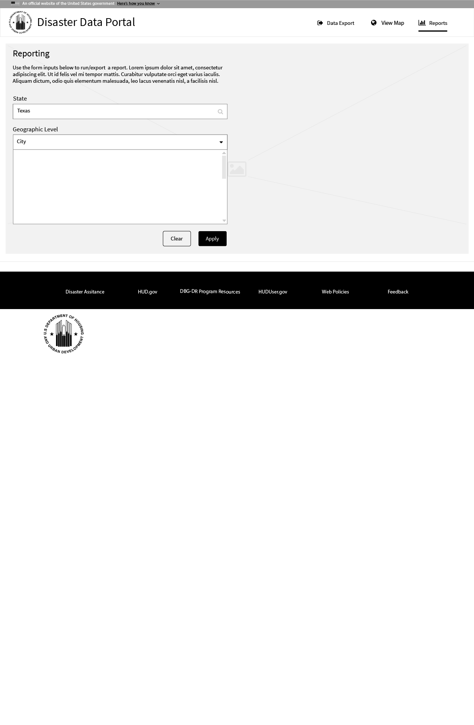

* 1. Once the user has selected a geographical level, a listbox is presented. As the user sets focus (click or tap), the cursor appears creating a new tag element. As the user types characters, the intellisense once again offers suggestions. (In the example, cities in the state of Texas are suggested).

*See figure 2.2*

The user can enter as many tag elements desired.

*See figure 2.3*

*Figure 2.2*

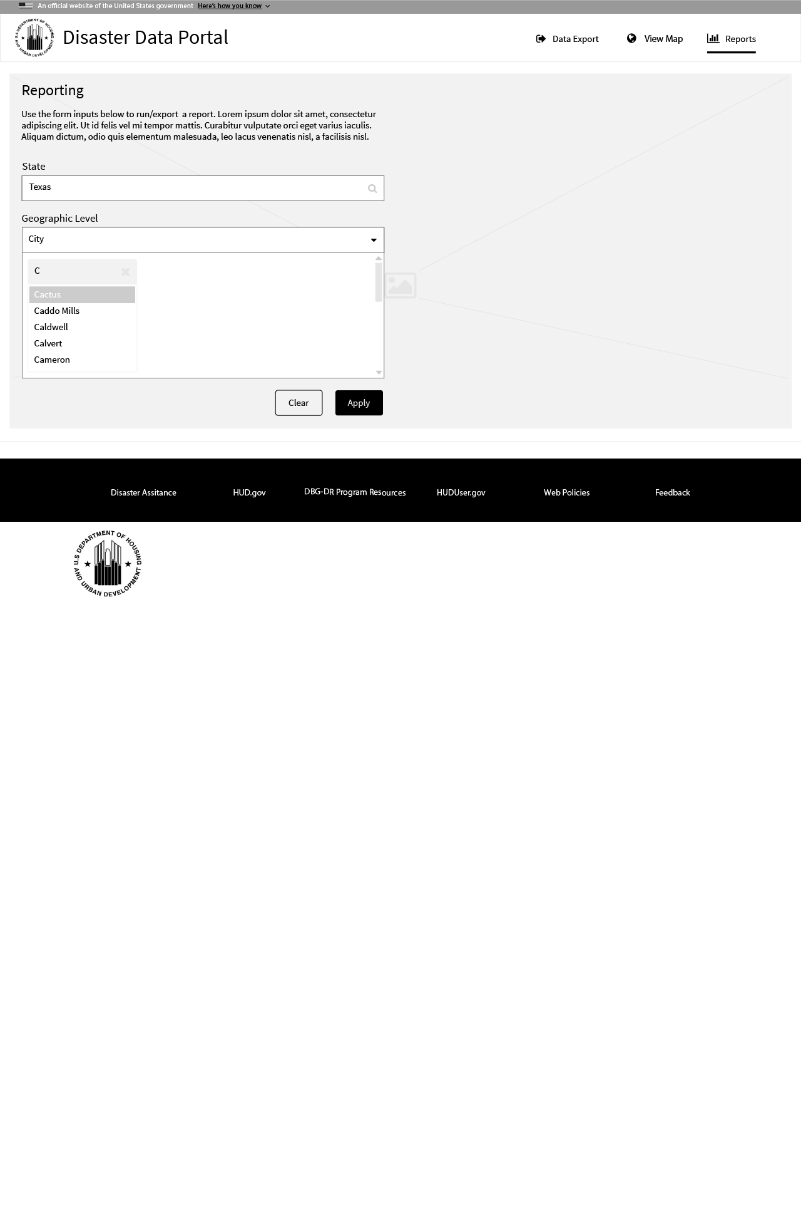

*Figure 2.3*

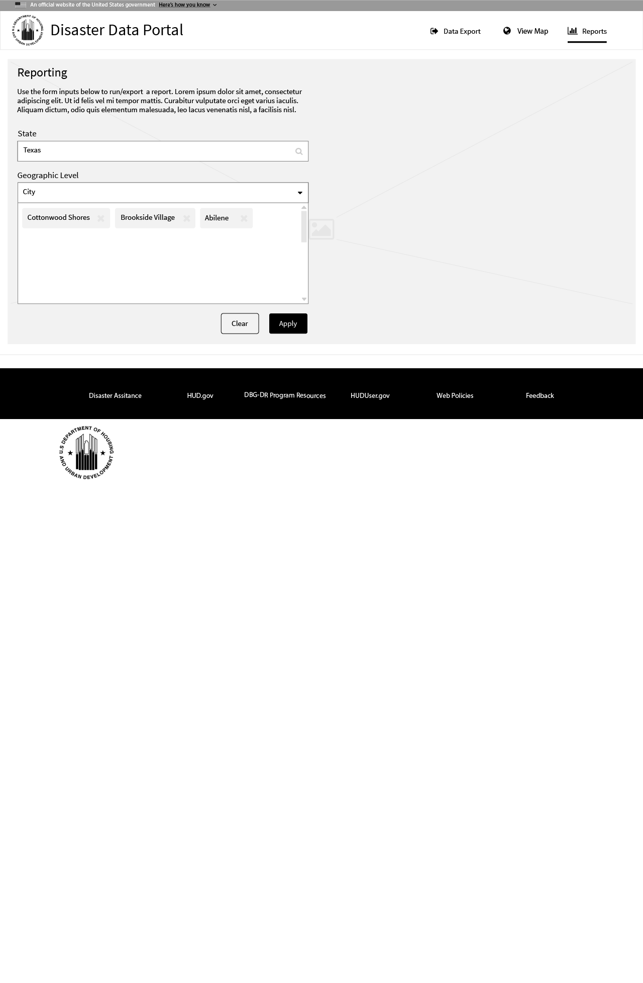

* 1. The user then has the option of either clearing the form or applying the parameters to create the report. As the report is being generated, the user is presented with an animation.

*See figure 3.1 for animation*

*See figure 3.2 for report*

*Figure 3.1*

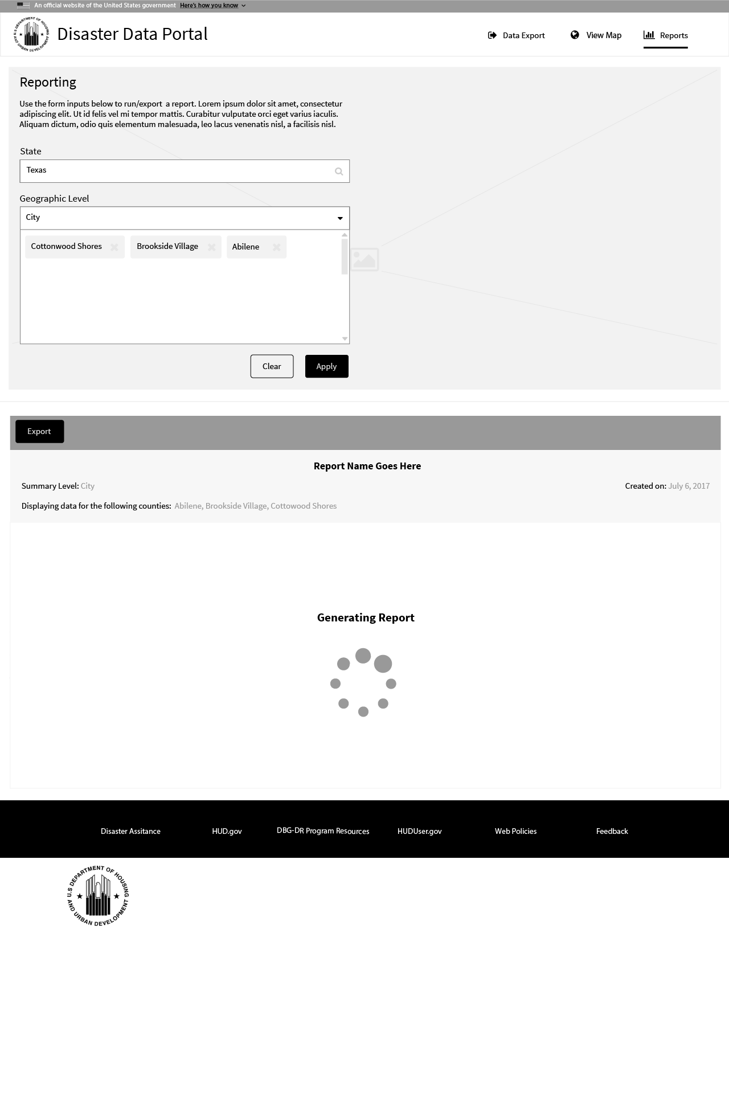

*Figure 3.2*

