**PART I**

**Python Programming**

**Exercise No.: 1 Date: 17.12.2021**

**PROGRAM TO PERFORM PUSH AND POP OPERATION IN STACK**

**AIM:**

To Write a python program to perform basic push and pop operation

**SOURCE CODE:**

**Program to Push and Pop elements in a list**

stack = []

stack.append('a')

stack.append('b')

stack.append('c')

print('Initial stack')

print(stack)

print('\nElements popped from stack:')

print(stack.pop())

print(stack.pop())

print(stack.pop())

print('\nStack after elements are popped:')

print(stack)

**OUTPUT:**

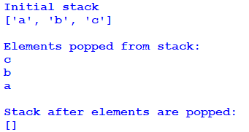

**Exercise No.: 2 Date: 23.12.2021**

**PROGRAM TO PERFORM BOOK OPERATION IN PYTHON**

**AIM:**

To Write a python program to perform book operation in python

**SOURCE CODE:**

**Book Operation using Stack in Python**

s = []

def push():

b_ID=int(input(‘Enter book no: ‘))

b_NAME=input(‘Enter book name: ‘)

b_PRICE=float(input(‘Enter price: ‘))

data=b_ID,b_NAME,b_PRICE

s.append(data)

print(“Book added to stack”)

def pop():

if len(s)==0:

print(‘Stack is empty’)

else:

dn = s.pop()

print(dn)

def disp():

if len(s)==0:

print(‘Empty stack’)

else:

for i in range(len(s)):

print(“Book Id :”,s[i][0])

print(“Book Name :”,s[i][1])

print(“Book Price :”,s[i][2])

while(1):

print(‘’’MENU

1. Push

2. Pop

3. Display

4. Exit’’’)

ch=int(input(‘Enter choice: ‘))

if (ch==1):

push()

elif (ch==2):

pop()

elif(ch==3):

disp()

elif (ch==4):

break

else:

print(‘Invalid input’)

**OUTPUT:**

**Exercise No.: 3 Date: 05.01.2022**

**PROGRAM TO PERFORM HOSTEL DETAILS USING STACK**

**AIM:**

To Write a python program to perform basic Hostel Operations in Python using Stack

**SOURCE CODE:**

host=[ ]

ch='y'

def push(host):

hn=int(input("Enter hostel number"))

ts=int(input("Enter Total students"))

tr=int(input("Enter total rooms"))

temp=[hn,ts,tr]

host.append(temp)

def pop(host):

if(host==[]):

print("No Record")

else:

print("Deleted Record is :",host.pop())

def display(host):

l=len(host)

print("Hostel Number\tTotal Students\tTotal Rooms")

for i in range(l-1,-1,-1):

print(host[i][0],"\t\t",host[i][1],"\t\t",host[i][2])

while(ch=='y' or ch=='Y'):

print("1. Add Record\n")

print("2. Delete Record\n")

print("3. Display Record\n")

print("4. Exit")

op=int(input("Enter the Choice"))

if(op==1):

push(host)

elif(op==2):

pop(host)

elif(op==3):

display(host)

elif(op==4):

break

ch=input("Do you want to enter more(Y/N)")

**OUTPUT:**

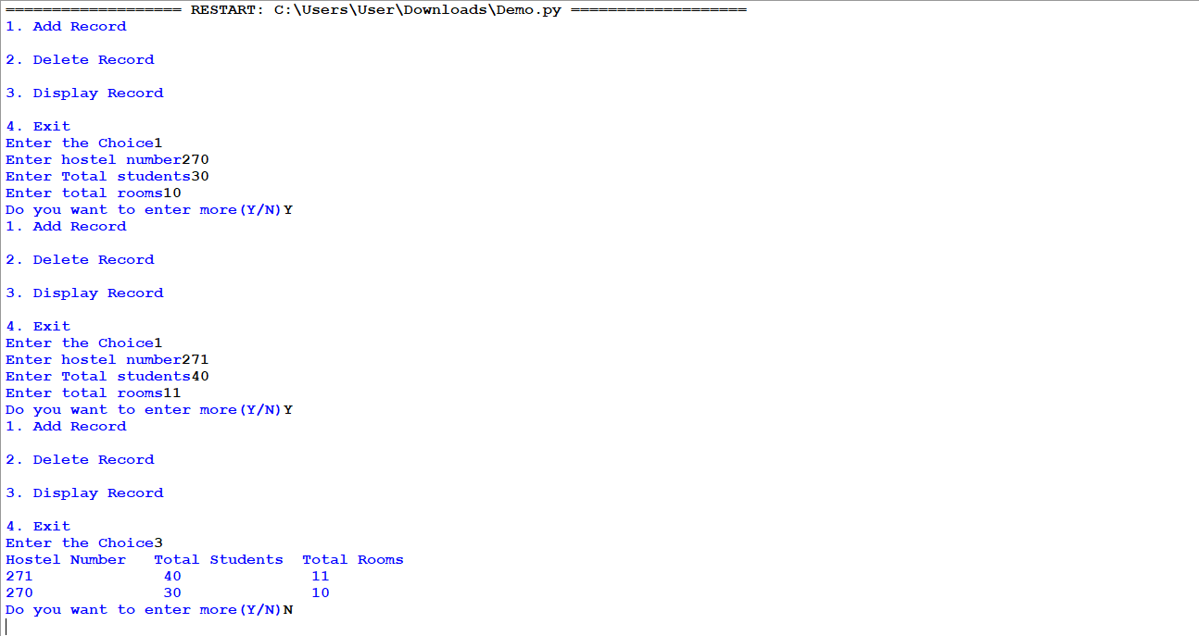

**Part II**

**SQL Queries**

**Exercise No.: 1 Date:10.02.2022**

**SQL QUERIES FOR A GIVEN TABLE**

**AIM:**

To Write a python program to perform basic Hostel Operations in Python using Stack

**Create Table for the following:**

Table : WATCH

|  |  |  |  |  |
| --- | --- | --- | --- | --- |
| **watchid** | **watch_name** | **price** | **type** | **Qty_store** |
| W001 | High Time | 10000 | Unisex | 100 |
| W002 | Lifetime | 15000 | Ladies | 150 |
| W003 | Wave | 20000 | Gents | 200 |
| W004 | High Fashion | 7000 | Unisex | 250 |
| W005 | Golden Time | 25000 | Gents | 100 |

1. Create a table called WATCH with watchid (char), wat ch_name (char), price int, type (char), qty_store (char).

2. Insert the values given.

**What will be the output of the following?**

3. Select sum(price) from watches where type=” Gents”;

4. Select max(price) from watches;

5. Select * from watches where Qty_store>100 and type like "U%";

6. Select type from watches where watch_name in ('Wave','Lifetime');

**OUTPUT:**

1.

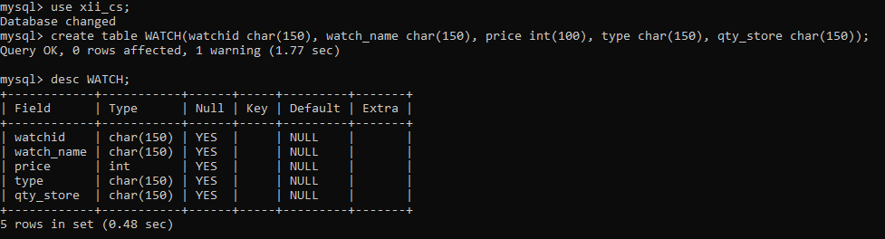

2.

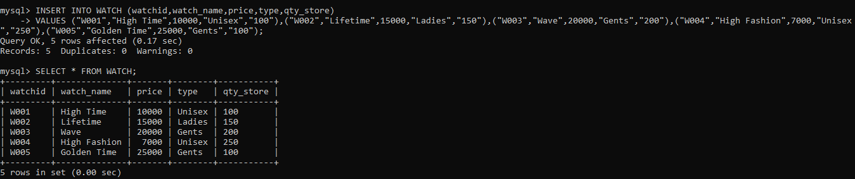

3.

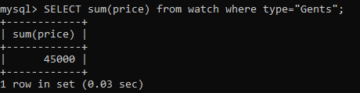

4.

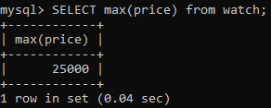

5.

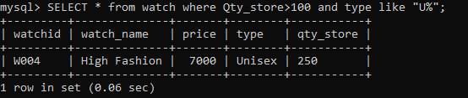

6.

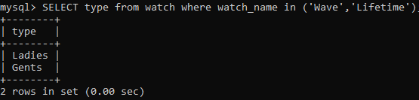

**Part III**

**Python – SQL Connectivity**

**Exercise No.: 1 Date: 15.02.2022**

**PROGRAM TO CREATE DATABASE USING PYTHON – SQL INTERFACE**

**AIM:**

To Write a python program to create a database

**SOURCE CODE:**

**Program to display all database**

import mysql.connector as sql

mydb = sql.connect(host="localhost",user="root",passwd="root")

mycursor = mydb.cursor()

mycursor.execute("CREATE DATABASE cs_sql") #Creating

print("Database created successfully !!")

mycursor.execute("SHOW DATABASES") #Checking

for x in mycursor:

print(x)

**OUTPUT:**

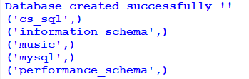

**Exercise No.: 2 Date: 21.02.2022**

**PROGRAM TO DISPLAY THE CONTENT OF THE TABLE USING PYTHON SQL INTERFACE**

**AIM:**

To Write a python program to display the contents of the table

**SOURCE CODE:**

**Program to display the content of a table**

import mysql.connector as sql

mydb = sql.connect(host="localhost",user="root",passwd="root",database="cs_sql")

mycursor = mydb.cursor()

mycursor.execute("CREATE TABLE student (Admission_ID INT(5),name VARCHAR(255),Physics INT(3),Chemistry INT(3),Maths INT(3))")

sql = """INSERT INTO student(Admission_ID,name,Physics,Chemistry,Maths)

VALUES(%s,%s,%s,%s,%s)"""

rows = [(1,'Amit',70,76,80),(2,'Sudha',80,95,85),(3,'Paresh',55,60,70)]

mycursor.executemany(sql,rows)

mydb.commit()

print("Table contents:")

mycursor.execute("SELECT * FROM student")

for x in mycursor:

print(x)

**OUTPUT:**

