• Quality control: An effective system for integrating the quality development, quality maintenance, and quality improvement efforts of the various groups in an organization, so as to enable production and services at economical levels which allow full customer satisfaction.

Phases of quality management
Quality management involves typically three phases
- Quality Planning
- Quality Assurance
- and Quality Control.
- Quality Planning: Here, the quality plan is created. Every plan should have a desired objective or goal and quality plan is no exception. The goal of quality management should be clearly communicated to all the stakeholders in a project. After the goal is defined, the measures to ensure the level of standard should be worked out. How will the customers be satisfied? What is the level of quality that the stakeholders are expecting? How to determine if the quality measures will lead to project success? When all the answers to these questions are in place, tasks should be delegated to respective team members and quality plan is initiated.
- Quality Assurance: This is a process that moves along with project throughout the lifecycle. Quality assurance is all about evaluating if a project is moving towards delivering quality services. If all the quality characteristics are in place the quality plan can proceeding in an effective manner. When quality goals are not achieved or are not in the process of getting achieved, necessary steps and corrective actions should be identified. Ensuring corrective actions too falls in the phase of quality assurance.
- Quality Control: Here, operational techniques are used in order to ensure quality standards. Any time a problem arises relating to quality or if the quality plan is not executed in the desired manner, corrective actions should be effective. Quality control involves monitoring project results and delivery to check if they are meeting desired results or not. If not then alternative actions should be implemented.
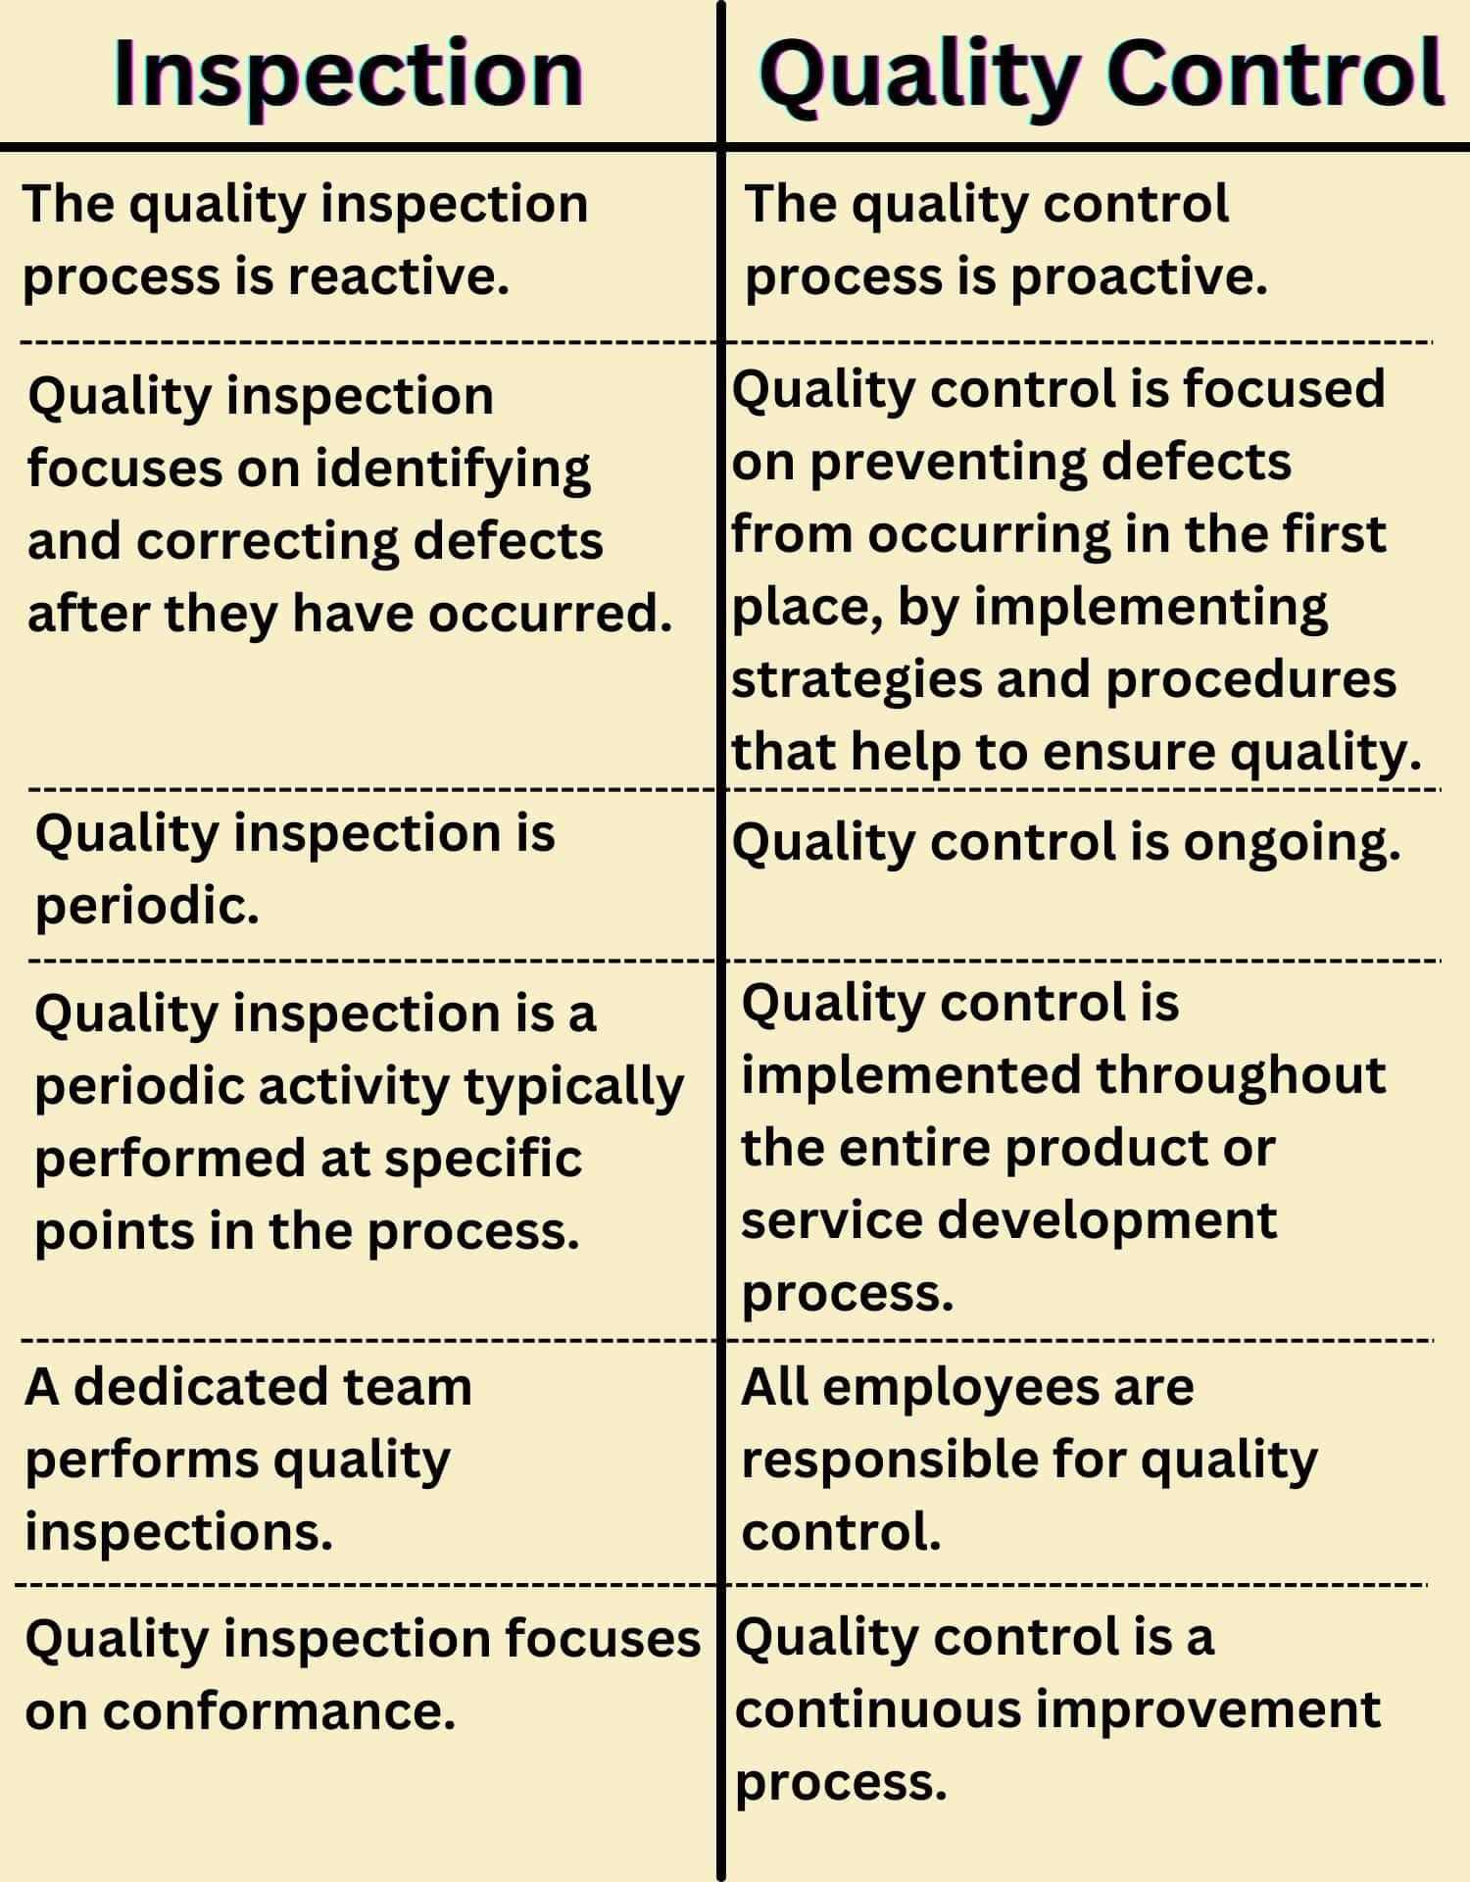

Components of Total Quality Management

Customer Focused

It is ultimately the customer who defines the worth of an organization. The benchmark of a brand is ultimately set up by the customers. All the efforts of the employee and organization are governed and validated by the customers only. Hence, it is important for the organization to identify its variety of customers and their needs.

Total Employee Involvement

For any successful company’s growth, it is essential for employees to be faithful and dedicated towards the company’s and its name. all employees of the organization should work with a common approach and goal.

Total employee commitment and dedication can be obtained only when an organization provides them with a proper culture and healthy work environment.

Process-Centered

Total quality management is a process centered process. It involves technical thinking. A TQM process is a series of steps. It takes inputs from suppliers and transforms them into outputs that are delivered to its customers.

A TQM process needs to be well-defined. The performance measures of the process need to be continuously monitored to avoid unexpected variation.

Integrated System

TQM is an integrated work approach. An organization consists of different departments and functional units. These units are usually horizontally connected to each other.

Total quality management executes the role in an integrated way. It combines up all the small and large processes. Integrated system helps the organization to achieve excellence in its products.

Strategic and systematic approach

Systemic approach is a critical part of the management quality. A strategic and systematic approach helps the organization to achieve excellence and deliver its target. Strategic development helps in achieving the vision, missions, and goals of the industry. It helps in developing quality as the core component of the process.

Continuous Improvement

Continuous improvement is the core element of total quality management. Quality is a never-ending process. It builds the organization in both analytics and strategic management. Continuous improvement brings competitiveness in the market and helps in meeting expectations of the stakeholders and customers.

Fact-based Decision Making

Total quality management helps the organization to participate in logical and technical decision making. Logical decision making further assists the organization to take accurate performance measures against the data and process. It helps in improving the accuracy and precision in targets.

Lag-free Communications

To facilitate total quality management, lag-free communication between the different components and departments of industry is essential. Communication plays a large role in maintaining effective communication, bringing timeliness in the project delivery and motivating employees at all levels.

Quality Function Deployment (QFD

Quality Function Deployment (QFD) is a structured approach in Total Quality Management (TQM) that aims to ensure that the design and production processes of a product or service align with customer needs and expectations. QFD involves translating customer requirements into specific product or service characteristics, enabling organizations to prioritize and improve quality based on customer satisfaction. Here's an overview of how QFD works within the context of TQM:

Key Principles of QFD in TQM:
- Voice of the Customer (VOC):
  - QFD begins with understanding and capturing the Voice of the Customer (VOC). This involves gathering and analyzing customer needs, preferences, and expectations regarding a product or service.
- House of Quality (HOQ):
  - The House of Quality is a key tool in QFD. It is a matrix that links customer requirements (WHATs) with engineering characteristics (HOWs). The matrix helps prioritize and align various aspects of product or service development.
- Customer Requirements (WHATs):
  - QFD starts by identifying and prioritizing customer requirements. These are the key features and attributes that customers expect from the product or service. The WHATs are typically qualitative and express the customer's perspective.
- Technical Requirements (HOWs):
  - Technical Requirements, or HOWs, are the engineering and production features that contribute to meeting the customer requirements. These are more quantitative and represent how the organization plans to fulfill customer expectations.
- Interrelationship Matrix:
  - QFD includes an interrelationship matrix that helps determine the degree of correlation between customer requirements and technical requirements. This matrix assists in identifying critical areas that need attention and improvement.
- Prioritization:
  - The QFD process allows for the prioritization of technical requirements based on their impact on meeting customer needs. This helps organizations focus on the most critical aspects of product or service development.
- Continuous Improvement:
  - QFD is not a one-time activity. It is a dynamic and iterative process that supports continuous improvement. As customer needs evolve or new technologies emerge, organizations can update their QFD matrices to stay aligned with changing requirements.
- Cross-Functional Collaboration:
  - QFD encourages cross-functional collaboration within an organization. It brings together teams from various departments (such as marketing, engineering, production, etc.) to work collectively towards meeting customer needs.
- Benchmarking:
  - QFD often involves benchmarking against competitors or industry standards. This helps organizations understand where they stand in comparison to others and identify areas for improvement.
- Employee Involvement:
  - Employees at all levels are involved in the QFD process. This inclusive approach ensures that insights from various perspectives are considered, and the organization benefits from the collective knowledge and expertise of its workforce.
- Customer Feedback Loop:
  - QFD establishes a feedback loop with customers. Continuous communication with customers helps organizations stay informed about changing preferences and ensures that products or services remain aligned with customer expectations.
- Introduction to Supply Chain Management:
- Definition: Supply chain management (SCM) is the process of overseeing and coordinating the production, distribution, storage, and acquisition of goods and services from the point of origin to the point of consumption. It involves the efficient and effective management of the entire network of activities, organizations, people, information, and resources involved in moving a product or service from the supplier to the customer.
- Key components of supply chain management include:
- Planning: Developing a strategy for how the supply chain will meet the requirements of the customer. This involves forecasting demand, planning inventory levels, and coordinating production schedules.
- Sourcing: Identifying and selecting suppliers to obtain the necessary materials and components to build the product. This involves negotiating contracts, managing relationships with suppliers, and ensuring the quality and timely delivery of goods.
- Manufacturing: The process of producing and assembling the product. This includes managing production schedules, quality control, and optimizing the manufacturing process for efficiency.
- Logistics: The management of the physical movement of goods, as well as the coordination of information and financial transactions throughout the supply chain. This includes transportation, warehousing, and distribution.
- Delivery: Ensuring that products reach the end customer in a timely and cost-effective manner. This involves optimizing transportation routes, managing inventory levels, and coordinating with retailers or distributors.
- Return of goods: Managing the return of defective or unwanted products and implementing processes for reverse logistics.

• Scope of supply chain management
- key aspects that fall within the scope of supply chain management:
- Procurement: This involves the sourcing and purchasing of raw materials, components, and goods from suppliers. It includes activities such as supplier selection, negotiation, and contract management.
- Production and Manufacturing: Supply chain management involves coordinating and optimizing the manufacturing process to ensure that products are produced efficiently, meeting quality standards, and aligning with demand forecasts.
- Logistics and Transportation: Managing the physical movement of goods from suppliers to manufacturers, and from manufacturers to distributors or retailers. This includes transportation modes, route optimization, and carrier selection.
- Warehousing and Inventory Management: Efficient storage and management of inventory are crucial components of supply chain management. This includes determining optimal inventory levels, warehouse location planning, and implementing systems to track and manage stock.
- Distribution: Coordinating the delivery of products to customers, whether through direct shipment or through intermediaries such as distributors or retailers.
- Information Systems and Technology: Leveraging technology and information systems to enhance visibility, coordination, and communication within the supply
chain. This includes the use of tools like Enterprise Resource Planning (ERP), Warehouse Management Systems (WMS), and Transportation Management Systems (TMS).
- Risk Management: Identifying and mitigating risks that could disrupt the supply chain, such as natural disasters, geopolitical events, or disruptions in the flow of materials.
- Sustainability and Environmental Concerns: Considering the environmental impact of supply chain activities and implementing sustainable practices. This includes reducing waste, optimizing transportation routes for fuel efficiency, and adopting eco-friendly packaging.
- Collaboration and Relationship Management: Building and maintaining strong relationships with suppliers, manufacturers, distributors, and other partners in the supply chain. Collaboration is essential for smooth and efficient operations.
- Customer Service: Ensuring customer satisfaction by delivering products on time, meeting quality standards, and providing excellent service throughout the supply chain process.
- Drivers of SCM
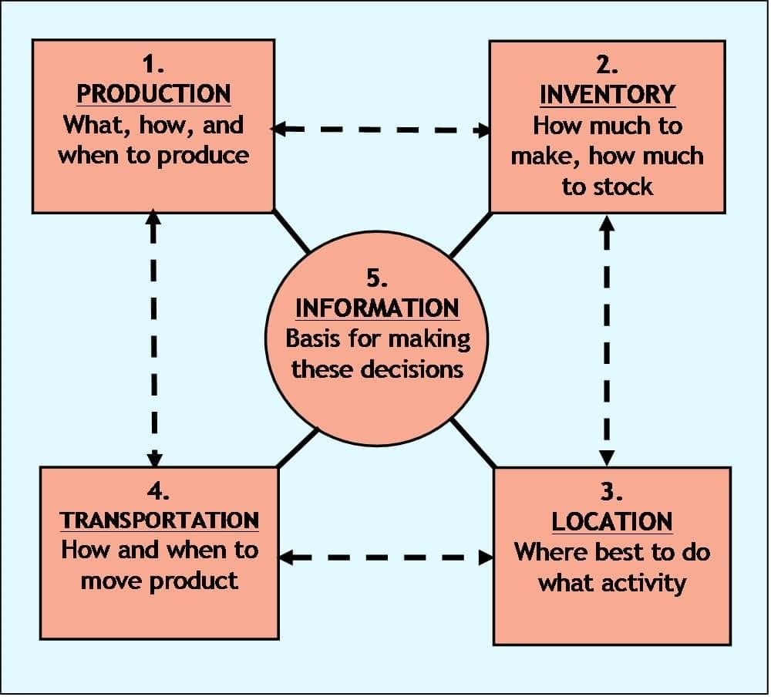
- The five drivers provide a useful framework for thinking about supply chain capabilities.
1. PRODUCTION
- This driver can be made very responsive by building factories that have a lot of excess capacity and use flexible manufacturing techniques to produce a wide range of items. To be even more responsive, a company could do their production in many smaller plants that are close to major groups of customers so delivery times would be shorter. If efficiency is desirable, then a company can build factories with very little excess capacity and have those factories optimized for producing a limited range of items. Further efficiency can also be gained by centralizing production in large central plants to get better economies of scale, even though delivery times might be longer.
- 2. INVENTORY
- Responsiveness can be had by stocking high levels of inventory for a wide range of products. Additional responsiveness can be gained by stocking products at many locations so as to have the inventory close to customers and available to them immediately. Efficiency in inventory management would call for reducing inventory levels of all items and especially of items that do not sell as frequently. Also, economies of scale and cost savings can be gotten by stocking inventory in only a few central locations such as regional distribution centers (DCs).

• 3. LOCATION
- A location decision that emphasizes responsiveness would be one where a company establishes many locations that are close to its customer base. For example, fast-food chains use location to be very responsive to their customers by opening up lots of stores in high volume markets. Efficiency can be achieved by operating from only a few locations and centralizing activities in common locations. An example of this is the way e-commerce retailers serve large geographical markets from only a few central locations that perform a wide range of activities.
- 4. TRANSPORTATION
- Responsiveness can be achieved by a transportation mode that is fast and flexible such as trucks and airplanes. Many companies that sell products through catalogs or on the Internet are able to provide high levels of responsiveness by using transportation to deliver their products often within 48 hours or less. FedEx and UPS are two companies that can provide very responsive transportation services. And now Amazon is expanding and operating its own transportation services in high volume markets to be more responsive to customer desires. Efficiency can be emphasized by transporting products in larger batches and doing it less often. The use of transportation modes such as ship, railroad, and pipelines can be very efficient. Transportation can also be made more efficient if it is originated out of a central hub facility or distribution center (DC) instead of from many separate branch locations.
- 5. INFORMATION
- The power of this driver grows stronger every year as the technology for collecting and sharing information becomes more wide spread, easier to use, and less expensive. Information, much like money, is a very useful commodity because it can be applied directly to enhance the performance of the other four supply chain drivers. High levels of responsiveness can be achieved when companies collect and share accurate and timely data generated by the operations of the other four drivers. An example of this is the supply chains that serve the electronics market; they are some of the most responsive in the world. Companies in these supply chains, the manufacturers, distributors, and the big retailers all collect and share data about customer demand, production schedules, and inventory levels. This enables companies in these supply chains to respond quickly to situations and new market demands in the high-change and unpredictable world of electronic devices (smartphones, sensors, home entertainment and video game equipment, etc.).
- Advantages and Limitations of Supply Chain Management:
- Advantages of Supply Chain Management :
- 1. Supply Chain Management helps to increase savings in labor and procurement costs.
- 2. Supply Chain Management helps to achieve better inventory control.
- 3. Supply Chain Management is used to get better control over suppliers.
- 4. Supply Chain Management can increase market visibility.
- 5. Chances of product failure rate can be reduced by Supply Chain Management.
- 6. Supply Chain Management is used to provide better information on customer needs, tastes
etc.,
- 7. Supply Chain Management helps to achieve regular and better communication with the customers.
- 8. Supply Chain Management helps to improve customer care service.
- 9. Supply Chain Management is used to achieve higher revenues.
- 10.Supply Chain Management increases performance and profitability.
- 11.Supply Chain Management is used to lower transportation, warehousing and packaging costs.
- 12.Supply Chain Management increases capacity, capability or flexibility.
- 13.Supply Chain Management enhance value for money.
- 14.Supply Chain Management is used to improve reputation of brand in market.
- 15.Supply Chain Management also increases the value of shareholder.
- 16.Supply Chain Management is used for faster and more accurate order processing.
- 17.Supply Chain Management allows higher discount on price to wholesaler due large order size.
- 18.Supply Chain Management is also good for returns and recall management.
- 19.Supply Chain Management is used for production tracking.
• Disadvantages of Supply Chain Management :
- 1. Sometimes Supply Chain Management can be very expensive to implement.
- 2. Competitors can easily copy the strategy of Supply Chain Management.
- 3. For better Supply Chain Management, proper skills and experience is required to achieve success.
- 4. Sometimes in Supply Chain Management various functions may be difficult to manage.
- 5. In Supply Chain Management there may be staff resistance.

