­­

**INTRODUCTION**

**This is an oops based program for guessing a random number .Here the class “random” creates a random integer r between 1-1000 and then a friend class “guess” does the work of guessing the number by taking input from the user through a friend function “details” .The program continues to take input from the user by providing certain hints and simultaneously counting the number of inputs .The ideal number of inputs is 10.If number of input is more than 10 then program provides the functionality to improve the efficiency of user.**

**CODE**

#include <bits/stdc++.h>

using namespace std;

class guess;//forward declaration

class Random // class random

{

private:

    int r;

public:

    Random() // generating a random number

    {

        srand(time(NULL));//seeding null

        r = 1 + (rand() % 1000);//generating between 1-1000

    }

    friend class guess; // friend class

};

class guess // class guess

{

private:

    int input;

    int k;

    Random *j ; // dynamic initialization

    string playername;

public:

    guess()

    {

        input = 0;

        k = 0;

    }

    friend void operator >>(istream &in,guess &Number_game)

    {

        details(Number_game);

        Number_game.guessing();

    }

    void guessing() // taking input from user

    {

        char ch;

        j=new Random;

        k=0;

        do

        {

            cout << "Guess the number between 1 and 1000!!!" << endl;

            cin >> input;

            k++;

            if (input < j->r)

                cout << "Too low try again!!" << endl;

            else if (input > j->r)

                cout << "Too high try again!!" << endl;

            else

            {

                int cnt = 0;

                cout << "Excellent you guessed the number would you like to play again!!\n" << endl;

            label://to get back to statement if user does not enter y/n

                cout << "press Y to try again and N to exit the game\n";

                cin >> ch;

                if (ch == 'Y' || ch == 'y')

                {

                    guessing();

                }

                else if (ch == 'N' || ch == 'n')

                {

                    break;

                }

                else

                {

                    cout << "enter a valid choice\n";

                    cnt++;

                if (cnt >= 3)

                {

                    cout << "Exiting the game!!" << endl; // win + ;😎

                    exit(0);

                }

                    goto label;

                }

            }

        } while (input != j->r);

        if (k < 10)

        {

            cout << "Either you know the secret or you got lucky!!\n" << endl;

            cout << "You just guessed in " << k << " attempts\n " << endl;

        }

        else if (k == 10)

        {

            cout << "haha you know the secret!!\n" << endl;

            cout << "You just guessed in " << k << " attempts \n" << endl;

        }

        else

        {

            try_again();

        }

    }

    void try_again() // to ask if user want to play again

    {

        int count = 0;

    to:

        cout << "you should be able to do better why should it take no more than 10 guesses!!\n" << endl;

        cout << "Do you want to try again ??\nEnter Y/N \n" << endl;

        char choice;

        cin >> choice;

        if (choice == 'Y' || choice == 'y')

        {

            k = 0;

            guessing();

        }

        else if (choice == 'N' || choice == 'n')

        {

            cout << "Do you want the  solution for the game Y/N" << endl;

            cin >> choice;

            if (choice == 'Y' || choice == 'y')

            {

                solution();

            }

            else if (choice == 'N' || choice == 'n')

            {

                cout << "Better luck next time!!" << endl;

                exit(0);

            }

            else{

                cout<<"Wrong input\nExiting game!!\n";

            }

        }

        else

        {

            cout << "You entered a wrong input" << endl;

            count++;

            if (count > 3)

            {

                cout << "Since Player is not entering right input.\n" << endl;

                cout << "We are providing the solution \n" << endl;

                solution();

                exit(0);

            }

            goto to;

        }

    }

    void solution()               // step by step solution to guess the number in 10 guesses

    {

        cout << "Our number was " << j->r;

        cout << " So the following steps should have been followed for the solution" << endl

             << endl;

        int low = 1, mid, high = 1000;

        int counter = 0;

        do

        {

            mid = (low + high) / 2;

            cout << "Take: " << mid << endl;

            if (mid == j->r)

            {

                break;

            }

            else if (mid < j->r)

            {

                cout << counter + 1 << ".The number is too low so take a number between " << mid<< " & " << high << endl;

                low = mid + 1;

            }

            else if (j->r < mid)

            {

                cout << counter + 1 << ".The number is too high so take a number between " << low << " & " << mid << endl;

                high = mid - 1;

            }

            counter++;

        } while (mid != j->r);

        cout << "So we found " << mid << " in " << counter << " attempts :)" << endl;

    }

    ~guess() // destructor

    {

        cout << "Game is Over" << endl;

    }

    friend void details(guess &number);

};

void details(guess &number){

    cout<<"Enter the player name\n";

    string nam;

    getline(cin,nam);

    number.playername=nam;

    cout<<"Welcome "<<number.playername<<endl;

}

int main()

{

    // random guess;

    guess number;

    cin>>number;

    // details(number);

    // number.guessing();

    return 0;

}

**CLASS RANDOM**

* **Creates a random number between 1 to 1000 using rand() [inbuilt in C++]**
* **srand time is set to NULL to get different number in every game**
* **Has a friend class “guess“**

**CLASS GUESS**

* **Dynamically initializes the class random ,hence creating a random number. Also initializes the count to 0.**
* **Member function “guessing()”**
  + - **Takes the input from user along with taking the account of number of inputs while providing the required hints to guess the number**
    - **The program continues to take the input till the user gets the right number.**
    - **If the number of inputs>10 the program provide the choice of playing the game again or getting the solution .**
* **Member function “try_again()”**
  + - **Provides a replay functionality to the user.**
    - **Asks the user for an efficient solution of the game**
* **Member function “solution()”**
  + - **Provides an efficient solution of the game with concept of binary search within an input span of 10**
* **Friend function “details()”**
* **Takes user’s details as input**
* **Provides friend functionality**

**OUTPUTS:**

**1.)** 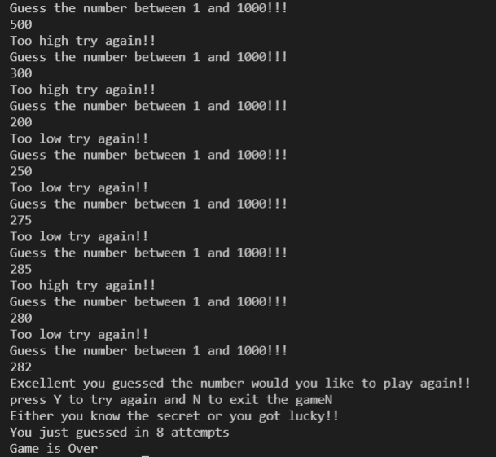

**2.)**

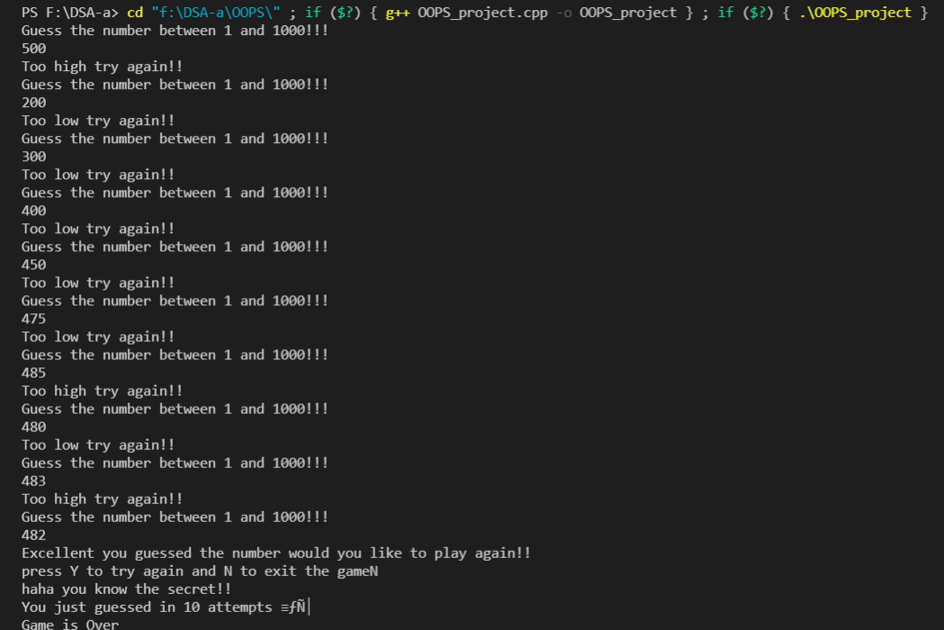

**3.)**

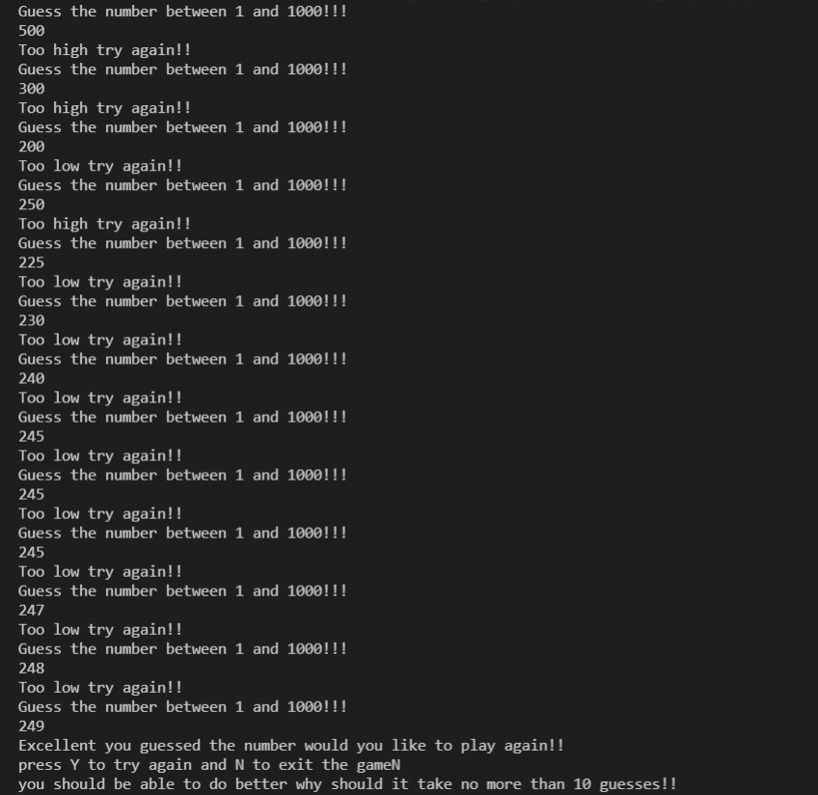

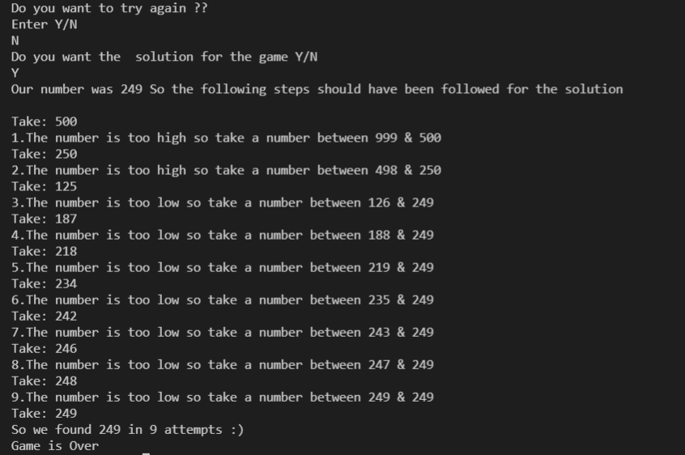

**4.)**

