# NAME- Khushal Khare

# ID – 18BCE7036

SUBJECT – SECURE CODING

## Install Frigate3 on Windows 7 VM: Frigate3 UI

Execute the exploit2.py to generate the payload_cmd.txt file:



File' Command Disk Llttlitips MâMager Paged Options Help . Aéo ¿'si'zr: !. °'.'i°':' 2 0 • 4 Z 5 5 t



#Data



nnins0O0 .r



List • Narñe • - C:\ Program Fix (x86)\ Frigate3\

. unacev2 dll 

Did you know...

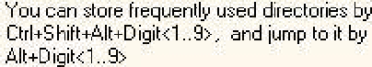

@"’ Show this dialog box nert time

List • Name •

; unacevs dll

ins000:r dat rar3 dll



rtl60. tb2k_d6

bpl

bpl

rtl60 tb2k_d6

bpl

bpl



- ,Here you all find some'advices that are to help you to Ifiâster Frgate quiddy and totally.

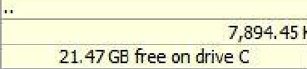

21.R7 GB 'Fee on drive C

32 1



 

### *0-*rg anize- *

.Include iq library • . Shar”e with. N w,fotdér:.

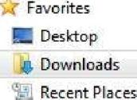Name

D ate mo dified T}’pe



Size

Libraries Docum ents MuEic Pictures

@ Vrdeos

Homegroup

j J Computer

Network

Vullln

.. " apl oit2

### Frigate3 Std v36

payload

pyth on-2.7J7

\/uIIIn

3..’31..’2021 11:12 PM File foI‹Iei

4 ‘5..’2021 11!04 AM P hen File

4.'' 9..’2021 10:50 Ak1 Application

4..-3..’2021 11:10 AM Text Doc unJent

3..-’31..‘2021 10!54 pK1 V.'”indcws In^taIIer ...

3.'’31..’2021 10:51 PM ';' inP7P. ZIP archi\ e



3 KB





19,112 KB

78”3 KB

 

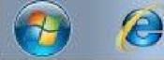

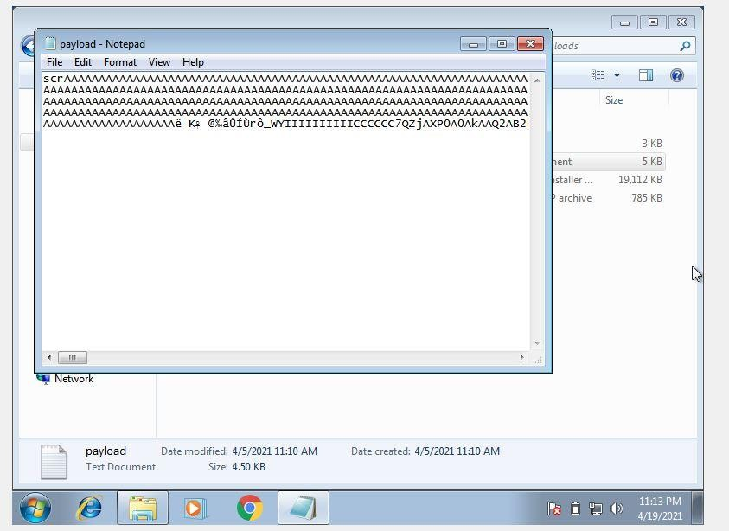

Copy the payload and open the frigate software with admin privileges, Go to disks and select find computer and paste the payload in it.

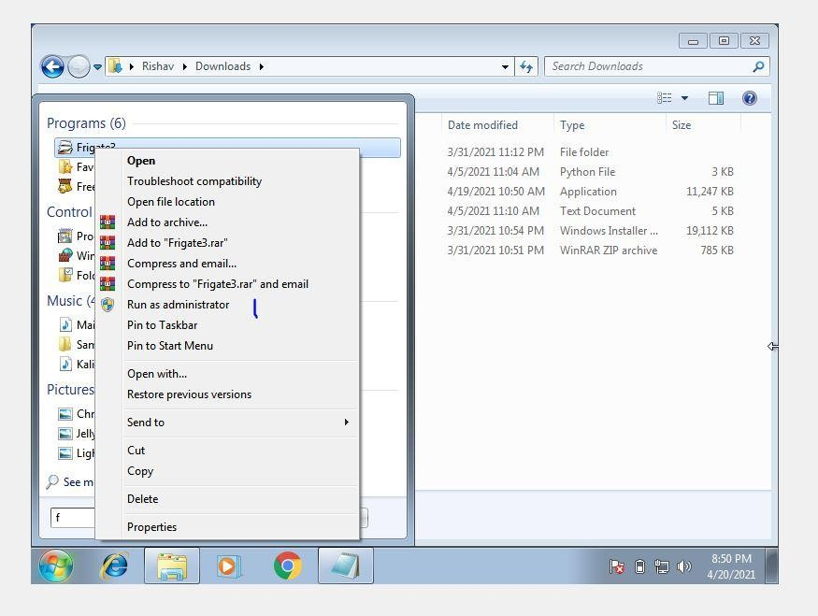

The CMD that opens after crashing the application opens with elevated privileges

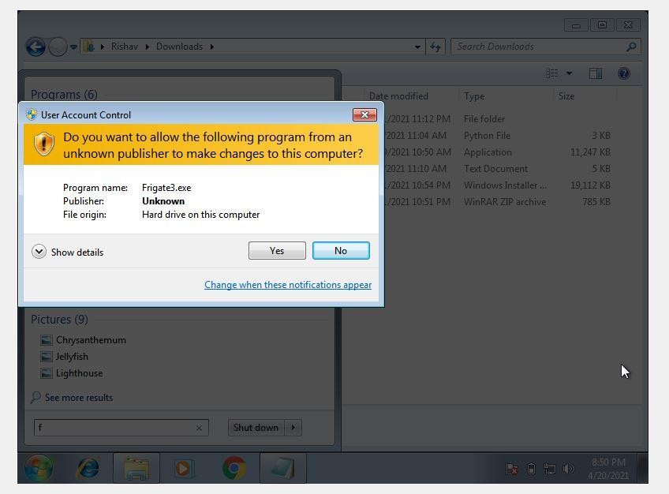

Type diskpart and follow the screenshots

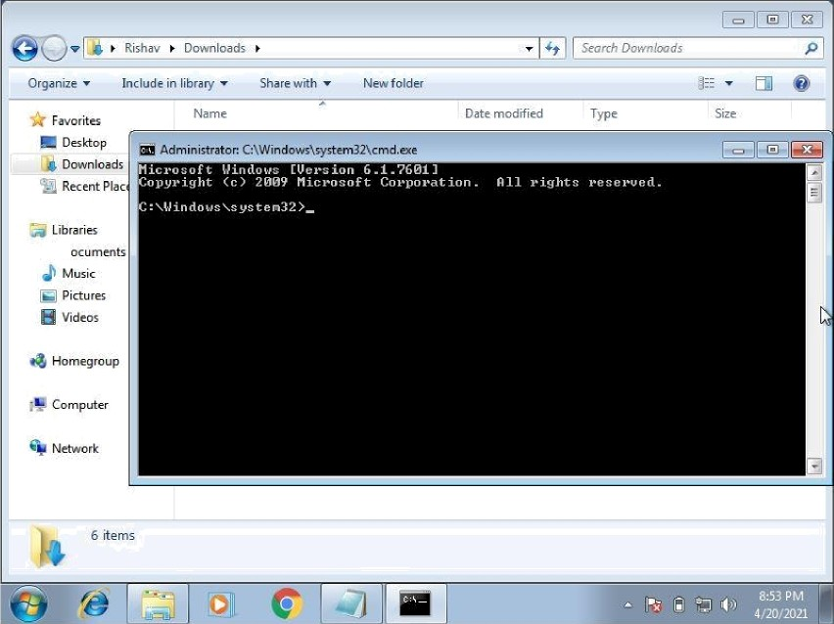

File Command Disk Utilities Manager Pages 0 ptions Help '' Add

|  |  |
| --- | --- |
| *Q* File Manager i .a. Frigate.rtf. /..@. Friqate Features. htm ! | |
| , C:\ Program File s (x86}1Frrgate3\ Li st • Nam e • - C:\ ProgrB m Files (x86)\ Frig Bte3\ List • Name •  .’'’<,unacezs dlI  .;’. anacevs dIl :r ’"”’anins000:': dat ’ :.Addons :r znins000:': dat  **'Data**  ,%' anrar3 dIl  **”-.Belp** • ”.vcl60 bpl  'é Computer'name: osZC0F 3KOXUQsrNCTS0AA  Frigate3 exe e e  **-¿¿¿pQgyg** IP Address: 0 0 0 0  : cabinet dIl dll  :’.4’.dcrawlik dll  elpackD6 kpl  #. Frigate Features htm **#. Frigate Features** htm  ,_:,Frigate rtt ’’’’, :,Frigate rtt  license txt license txt  _rtl6O bsl rtI6O bsl  ””!tkzk d6 bpl **””!tkzk d6 bpl** | |
| 7,89’4 5hBin l8Nes 7,B99, 95 GB in lB Ules  Z1.p7GBteeondriveC ”’ ’ ’  21, A7 GB free on drive C |  |





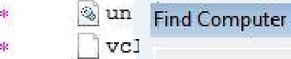

Here you r'iII find some advices that are to help you to master Frigate quiddy and totally.

. *0 5-**-7':







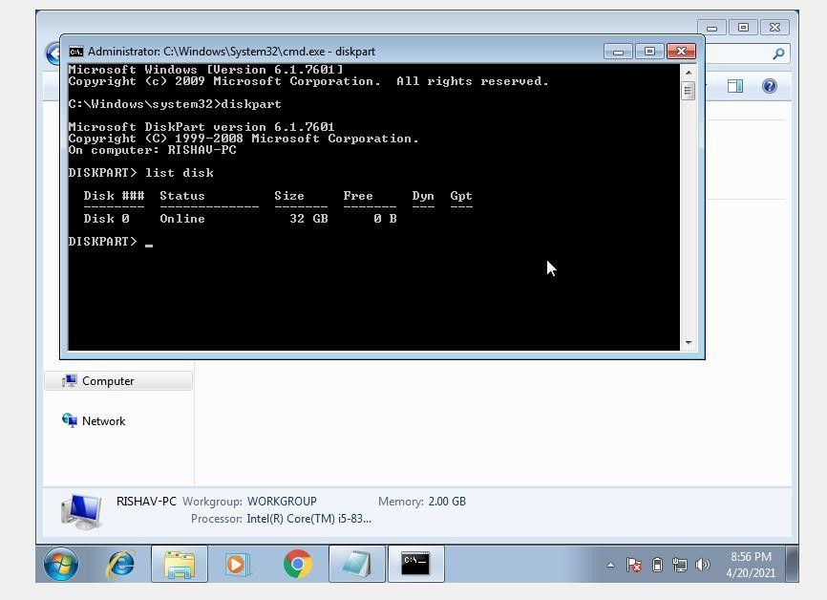

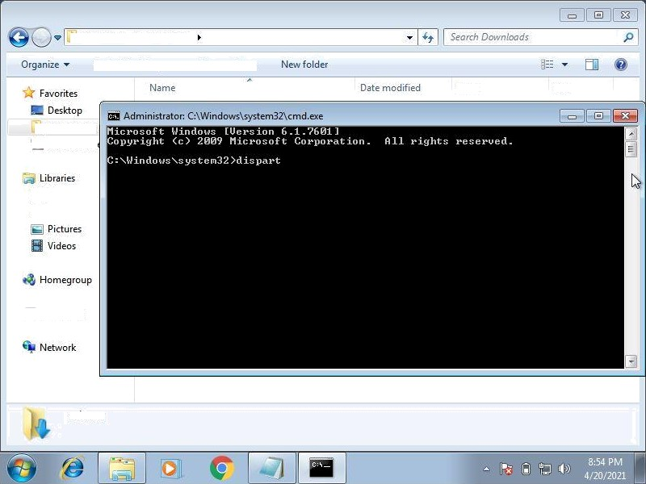

@ r Ris h a\’ r D cwn Io a d s

In clu de in library Share.with

Type

Size

@ Downloads

'-':._ Recent pIac

. Documents

Music

¿T: Computer

6 items

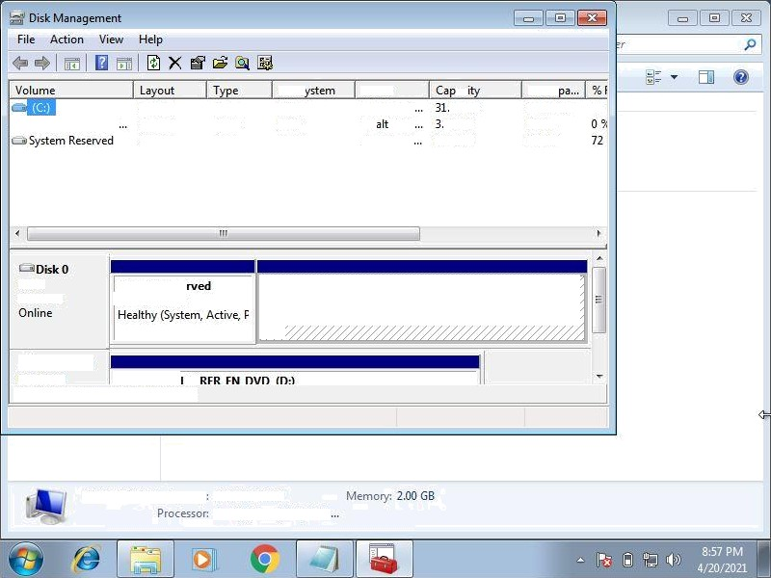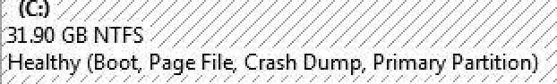

Simple

GSp1RMCULXFRE Simple

Simple

Basic Basic Basic

File S NTFS UDF NTFS

Status ac

Healthy (B 90 GB

He hy (p 09 GB Healthy (S 100 MB

Free S

21.47 GB 67

0 MB

72 MB

Baie

32.00 GB

System Rese

:100 MB NTFS

DCD-ROM 0

CD- ROM . f.5P1RHfT T XF

Unalloc ated primary partition