|  |  |
| --- | --- |
| Poll Workers Helping Americans Vote Logo with EAC seal in the middle |  |

**FOR IMMEDIATE RELEASE**   
**LOCAL CONTACT:** [NAME], [EMAIL]   
**EAC CONTACT:** Greg Clark, gclark@eac.gov

**[COUNTY NAME] CELEBRATES POLL WORKERS HELPING AMERICANS VOTE**

**[CITY], [STATE]** – Today, the **[COUNTY/LOCAL ELECTION OFFICE]** joined a national effort to recognize election officials across the nation for their critical role in helping Americans vote.

The “Poll Workers Helping Americans Vote” initiative was launched by the [U.S. Election Assistance Commission (EAC)](https://www.eac.gov/) earlier this year. The initiative aims to raise awareness about the role election workers play in our communities, our nation, and our democracy.

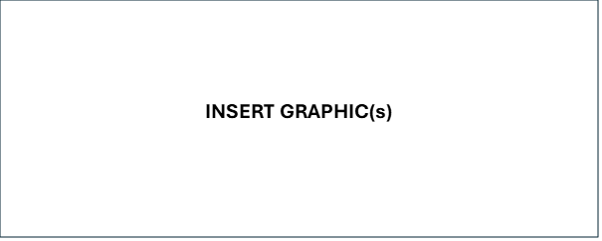  
  
“Poll workers are key to the democratic process and shepherding the American experiment, which was first penned in the late 1700s and still being played out today in communities around our nation,” **said [SPOKESPERSON].** “We are so lucky to have this great group of individuals working in our community to help their friends and neighbors through the voting process.”

Poll workers are vital to the election process, but in many states and localities recruitment remains a challenge for election offices. A lack of poll workers could lead to fewer polling locations, longer lines, and more voter confusion. By sharing positive photos of election workers connecting with their communities, this campaign aims to raise awareness of the positive impacts of poll workers in their communities. State and local election offices can participate by sharing a photo of election workers on social media. More information on this initiative can be found here.

+++

The [U.S. Election Assistance Commission](http://www.eac.gov/) (EAC) was established by the Help America Vote Act of 2002 (HAVA). It is an independent, bipartisan commission charged with ensuring secure, accurate, and accessible elections by developing guidance to meet HAVA requirements, adopting voluntary voting system guidelines, and serving as a national clearinghouse of information on election administration. The EAC also accredits testing laboratories and certifies voting systems, as well as administers the use of HAVA funds. For more information, visit [www.eac.gov.](http://www.eac.gov. )

###