МИНОБРНАУКИ РОССИИ

Федеральное государственное бюджетное образовательное учреждение высшего образования

НИЖЕГОРОДСКИЙ ГОСУДАРСТВЕННЫЙ ТЕХНИЧЕСКИЙ

УНИВЕРСИТЕТ им. Р.Е.АЛЕКСЕЕВА

Институт радиоэлектроники и информационных технологий

Кафедра «Вычислительные системы и технологии»

ОТЧЁТ

По лабораторной работе №1

по дисциплине «Аппаратное и программное обеспечение   
роботизированных систем»

ПРОВЕРИЛ:

________________ Гай В.Е.

СТУДЕНТ:

_______________ Анисимова Е.С.

17-В-1

Работа защищена «___» ____________

С оценкой ________________________

Нижний Новгород

2020

**1. Схема робота**

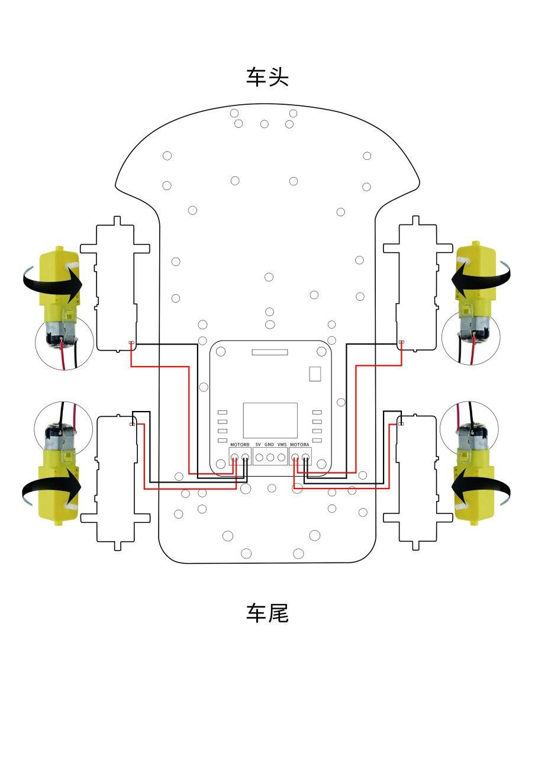

**2. Код**

#include <IRremote.h> // the library is required for Arduino to work with an IR receiver

int receiverpin = 11;// initialization of infrared signal output

int pinI1=A1;// initialization of I1 interface

int pinI2=A0;// initialization of I2 interface

int speedpin1=6;// initialization of EA interface (speed control)

int pinI3=A3;// initialization of I3 interface

int pinI4=A2;// initialization of I4 interface

int speedpin2=5;// initialization of EB interface (speed control)

#define ADVAN 0xFF629D // remote control (7 - «forward»)

#define BAC 0xFFA857 // remote control (8 - «back»)

#define STO 0xFF02FD // remote control (6 - «stop»)

#define left 0xFF22DD // remote control (left)

#define right 0xFFC23D // remote control (right)

IRrecv irrecv(receiverpin);// initialize port 11 (IR receiver port)

// By downloading the program, Arduino gives the code the opportunity to participate in the initialization of the system. To do this, it is necessary to indicate to the microcontroller the commands that it will execute at the time of loading and then forget about them (i.e. these commands will be executed only once at system startup). Therefore, you need to select the block in which these commands will be stored. Void setup () is such a place inside the Arduino sketch.

void setup() {

Serial.begin(9600);// determine the serial connection and set the data transfer rate in bit / c

irrecv.enableIRIn();//IR receiver start

pinMode(pinI1,OUTPUT);// define pin A1 (output interface)

pinMode(pinI2,OUTPUT); // define pin A0 (output interface)

pinMode(speedpin1,OUTPUT); // define pin 6 (output interface)

pinMode(pinI3,OUTPUT);// // define pin A2 (output interface)

pinMode(pinI4,OUTPUT); // define pin A3 (output interface)

pinMode(speedpin2,OUTPUT); // define pin 5 (output interface)

pinMode(receiverpin,INPUT); // define pin 11 (output interface)

irrecv.enableIRIn();//IR receiver start

}

// After calling the setup () function, which initializes and sets the initial values, the loop () function executes a loop, allowing our program to perform calculations and respond to them.

void loop() {

if (irrecv.decode(&results)) // if the key is pressed {

Serial.println(results.value, HEX); // output the signal received from the port to the console in hexadecimal value

switch(results.value) // apply the switch statement to the value read from the IR receiver {

case ADVAN: // if pressed the "7"

        goForward (1000); // move forward with a speed of 1000 units

        break; // pass control to the next statement after switch

      case BAC: // if you pressed the "8" key

        goBackward (1000); // move back at a speed of 1000 units

        break; // pass control to the next statement after switch

         case left: // if you pressed the left key

        goLeft (1000); // turn left at a speed of 1000 units

        break; // pass control to the next statement after switch

         case right: // if you pressed the right key

        goRight (1000); //// turn right at a speed of 1000 units

        break; // pass control to the next statement after switch

      case STO: // if the "6" key is pressed

        stopa (); //stop

        break; // pass control to the next statement after switch

     default: // if the value did not match the cases

        delay (100); // make a delay of 100 ms

        Serial.println (results.value); // print the value from the IR receiver to the console

}

irrecv.resume(); // Считываем следующее значение с ИК приемника

}

delay (100); // delay of 100 ms}

// User-defined functions, executed once every time from setup or loop blocks

void goForward (int a) // forward function {

analogWrite (speedpin1, a); // set the input speed of the analog value

analogWrite (speedpin2, a); // set the input speed of the analog value

digitalWrite (pinI1, LOW); // I1 low output

digitalWrite (pinI2, HIGH); // I2 output high level

digitalWrite (pinI3, LOW); // I3 low output

digitalWrite (pinI4, HIGH); // I4 output high level

delay (100); // delay in 100 ms

}

void goBackward (int b) // backward function {

analogWrite (speedpin1, b); // set the input speed of the analog value

analogWrite (speedpin2, b); // set the input speed of the analog value

digitalWrite (pinI1, HIGH); // I1 output high level

digitalWrite (pinI2, LOW); // I2 low output

digitalWrite (pinI3, HIGH); // I3 output high level

digitalWrite (pinI4, LOW); // I4 output low

delay (100); // delay in 100ms

}

void goLeft (int c) // function of movement to the left {

analogWrite (speedpin1, c); // set the input speed of the analog value

analogWrite (speedpin2, c); // set the input speed of the analog value

digitalWrite (pinI1, LOW); // I1 output low

digitalWrite (pinI2, HIGH); // I2 output high level

digitalWrite (pinI3, HIGH); // I3 output low

digitalWrite (pinI4, LOW); // I4 output high level

delay (100); // delay in 100ms

}

void goRight (int d) // function of movement to the right {

analogWrite (speedpin1, d); // set the input speed of the analog value

analogWrite (speedpin2, d); // set the input speed of the analog value

digitalWrite (pinI1, HIGH); // I1 output high level

digitalWrite (pinI2, LOW); // I2 low output

digitalWrite (pinI3, LOW); // I3 output high level

digitalWrite (pinI4, HIGH); // I4 output low

delay (100); // delay in 100ms

}

void stopa () // stop function {

digitalWrite (pinI1, LOW); // I1 low output (0 V output)

digitalWrite (pinI2, LOW); // I2 low output (0 V output)

digitalWrite (pinI3, LOW); // I2 low output (0 V output)

digitalWrite (pinI4, LOW); // I2 low output (0 V output)

delay (100); // delay of 100 ms

}