Part 1:
The relational database component of the NASA Near-Earth Object Tracker system is designed to store the core structured data of the application. A relational model was selected because several parts of the system require clear relationships, strong consistency, and integrity constraints. This is especially important for user records, asteroid records, close-approach data, and the relationship between users and the asteroids they save.
The final relational design includes four main tables. Users, asteroids, close approaches, and user favorites. Together, these tables model the core structured behavior of the system: users can search for and save asteroids, and each asteroid can have one or more close-approach events associated with it.
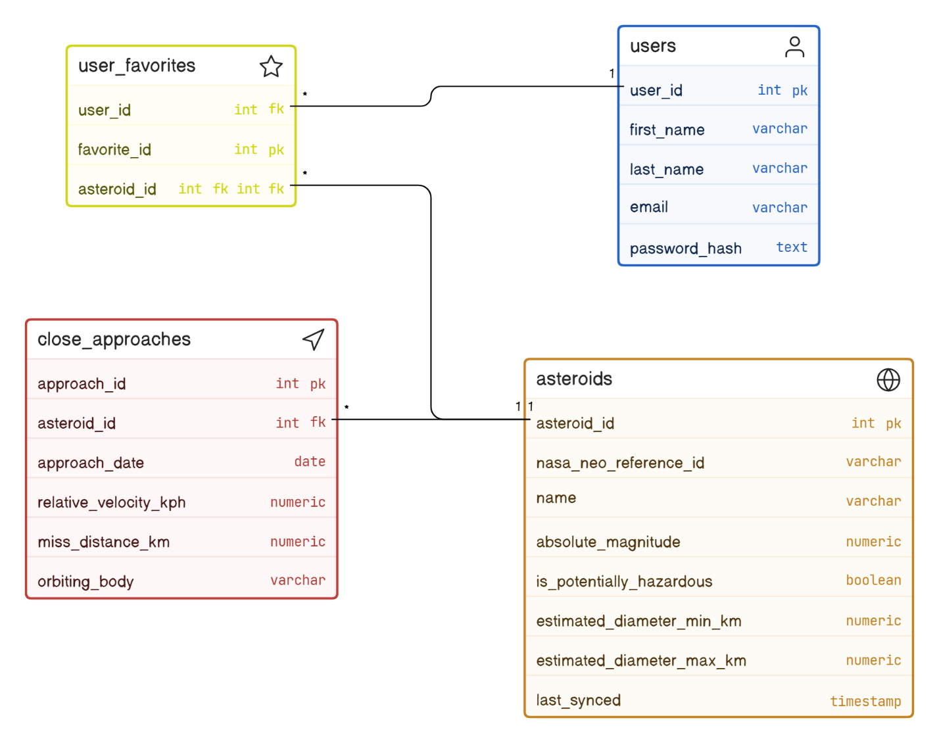

Key Entities:
Users: The users table stores registered account information for people using the system. Each user is uniquely identified by user_id, and each email address must be unique. The table also uses a password_hash for account verification.
Asteroids: The asteroids table stores the structured asteroid data used by the relational system. Each asteroid has a unique primary key and stores the NASA NEO reference id for external identification. Specific attributes such as absolute magnitude, and estimated diameter is stored in here as well due to them being specific characteristics of the asteroid. The last synced attribute is stored in here as well to indicate when the record was last refreshed from the NASA API.
Close_approaches: The close_approaches table stores specific data if the asteroid will have a close approach with earth and gives specific information such as the approach date, and the miss distance of the asteroid.
User_favorites: The user_favorites table connects users and asteroids. This table is necessary due to users being able to save multiple asteroids and a single asteroid being able to be saved by many users. It acts as a junction table to resolve the many-to-many relationship between users and asteroids.
Relationships:
User to User_favorites:
Cardinality: 1:M
One user can save many asteroids, user_favorites act as a junction table between users, and asteroids.
Asteroids to Close_approaches:
Cardinality: 1:M
One asteroid can have many close approaches, but each close approach only belongs to one asteroid.
Asteroids to users:
Cardinality: 1:M
One asteroid can be saved by many users, and one user can save many users. To solve this many to many relationship, user favorites is used as a junction table.
SQL Code:
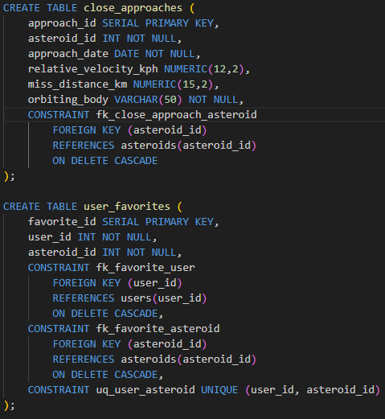
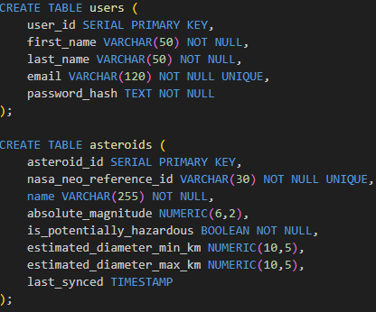

Constraints:
Primary keys were added to preserve data integrity. Primary keys were added to each table, so each row is unique. Foreign keys were added to each table to show the relationship between the tables. The users table has the unique constraint on the email attribute to ensure that each account is unique to just one email address. The unique NASA NEO reference id ensures that each time an asteroid is synced with the database, a new asteroid is not created. The constraints in the user_favorites table ensure that the user cannot favorite the same asteroid multiple times, and that it will update on deleting that favorite. Multiple NOT NULL’s were added to ensure that crucial information is always present such as in the asteroid table requiring a NASA NEO reference id and a name.

