**Control Home Appliances by Telegram Application using Raspberry Pi**

**ABSTRACT**

As our life is mostly affected by mobile phones and especially through social media applications. These applications are playing a significant role in everyone’s hand and so we are using it for a variety of applications such as chatting, video sharing and a lot of work. Now, to make our life further easier we are going to use social media(Telegram) application to control the applications using a system called Raspberry Pi. In this practical , we are going to use Telegram application to control home applications. In this, we will switch on and switch off the given application through this application by chats. We are already using social media in our day-to-day life .Thus, we can do some physical things social media.

**BLOCK DIAGRAM**

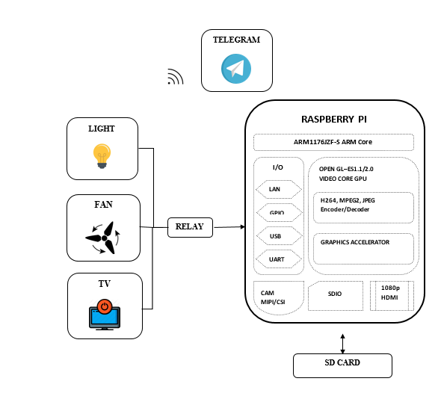

**BLOCK DIAGRAM DESCRIPTION**

Raspberry Pi system is connected with the internet to get chat messages from the Telegram Application and the appliances that we have to control should be connected to the GPIO pins of Raspberry Pi through relay circuit.

**PRACTICAL DESCRIPTION**

Raspberry Pi is connected to the internet, which is programmed in such a way for receiving chats from the Telegram Application ,whenever we send messages to the registered number to switch on the light as chat lights get turned on similarity appliances can be turned off by sending OFF chats. Command chats can be configurable.

**HARDWARE REQUIRED**

1. Raspberry Pi
2. Power Adapter
3. HDMI to VGA converter
4. Relay
5. Home Appliances

**SOFTWARE REQUIRED**

1. SD Card Formatter
2. Win64 Disk Imager
3. Telegram Application for Android OS
4. Teleport

**LIBRARIES USED**

1. RPi.GPIO as GPIO for accessing GPIO pins of Raspberry Pi
2. Time library for delay functions

**CONCLUSION**

This practical helps us to control appliances using Telegram android application along with this we are also need to reduce the usage of smartphones for better real-life experience rather than enjoying our life in virtual world.