System Requirements Statement (SRS) –

Event Booking Web Application

Doc. Ref. :

Version :

Status :

Created by :

Date :

1. Introduction 3

2. Functional Requirements 4

2.1 Registered Attendee Module 5

2.2 Registered Event Organiser Module 11

2.3 admin Module 17

2.4 message acknoeledgement Module 21

2.5 Use Case Diagram………………………………………………………………,,22

# Introduction

This document explains the system requirements and scope for developing Event Booking Web Application.

This document communicates the business requirements and scope for developing Event Booking Web Application. The scope of this document is to define the functional and nonfunctional requirements, business rules and other constraints requirements.

# Functional Requirements

The Account part of Event Booking System has three modules which are divided as below.

|  |  |  |
| --- | --- | --- |
| **No** | **BRS requirement ID** | **Description** |
| **2.1** | **Registered Attendee Module** | |
| **2.1.1** | **F1** | **Account Creation Process** |
| **2.1.2** | **F2** | **Login Process** |
| **2.1.3** | **F3** | **Forgot Password Process** |
| **2.1.4** | **F4** | **Change Password Process** |
| **2.1.5** | **F5** | **Update Account Process** |
| **2.1.6** | **F6** | **Search Events** |
| **2.1.7** | **F7** | **Book Events** |
| **2.1.8** | **F8** | **Cancel Booking** |
| **2.1.9** | **F9** | **View Feedback** |
| **2.2** | **Registered Event Organiser Module** | |
| **2.2.1** | **F11** | **Account Creation Process** |
| **2.2.2** | **F12** | **Login Process** |
| **2.2.3** | **F13** | **Forgot Password Process** |
| **2.2.4** | **F14** | **Change Password Process** |
|  |  |  |
| **2.2.5** | **F15** | **Update Account Process** |
| **2.2.6** | **F16** | **Add Event** |
| **2.2.7** | **F17** | **Update Event Details** |
| **2.2.8** | **F18** | **Cancel Event** |
| **2.2.9** | **F19** | **View Feedback** |
| **2.3 Admin Module** | | |
| **2.3.1** | **F21** | **Login Process** |
| **2.3.2** | **F22** | **Forgot Password Process** |
| **2.3.3** | **F23** | **Change Password Process** |
| **2.3.4** | **F25** | **View Event** |
| **2.3.6** | **F26** | **Create Category** |
| **2.3.7** | **F27** | **Create Venue** |
| **2.3.8** | **F28** | **View Transaction** |
| **2.3.9** | **F29** | **View Feedback** |
| **2.4 Message Acknowledgement Module** | | |
| **2.4.1** | **F27** | **Sends Messages of Acknowledgement** |

### 2.1 Attendee Module

* Attendee is the user of the system who wants to book events.
* Attendee can look for the availability of tickets and book them.

#### 2.1.1 Account Creation Process

* The Event Booking System requires attendees to create an account before using it. Therefore, the system should provide a function that enables attendees to create an account.
* When a user creates a new account, the function demands three pieces of information described below.

1. **Login Information**
2. **Contact Details**
3. **Security Question Information**

##### 1. **Login Information**

The Login Information consists of the following items:

1. UserID
2. Password
3. First Name
4. Last Name
5. E-mail address
6. User Type

* **All items are compulsory.**
* **UserID**
  + The UserID should be unique. If the UserID matches any previously registered UserID, it should not be allowed.
* **Password**
  + The Password must be between 8 and 16 characters and include at least one numeric figure, one uppercase letter (A-Z), one lowercase letter (a-z), and one special character (#, $, %, &, etc.).
  + The Password is masked by dummy characters. Re-entering the Password is required.
  + The Password must be encrypted in the System.
* **User Type**
  + The User Type falls into three categories:
    1. Attendee
    2. Organizer
    3. Administrator
  + In the Account Creation Process, the user can select "Attendee".
  + The "Administrator" user type cannot be selected by anyone, as it is pre-implemented in the System.

##### 2**. Contact Details**

The Contact Details consist of the following items:

1. Permanent Address
2. Contact Phone No

* **All items are compulsory.**
* **Permanent Address**
  + Permanent Address should be filled.
  + Only the state should be selected from options.

##### 3. **Security Question Information**

The Security Question Information is needed when an attendee loses their Password. It consists of two items:

1. Selected Question
2. Answer

* **All items are compulsory.**
* **Questions**
  + Questions which are difficult to answer for anyone else are prepared in advance (e.g., "Which color do you like most?").
  + The attendee selects a question from the options and registers an answer.
* **Login information should be entered on one screen, while attendee information and Security Question information should be entered on another screen.**

#### 2.1.2 Login Process

* The Booking System always requires user authentication before use, except when a new account is successfully created.
* User authentication requires UserID and Password. These should be checked in three ways:

1. **Existence and Correctness**
   * The UserID and Password should match what the user has registered.
   * If they do not match, user authentication is denied.
2. **User Type Check**
   * The User Type linked to the UserID should be "Attendee".
   * If the User Type is "Attendee", the user is placed on the “Attendee Home” page.
3. **UserID Availability**
   * The Administrator can decide whether the UserID is available or suspended (refer to the SRS of the Admin part).
   * If the attendee is rejected, user authentication is not provided.

* The attendee account remains active for the duration decided by the Admin.
* Only when all three checks are successfully completed can the attendee be placed on the respective page.
* The “Attendee Home” provides the following items:

1. A trigger to Logout
2. A trigger to update Account
3. A trigger to Change Password
4. A trigger to Search Event
5. A trigger to Book Event
6. A trigger to Cancel Booking
7. A trigger to Give Feedback

#### 2.1.3 Forgot Password Process

* When a system user loses their Password, a recovery method is provided by the Booking System.

The recovery method is as follows:

1. The system user enters their UserID.
2. The Booking System demands the Answer which was registered when the Account was created.
3. Only when the Answer is correct, the attendee will be redirected to the “Reset Password” page.
4. If the answer is incorrect, the correct answer is demanded again.

* The attendee manually changes the password when redirected to the “Reset Password” page.
  + The new password should consist of 8 to 16 characters, including at least one numeric figure, one uppercase letter, one lowercase letter, and one special character.

This process ensures the attendee can securely and efficiently recover their password within the Event Booking System.

#### 2.1.4 Change Password Process

* When an attendee wants to change their Password, the System provides a function available after authentication.
* The function demands the current password and the new password.
  + The new password should consist of 8 to 16 characters, including at least one numeric figure, one uppercase letter, one lowercase letter, and one special character.
  + Both the current password and the new password are masked by dummy characters.
  + The new password must be entered twice to avoid a typing error.
* Only when the current password is correct can the attendee change their Password.
* When the current password is changed to a new password, the Booking System compels user authentication again.

#### 2.1.5 Search Event

* Search conditions are as follows:

1. Event category
2. Price range

#### 2.1.6 View Event

* Attendees can view event details such as:

1. Event Name
2. Event Date and Time
3. Event Location
4. Ticket Availability
5. Event Description

#### 2.1.7 Book Event

* To book an event, the following steps are followed:

1. The attendee selects an event.
2. The system checks ticket availability.
3. The attendee selects the number of tickets.
4. The attendee confirms the booking.
5. Payment details are entered.
6. A booking confirmation is provided.

#### 2.1.8 Cancel Booking

* To cancel a booking, the following steps are followed:

1. The attendee selects the booking to be cancelled.
2. The system confirms the cancellation.
3. A cancellation confirmation is provided.

#### 2.1.9 Give Feedback

* Attendees can provide feedback on events they have attended.
  + Feedback includes:
    1. Rating (out of 5 stars)
    2. Comments

This feedback is used to improve future events and services.

## Organizer Module

### Account Creation Process

* The Organizer Module is a part of the Event Booking System. It includes functionalities for organizers to register, log in, manage events, view bookings, handle pricing, and view feedback from attendees.
* Organizer Registration
* Organizer Login
* Password Management (Forgot, Update, Change Password)
* Event Management (Add, Update, View, Cancel Events)
* Manage Event Pricing
* View Bookings
* View Feedback
* When Organizer creates new account, the function demands four information described as below.

1. Login information

2.Contact Details

3.Security Question Information

4.Payment information.

* The Login information

The Login information consists of some items described as below.

5.UserID

6.Password

7.First Name

8.Last Name

9.E-mail address

* + All items are compulsory demanded.
  + UserID
* The UserID should be unique. If the UserID correspond with not case-sensitive to other which is previously registered, the UserID should not be registered as an account.
  + Password
* The Password has constrains which makes the Password consists of more than or equal 8 and less than or equal 16 characteristics including characters described as below.

1.Numeric figure (at least one)

2.Capital alphabet (A-Z)(at least one)

3.Small alphabet (a-z)(at least one)

4.Special character (#, $, %, &, etc.) (at least one)

* The Password is masked by dummy characters. The re-entering Password is demanded.
* The Password must be encrypted in e-Farming System.
* Contact Details
* The Contact Detail consists of some items described as below.

1.Permanent Address

2.Contact Phone No

* + All items are compulsory demanded.
  + Permanent Address
* Permanent Address should be filled.
* But only the state should be selected from options.
* The Security Question information

The Security Question information is needed when Organizer lost their Password. This information consists of two items described as below.

1. Selected Question
2. Answer
   * All items are compulsory demanded.
   * Some questions which are difficult to answer for anyone else are prepared in advance.

E.g. which color do you like most?

* + A question should be selected from options by the Organizer, and the Answer is registered by the Organizerr.
* Login information should be entered on one screen, and then Organizer information and Security Question information should be entered on another screen.

### Login Process

* Event Booking System always compels Organizer authentication before using itself except when a new account is successfully created.
* The user authentication demands UserID and Password. The UserID and the Password should be checked in three ways.
  + First, The UserID and the Password should be existed and correct.
* If The UserID and the Password are not equal to what the user has registered, the user authentication cannot be provided.
  + Finally, UserID should be available.
* The Administrator can decide whether the UserID is available or suspended – Refer to the SRS of the Admin part.
* The Organizer account should alive for so long as the duration decided by Admin.
* The “Organize Home” provides the some items described as below.

1. A trigger to logout
2. A trigger to update Account
3. A trigger to Change Password
4. A trigger to Add Event
5. A trigger to Update Event
6. A trigger to Cancel event
7. A trigger to View Bookings
8. A trigger to View Feedback

### Forgot Password Process

* When Organizer lost their Password, the recovery method should be provided by Event Booking system.

The recovery method is described as below.

* + First, organizer enters their UserID for Event Booking system.
  + Next, Event Booking system demands the Answer which has been registered since when the Account was created.
  + Only when the Answer is correct organizer get the new password by E-mail which also has been registered since when the Account was created.
  + The new password is automatically generated by Event Booking system
* Of course, the new password should consist of more than or equal 8 and less than or equal 16 characteristics including at least a numeric figure, a capital alphabet, a small alphabet, and a special character.
* As a consequence, The Organizer could get the user authentication using the new password.
  + Then, the Organizer had better change the new password manually.
* If the Answer is not correct, otherwise, the correct Answer is demanded for Organizer again.
  + In that case, Of course, Organizer couldn’t get the new password.

### Change Password Process

* When Organizer wants to change their Password, the measure should be provided by Event Booking system
* Therefore, Event Booking system should provide the function which is available after getting the Organizer authentication.
* The function demands the current password and the new password.
  + Of course, the new password should consist of more than or equal 8 and less than or equal 16 characteristics including at least a numeric figure, a capital alphabet, a small alphabet, and a special character.
  + The current password and the new password are masked by using dummy characters.
  + The new password is demanded to enter twice to avoid a typing error.
* Only when the current password is correct, Organizerr could change their Password.
* When the current password is changed into new password, Event Booking system compels Wholesaler authentication again.

### Add Event

* Allow organizer to add a new event. Organizer can select the event and they can choose venue from the list.

### 2.2.6 Update Event Detail

• Allows organizers to update details of an existing event

Organizer can update Event details, event type, Date of event and Venue

### 2.2.7 View Booking

• Allows organizers to view bookings for their events.

**2.2.8 Cancel Events**

• Allows organizers to cancel an event

**2.2.9 View Feedback**

• Allows organizers to view feedback from attendees.

• Organizer login to their account then he could see the feedback list**.**

## Admin Module

**Administrator should be responsible for the following activities:**

**2.3.1 Login Process**

* Event Booking System always requires user authentication before using itself except when a new account is successfully created.
* The user authentication demands UserID and Password. The UserID and the Password should be checked in three ways:
  + **First:** The UserID and the Password should be existed and correct.

If The UserID and the Password are not equal to what the admin has registered, the Admin authentication cannot be provided.

**Second:** The User Type linked to the UserID should be "Admin".

When the User Type is "Admin", the user can be placed on “Admin Home”.

**Finally:** UserID should be available.

The Administrator can decide whether the UserID is available or suspended – Refer to the SRS of the Admin part.

If the user is rejected, user authentication is not provided for the system user.

The Admin account should be alive for as long as the duration decided by the Admin.

Only when the three checks are successfully completed, Admin can be placed on the respected page.

**The “Admin Home” provides the following items:**

1. A trigger to logout
2. A trigger to update Account
3. A trigger to Change Password
4. A trigger to View Event
5. A trigger to Create Category
6. A trigger to Venue
7. A trigger to Transaction
8. A trigger to view feedback

#### 2.3.2 Forgot Password Process

* When Admin loses their Password, the recovery method should be provided by the Event Booking System. The recovery method is described below:
  + **First:** Admin enters their UserID for Event Booking System.
  + They will enter the E-mail ID since when the Account was created.
  + Only when the E-mail ID is correct, Admin gets the new password by E-mail which also has been registered since when the Account was created.
  + The new password is automatically generated by Event Booking System.
    - The new password should consist of more than or equal 8 and less than or equal 16 characteristics including at least a numeric figure, a capital alphabet, a small alphabet, and a special character.
* As a consequence, The Admin could get the Admin authentication using the new password.
  + Then, the Admin had better change the new password manually.

### Change Password Process

* When Admin wants to change their Password, the measure should be provided by the Event Booking System.
* Therefore, Event Booking System should provide the function which is available after getting the Admin authentication.
* The function demands the current password and the new password.
  + The new password should consist of more than or equal 8 and less than or equal 16 characteristics including at least a numeric figure, a capital alphabet, a small alphabet, and a special character.
  + The current password and the new password are masked by using dummy characters.
  + The new password is demanded to enter twice to avoid a typing error.
* Only when the current password is correct, Admin could change their Password.
* When the current password is changed into a new password, Event Booking System compels user authentication again.

#### 2.3.4 Update Account Process

* Event Booking System should provide the function which makes the account updated for Admin.
* The information Admin could update is described below:

**Login Information:**

* + First Name
  + Last Name
  + E-mail address
    - All items are compulsory demanded, but updating is optional.

**User Information:**

* + User Name
  + User Phone No
  + E-mail address
  + Permanent address
    - All items are compulsory demanded, but updating is optional.

**Security Question Information:**

* + Selected Question
  + Answer
    - All items are compulsory demanded, but updating is optional.

## 2.3.5 View Event

**Event Details:**

* Event Name: The official title of the event.
* Date: The scheduled date of the event.
* Time: The starting time of the event.
* Duration: The total time the event will last.
* Location: The venue where the event is held.
* Description: A detailed summary of what the event is about.
* Organizer Info: Information about the person or organization hosting the event.
* Contact Details: Contact information for inquiries (phone number, email, etc.).

**Attendance and Registrations:**

* Total Capacity: The maximum number of attendees the event can accommodate.
* Total Registrations: The number of people registered for the event.
* Attendee Details: Optional information about registered attendees (names, contact information).

**Ticket Information:**

* Ticket Types: Different categories of tickets available (e.g., VIP, General Admission).
* Prices: The cost associated with each ticket type.
* Available Quantities: The number of tickets remaining for each type.

### 2.1.1.2 Create Category

**Category Details:**

* Category Name: The name of the category (e.g., Sports).
  + Sub-Types: Specific sub-categories within the main category (e.g., Cricket Matches, Football Matches).
* Description: An overview of the category (e.g., Entertainment).
  + Sub-Types: Specific sub-categories within the main category (e.g., Movies, Plays, Concerts).

### 2.3.6 Venue Details

**Venue Information:**

* Venue Name: The official name of the venue (e.g., City Hall Auditorium).
* Address: The full address of the venue (e.g., 123 Main Street, City, State, Zip Code).
* Capacity: The maximum number of people the venue can accommodate.
* Email: The contact email for the venue (e.g., venue@example.com).
* Phone Number: The contact phone number for the venue (e.g., +1234567890).

### 2.3.7 Transaction Details

**Transaction Information:**

* Transaction ID: A unique identifier for the transaction.
* Date: The date and time the transaction was made.
* Amount: The total amount of money involved in the transaction.
* Status: The current status of the transaction (Pending, Completed, Refunded).
* Payment Method: The method used for payment (Credit Card, PayPal, Bank Transfer).
* Event Name: The name of the event associated with the transaction.
* Attendee: The name of the attendee/participant.
* Ticket Type: The type of ticket purchased.
* Booking Reference: A reference number or ID associated with the booking.

**Payment Details:**

* Billing Information: The billing address, if applicable.
* Payment Status: The status of the payment (Paid, Unpaid, Failed).

### Record Generation

• Admin should able to see all the records from any users.

• Daily report of enrolment to admin.

• Monthly report of enrolment as per the states to admin.

### Accounts Management

• Admin should able to manage all the accounts with following activities,

1. Enable accounts

2. Disable accounts

## Message Acknowledgement Module

• In following conditions acknowledgement to be send

1. After completion of successful registration.
2. After every successful transaction (buy, sale).
3. Now the messages are being sent by using email but in future we can have mobile sms.

#### 2.5 Use Case Diagram

**Admin:**

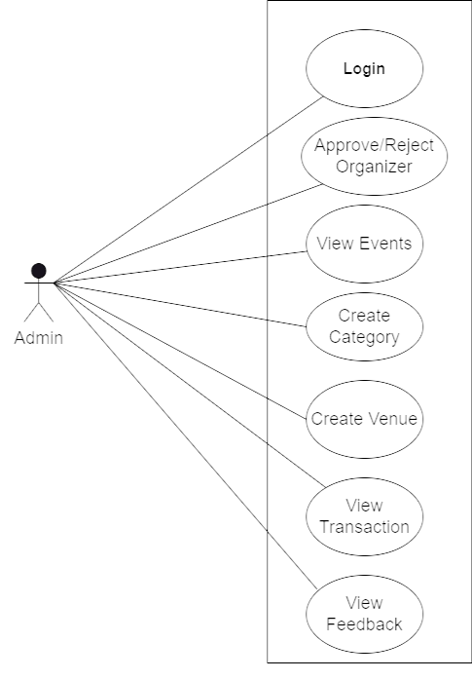

*Fig. Use case diagram for admin*

1. In Admin use case diagram Admin is the Actor.
2. Admin can handle following use cases:
3. Login
4. Approve and Register Organizer
5. View Events
6. Create Events
7. View Transaction
8. View Feedback

**Attendee:**

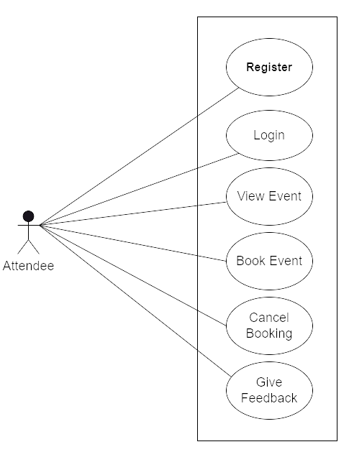

1. In Attendee use case diagram Attendee is the Actor.
2. Attendee can handle following use cases:
3. Register
4. Login
5. View Event
6. Book Event
7. Cancel Booking
8. Give Feedback

**Organizer:**

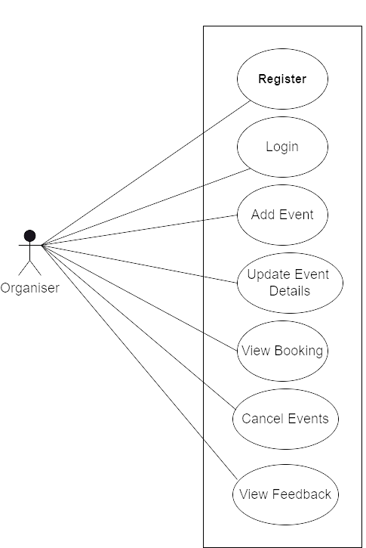

*Fig. Use case diagram for Organizer*

1. In Organizer use case diagram Organizer is the Actor**.**
2. Organizer can handle following use cases:
3. Register
4. Login
5. Add Event
6. Update Event Details
7. View Booking
8. Cancel Events
9. View Feedback