**Experiment No.1**

**Arun Singhal 18SCSE1010375**

**print("Arun Singhal 18SCSE1010375")**

**start=int(input("enter your starting range"))**

**end=int(input("enter your ending range"))**

**for val in range(start,end+1):**

**if val>1:**

**for n in range(2,val):**

**if(val%n)==0:**

**break**

**else:**

**print(val)**

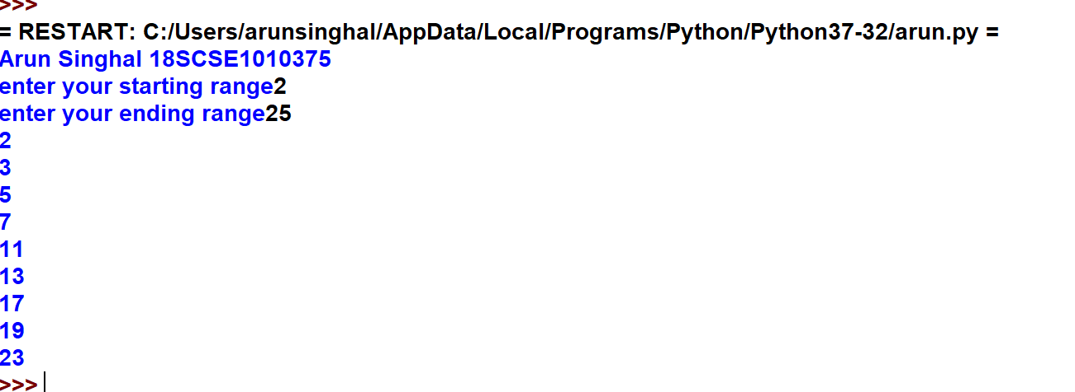

**Experiment no.2**

**Arun Singhal 18SCSE1010375**

**print("Arun Singhal 18SCSE1010375")**

**def calculateCube(n):**

**return n*n*n**

**numbers=(1,2,3,4)**

**result=map(calculateCube,numbers)**

**print(result)**

**numbersCube=set(result)**

**print(numbersCube)**

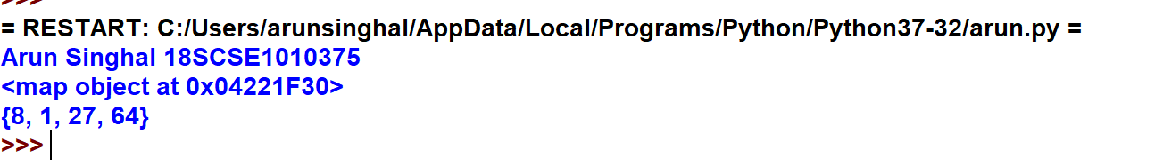

**Experiment No.3**

**Arun Singhal 18SCSE1010375**

**print("Arun Singhal 18SCSE1010375")**

**a=20**

**b=10**

**c=15**

**d=5**

**e=0**

**e=(a+b)*c/d**

**print("value of (a+b)*c/d is",e)**

**e=((a+b)*c)/d**

**print("value of ((a+b)*c)/d is ",e)**

**e=(a+b)*(c/d)**

**print("value of (a+b)*(c/d) is",e)**

**e=a+(b*c)/d**

**print("value of a+(b*c)/d is",e)**

**e=a*b//c**

**print("value of a*b//c is",e)**

