**Experiment No.4(a)**

**Arun Singhal 18SCSE1010375**

**n=int(input("enter number"))**

**rev=0**

**while(n>0):**

**dig=n%10**

**rev=rev*10+dig**

**n=n//10**

**print("reverse of given number",rev)**

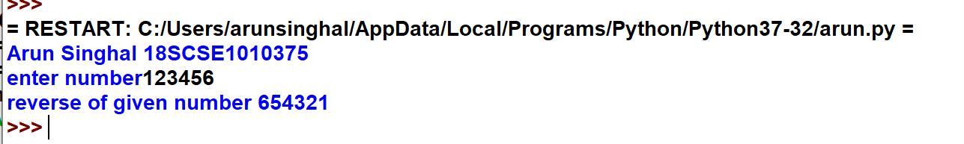

**Experiment No.4(b)**

**n=int(input("enter a number"))**

**tot=0**

**while(n>0):**

**dig=n%10**

**tot=tot+dig**

**n=n//10**

**print("the total sum of digits is:",tot)**

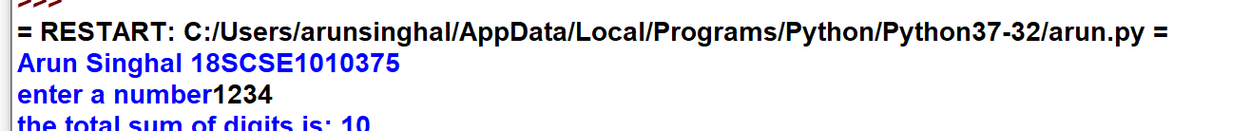

**Experiment no 5**

**ArunSinghal 18SCSE1010375**

**player1=int(input("player 1 enter the number between 1 to 6:"))**

**player2=int(input("player 2 enter the number between 1 to 6:"))**

**import random**

**r1=random.randint(1,7)**

**print("dice number is %d"%(r1))**

**if r1==player1:**

**print("player1 win %d"%(r1))**

**elif r1==player2:**

**print("player2 win %d"%(r1))**

**else:**

**print("no one win is winner %d"%(r1))**

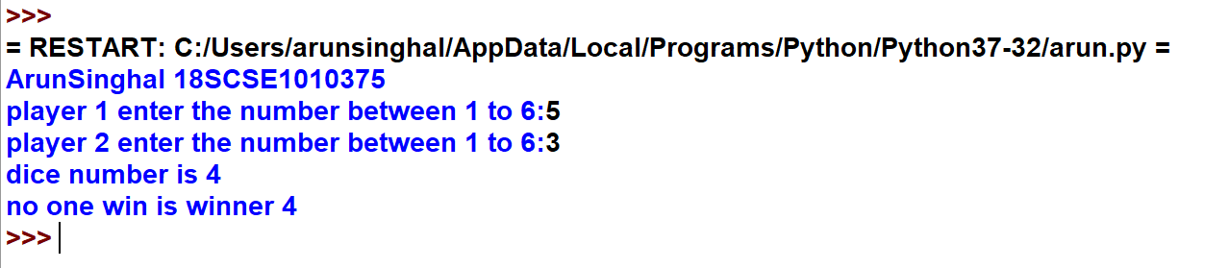

**Experiment No.6**

**Arun Singhal 18SCSE1010375**

**import math**

**a=5.4**

**print("the ceil of 2.3 is:",end=" ")**

**print(math.ceil(a))**

**print("the floor of 2.3 is:",end=" ")**

**print(math.floor(a))**

**x=-69**

**y=6**

**print("the absolute value of -69 is:",end=" ")**

**print(math.fabs(x))**

**print("The factorial of 6 is:",end=" ")**

**print(math.factorial(y))**

**p=-69**

**q=24.7**

**r=35**

**s=7**

**print("the copysigned value of -69 and 24.7 is:",end=" ")**

**print(math.copysign(24.7,-69))**

**print("the gcd of 7 and 35 is:",end=" ")**

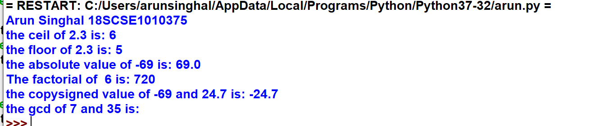

Experiment No. 7

Arun Singhal 18SCSE1010375

**string=input("enter string:")**

**if(string==string[::-1]):**

**print("string is palindrome")**

**else:**

**print("string is not palindrome")**

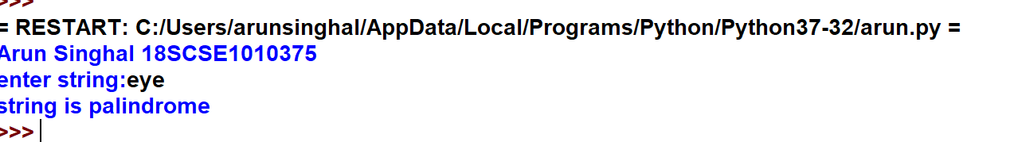

**Experiment No.8**

**Arun Singhal 18SCSE1010375**

**print("Arun Singhal 18SCSE1010375")**

**string=input("please enter your own string")**

**char=input("please enter your own character")**

**count=0**

**for i in range(len(string)):**

**if(string[i]==char):**

**count=count+1**

**print("The total number of times",char,"has occured=",count)**

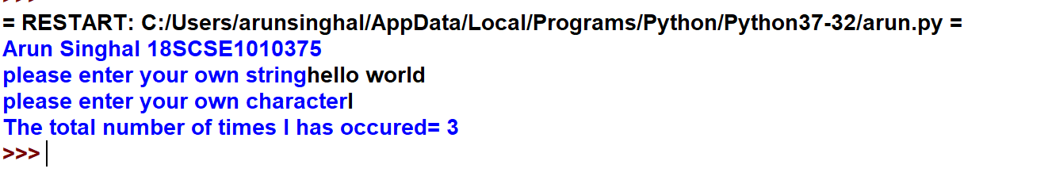

**Experiment No.9**

**Arun Singhal 18SCSE1010375**

**print("Arun Singhal 18SCSE1010375")**

**dict1={'name':'deepanshu','collage':'sharda collage','course':'b.tech','branch':'cs','cgpa':'6.3'}**

**dict2={'name':'naman','collage':'amity collage','course':'m.tech','branch':'mechanical','cgpa':'9.5'}**

**dict3={'name':'divanshu','collage':'galgotia collage','course':'bsc','branch':'chemistry','cgpa':'7.5'}**

**roll=int(input("enter the roll number:"))**

**if roll==1:**

**for key,value in dict1.items():**

**print(key,":",value)**

**elif roll==2:**

**for key,value in dict2.items():**

**print(key,":",value)**

**elif roll==3:**

**for key,value in dict3.items():**

**print(key,":",value)**

**else:**

**print("roll number is not found")**

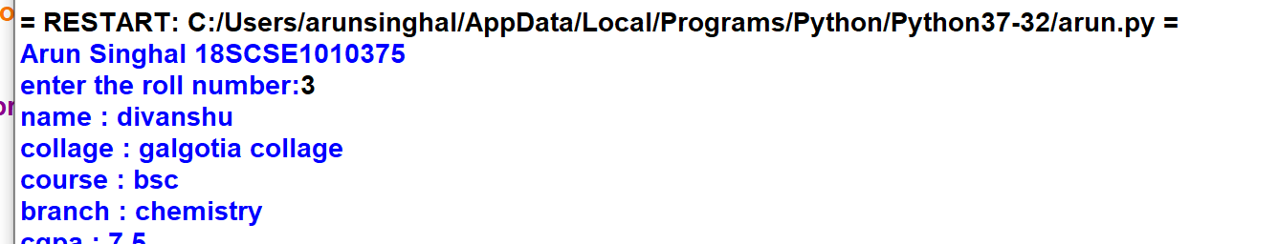

**Experiment No.10**

**Arun Singhal 18SCSE1010375**

**print("Arun Singhal 18SCSE1010375")**

**prices={}**

**prices["banana"]=4**

**prices["apple"]=2**

**prices["orange"]=1.5**

**prices["pear"]=3**

**stock={}**

**stock["banana"]=6**

**stock["apple"]=0**

**stock["orange"]=32**

**stock["pear"]=15**

**for food in prices:**

**print(food)**

**print("price:%s"%prices[food])**

**print("stock:%s"%stock[food])**

**total=0**

**for price in prices:**

**money=prices[price]*stock[price]**

**print(money)**

**total=total+money**

**print("the total money is",total)**

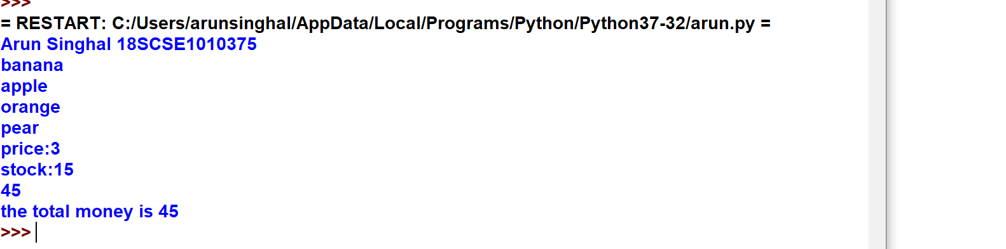

**Experiment No.11**

**Arun Singhal 18SCSE1010375**

**print("Arun Singhal 18SCSE1010375")**

**import datetime**

**import calendar**

**def findDay(date):**

**born=datetime.datetime.strptime(date,'%d %m %Y').weekday()**

**return(calendar.day_name[born])**

**date=input("enter date")**

**print(findDay(date))**

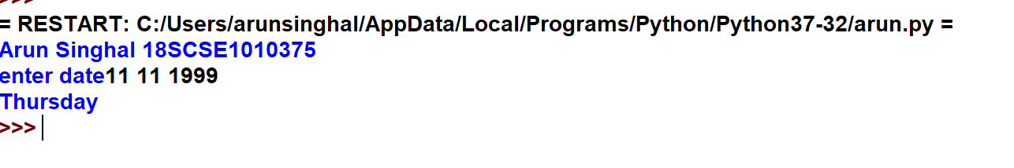

**Experiment No.12**

**Arun Singhal 18SCSE1010375**

**print("Arun Singhal 18SCSE1010375")**

**from datetime import date**

**f_date=date(1999,11,11)**

**l_date=date(2019,11,6)**

**delta=l_date-f_date**

**print("No. of days between these two dates are:",delta.days)**

